|  |  |  |  |  |
| --- | --- | --- | --- | --- |
| Current State | Input | | Next State | Output |
| L | A |
| 00 | 0 | 0 | 00 | 0 |
| 00 | 0 | 1 | 00 | 0 |
| 00 | 1 | 0 | 01 | 1 |
| 00 | 1 | 1 | 01 | 1 |
| 01 | 0 | 0 | 10 | 0 |
| 01 | 0 | 1 | 10 | 0 |
| 01 | 1 | 0 | 01 | 1 |
| 01 | 1 | 1 | 01 | 1 |
| 10 | 0 | 0 | 01 | 1 |
| 10 | 0 | 1 | 00 | 0 |
| 10 | 1 | 0 | 01 | 1 |
| 10 | 1 | 1 | 00 | 0 |

S0



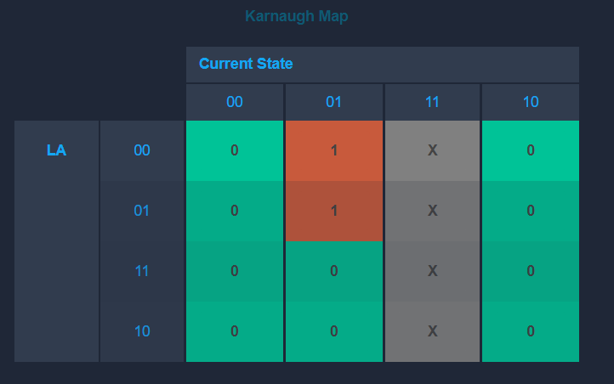

S1



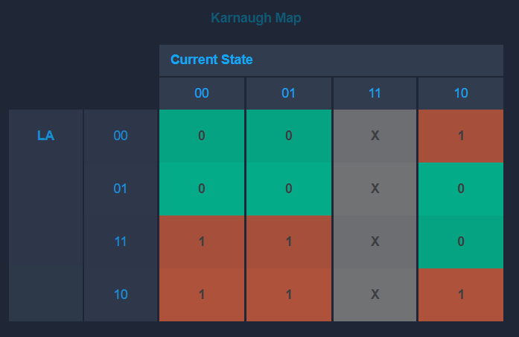

Output





