Guide: Environment Setup for Huawei Cloud Development

Huawei Technologies CO., LTD
v3.8.0

Contents

1 Provision a Flexus X Instance on Huawei Cloud
General Objective: Provision a Flexus X instance on Huawei Cloud that will host a complete coding stack environment: the oh-my-coding-maas-gateway (a LiteLLM-based proxy with load balancing, virtual keys, and Grafana observability), governance tooling, and multiple coding agents — with OpenCode as the primary one. By the end of this chapter you will have a running Flexus X instance with a public IP accessible over SSH.
Prerequisites:
- Active Huawei Cloud account with IAM credentials.
- Permission to create security groups, Flexus X instances, and EIPs.
- A key pair created in the Console, or permission to create one.
- A web browser (Chrome, Firefox, or Edge).
​
Info
This guide assumes the sa-brazil-1 region. Adjust the region if your account is registered elsewhere.

1.1 Create the security group (sg-xgate)
Objective:
Create a security group that allows SSH access on port 4444 from specific Huawei internal IPs only.

Info
We use port 4444 instead of the standard SSH port 22 because the Huawei corporate proxy blocks outbound connections on port 22. Port 4444 is allowed through the proxy and works reliably for SSH.

Step by step:
- In the Console, go to VPC → Security Groups and click Create Security Group.
- Name it sg-xgate and add the following inbound rules:
- Rule 1:
Protocol: TCP
Port: 4444
Source: 119.8.89.193/32
Description: SSH for Huawei internal user 1
Rule 2:
Protocol: TCP
Port: 4444
Source: 119.8.89.3/32
Description: SSH for Huawei internal user 2
Rule 3:
Protocol: TCP
Port: 4444
Source: 119.8.193.3/32
Description: SSH for Huawei internal user 3
- Click OK to create the security group.
Tip
Each /32 rule restricts access to exactly one IP address. Only the three listed Huawei internal IPs can reach the instance on port 4444 — no other inbound traffic is allowed.

1.2 Create the Flexus X instance
Objective:
Launch a single Flexus X instance using the Console wizard, using the security group created above.

Step by step:
- Log in to the Huawei Cloud Console and select the sa-brazil-1 region in the top-right corner.
- Open the service catalog and select Flexus X (under Compute).
- Click Create Flexus X to open the creation wizard.
- Under Billing Mode, select Pay-per-use.
Tip
- Pay-per-use bills by the hour with no long-term commitment. You only pay for the time the instance is running. This is ideal for development and testing — stop the instance when not in use to reduce costs.

- Set the compute resources using the slider: drag to 4 vCPU and 16 GB RAM.
Info
- Flexus X uses a slider for vCPU and memory instead of fixed flavor names. The resulting flavor ID is x1.4u.16g, but you select it by dragging the vCPU and RAM controls — there is no flavor dropdown.

- Fill in the remaining basic configuration:
- AZ: Any (choose the availability zone you prefer)
Image: Ubuntu 24.04 Server 64bit
Disk: 100 GB General Purpose SSD
VPC: vpc-default
Subnet: subnet-default
Security Group: sg-xgate (port 4444, Huawei internal IPs only)
Important
- The EIP is auto-assigned and configured to be released when the instance is deleted. If you need a fixed IP that persists across stop/start cycles, allocate a dedicated EIP and bind it manually after creation.

- Under EIP settings, configure the public IP:
- EIP: Auto-assign
Billing: Pay by traffic
Bandwidth: 1000 Mbit/s
Release: Yes — release EIP when instance is deleted
- Under Cloud Eye, enable monitoring (recommended).
Info
- Cloud Eye is a monitoring service that provides functions such as real-time monitoring, alarm reporting, resource grouping, and website monitoring. Enabling it gives you visibility into instance health, CPU, memory, and network metrics out of the box.

- Set the instance name to flexusx-dev (or any name you prefer).
- Under Login Configuration, select Key pair as the authentication method. If you do not yet have a key pair, click Create Key Pair to generate one inside Huawei Cloud and download the .pem file.
Info
- The key pair is the primary access method. Later, you can set a root password on the instance (via the Console or after first login with the key) to have a second way to access the instance.

- Click Create Now and wait for the status to change to Running.

1.3 Verify the instance
On the instance details page, copy the EIP field. This is the address you will use to connect in the next chapters.
Step | What to check | Expected result
Security group | `sg-xgate` with TCP 4444 rules | 3 inbound rules
Billing mode | Pay-per-use selected | Hourly billing
Compute | 4 vCPU, 16 GB RAM via slider | Flavor `x1.4u.16g`
Image | Ubuntu 24.04 Server 64bit | Selected
EIP | Auto-assigned | Public IP available
Cloud Eye | Monitoring enabled | Metrics visible
Instance name | `flexusx-dev` | Set
Key pair | Created and downloaded | `.pem` file saved
Instance | Status is **Running** | EIP copied

2 Configure Flexus X for Remote Access
General Objective: Prepare the Flexus X instance for remote access by setting a root password via the Console and changing the SSH port from 22 to 4444. This is required because the Huawei corporate proxy blocks outbound connections on port 22.
Prerequisites:
- Chapter 1 completed — Flexus X instance running with a public IP.
- Access to the Huawei Cloud Console.
​

2.1 Set the root password
Objective:
Use the Console to reset the root password of the Flexus X instance.

Step by step:
- In the Console, navigate to Flexus X and click on the instance flexusx-dev.
- In the instance details page, click More → Reset Password.
- 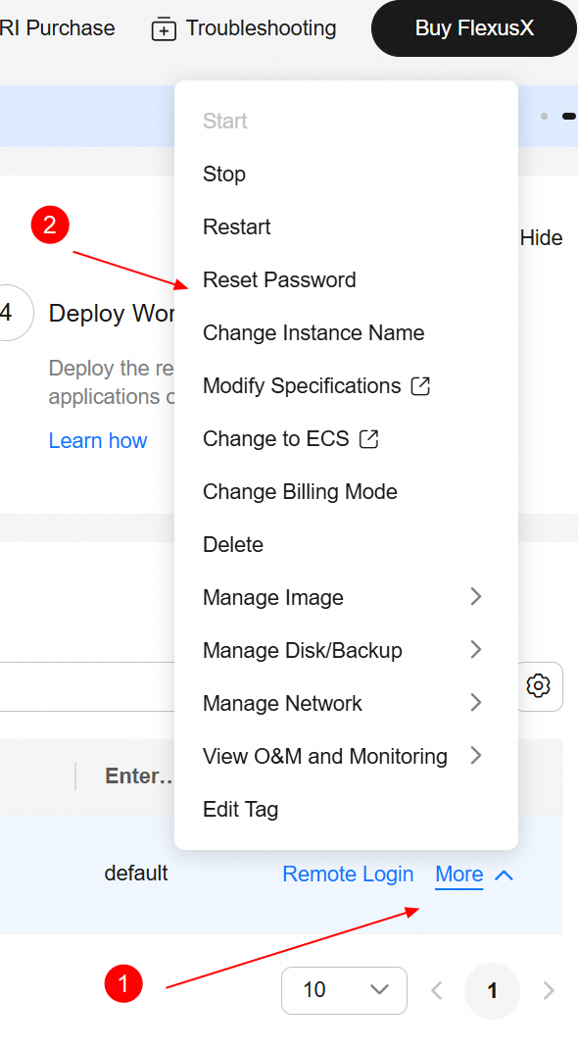
- Reset Password option in the Flexus X details page.
- Enter a strong root password and confirm. Click OK.
- The instance will restart automatically. Wait for the status to return to Running.
Important
Choose a strong password (12+ characters, mixed case, digits, symbols). This password enables remote login directly from the Console and serves as a second access method alongside the SSH key pair.

2.2 Change the SSH port to 4444
Objective:
Log in via the Console remote login, edit sshd_config, and change the SSH port from 22 to 4444.

Step by step:
- In the instance details page, click Remote Login. A browser-based terminal opens.
- 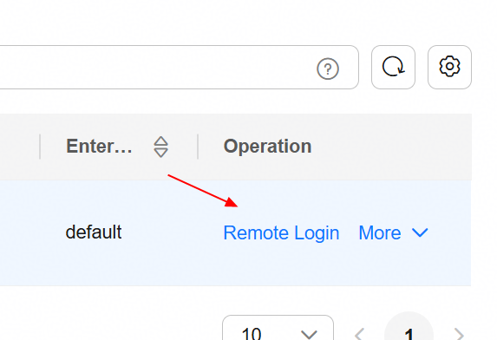
- Remote Login button in the Flexus X details page.
- Log in as root using the password set in the previous subsection.
- Open the SSH daemon configuration file:
- sudo vim /etc/ssh/sshd_config
- Find the line Port 22 (or \#Port 22) and change it to:
- Port 4444
- Save and exit vim (:wq).
- Reboot the instance from the Console to apply the change. The SSH daemon will start automatically on port 4444 after reboot.
- 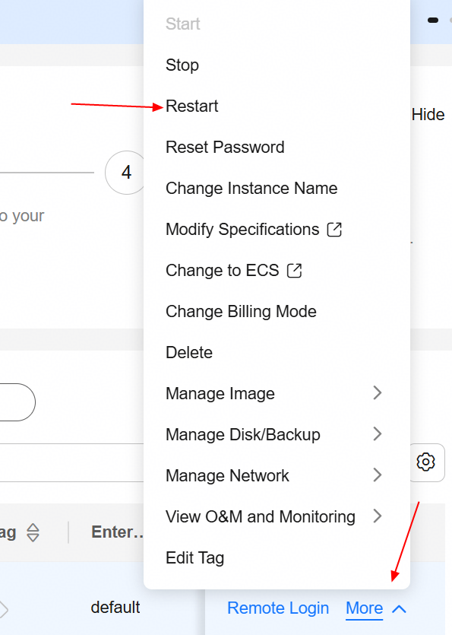
- Restart the Flexus X instance from the Console.
Important
- The reboot is mandatory — not optional. Until the instance is rebooted, SSH continues listening on port 22 and the proxy CONNECT to port 4444 will fail with Ncat: Error reading proxy response Status-Line. If you skip this step, all subsequent SSH connections through the proxy will fail.

Info
After this change, SSH connections must use Port 4444 explicitly. The security group sg-xgate (created in Chapter 1) already allows inbound TCP 4444 from the authorized Huawei internal IPs.

2.3 Verify the configuration
Use the table below to confirm all steps were completed successfully before proceeding to the next chapter:
Step | What to check | Expected result
Security group | `sg-xgate` exists with TCP 4444 rules | 3 inbound rules
Flexus X running | Instance `flexusx-dev` status | **Running**
Root password | Remote Login works with password | Shell prompt
SSH port | `sshd_config` has `Port 4444` | Config saved
SSH restart | Instance rebooted from Console | Service active

3 Install ncat and SSH Connection Topology
General Objective: Install ncat (from Nmap) on your local Windows machine and understand the SSH connection topology through the Huawei corporate proxy (xgate). ncat serves as the SSH ProxyCommand, tunneling SSH through the HTTP proxy via the CONNECT method.
Prerequisites:
- Chapter 2 completed — Flexus X configured with root password and SSH on port 4444.
- The private key file (.pem) downloaded from Huawei Cloud.
​
Info
Premises:
- The proxy is xgate (Huawei corporate proxy) at proxy.huawei.com:8080.
- SSH runs on port 4444 (configured in Chapter 2).
- Login as root using the key pair from Chapter 1.
- ncat (from Nmap) is used as the ProxyCommand to tunnel SSH through the HTTP proxy via the CONNECT method.
- Proxy authentication is transparent — it is handled by the corporate VPN, not by credentials in the SSH config.

3.1 How the connection works
When you specify a ProxyCommand in the SSH config, SSH launches ncat as a child process. ncat performs the HTTP CONNECT handshake with the proxy:
ncat -> proxy: CONNECT <EIP>:4444 HTTP/1.1
Host: <EIP>:4444
proxy -> ncat: HTTP/1.1 200 Connection Established
[Both sides now send raw TCP bytes -- SSH negotiation begins over the tunnel]
After the 200 Connection Established response, the proxy becomes a blind TCP relay — it neither inspects nor modifies the SSH traffic. SSH key exchange, encryption, and authentication all happen inside this tunnel as if it were a direct TCP connection.
Info
The corporate proxy blocks CONNECT to port 22 (standard SSH) but allows it to port 4444. Enterprise HTTP proxies implement a CONNECT port allowlist: port 443 (HTTPS) is always allowed, port 22 is usually blocked, and port 4444 is often allowed because it is commonly used for HTTPS-alt. This is why we configured SSH on port 4444 in Chapter 2.

3.2 Why ncat
ncat is the chosen proxy tunnel tool for several reasons:
- Full HTTP CONNECT support — ncat implements the CONNECT method natively via --proxy-type http.
- Actively maintained — part of the Nmap project, with regular releases and bug fixes.
- IPv4 forcing — the -4 flag prevents failed IPv6 attempts through the proxy.
- Connect timeout — the -w flag prevents indefinite hangs if the proxy is unreachable.
- Proxy auth support — --proxy-auth and the NCAT\_PROXY\_AUTH environment variable, if explicit credentials are ever needed.
Info
connect.exe (from Git for Windows) is a lighter alternative that ships with Git, but it lacks the -4 (force IPv4) and -w (connect timeout) flags, which are important for reliable proxied connections. ncat provides better control over the tunnel behavior.

3.3 Install ncat on Windows
Objective:
Install Nmap, which provides ncat.exe — the proxy tunnel tool used by SSH ProxyCommand.

Step by step:
- Download the Nmap installer from nmap.org/download.html. Use the Latest stable release self-installer (nmap-7.991-setup.exe, tested and verified).
- Run the installer (right-click Run as Administrator).
- During installation, uncheck Npcap — it is a kernel driver for packet capture and is not needed for proxy tunneling. Also uncheck Zenmap, Nping, and Ndiff for a minimal install.
- 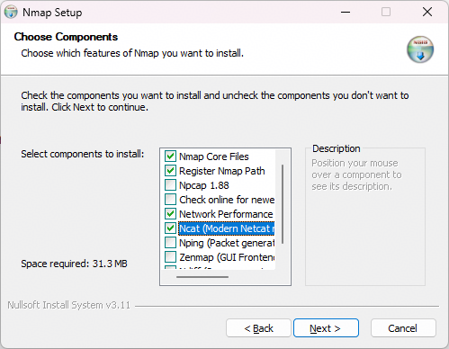
- Nmap installer component selection — uncheck Npcap, Zenmap, Nping, and Ndiff.
Tip
- Skipping Npcap avoids a kernel driver install and potential reboot. ncat in proxy mode uses standard Winsock2 TCP sockets and does not need Npcap at all.

- Choose the default install path: C:\textbackslash Program Files (x86)\textbackslash Nmap.
- After installation, verify that ncat.exe is available:
- "C:\Program Files (x86)\Nmap\ncat.exe" --version
- If the command shows the version string, the installation is correct.
Important
Nmap is commonly flagged by antivirus software due to port-scanning heuristics. Windows Defender may quarantine ncat.exe on download or block execution. Add an exclusion for the Nmap folder and the ncat.exe process in Windows Security → Virus & threat protection → Exclusions. If ncat.exe was already quarantined, restore it from Protection history before adding the exclusion.

Step | What to check | Expected result
Nmap download | `nmap-7.991-setup.exe` saved | Installer ready
Components | Npcap, Zenmap, Nping, Ndiff unchecked | Minimal install
Install path | `C:\Program Files (x86)\Nmap` | Default path
ncat.exe | `ncat –version` shows version | Installed correctly
Antivirus | Exclusion added for Nmap folder | `ncat.exe` not blocked

4 Install VS Code and Connect via Remote-SSH
General Objective: Install VS Code from scratch on your local Windows machine, install the Remote-SSH extension, configure the SSH config file using VS Code as the editor, and connect to the Flexus X instance.
Prerequisites:
- Chapter 3 completed — ncat installed and proxy tunnel understood.
- The private key file (.pem) downloaded from Huawei Cloud.
​

4.1 Install VS Code
Step by step:
- Download VS Code from code.visualstudio.com/download. Choose the Windows installer (User Installer, 64-bit).
- Run the installer with the default settings.
- After installation, verify VS Code is available:
- code --version

4.2 Install the Remote-SSH extension
Step by step:
- Open VS Code on your local Windows machine.
- Install the Remote - SSH extension (publisher: Microsoft):
- code --install-extension ms-vscode-remote.remote-ssh

4.3 Configure the SSH config file
Objective:
Create an SSH config entry that tunnels through the Huawei proxy using ncat from Nmap. Use VS Code as the editor.

Step by step:
- Open or create the SSH config file using VS Code:
- code %USERPROFILE%\.ssh\config
- Add the following configuration. Replace these placeholders with your values:
  - <host-name> — a name of your choice (e.g., flexusx-dev)
  - <EIP> — the Flexus X public IP copied from Chapter 1
  - <user> — your Windows username (e.g., w00946241)
  - <key-file> — the name of your .pem key file downloaded from Huawei Cloud (e.g., KeyPair-opencode)
- Host <host-name>
HostName <EIP>
User root
Port 4444
IdentityFile "C:\Users\<user>\.ssh\<key-file>.pem"
ProxyCommand "C:\Program Files (x86)\Nmap\ncat.exe" -4 -w 10 --proxy proxy.huawei.com:8080 --proxy-type http %h %p
ServerAliveInterval 15
ServerAliveCountMax 4
ConnectTimeout 10
TCPKeepAlive yes
StrictHostKeyChecking accept-new
Info
- The IdentityFile path has two placeholders: <user> is your Windows username (the folder under C:\Users\), and <key-file> is the name of the .pem file downloaded from Huawei Cloud in Chapter 1. For example: C:\Users\w00946241\.ssh\KeyPair-opencode.pem.

4.4 What each ncat flag does
Flag | Purpose
`-4` | Force IPv4 (avoids failed IPv6 attempts through the proxy)
`-w 10` | 10-second connect timeout (prevents indefinite hang)
`–proxy` | Proxy address and port (`proxy.huawei.com:8080`)
`–proxy-type http` | Use HTTP CONNECT method
`%h` | Substituted by SSH with the HostName (the EIP)
`%p` | Substituted by SSH with the Port (4444)
Tip
The ServerAliveInterval 15 and ServerAliveCountMax 4 settings send a keepalive every 15 seconds and disconnect after 4 missed keepalives (60 seconds dead detection). This is critical for proxied connections, which may drop idle sessions after 5–30 minutes.

4.5 Connect to the Flexus X via VS Code
Step by step:
- Press F1 to open the Command Palette, type Remote-SSH: Connect to Host..., and press Enter.
- 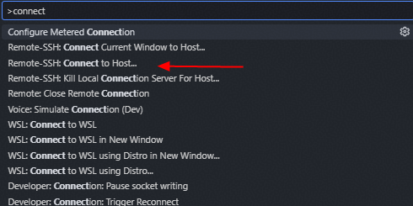
- VS Code Command Palette — select Remote-SSH: Connect to Host...
- Select your host name (e.g., flexusx-dev) from the list of configured hosts.
- If prompted to select the platform type, choose Linux. This tells VS Code which server binary to download and avoids auto-detection delays.
Info
- VS Code only asks for the platform type the first time you connect to a new host. The selection is saved in your local settings (remote.SSH.remotePlatform) and reused on subsequent connections.

- VS Code opens a new window and begins connecting. On the first connection, it downloads and installs the VS Code Server on the remote instance — this takes about 1–2 minutes. Subsequent connections are faster.
- Once connected, click Open Folder and select /home (or your working directory).
- Verify the connection by opening a terminal in VS Code (Ctrl+`) and running:
- uname -a
df -h
Info
The first connection installs the VS Code Server on the remote instance, which requires outbound internet access on port 443 (HTTPS). The Flexus X instance has an EIP, so it typically has outbound internet access. If the connection hangs during server installation, verify with curl -sI https://update.code.visualstudio.com from the instance.

4.6 Troubleshooting
If the connection fails, check these common issues:
- Ncat: Error reading proxy response — SSH was not restarted after the port change (Chapter 2). Fix: reboot the instance from the Console.
- Ncat: Error reading proxy response — proxy CONNECT permission missing for this IP. Fix: request IT permission for the instance EIP on port 4444.
- Connection timed out — proxy unreachable or CONNECT blocked. Fix: verify proxy address; test ncat with the -v flag.
- UNPROTECTED PRIVATE KEY FILE — key permissions too open. Fix: run icacls to restrict the key file to your user only.
- VS Code hangs on first connect — instance cannot reach internet on port 443. Fix: verify curl -sI https://update.code.visualstudio.com from the instance.
- $PLATFORM is undefined — SSH connection failed before server install. Fix: check the Remote-SSH output log; fix the underlying SSH error first.
Info
To debug the proxy connection, run ncat directly with verbose output:
"C:\Program Files (x86)\Nmap\ncat.exe" -v --proxy proxy.huawei.com:8080 --proxy-type http <EIP> 4444
This shows the CONNECT request and the proxy’s raw response (or connection close). For SSH-level debugging, run ssh -vvv <host-name> "echo ok".

Step | What to check | Expected result
VS Code | `code –version` works | Installed
Remote-SSH | Extension installed | Active
SSH config | Host entry with ncat ProxyCommand | Config saved
Connection | Remote-SSH connects to host | Flexus X accessible
Terminal | `uname -a` and `df -h` | Output verified

5 Install the MaaS Coding Gateway
General Objective: Install the oh-my-coding-maas-gateway on the Flexus X instance. This is a self-hosted LiteLLM proxy that routes Huawei ModelArts MaaS models to coding tools with load balancing, virtual keys, dual-format API endpoints, and Prometheus + Grafana observability.
Prerequisites:
- Chapter 4 completed — VS Code connected to the Flexus X via Remote-SSH.
- Docker and Docker Compose available (the installer handles this).
- A Huawei ModelArts MaaS API key.
​

5.1 Overview
The oh-my-coding-maas-gateway is a self-hosted proxy gateway that sits between your coding tools and Huawei ModelArts MaaS (Model-as-a-Service) models. It provides:
- Load balancing — distributes requests across multiple MaaS API keys (N keys $→$ N deployments per model per format).
- Virtual key management — each coding tool gets its own virtual key with unlimited budget, isolated from the real MaaS keys.
- Dual-format API endpoints — OpenAI Chat Completions (/v1/chat/completions) and Anthropic Messages (/v1/messages), so tools using different API formats can all reach the same MaaS models.
- Budget tracking — per-key spend tracking via LiteLLM + PostgreSQL, with cost-per-token configured for all models.
- Full observability — Prometheus metrics + Grafana 39-panel dashboard (latency, errors, throughput, tokens, cache, cost).
Info
The gateway repository is at wallacelw/oh-my-coding-maas-gateway. It supports 4 models: glm-5.2 (1M context), glm-5.1, deepseek-v4-pro, and deepseek-v4-flash (384K max output). This guide was tested with v1.10.9; the installation process is the same for newer versions.

5.2 Architecture
The gateway deploys 4 Docker containers via Docker Compose:
Tools LiteLLM (:4000) Huawei MaaS
───── ─────────────── ────────────
opencode --> /v1/chat/completions --> openai/ --> MaaS OpenAI endpoint
Codex CLI --> /v1/responses --> openai/ --> MaaS OpenAI endpoint
Claude Code --> /v1/messages --> anthropic/ --> MaaS Anthropic endpoint
Pi agent --> /v1/chat/completions --> openai/ --> MaaS OpenAI endpoint
LiteLLM: load-balances across N MaaS keys . PostgreSQL (:5432)
Observability: LiteLLM --/metrics--> Prometheus (:9090) --> Grafana (:3000)
Service | Port | Purpose
LiteLLM Proxy | 4000 | API gateway (OpenAI + Anthropic format)
PostgreSQL | 5432 | LiteLLM database (keys, spend, config)
Prometheus | 9090 | Metrics storage and querying
Grafana | 3000 | Dashboard visualization (39 panels)
Info
All ports bind to 127.0.0.1 (localhost only) by default. To access Grafana and the LiteLLM Admin UI from your local machine, use SSH port forwarding in VS Code or add port forwards in the Remote-SSH connection.

Each model has two deployments — one OpenAI, one Anthropic — so all tools can use the same MaaS models regardless of their API format. The claude- prefix (e.g., claude-glm-5.2) prevents routing conflicts in LiteLLM.

5.3 Run the bootstrap installer
Objective:
Install the gateway using the one-command bootstrap script.

Step by step:
- In the VS Code remote terminal, run the bootstrap script:
- curl -fsSL https://raw.githubusercontent.com/wallacelw/oh-my-coding-maas-gateway/main/scripts/bootstrap.sh | bash
- The installer will:
  - Prompt for your Huawei MaaS API key.
  - Show an interactive menu to select which coding tools to install (opencode, Codex CLI, Claude Code, Pi agent).
  - Auto-install prerequisites (Docker, Node.js, etc.).
  - Deploy the proxy + observability stack (LiteLLM, PostgreSQL, Prometheus, Grafana).
  - Configure each tool with its own virtual key.
  - Run 120 validation checks and offer to install the companion skill.
Important
- Estimated time: ~5 min for a fresh install, ~2 min for an upgrade. If you are behind a proxy, ensure http_proxy and https_proxy environment variables are set before running the script.

Tip
For non-interactive installs (CI/automation), pass the API key directly. The -y flag suppresses all prompts (prerequisites, tool selection, skill install):
curl -fsSL https://raw.githubusercontent.com/wallacelw/oh-my-coding-maas-gateway/main/scripts/bootstrap.sh | bash -s -- -y --api-key=sk-xxxx

5.4 Verify the installation
Step by step:
- Check that the proxy is running:
- curl http://localhost:4000/health
- Open the Grafana dashboard at http://localhost:3000 to monitor usage and metrics (39 panels across 7 sections).
- Open the LiteLLM Admin UI at http://localhost:4000/ui to manage virtual keys and model routing.
- Launch your coding tool:
- opencode # or: codex or: claude --bare or: pi
Tip
To upgrade the gateway later, re-run the same bootstrap command. It detects existing installs, compares versions, and pulls updates — all secrets and data are preserved.

Step | What to check | Expected result
Bootstrap | Installer completed | All services deployed
Proxy health | `curl localhost:4000/health` | Healthy
Grafana | `localhost:3000` | Dashboard accessible
LiteLLM UI | `localhost:4000/ui` | Admin UI accessible
Coding tool | Launched and connected | Gateway routing

6 Install the Huawei Document Templates Project
General Objective: Clone the Huawei document templates repository on the Flexus X instance, run the setup script, and verify that the LaTeX toolchain and the coding agent skill are ready for use. The script assumes a fresh Ubuntu install — it installs all dependencies from scratch and configures VS Code at the user level.
Prerequisites:
- Chapter 5 completed — MaaS gateway installed and running.
- Git installed (sudo apt install git).
- The repository URL for the Huawei document templates project.
- A fresh Ubuntu 24.04 instance (no prior LaTeX installation required).
​
Info
The install.sh script is idempotent — it is safe to run multiple times. It merges VS Code settings rather than overwriting them, and apt-get install skips packages that are already present.

6.1 Clone and set up the project
Step by step:
- Run the one-liner install (clones the repo to /home/huawei-doc-templates and installs everything):
- cd /home
curl -fsSL https://raw.githubusercontent.com/wallacelw/huawei-doc-templates/main/scripts/install.sh | bash
Info
- The script installs XeLaTeX, latexmk, fonts (HarmonyOS Sans + Cascadia Code), the opencode skills, and configures VS Code LaTeX Workshop. When run interactively (./scripts/install.sh), it prompts for optional components (skills and VS Code — both default to yes). When run via one-liner, all components are installed automatically. It is idempotent — safe to re-run.

Info
- If an existing installation is detected, the one-liner prompts to update: Update v3.3.6 → v3.3.7? [Y/n]. It pulls the latest version and re-runs the installer. No need to git pull manually.

- Verify the LaTeX toolchain:
- xelatex --version
latexmk --version

6.2 Compile the sample guides
The project includes a self-documenting Makefile. To compile all samples (guide + technical, Portuguese + English):
Step by step:
- From the repository root, run:
- make samples
- Verify the PDFs were generated:
- ls -l examples/guide/pt/main.pdf
ls -l examples/guide/en/main.pdf
ls -l examples/technical/pt/main.pdf
ls -l examples/technical/en/main.pdf
Tip
To compile a single project, use make project DIR=examples/guide/pt or run latexmk main.tex from the project’s src/ directory. Run make with no arguments to see all available targets.

6.3 Create your first guide with the skill
Step by step:
- In the VS Code remote terminal, launch your coding agent:
- cd /home/huawei-doc-templates
opencode # or: codex, claude --bare, pi
- Run the guide skill:
- /skill huawei-template-guide
- The skill will ask for:
  - Title — e.g. “Provisioning an OBS Bucket”
  - Language — Portuguese or English
  - Project name — used as the folder name
  - Location — where to create the project folder
- The skill generates the .tex file, creates a .latexmkrc with the correct TEXINPUTS, compiles the document, and reports the page count.
- Ready
Info
The skill is auto-discovered via opencode.json which registers templates/ as a skill discovery path. No manual skill installation is needed when working inside the repo.

6.4 Write content using template commands
The template provides commands for common guide elements:
Headings (automatic numbering, H1 starts on a new page):
\section{Chapter Title} % H1: giant number + title + rule
\subsection{Section Title} % H2
\subsubsection{Subsection Title} % H3
Objectives block (closes with a horizontal rule):
\begin{objectives}
\generalobjective{...}
\prerequisites
\begin{itemize}
\item ...
\end{itemize}
\end{objectives}
Step-by-step and objectives (used inside subsections):
\objective{...}
\stepbystep
\begin{enumerate}
\item ...
\end{enumerate}
Callout boxes (environment syntax):
- warning — amber warning box
- tip — green tip box
- infobox — blue info box
Code blocks and inline commands:
- \textbackslash begin\{code\} — code block (verbatim, no escaping needed inside)
- \textbackslash begin\{code\}[bash] — same, with a language hint
- \textbackslash inlinecode\{...\} — inline monospace code
Images, links, and other inline commands:
\image{assets/screenshot.png} % centered image
\imagecap{assets/screenshot.png}{caption} % image with numbered caption
\note{Italic observation.} % note paragraph
\weblink{https://...}{link text} % blue clickable link
\menu{VPC, Security Groups} % menu path: VPC -> Security Groups
\badge{New} % inline red label
Info
The project also includes a technical template for technical reports. Use /skill huawei-template-technical to create technical reports with a 5-section structure (problem, root cause analysis, root cause, trigger condition, workaround). See templates/technical/SKILL.md for the full command reference.

Step | What to check | Expected result
Repository | Cloned to `/home/huawei-doc-templates` | Files present
install.sh | Completed without errors | Dependencies installed
XeLaTeX | `xelatex –version` works | Toolchain ready
latexmk | `latexmk –version` works | Build system ready
Sample PDFs | `make samples` compiles all | Guide + technical, PT + EN
Skill | `/skill huawei-template-guide` | Available

7 Tips and Tricks
General Objective: Learn practical tips for working efficiently with the Huawei Cloud development environment, including persistent terminal sessions with tmux.
​

7.1 Using tmux for persistent sessions
When working over SSH, your opencode session is tied to the SSH connection. If the connection drops (network issue, VPN timeout, laptop sleep), the opencode process is killed and all context is lost. tmux solves this by decoupling the terminal from the SSH connection — the session keeps running on the server even when you disconnect, and you can reattach to it when you reconnect.
Step by step:
- Install tmux (if not already installed):
- sudo apt install tmux
- Start a new tmux session before launching opencode:
- tmux new -s opencode
- Inside the tmux session, start opencode as usual:
- opencode
- If SSH disconnects, the opencode session keeps running. Reconnect to the server and reattach:
- tmux attach -t opencode
- To list existing sessions:
- tmux ls
Tip
Always start your opencode session inside tmux. If you forget and start opencode directly, you can’t retroactively attach it to tmux — you’d need to restart opencode inside a new tmux session.

7.1.1 Essential tmux commands
Command | Purpose
`tmux new -s <name>` | Start a new named session
`tmux attach -t <name>` | Reattach to an existing session
`tmux ls` | List all sessions
`tmux kill-session -t <name>` | Kill a specific session
`Ctrl-b d` | Detach from session (keeps it running)
`Ctrl-b c` | Create a new window
`Ctrl-b %` | Split pane vertically
`Ctrl-b "` | Split pane horizontally
`Ctrl-b n` | Next window
`Ctrl-b p` | Previous window
`Ctrl-b [` | Enter scroll/copy mode

7.1.2 tmux configuration for opencode
Create or edit \textasciitilde/.tmux.conf with the following settings to optimize tmux for use with opencode:
# Reduce escape key delay — critical for opencode (default is 500ms)
set -g escape-time 10
# Enable mouse support (scroll, select panes, resize)
set -g mouse on
# Enable clipboard integration (tmux 2.9+)
set -g set-clipboard on
# Allow nested apps to access system clipboard (WSL2 with WSLg)
set -g allow-passthrough on
# Enable extended keys so Shift+Enter works in opencode
set -s extended-keys on
set -as terminal-features 'xterm*:extkeys'
# Use CSI-u encoding format (requires tmux 3.5+)
set -s extended-keys-format csi-u
After editing the config, reload it without restarting tmux:
tmux source-file ~/.tmux.conf
Important
The escape-time setting is critical. The default 500ms delay causes opencode to receive Escape key presses late, which breaks modal editing and menu navigation. Always set it to 10 or lower.

Important
The extended-keys-format csi-u setting requires tmux 3.5 or later. If you get an invalid option: extended-keys-format error, your tmux is too old. Check with tmux -V. To upgrade tmux to 3.5+ from source:
sudo apt install build-essential autotools-dev libevent-dev libncurses-dev
cd /tmp && git clone https://github.com/tmux/tmux.git && cd tmux
sh autogen.sh && ./configure && make && sudo make install
After upgrading, remove the old binary from /usr/bin/tmux if needed (which tmux should point to /usr/local/bin/tmux). Then reload the config: tmux source-file /.tmux.conf.

Tip
If you cannot upgrade tmux, use Ctrl+J to insert a newline in opencode — it works with zero configuration on any tmux version.

Info
For more tips on using tmux with opencode, including WSL2 clipboard integration and keybinding workflows, see Luke Manning’s blog post.

8 Operations and Maintenance
General Objective: Update, uninstall, or clean up the software and cloud resources created in this guide. All operations in this chapter are optional.
​

8.1 Updating the MaaS Gateway
To update the oh-my-coding-maas-gateway to a newer version:
Step by step:
- Re-run the bootstrap script in the VS Code remote terminal:
- curl -fsSL https://raw.githubusercontent.com/wallacelw/oh-my-coding-maas-gateway/main/scripts/bootstrap.sh | bash
- The installer detects the existing installation, pulls updates, and preserves all secrets, virtual keys, and data.
- To update only the coding tools (without touching the proxy stack):
- cd /home/oh-my-coding-maas-gateway
./scripts/update.sh

8.2 Updating the Document Templates
To update the Huawei document templates project:
Step by step:
- Re-run the one-liner — it detects the existing installation and prompts to update:
- curl -fsSL https://raw.githubusercontent.com/wallacelw/huawei-doc-templates/main/scripts/install.sh | bash
- The script pulls the latest version, shows the version change (v3.3.6 → v3.3.7), and re-runs the installer. New templates, commands, or modules are installed automatically.

8.3 Uninstalling the MaaS Gateway
To remove the oh-my-coding-maas-gateway:
Step by step:
- Run the uninstall script:
- cd /home/oh-my-coding-maas-gateway
./scripts/uninstall.sh --all --yes
- This stops and removes Docker containers, volumes, and images, removes coding tool configs (opencode, Codex, Claude, Pi), and deletes the repository.
- To remove only specific components:
- ./scripts/uninstall.sh --tool=opencode # remove one tool
./scripts/uninstall.sh --docker # remove Docker stack only

8.4 Uninstalling the Document Templates
To remove the Huawei document templates installation:
Step by step:
- Run the uninstall script (interactive menu with 5 options):
- cd /home/huawei-doc-templates
./scripts/uninstall.sh
- Or use the one-liner:
- curl -fsSL https://raw.githubusercontent.com/wallacelw/huawei-doc-templates/main/scripts/uninstall.sh | bash
- The interactive menu offers:
  - Option 1: All installed components (skills, modules, font, VS Code)
  - Option 2: Everything + apt packages (WARNING: breaks other TeX)
  - Option 3: Delete repository directory (all files, guides, documents)
  - Option 4: Remove 100% — everything + apt + repo (nuclear option)
  - Option 5: Choose specific components individually
- To preview what would be removed before running:
- ./scripts/uninstall.sh --all --dry-run
- To also remove apt packages (texlive, latexmk, fonts, pandoc):
- ./scripts/uninstall.sh --all --packages --yes
Important
- Removing apt packages will break any other LaTeX documents on the instance. Only use –packages if you are decommissioning the instance.

8.5 Deleting cloud resources (optional)
If you no longer need the Flexus X instance, delete it to stop incurring charges:
Step by step:
- In the Console, navigate to Flexus X.
- Select the instance flexusx-dev, click More and choose Delete.
- Confirm deletion. The EIP is released automatically (configured in Chapter 1 to release on instance deletion).
- Navigate to VPC → Security Groups, select sg-xgate, and delete it.
- Remove the SSH config entry for flexusx-dev from your Windows SSH config file (C:\textbackslash Users\textbackslash <user>\textbackslash .ssh\textbackslash config).
Important
If you used Terraform to provision the infrastructure, run terraform destroy instead to remove all resources declared in the configuration.

Step | What to check | Expected result
Gateway update | Re-run bootstrap | New version running
Templates update | `git pull && ./scripts/install.sh` | New templates available
Gateway uninstall | `./scripts/uninstall.sh –all` | Docker stack removed
Templates uninstall | `./scripts/uninstall.sh –all` | Skills + modules removed
Cloud cleanup | `flexusx-dev` deleted | No running instance
EIP | Released | No public IP charges
Security group | `sg-xgate` deleted | No SG charges
SSH config | Host entry removed | Clean config
This guide was generated using the guide.cls template. For the full command reference, see the template’s README.md or run /skill huawei-template-guide in your coding agent.

9 Changelog

3.8.0 2026-09-13
Added Chapter 7: Tips and Tricks with tmux for persistent SSH sessions, essential tmux commands, and tmux configuration for opencode (escape-time, mouse, clipboard, extended-keys for Shift+Enter).
3.7.0 2026-09-13
Added testbook template for POC/acceptance test case documents with testcase environment and [noanswers] option.
3.6.0 2026-09-13
Added \setdocauthors command and [noauthors] class option to both templates. Authors are displayed on the cover page (optional — hidden if not set or if [noauthors] is passed). Demonstrated in all 4 samples.
3.5.0 2026-09-13
Reorganized project structure: moved build.sh, install.sh, and uninstall.sh from repo root to scripts/ directory. Updated all references in Makefile, README, AGENTS.md, SKILL.md, and setup guide. One-liner URLs now use main/scripts/install.sh.
3.4.0 2026-09-13
install.sh: opencode skills and VS Code LaTeX Workshop are now optional prompts (default yes). Removed LTeX extension (was failing to install). One-liner detects existing installation and prompts to update with version display (v3.3.6 → v3.3.7). Uses absolute paths to prevent nested clones.
uninstall.sh: Added one-liner support (curl | bash). Added “Remove 100%” nuclear option (option 4) to interactive menu. Added –repo flag.
Updated Chapter 6 with optional component prompts and update detection. Updated Chapter 7 with one-liner update/uninstall and full menu documentation.
3.3.0 2026-09-13
Moved pre-compiled setup guide to setup-guide/ folder in repo root with all four formats (PDF, MD, DOCX, HTML). Users can read these before cloning to understand the installation process.
Updated Makefile setup-guide target to generate and copy all four formats.
Updated README with pre-compiled setup guide section and format comparison table.
Updated .gitignore to track all four formats in setup-guide/.
3.2.1 2026-09-13
Renamed Chapter 7 from “Clean Up” to “Operations and Maintenance”. Added subsections for updating and uninstalling both the MaaS Gateway and the document templates. Added cloud resource cleanup as an optional subsection.
3.2.0 2026-09-13
Added uninstall.sh script with interactive menu, –all, –yes, and –dry-run flags. Removes opencode skills, .sty modules, HarmonyOS Sans font, /etc/LatexMk fix, and VS Code settings.
Fixed install.sh: show apt-get output (was hidden), suppress fvextra build noise, fix font detection (fc-list : family), fix test compilation paths (src/ subdirectory), fix LTeX extension success/failure reporting.
Updated Chapter 7 with uninstall instructions.
3.1.2 2026-09-13
Added output format guide to README.md: comparison table of PDF, Markdown, DOCX, and HTML with purpose, copy-paste quality, and limitations. Recommends Markdown for copy-paste.
3.1.1 2026-09-13
Updated MaaS Gateway chapter to v1.10.9: non-interactive mode (-y) now suppresses all prompts (prerequisites, tool selection, skill install).
Changed project clone path from ~ (root home) to /home as default working directory.
Added project standards to AGENTS.md: workflow, end-to-end validation, code style, git conventions, when unsure.
3.1.0 2026-09-13
Switched from ECS to Flexus X instance (4 vCPU, 16 GB RAM via slider, flavor x1.4u.16g) — more cost-efficient and robust. Updated creation steps to match Flexus X console order: billing mode first, vCPU/RAM slider (no flavor dropdown), Cloud Eye monitoring (recommended), then instance name and key pair login. Replaced screenshots with Flexus X console images.
Rewrote Chapter 3: switched from connect.exe to ncat (from Nmap) as the SSH ProxyCommand. Added explanation of HTTP CONNECT method, why port 4444 works, why ncat is chosen, ncat installation with antivirus exclusions, flag reference table, and improved keepalive settings.
Restructured chapters: moved SSH config and VS Code connection to new Chapter 4 (Install VS Code and Connect via Remote-SSH). Chapters 5–7 renumbered.
Added verification checklist tables to all 7 chapters.
Added mandatory reboot warning in Chapter 2 (SSH port change). Added troubleshooting subsection in Chapter 4 with common SSH connection issues and ncat debugging commands.
3.0.1 2026-09-13
Minor fixes: test-filter.sh auto-discovery, build.sh help text, Makefile aggregate descriptions, 5-section comment correction, CHANGELOG version gap note, callout-in-code fix, CI font auto-discovery, dofile path comment, test-sync.sh header.
3.0.0 2026-09-13
Modular pipeline refactoring: shared Lua filter factory, shared DOCX fix logic, build system auto-discovery, unified format pipeline, GitHub Actions CI.
2.16.0 2026-09-13
Updated to match template v2.16.0 — Lua filter fixes, build system updates, and technical template parity improvements.
2.13.0 2026-08-24
Foundation refactoring Phase 4: make DOCX –fix post-processing robust. Replaced all silent-skip guards in create-reference-docx.py with loud RuntimeError assertions for expected XML elements (Heading1-4, Title, VerbatimChar, Normal, docDefaults, numbering indentation). Added pandoc version pin (3.1.0–3.2.0) to catch output-structure regressions on upgrade. Extended test-docx-fix.sh with version check and 4 loud-failure tests (missing style $→$ non-zero exit).
2.12.0 2026-08-24
Foundation refactoring Phase 3: introduce parse_preamble() in the Lua filter, extracting all class options (portuguese, indentbody, notime, nochangelog) and all \set* command values into a single preamble state object. Fixes 6 L18 divergences at root cause: English TOC label (“Table of Contents” $→$ “Contents”), [notime] now gates time in DOCX/HTML, [nochangelog] now suppresses changelog in non-PDF formats, \setcoverlogo honored instead of hardcoded, \setheaderlogo warns if set in non-PDF, \note renders as italic in all formats (matching PDF). Any future preamble command or class option now flows through automatically.
2.11.0 2026-08-24
Foundation refactoring Phase 2: extend test matrix to cover all 3 output formats $×$ 3 documents (9 cells). round-trip.sh now generates DOCX, counts structures in word/document.xml, and checks cross-format consistency (headings, images, code blocks, tables, callouts, 0 raw LaTeX across MD+DOCX+HTML). Added test-docx-fix.sh smoke test asserting H1 red border, heading colors, list indentation, and footer PAGE field in patched styles.xml.
2.10.0 2026-08-24
Foundation refactoring Phase 1: sync cls version to project tag, fix stale doc references (L16 output count, L-range, setup-guide feature claim), add test-sync.sh for version consistency checking.
2.9.1 2026-08-23
HTML and Markdown outputs now embed images as base64 data URIs. HTML uses pandoc –embed-resources, MD uses post-processing with embed-images.py. Outputs are self-contained — no external image files needed.
2.9.0 2026-08-23
DOCX: fix content width (8504→9638tw, margins are 2cm not 3cm). Add footer page numbers. Style TOC heading (22pt bold + rule). Add hutable table width + fixed layout.
2.8.3 2026-08-23
DOCX fix: callout tables now have explicit width (8504tw) and fixed layout. Changelog section heading now uses custom H1 format (56pt number, red border, right tab) instead of pandoc’s default.
2.8.2 2026-08-23
DOCX H1 heading: reverted table approach to paragraph with tab stop + red bottom border. Table broke navigation pane and TOC field. Paragraph preserves Heading1 style for navigation while matching PDF layout (number left, title right, red rule below).
2.8.1 2026-08-23
DOCX heading fix: text color reverted to black (was incorrectly changed to Huawei red in v2.8.0). H1 now uses a two-column table (number left, title right) with red bottom rule. H2-H4 use simple inline format (number + title, no right tab stop).
2.8.0 2026-08-23
DOCX output: match PDF styling — heading colors (Huawei red), H1 number size (56pt), callout borders (left-only) and padding, changelog formatting (rules, bold version, italic date), caption style (9pt bold), badge style (8pt bold white on red), list indentation.
2.7.1 2026-08-17
Rename project repository to all lowercase (huawei-doc-templates).
2.7.0 2026-08-12
The changelog environment now emits its own section heading; [nochangelog] suppresses the heading and entries in one switch.
2.6.1 2026-08-12
Fix hutable centering and row-color fill (switched to \hline for colortbl compatibility).
2.6.0 2026-08-12
Switched verification table to the new hutable full-grid style.
Floats now default to [H] placement (in-source order).
2.5.1 2026-08-10
H1 section title size reduced from 27pt to 20pt.
2.5.0 2026-08-10
Default image size increased: width 65% $→$ 90% of text width, height 40% $→$ 50% of text height.
2.4.0 2026-08-10
Enlarged H1 section title (18pt $→$ 27pt, 50% bigger).
nochangelog option now hides version, date, and time on the cover page.
2.3.1 2026-08-09
Rolled back /ActualText markers — broke code block rendering.
2.3.0 2026-08-09
Added key-value sizing options to \image and \imagecap — width and height can now be set independently.
2.2.4 2026-08-09
Fixed PDF copy-paste of URLs in code blocks — disabled Cascadia Code programming ligatures (calt) that corrupted // into )) on copy.
2.2.3 2026-08-09
Fixed italic font rendering — HarmonyOS Sans and Cascadia Code have no italic variants; enabled synthetic slant (AutoFakeSlant).
2.2.2 2026-08-08
Fixed chapter reference in prerequisite (Chapter 3 → Chapter 4).
2.2.1 2026-08-08
Changed table and figure caption labels to black (was Huawei red).
2.2.0 2026-08-08
Added Huawei-branded table styling: red header bar, alternating row colors, and bordered cells.
2.1.0 2026-08-06
Updated ECS flavor to ac8.xlarge.2 (4 vCPU, 8 GB RAM).
Updated OS image to Ubuntu 24.04 Server 64bit.
Increased disk size to 100 GB.
Recommended pay-per-use billing mode.
EIP auto-assigned: pay by traffic, 1000 Mbit/s, release with ECS.
Key pair authentication (created in Huawei Cloud); root password can be set later as a second access method.
Security group sg-xgate now created before the ECS instance.
Replaced SSH port 22 with port 4444 (Huawei proxy blocks port 22).
Restricted SSH access to three specific Huawei internal IPs (119.8.89.193, 119.8.89.3, 119.8.193.3).
Added Port 4444 to SSH config examples.
2.0.0 2026-08-05
Replaced OpenCode with oh-my-coding-maas-gateway as the default coding environment.
Added changelog and versioning support to the template (\setdocversion, \setdocdate, changelog environment).
Renamed info environment to infobox to avoid package name collisions.
Fixed external file code block implementation (\codefile).
1.0.0 2026-08-05
Initial version.
Added ECS provisioning on Huawei Cloud.
Added SSH with proxy configuration for VS Code Remote-SSH.
Replaced OpenCode with oh-my-coding-maas-gateway (LiteLLM proxy with load balancing, virtual keys, and Grafana observability).
Added Huawei document templates project setup.
Added changelog and versioning support to the template.

