

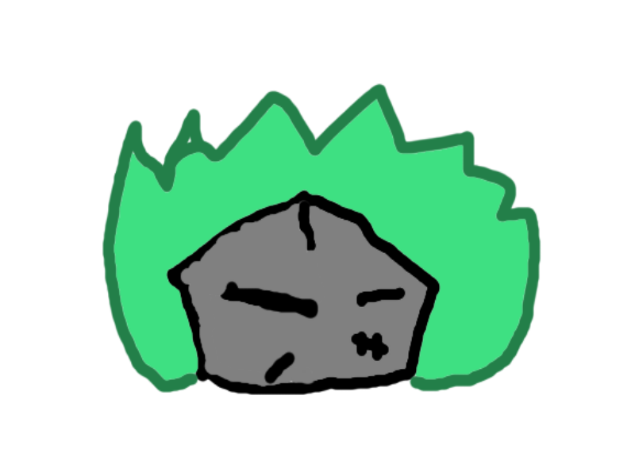



ENGM 3700.02

21 April 2016

|  |  |
| --- | --- |
| Ghost Grab | Abstract  A location-based mobile app that lets you search for ghosts for points. The more ghosts you ‘nab, the more points you get!  Dylan Dover, Jason Mayer, Selina Chen, Lawrence Waller |

Title

# Heading

Executive Summary

Problems and Overcoming them

Scheduling

Future

Risk

Responsibility Matrix

Quality/Testing Plan

Future

