Ghost Grab

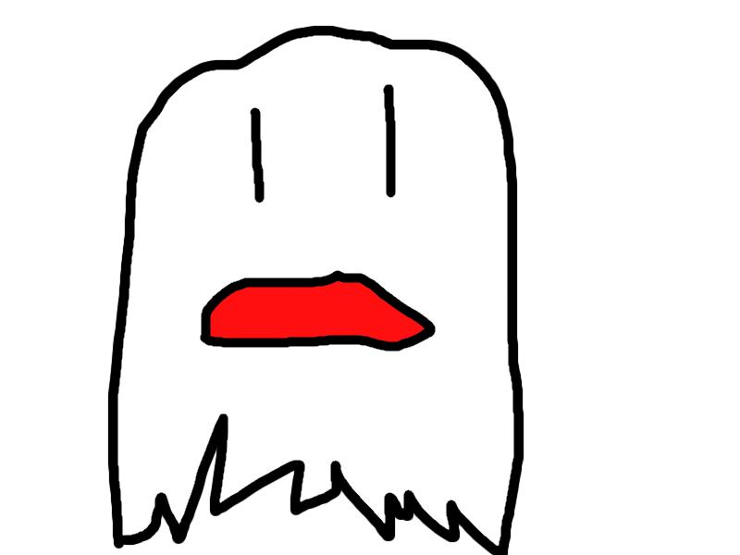

Dylan Dover, Selina Chen, Jason Mayer, Lawrence Waller

ENGM 3700.02

04/21/2016

# Executive Summary

Our company will design an innovative Android game called GhostGrab that will utilize GPS coordinates to create an immersive environment. We will utilize a number of tools and frameworks to accomplish this goal. Among them are Unity on the client-side and node.js on the server-side.

GhostGrab will be a location-based game that will allow users to use their phones to view and capture “ghosts” across a chosen location radius and release them or set them on others for points. Users will have to play mini-games or solve riddles to capture ghosts and there may be random team competitions, allowing users to collect bonus points. There will be a leaderboard, which will update in real-time to show who is leading in points and allow users to track their rank and the ranks of their friends. Created in Unity, it will be easily portable to a variety of platforms, though for a minimum viable product, we will be releasing an Android-only version.

To keep the game interesting over time, updates will be available in the form of new ghosts and new mini-games. This model makes it possible to easily update the game with minimal time investment, meaning that our company will have time to pursue other projects simultaneously.

[Update UML and put it here]

Contents

Executive Summary 2

Scheduling 4

Responsibility Matrix 5

Risk Management 6

Problems & Solutions 7

Quality Assurance 8

Future Plans 9

# Scheduling

Our company will design an innovative Android game called GhostGrab that will utilize GPS coordinates to create an immersive environment. We will utilize a number of tools and frameworks to accomplish this goal. Among them are Unity on the client-side and node.js on the server-side.

GhostGrab will be a location-based game that will allow users to use their phones to view and capture “ghosts” across a chosen location radius and release them or set them on others for points. Users will have to play mini-games or solve riddles to capture ghosts and there may be random team competitions, allowing users to collect bonus points. There will be a leaderboard, which will update in real-time to show who is leading in points and allow users to track their rank and the ranks of their friends. Created in Unity, it will be easily portable to a variety of platforms, though for a minimum viable product, we will be releasing an Android-only version.

To keep the game interesting over time, updates will be available in the form of new ghosts and new mini-games. This model makes it possible to easily update the game with minimal time investment, meaning that our company will have time to pursue other projects simultaneously.

# Responsibility Matrix

# Risk Management

# Problems & Solutions

Much of the initial problems that arose came from client-server interaction. Unity is a rather new.

Solved by using a library called UnityHTTP provided by <https://github.com/andyburke/UnityHTTP>, which is itself based on Simon Wittber’s UnityWeb code, and therefore is licensed under GPL, which is GNU General Public License, which allows end users, whether they be companies or individuals, to run, study, modify, and share the software. This eliminated much of the work and provided a neat way how Unity interacts with JSON web requests.

# Quality Assurance

Our company will design an innovative Android game called GhostGrab that will utilize GPS coordinates to create an immersive environment. We will utilize a number of tools and frameworks to accomplish this goal. Among them are Unity on the client-side and node.js on the server-side.

GhostGrab will be a location-based game that will allow users to use their phones to view and capture “ghosts” across a chosen location radius and release them or set them on others for points. Users will have to play mini-games or solve riddles to capture ghosts and there may be random team competitions, allowing users to collect bonus points. There will be a leaderboard, which will update in real-time to show who is leading in points and allow users to track their rank and the ranks of their friends. Created in Unity, it will be easily portable to a variety of platforms, though for a minimum viable product, we will be releasing an Android-only version.

To keep the game interesting over time, updates will be available in the form of new ghosts and new mini-games. This model makes it possible to easily update the game with minimal time investment, meaning that our company will have time to pursue other projects simultaneously.

# Future Plans

The current model of our product allows users to capture ghosts for points, which while acceptable for a minimum viable product is rather boring.

As mentioned in the executive summary, we intend to release updates, which will contain more features for our product to make the game more interesting. One such update we plan to release is one that will allow users to set their captured ghosts on other users, which hit points.

Currently, ghosts are differentiated by their appearance and the points they carry. In the future, we would differentiate more between the ghosts by adding mini-games and movements specific to each ghost type.