Ghost Grab

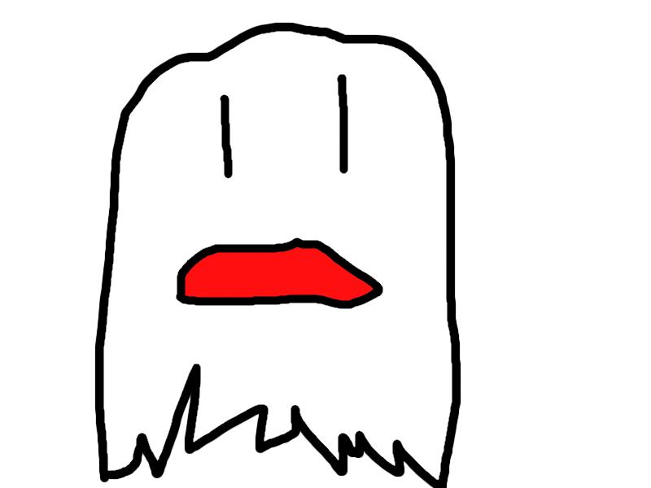

Dylan Dover, Selina Chen, Jason Mayer, Lawrence Waller

ENGM 3700

04/21/2016

# Executive Summary

Our company will design an innovative Android game called GhostGrab that will utilize GPS coordinates to create an immersive environment. We will utilize a number of tools and frameworks to accomplish this goal. Among them are Unity on the client-side and node.js on the server-side.

GhostGrab will be a location-based game that will allow users to use their phones to view and capture “ghosts” across a chosen location radius and release them or set them on others for points. Users will have to play mini-games or solve riddles to capture ghosts and there may be random team competitions, allowing users to collect bonus points. There will be a leaderboard, which will update in real-time to show who is leading in points and allow users to track their rank and the ranks of their friends. Created in Unity, it will be easily portable to a variety of platforms, though for a minimum viable product, we will be releasing an Android-only version.

To keep the game interesting over time, updates will be available in the form of new ghosts and new mini-games. This model makes it possible to easily update the game with minimal time investment, meaning that our company will have time to pursue other projects simultaneously.

[Update UML and put it here]

# Scheduling

Our company will design an innovative Android game called GhostGrab that will utilize GPS coordinates to create an immersive environment. We will utilize a number of tools and frameworks to accomplish this goal. Among them are Unity on the client-side and node.js on the server-side.

GhostGrab will be a location-based game that will allow users to use their phones to view and capture “ghosts” across a chosen location radius and release them or set them on others for points. Users will have to play mini-games or solve riddles to capture ghosts and there may be random team competitions, allowing users to collect bonus points. There will be a leaderboard, which will update in real-time to show who is leading in points and allow users to track their rank and the ranks of their friends. Created in Unity, it will be easily portable to a variety of platforms, though for a minimum viable product, we will be releasing an Android-only version.

To keep the game interesting over time, updates will be available in the form of new ghosts and new mini-games. This model makes it possible to easily update the game with minimal time investment, meaning that our company will have time to pursue other projects simultaneously.

# Responsibility Matrix

Our company will design an innovative Android game called GhostGrab that will utilize GPS coordinates to create an immersive environment. We will utilize a number of tools and frameworks to accomplish this goal. Among them are Unity on the client-side and node.js on the server-side.

GhostGrab will be a location-based game that will allow users to use their phones to view and capture “ghosts” across a chosen location radius and release them or set them on others for points. Users will have to play mini-games or solve riddles to capture ghosts and there may be random team competitions, allowing users to collect bonus points. There will be a leaderboard, which will update in real-time to show who is leading in points and allow users to track their rank and the ranks of their friends. Created in Unity, it will be easily portable to a variety of platforms, though for a minimum viable product, we will be releasing an Android-only version.

To keep the game interesting over time, updates will be available in the form of new ghosts and new mini-games. This model makes it possible to easily update the game with minimal time investment, meaning that our company will have time to pursue other projects simultaneously.

# Risk Management

Our company will design an innovative Android game called GhostGrab that will utilize GPS coordinates to create an immersive environment. We will utilize a number of tools and frameworks to accomplish this goal. Among them are Unity on the client-side and node.js on the server-side.

GhostGrab will be a location-based game that will allow users to use their phones to view and capture “ghosts” across a chosen location radius and release them or set them on others for points. Users will have to play mini-games or solve riddles to capture ghosts and there may be random team competitions, allowing users to collect bonus points. There will be a leaderboard, which will update in real-time to show who is leading in points and allow users to track their rank and the ranks of their friends. Created in Unity, it will be easily portable to a variety of platforms, though for a minimum viable product, we will be releasing an Android-only version.

To keep the game interesting over time, updates will be available in the form of new ghosts and new mini-games. This model makes it possible to easily update the game with minimal time investment, meaning that our company will have time to pursue other projects simultaneously.

# Problems & Solutions

Our company will design an innovative Android game called GhostGrab that will utilize GPS coordinates to create an immersive environment. We will utilize a number of tools and frameworks to accomplish this goal. Among them are Unity on the client-side and node.js on the server-side.

GhostGrab will be a location-based game that will allow users to use their phones to view and capture “ghosts” across a chosen location radius and release them or set them on others for points. Users will have to play mini-games or solve riddles to capture ghosts and there may be random team competitions, allowing users to collect bonus points. There will be a leaderboard, which will update in real-time to show who is leading in points and allow users to track their rank and the ranks of their friends. Created in Unity, it will be easily portable to a variety of platforms, though for a minimum viable product, we will be releasing an Android-only version.

To keep the game interesting over time, updates will be available in the form of new ghosts and new mini-games. This model makes it possible to easily update the game with minimal time investment, meaning that our company will have time to pursue other projects simultaneously.

# Quality Assurance

Our company will design an innovative Android game called GhostGrab that will utilize GPS coordinates to create an immersive environment. We will utilize a number of tools and frameworks to accomplish this goal. Among them are Unity on the client-side and node.js on the server-side.

GhostGrab will be a location-based game that will allow users to use their phones to view and capture “ghosts” across a chosen location radius and release them or set them on others for points. Users will have to play mini-games or solve riddles to capture ghosts and there may be random team competitions, allowing users to collect bonus points. There will be a leaderboard, which will update in real-time to show who is leading in points and allow users to track their rank and the ranks of their friends. Created in Unity, it will be easily portable to a variety of platforms, though for a minimum viable product, we will be releasing an Android-only version.

To keep the game interesting over time, updates will be available in the form of new ghosts and new mini-games. This model makes it possible to easily update the game with minimal time investment, meaning that our company will have time to pursue other projects simultaneously.

# Future Plans

Our company will design an innovative Android game called GhostGrab that will utilize GPS coordinates to create an immersive environment. We will utilize a number of tools and frameworks to accomplish this goal. Among them are Unity on the client-side and node.js on the server-side.

GhostGrab will be a location-based game that will allow users to use their phones to view and capture “ghosts” across a chosen location radius and release them or set them on others for points. Users will have to play mini-games or solve riddles to capture ghosts and there may be random team competitions, allowing users to collect bonus points. There will be a leaderboard, which will update in real-time to show who is leading in points and allow users to track their rank and the ranks of their friends. Created in Unity, it will be easily portable to a variety of platforms, though for a minimum viable product, we will be releasing an Android-only version.

To keep the game interesting over time, updates will be available in the form of new ghosts and new mini-games. This model makes it possible to easily update the game with minimal time investment, meaning that our company will have time to pursue other projects simultaneously.