Part 2: Write smart contracts

In order to create your supply chain DApp, you will need to properly manage user permissions and track a product’s authenticity.
The smart contract(s) you you build should have these requirements:
Requirement 1 | Define and implement interfaces
Requirement 2 | Build out AccessControl Contracts
Requirement 3 | Build out Base Contract
Requirement 4 | Build out Core Contract
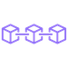

Requirement 1: Define and implement required interfaces

First, download the provided starter code and review all the files. Add in any interfaces you use.
Download Starter Code
The starter code contains a skeleton for the smart contracts, test file, and migration files you will need to build out. Since there will be quite a bit of specialized logic, the code is split into smaller contracts that bundle related code together. The subcontract inheritance looks like this:
contract AccessControl
contract Base is AccessControl
contract Core is Base
- AccessControl - Collection of Contracts: These contracts manages the various addresses and constraints for operations that can be executed only by specific roles.
- Base - SupplyChain.sol: This is where we define the most fundamental code shared throughout the core functionality. This includes our main data storage, constants and data types, plus internal functions for managing these items.
- Core - Ownable.sol: is the contract that controls ownership and transfer of ownership.

Requirement 2: Build out AccessControl Contracts

From the Starter Code, the files in coffeeaccesscontrol controls access control for each actor.
Build out these contracts so that each actor’s role in your supply chain is distinct with no overlap in their access abilities. The abilities listed for each role are exhaustive.
Example of 4 actors in a coffee supply chain are:
- Farmer: The Farmer can harvest coffee beans, process coffee beans, pack coffee palettes, add coffee palettes, ship coffee palettes, and track authenticity.
- Distributor: The Distributor can buy coffee palettes and track authenticity.
- Retailer: The Retailer can receive coffee palettes and track authenticity.
- Consumer: The consumer can buy coffee palettes and track authenticity.

Requirement 3: Build out Base Contract

From the Starter Code, SupplyChain.sol contract holds all common structs, events and base variables.
This smart contract must implement functions that track:
- Product ID
- Product UPC
- Origination Information
- Origin Actor (e.g. Farmer ID, Farmer Name, )
- Misc. organization information (e.g. Farmer Information)
- Longitude and Latitude of Origin Coordinates (e.g. Farm’s Longitude and Latitude)
- Product notes
- Product price

Requirement 4: Build out Core Contract

Ownable.sol is the contract that controls ownership and transfer of ownership.
This Core Contract must implement:
- Ownable -
- Secondary -
This has been provided in the starter code.

Part 3: Test smart contract code coverage

Requirement: Smart contract has associated tests

For this project, as with any project, make sure to test your smart contracts to ensure they are working properly in different situations without any risk.

Requirement: Smart contract has associated tests

At minimum, test every function for every function you implemented from your Sequence Diagram. For example, from this Sequence Diagram we would need to test 10 functions:
- harvestItem()
- processItem()
- packItem()
- addItem()
- buyItem()
- shiptItem()
- receiveItem()
- purchaseItem()
- fetchItemBufferOne()
- fetchItemBufferTwo()
Once your smart contract is created, it’s time to go live! For this project, deploy your smart contract on the Ethereum RINKEBY test network.
Requirement 1 | Deploy smart contract on a public test network
Requirement 2 | Submit Transaction hash, contract hash, and contract address

Requirement 1: Deploy smart contract on a public test network

Using Truffle framework, deploy your smart contract with the Rinkeby test network. Take note of your contract hash and address after successful deployment.
Tip: Refer to Infura screencast for assistance on deploying your smart contract with Infura and Truffle.

Requirement 2: Submit Contract Address

Provide a document with your project submission that includes the contract address.
Document for your project must be in either ".txt" or ".md" format.
Hint: You can view the Contract address using a blockchain explorer (e.g. Etherscan).
Example of a random Contract address on the Rinkeby test network : https://rinkeby.etherscan.io/address/0xfb0720c0715e68f80c0c0437c9c491abfed9e7ab#code

Part 5: Modify client code to interact with smart contract

Create the frontend that allows your users to interact with your DApp. This should be a simple and clean frontend that manages product lifecycle as the product navigates down the supply chain.
Using javascript, create a single JS file with all web3 functions that allows your client code to interact with you smart contracts.
The coffee example in the boilerplate provides this code for you.

Requirement: Configure client code for each actor

Front-end is configured to:
- 1) Submit a product for shipment (farmer to the distributor, distributor to retailer, etc).
- 2) Receive product from shipment.
- 3) Validate the authenticity of the product.
Frontend code can be downloaded and executed from a local environmen

Project Submission

Project Requirements

Your project will be evaluated using the Project Rubric. For a project to pass, all criteria must Meet Specifications. Please thoroughly read through the rubric before beginning to build your project.
Before submitting your project, make sure you’ve included these files:
- A project write-up (.txt, .doc, or .md) that includes:
  - The contract address
  - If libraries were used, include why these libraries were adopted.
  - If IPFS is used, include how IPFS is used in this project.
  - Program version numbers (This information will help your reviewer troubleshoot your project if any issues arise):
  - node version number
  - Truffle version number
  - web3 version number
- Your project files
- UML documents:
  - Activity
  - Sequence
  - State
  - Class (Data Model)

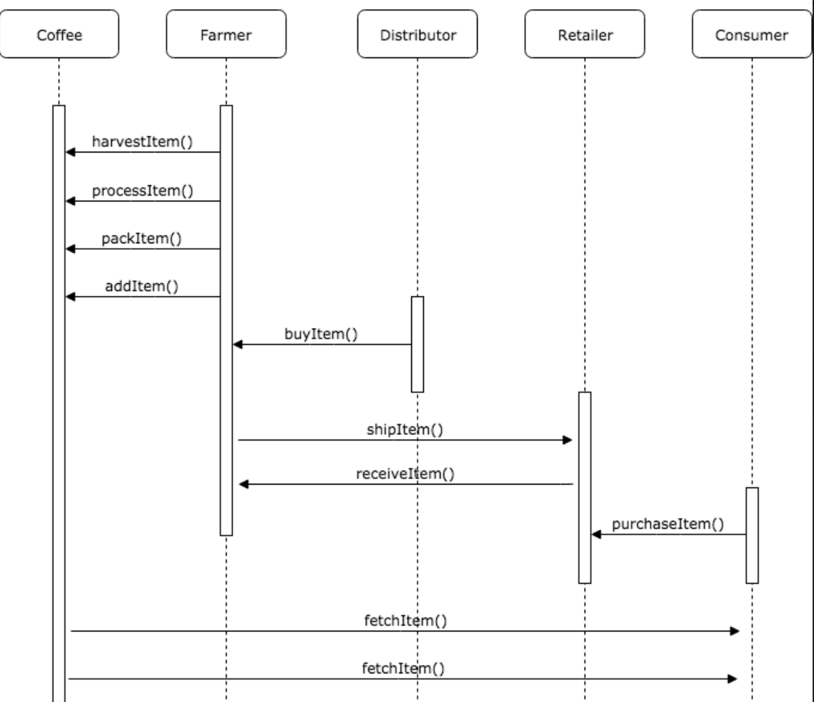

- Search or ask questions in Knowledge.

