การทดลอง
เรื่อง Sequential vs. Parallel Performance
จัดทำโดย
นายวรดร พรมอนันต์ รหัส 67543206020-9
ห้อง ENGCE200_SEC 1
เสนอ
อาจารย์นุรักษ์ ไชยศรี
ใบงานนี้เป็นส่วนหนึ่งของวิชา
ENGCE125
ระบบปฏิบัติการ
(Operating Systems)
หลักสูตร วศ.บ. วิศวกรรมคอมพิวเตอร์
สาขาวิชาวิศวกรรมไฟฟ้า คณะ วิศวกรรมศาสตร์
มหาวิทยาลัยเทคโนโลยีราชมงคลล้านนา ภาคพายับ เชียงใหม่
ภาคเรียนที่ 2 ปีการศึกษา 2568

/* Main Class */
import java.util.Arrays;
public class MainFunction {
public static void main(String[] args) {
//create Data
int size = 1000;
int lengthOfDataRandom = 1_000_00;
int[] numbers1 = new int[size]; //reference type
int[] numbers2 = new int[size]; //reference type
for (int i = 0; i < size; i++) {
numbers1[i] = (int) (Math.random() * lengthOfDataRandom);
numbers2[i] = numbers1[i] ;
}//end for
viewCore V = new viewCore();
Sequential seq = new Sequential();
long startTime;
long endTime;
long duration;
//Sequential
System.out.println("Normal Array: " + Arrays.toString(numbers1));
startTime = System.nanoTime(); //START
seq.sortSequentialAndStats(numbers1);
endTime = System.nanoTime(); //STOP
duration = endTime - startTime;
System.out.println("Sorted Array: " + Arrays.toString(numbers1));
System.out.println("Meaning time (milliseconds): " + (duration / 1_000_000.0) + " ms");
System.out.println("//---------------------------------//");
//Data parallelism
System.out.println("Original Array: " + Arrays.toString(numbers2));
startTime = System.nanoTime(); //START
V.dataParallelism(numbers2);
endTime = System.nanoTime(); //STOP
duration = endTime - startTime;
System.out.println("Sorted Array: " + Arrays.toString(numbers2));
System.out.println("Meaning time (milliseconds): " + (duration / 1_000_000.0) + " ms");
//Task parallelism
System.out.println("//----------------------------------//");
startTime = System.nanoTime(); //START
V.taskParallelism(numbers2);
endTime = System.nanoTime(); //STOP
duration = endTime - startTime;
System.out.println("Meaning time (milliseconds): " + (duration / 1_000_000.0) + " ms");
}
}

/* Parallelism */

import java.util.concurrent.*;
import java.util.concurrent.atomic.AtomicLong;
public class viewCore {
public void core() {
int size = 100;
int cores = Runtime.getRuntime().availableProcessors();
System.out.println(cores + " Cores");
int chunkSize = size / cores;
System.out.println(chunkSize);
}
public void dataParallelism(int[] data) {
int size = data.length;
QuickSort sort = new QuickSort();
int cores = Runtime.getRuntime().availableProcessors();
ExecutorService executor = Executors.newFixedThreadPool(cores);
int chunkSize = size / cores;
for (int i = 0; i < cores; i++) {
int start = i * chunkSize;
//if last = size else = (i + 1) * chunkSize
int end = (i == cores - 1) ? size : (i + 1) * chunkSize;
executor.submit(() -> {
sort.quickSort(data, start, end - 1);
});//end function
}//end for
executor.shutdown();

try {
if (!executor.awaitTermination(60, TimeUnit.SECONDS)) {
executor.shutdownNow();
}
} catch (InterruptedException e) {
executor.shutdownNow();
}
// merge data
int currentSortedEnd = chunkSize - 1;
for (int i = 1 ; i < cores ; i++) { //1-11
// Find the end point of the next chunk to merge
int nextChunkEnd = (i == cores - 1) ? size - 1 : (i + 1) * chunkSize - 1;
sort.merge(data, 0, currentSortedEnd, nextChunkEnd);
currentSortedEnd = nextChunkEnd;
}
}
public void taskParallelism(int[] data) {
AtomicLong max = new AtomicLong(Long.MAX_VALUE);
AtomicLong min = new AtomicLong(Long.MIN_VALUE);
AtomicLong avg = new AtomicLong(0);
AtomicLong mean = new AtomicLong(0);
double[] med = new double[1];

int cores = Runtime.getRuntime().availableProcessors();
ExecutorService executor = Executors.newFixedThreadPool(cores);

//MAX
executor.submit(() -> {
max.set(taskMax(data));
});
//Min
executor.submit(() -> {
min.set(taskMin(data));
});
//AVG
executor.submit(() -> {
avg.set(taskAvg(data));
});
//Mean
executor.submit(() -> {
mean.set(taskAvg(data));
});
executor.submit(() -> {
med[0] = median(data);
});
executor.shutdown();
try {
if (!executor.awaitTermination(60, TimeUnit.SECONDS)) {
executor.shutdownNow();
}
} catch (InterruptedException e) {
executor.shutdownNow();
}

System.out.println("max = " + max);
System.out.println("Min = " + min);
System.out.println("AVG = " + avg);
System.out.println("Mean = " + mean);
}//end taskParallelism
public long taskMax(int[] data) {
long max = 0;
for (int i = 0; i < data.length; i++) {
if (data[i] > max) {
max = data[i];
}
}//end for
return max;
}
public long taskMin(int[] data) {
long min = 9_999_999;
for (int i = 0; i < data.length; i++) {
if (data[i] < min) {
min = data[i];
}
}//end for
return min;
}

public long taskAvg(int[] data) {
long total = 0;
long avg;
for (int i = 0; i < data.length; i++) {
total += data[i];
}
avg = total / data.length;
return avg;
}
public double median(int[] data) {
int size = data.length;
int mid = size / 2;
if (size % 2 != 0) {
// For odd numbers: Pick the middle number (e.g., 5/2 = 2, which is the 3rd index)
return (double) data[mid];
} else {
// For even numbers: Add the two middle numbers together and divide by 2
return (double) (data[mid - 1] + data[mid]) / 2.0;
}
}
}

/* Seq */
import java.util.Arrays;
public class Sequential {
public void sortSequentialAndStats(int[] data) {
long max = -1;
long min = 9_999_999;
long total = 0;
long avg;
Arrays.sort(data);
for (int I = 0; I < data.length; i++) {
if (data[i] > max) {
max = data[i];
}
}
for (int I = 0; I < data.length; i++) {
if (data[i] < min) {
min = data[i];
}
}
for (int I = 0; I < data.length; i++) {
total += data[i];
}
avg = total / data.length;
System.out.println(“Max = “ + max);
System.out.println(“Min = “ + min);
System.out.println(“AVG = “ + avg);
}//end void }//end class Sequential

/* OUTPUT */
Data = 100
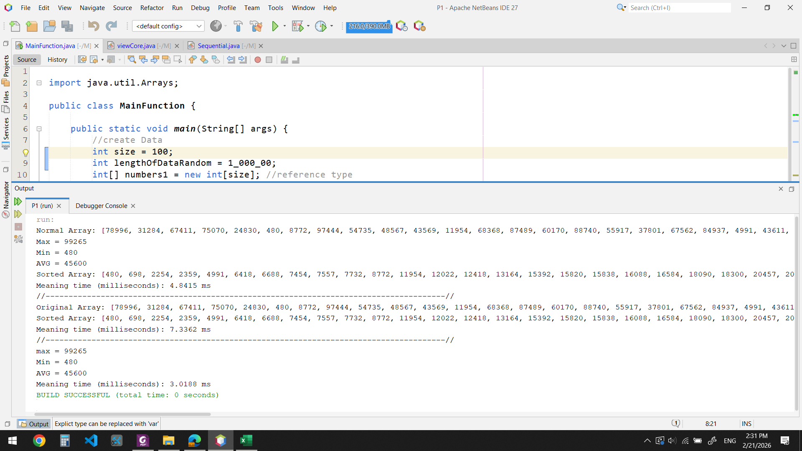
Data = 1,000
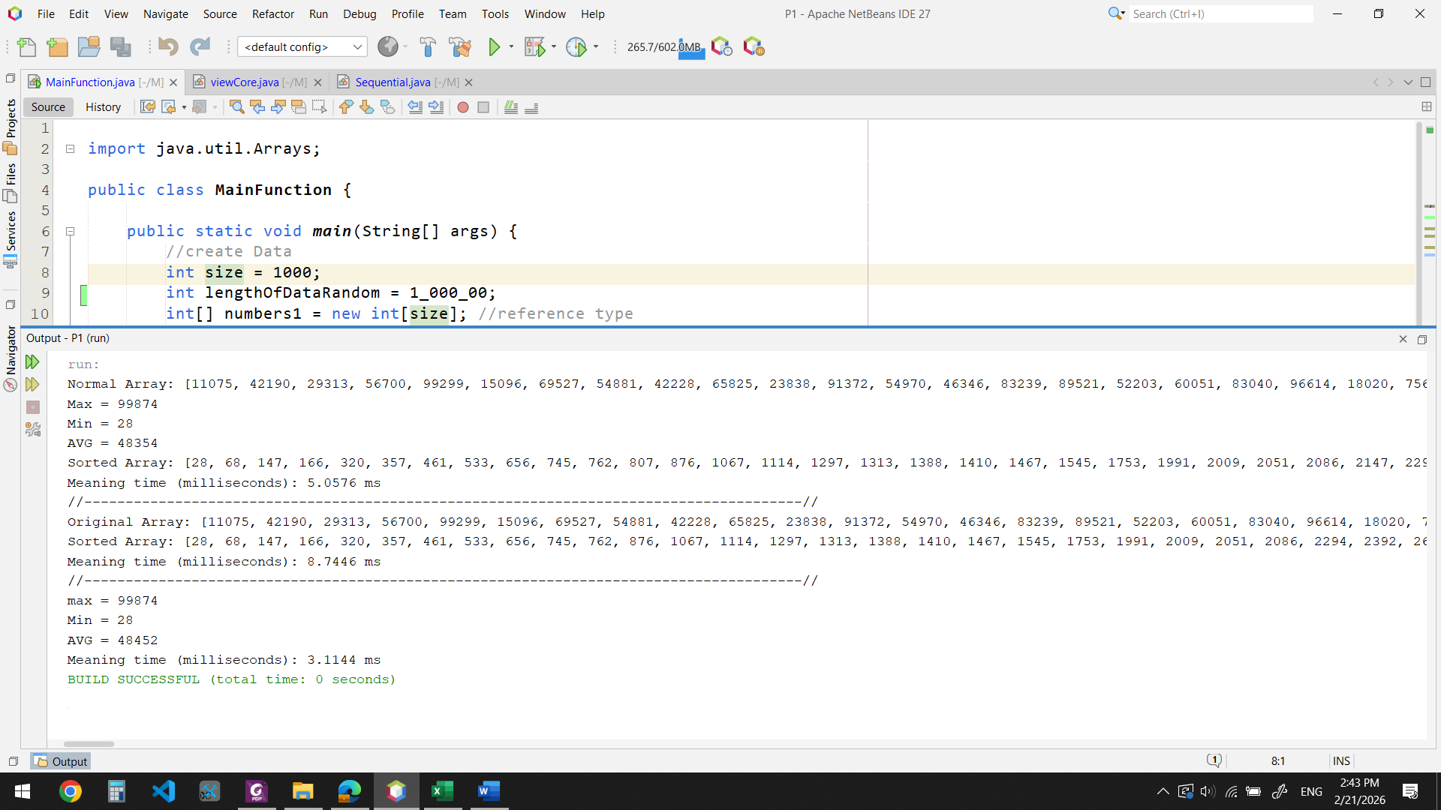

Data = 10,000
