I See You, ICU: Forecasting Unplanned Ward-to-ICU Transfer
Milestone: M3 exploratory data analysis and feature set
IE 7275: Machine Learning and Data Analytics, Fall 2026

Ka Won Cho
Minh Tuong Le
Shanti Ram Pokhrel
cho.kawon@northeastern.edu
le.tuo@northeastern.edu
pokhrel.sha@northeastern.edu

Percentage of Effort Contributed by Ka Won Cho: 33.3%
Percentage of Effort Contributed by Minh Tuong Le: 33.3%

Percentage of Effort Contributed by Shanti Ram Pokhrel: 33.3%

Signature of Ka Won Cho:____________________
Signature of Minh Tuong Le:____________________
Signature of Shanti Ram Pokhrel: Shanti Ram Pokhrel
Submission Date: 2026.10.27 .

1. Data Overview
This milestone prepares a modeling table for I See You, ICU, a watchlist that scores frequently admitted inpatients for unplanned transfer from a hospital ward to an intensive care unit (ICU) within the next 24 hours and the next 48 hours. A score is produced once each morning at 08:00 for every patient on a medical or surgical ward; the intended user is a bed coordinator who will review the top 10% of scores (Cho et al., proposal M2). The source is MIMIC-IV version 3.1 (Johnson et al., 2024), the hosp and icu modules, downloaded in October 2026 under the PhysioNet Credentialed Health Data License 1.5.0. The files are not in the repository. Access requires a credentialed PhysioNet account and Data Use Agreement.
One modeling row is one ward-day snapshot: the intersection of an admission, a calendar morning, and a care unit that is neither an ICU nor a non-ward location such as the emergency department, psychiatry, obstetrics, or the PACU. The snapshot table has 725,334 rows and 101 columns, of which three identify the patient, admission, and time; two are labels (y_24h, y_48h); and 96 are candidate features. Across all snapshots, 6,517 (0.90%) are followed by an ICU transfer within 24 hours and 11,241 (1.55%) within 48 hours. The labels are not a column in the raw files. They are defined from transfers: the first entry into one of eight true ICUs after the snapshot, provided that entry falls inside the 24-hour or 48-hour window. Admissions that begin in the ICU are excluded, so the event is a ward-to-ICU transfer rather than an ICU stay that was planned at the door.
Two cohort rules changed after M2. First, a prior discharge now counts as a readmission only if it occurred at least one hour earlier (and within 365 days). Gaps shorter than one hour are treated as administrative bounce-backs of the same stay. Second, psychiatry, obstetrics, the PACU, and nursery units are no longer treated as wards. Psychiatry alone contributed tens of thousands of snapshots with a 0% transfer rate and would have diluted both the class balance and the watchlist population. The resulting cohort is 153,448 unplanned adult readmissions among 55,012 patients, of which 10,108 admissions (6.6%) have a later ward-to-ICU transfer. That is smaller than the M2 sketch of all readmissions, by design: the model is restricted to patients who are on a floor where a morning watchlist is operationally meaningful.
Table 1. Cohort construction from cleaned MIMIC-IV v3.1 admissions. Each row is an admission.
Step | Rule | Admissions remaining
0 | Valid admissions (discharge after admit) | 545,848
1 | Prior discharge in [1 hour, 365 days] | 227,193
2 | Not ELECTIVE or SURGICAL SAME DAY ADMISSION | 205,352
3 | Age ≥ 18 years | 205,352
4 | At least one medical/surgical ward stay | 167,789
5 | Not admitted straight to the ICU | 153,448
2. Data Cleaning and Preparation
Raw files in data/raw/ are never modified. python -m icu_forecast.clean writes parquet tables to data/processed/ and a machine-readable cleaning_report.json. Counts below come from that report.
Table | Original rows | Processed rows | What was kept
admissions | 546,028 | 545,848 (admissions_all) and 153,448 (cohort) | All valid admissions for history; cohort is prior discharge in [1 hour, 365 days], unplanned, adult, medical/surgical ward stay, not straight to the ICU
transfers | 2,413,581 | 414,892 | Only cohort admissions; no discharge rows or rows without an admission
labevents | 158,374,764 | 12,496,372 | Only cohort admissions and 21 lab tests
prescriptions | 20,292,611 | 5,938,333 | Only cohort admissions (includes ACEI flag)
diagnoses_icd | 6,364,488 | 4,111,743 | Only cohort patients
omr | 7,753,027 | 4,435,808 | Only cohort patients; BP, weight, and BMI
services | 593,071 | 168,442 | Only cohort admissions
# | File | Used in
1 | hosp/admissions.csv.gz | clean.py: cohort, history
2 | hosp/patients.csv.gz | clean.py: sex, age
3 | hosp/transfers.csv.gz | clean.py: ward and ICU times, snapshots, labels
4 | icu/icustays.csv.gz | clean.py: cross-check of ICU times only
5 | hosp/services.csv.gz | clean.py: current service
6 | hosp/labevents.csv.gz | clean.py: 21 lab tests
7 | hosp/prescriptions.csv.gz | clean.py: medication classes
8 | hosp/diagnoses_icd.csv.gz | clean.py: comorbidities
9 | hosp/omr.csv.gz | clean.py: outpatient BP, weight, BMI

Admissions. Of 546,028 raw admissions, 180 were dropped because discharge time was not after admission time. Eleven death timestamps that preceded admission were set to missing. Forty-seven stays overlapped the previous stay for the same patient; they remain in the table but are not counted as readmissions. There were no duplicate hadm_id values.
Transfers. From 2,413,581 raw transfer rows, 408,977 emergency visits without an admission and 546,024 discharge events (not a location) were removed, along with three exact duplicates. No row had out time before in time. ICU entry time from transfers agrees with icustays within one minute for 97.2% of admissions; transfers remain the source of the label because they record the unit sequence on the ward as well.
Laboratories. labevents was streamed in blocks. After restriction to cohort admissions and the 21 configured tests, 12,552,675 rows remained from 158,374,764. Then 54,679 rows without a numeric value (comments such as hemolyzed) were dropped; 39 store times that preceded draw time were reset to draw time; and 318 values outside the plausible ranges in config.yaml were removed as recording or unit errors (glucose 94, magnesium 62, creatinine 58, calcium 48, and smaller counts for other tests). A pH of 70 is an error; a lactate of 15 mmol/L is rare but clinically real and is kept. After 1,306 duplicate results, 12,496,372 lab rows remain. Missingness in the later snapshot table is not a data-entry hole: most wards do not order lactate or blood gas every morning. In the training split, 78.4% of snapshots have no lactate_last and 88.9% have no pCO2_last, while routine chemistries are missing in about 11% of snapshots (Figure 4). Those gaps are informative and are left missing for tree models; logistic regression will receive a training-only median plus a missingness indicator (prepare.py).
Outliers. Age has no IQR outliers in the adult cohort. Lactate_last has 3,160 IQR flags and 1,428 Z-score flags on the training split; these are treated as genuine extremes, not errors, because they lie inside the configured 0.1–35 mmol/L range. Outpatient measurements used the same logic: 2,330 implausible OMR values were dropped (diastolic 1,133, BMI 618, weight 569, systolic 10), while extreme but plausible vitals were kept.
Prescriptions, diagnoses, and services. Prescriptions were restricted to the cohort (6,554,953 rows), then 9,682 orders with missing start time or drug name and 606,938 duplicates were removed, leaving 5,938,333 orders. Drug names were lower-cased and matched to seven classes, including ACE inhibitors (39,640 orders). Diagnoses lost 288 duplicate codes (4,111,743 rows). Services had no duplicates (168,442 rows). Blood-pressure text such as 120/80 was split into systolic and diastolic before range checks.
Encoding. Four categoricals stay as pandas categories whose levels are taken from the training split: admission_type, admission_location, careunit, and curr_service. LightGBM can split on them directly. For logistic regression, prepare.py one-hot encodes them with infrequent levels (under 0.1% of training rows) collapsed, and never uses the test split to define levels. gender_male is already a 0/1 indicator. Comorbidity flags and prior-ICU are 0/1 from earlier discharges only.

Meaning | Features | Source and join | Why it predicts ICU transfer | Known at prediction time because
Demographics, admission | age, sex, admission type and location, ward unit, hours since admission, days since previous discharge | admissions, patients, transfers | Older patients and some units (cardiology, transplant) carry more risk; risk changes over the stay (Figure 6) | Recorded at admission or at the snapshot
History | prior admissions (total, last 365 days), prior ICU stay, length of previous stay | admissions by subject_id | Frequent and recent admissions mark fragile patients | Only admissions discharged before this one
Comorbidities | heart failure, COPD, chronic kidney disease, diabetes, cancer, liver disease, sepsis | diagnoses_icd by subject_id | Chronic disease raises the chance of decompensation | Only diagnoses from earlier discharges
Outpatient | systolic and diastolic BP, weight, BMI | omr by subject_id | Baseline health status | Measured before the admission day
Service | current service | services by hadm_id and time | Medical and surgical services differ in risk | Last service change before the snapshot
Medications | new orders, new IV orders, and antibiotics, IV antibiotics, vasopressors, diuretics, opioids, insulin, anticoagulants, ACE inhibitors in the last 24 h (10 features) | prescriptions by hadm_id | Escalation of treatment (IV antibiotics, diuretics) signals deterioration | starttime before the snapshot
Labs | last value, change since previous, and count over 24 h for 21 tests (63 features; no min24h / max24h) | labevents by hadm_id | Abnormal and worsening labs (lactate, BUN, WBC) and labs being ordered at all signal concern | Result released (storetime) before the snapshot

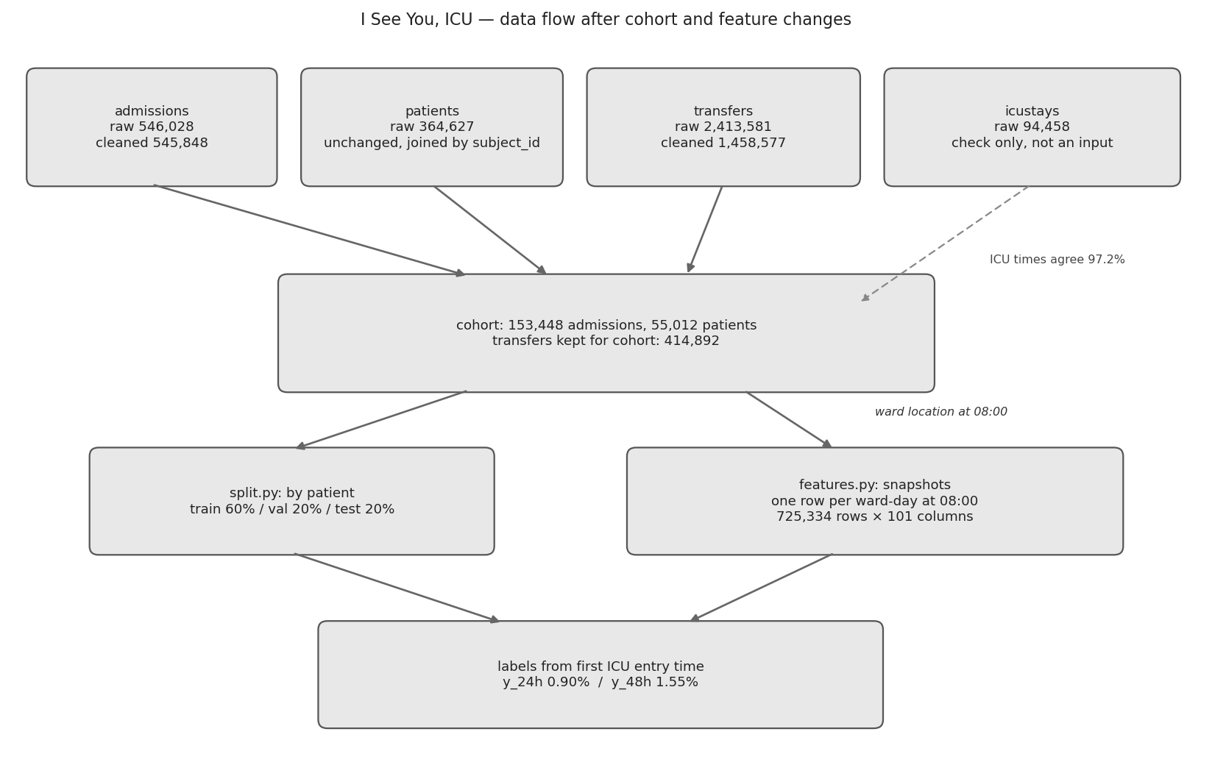

3. Data Partitioning
The split is by patient, not by snapshot or admission. One person contributes several admissions and many daily rows; a random row split would put the same physiology in both train and test and would overstate performance. Every subject_id is assigned to exactly one of train, validation, or test in a 60/20/20 ratio, stratified on whether that patient ever had a ward-to-ICU transfer, with seed 7275 (the course number) in config.yaml. The assignment is written before any figure in this report was drawn. All exploratory analysis, imputation, scaling, encoding, and PCA below use only the training patients. The test patients are unused until M4 final evaluation.
Table 2. Patient-level 60/20/20 split, stratified on ever having a ward-to-ICU transfer, seed 7275. ICU rate is the share of admissions in that split with a later unplanned ICU entry.
Split | Patients | Admissions | Admissions with ICU transfer | Snapshots
Train | 33,006 | 91,786 | 6,060 (6.60%) | 436,541
Validation | 11,003 | 31,331 | 2,009 (6.41%) | 145,686
Test | 11,003 | 30,331 | 2,039 (6.72%) | 143,107
Total | 55,012 | 153,448 | 10,108 (6.59%) | 725,334
4. Exploratory Data Analysis
Unless noted, every figure uses the 436,541 training snapshots (33,006 patients). The 24-hour label is positive on 3,900 snapshots (0.89%) and the 48-hour label on 6,718 (1.54%). Figure 1 shows that class balance. Accuracy is the wrong metric: a constant “no transfer” rule would be 99.1% accurate. Precision–recall area and recall in the top 10% of scores match the watchlist use case and will be the M4 metrics.
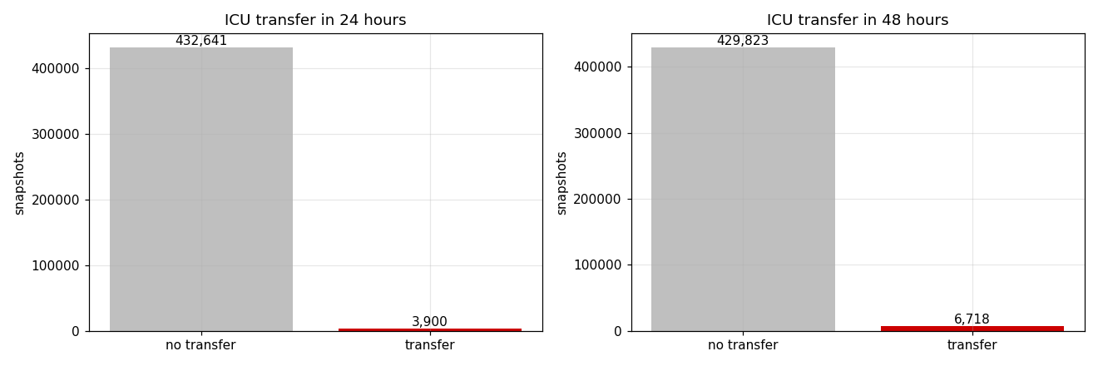
Figure 1. Class balance of the 24-hour and 48-hour ICU-transfer labels among 436,541 training snapshots. Positives are 0.89% (24 h) and 1.54% (48 h), so later models must be scored with precision–recall measures rather than accuracy.
Daily 08:00 snapshots cannot see every transfer. Of 6,060 training admissions with a ward-to-ICU event, 31.3% occur at or before the first morning snapshot, typically because the patient deteriorates within a few hours of arrival (Figure 2; median time to ICU is 29.8 hours, 25th percentile 6.0 hours). Those early events are a coverage limit of the product, not a labeling bug. The watchlist is a morning tool; a separate admission-time score would be needed for the first night.
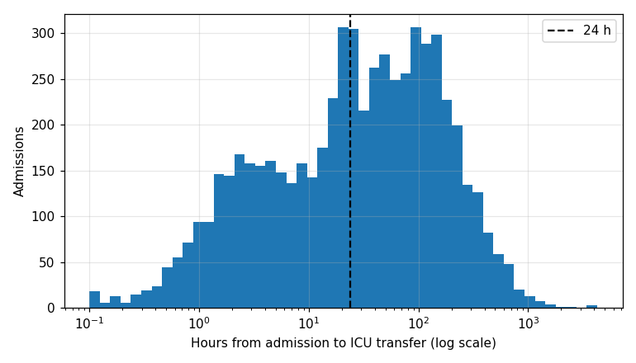
Figure 2. Hours from admission to first ward-to-ICU transfer among 6,060 training admissions that transfer, on a log time axis. The dashed line is 24 hours. 31.3% of transfers happen before the first 08:00 snapshot, so morning features cannot predict them.
Among snapshots that do exist, laboratory level tracks the label. Figure 3 bins six last-value labs into deciles on the training split. Transfer rate rises with lactate, BUN, and WBC and falls with albumin, bicarbonate, and platelets, which matches bedside physiology and supports keeping named last values rather than collapsing them into a single severity score.
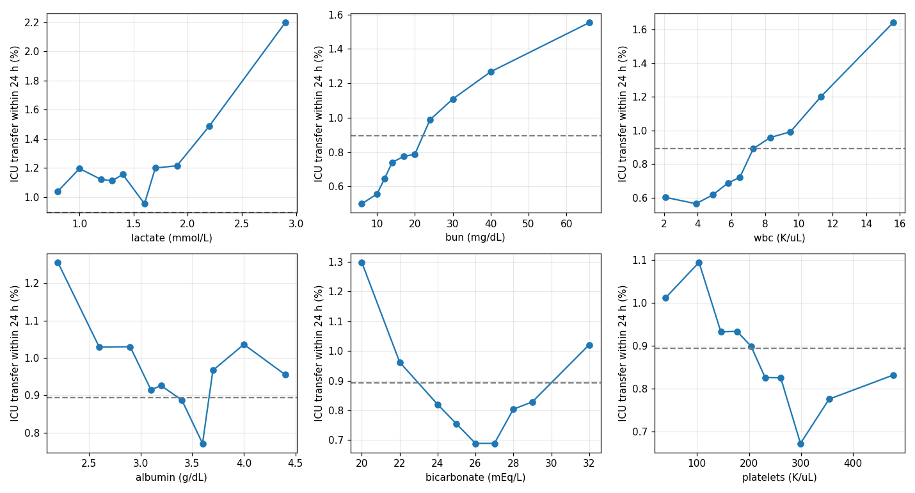
Figure 3. Twenty-four-hour ICU transfer rate by decile of six last laboratory values in the training split (dashed line: overall 0.89% rate). Higher lactate, BUN, and WBC, and lower albumin, bicarbonate, and platelets, coincide with higher transfer risk and motivate keeping these named labs.
Whether a lab was ordered is itself a signal. Figure 4 compares 24-hour transfer rates when a test was measured in the last 24 hours versus when it was not. Lactate was measured in only 3.9% of training snapshots, but the transfer rate is 3.61% when it was measured and 0.78% when it was not. pH and troponin T show the same pattern. Creatinine, which is routine, does not. We therefore keep a 24-hour count for every lab (zero if unordered) and do not impute “normal” into unused blood-gas slots for tree models.
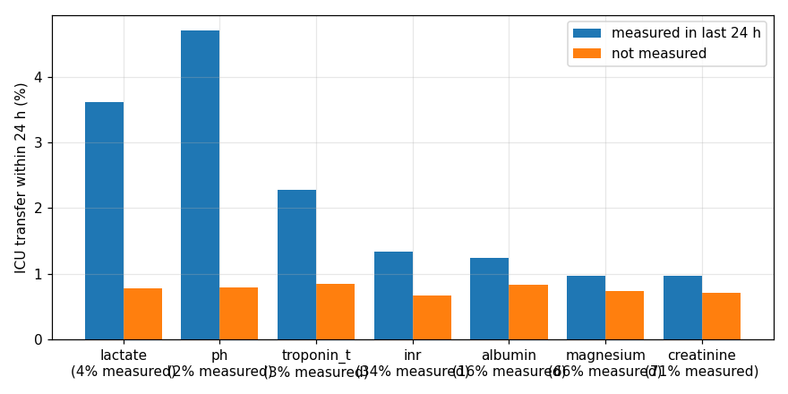
Figure 4. Twenty-four-hour ICU transfer rate in the training split according to whether each lab was measured in the prior 24 hours. For lactate, pH, and troponin T, an order is associated with several-fold higher risk, so missingness is informative rather than noise to be filled.
Among last values, the strongest Spearman associations on a 200,000-row training sample are BUN with creatinine (0.72) and chloride with sodium (0.61). Figure 5 shows the rest of the panel. Correlations are moderate, not collinear, except for the min/max-versus-last redundancy discussed in Section 6. Age and time since admission are only weakly related to the routine labs (Figure 6 in the notebook; Pearson coefficients near zero), so they add complementary information. Transfer risk is highest on day 0–1 (1.38% within 24 hours) and then settles near 0.8% (Figure 6). Ward mix matters: Medicine contributes the most snapshots, while smaller units have different rates, which is why careunit is a feature and why the split is by patient rather than by ward-day.
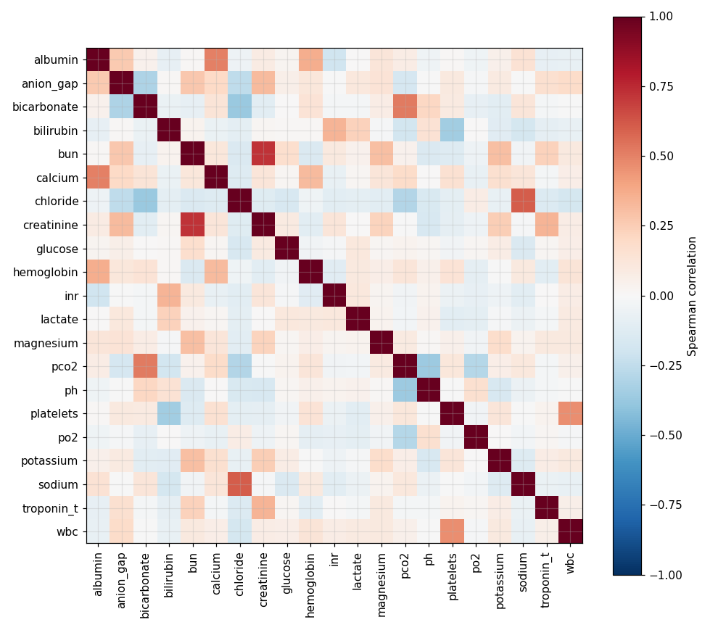
Figure 5. Spearman correlation among last laboratory values on a 200,000-row sample of the training split. The strongest pair is BUN and creatinine (0.72). Panel is only moderately correlated, which later limits how much PCA can compress it (Section 5).
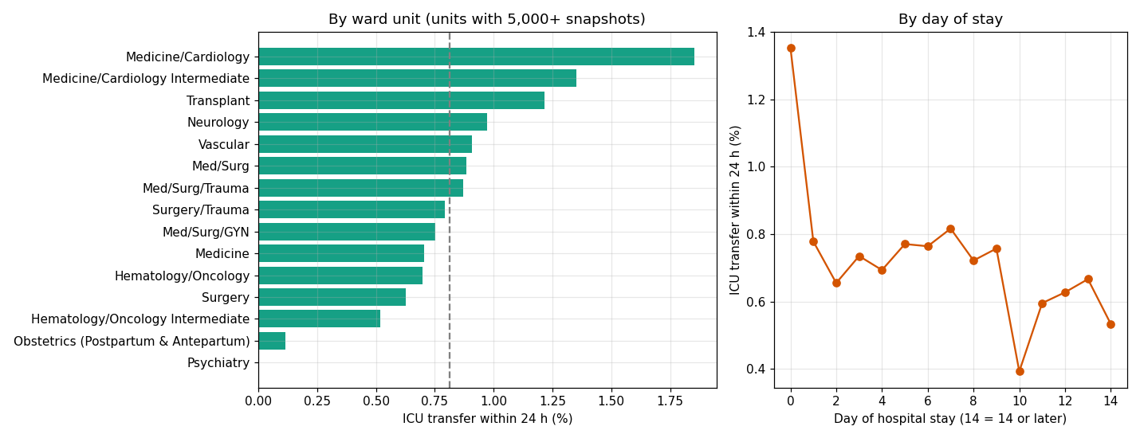
Figure 6. Share of training snapshots followed by ICU transfer within 24 hours and 48 hours, by time since admission. Risk is highest in the first hospital day and then declines, which supports hours_since_admit as a feature and cautions against pooling all ward-days as i.i.d. rows.
5. Dimension Reduction
PCA was fitted on the training split only, using the latest value of each lab with under 30% missingness: hemoglobin, platelets, WBC, potassium, sodium, creatinine, chloride, BUN, bicarbonate, anion gap, glucose, magnesium, and calcium (13 tests). Rarely ordered tests such as lactate and blood gases were excluded because a median fill would mostly impute a value the clinician never saw. Inputs were median-imputed and standardized on training statistics, then decomposed.
Eight components are required for 80% of the variance and 10 for 90% (Figure 7). The Kaiser rule (eigenvalue greater than 1) retains 6 components and only 69.7% of the variance. That is little compression: the 13 named labs would be replaced by 8 mixed axes that a bed coordinator cannot read. PC1 is a kidney/metabolic direction (BUN, creatinine, anion gap), which is interpretable, but the remaining components mix unrelated tests. Because Figure 5 already showed only moderate correlation, this result is expected.
Decision: do not use the principal components as M4 inputs. LightGBM can split on correlated named labs and on missingness natively. Logistic regression will keep the named labs with training-only scaling. The fitted PCA is documented in notebooks/02_pca.ipynb for completeness. A well-reasoned decision not to use the reduced representation is the outcome of this section, not a skipped step.
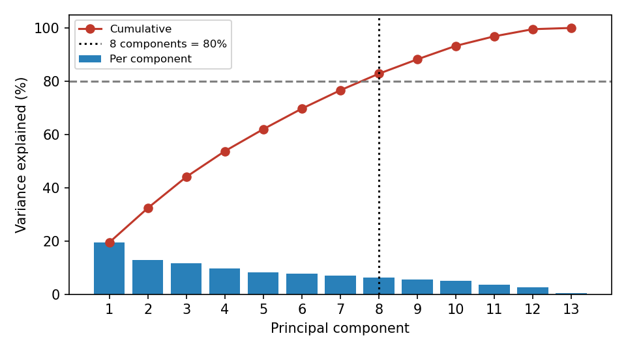
Figure 7. Variance explained by principal components of the 13 routine last lab values, fitted on the training split after median imputation and scaling. Eight components reach 80% and 10 reach 90%. Kaiser’s rule keeps 6 components (69.7% of variance). Compression is too small, and the components are harder to explain than named labs, so PCA is not used in the feature set.
6. Feature Set
The modeling table is features.parquet: 96 features known at 08:00, plus identifiers and labels. Every value uses only information released strictly before the snapshot. Labs enter by storetime (result release), not charttime (draw). Diagnoses come only from earlier discharges. Prescriptions use starttime. Snapshots stop at the first ICU entry, discharge, or death; zero snapshots sit at or after ICU entry. Table 3 lists the feature families. Lab columns follow one pattern for each of 21 tests: last value, delta from the previous result, and count of results in the prior 24 hours.
Table 3. Feature set for M4. Lab rows stand for 21 tests (creatinine, BUN, sodium, potassium, chloride, bicarbonate, anion gap, magnesium, calcium, glucose, WBC, hemoglobin, platelets, INR, bilirubin, albumin, troponin T, lactate, pH, pO2, pCO2).
Feature | Type | Origin | Transformation | Reason for inclusion
age, gender_male | numeric | raw | age in years; male = 1 | Risk rises with age in training (Section 4)
admission_type, admission_location | categorical | raw | train-level categories; one-hot for linear models | Emergency versus observation pathways differ
careunit | categorical | raw | train-level categories | Transfer rates differ by ward (Section 4)
hours_since_admit | numeric | engineered | hours from admittime to 08:00 | Highest risk on day 0–1 (Figure 6)
days_since_prev_disch, n_prior_adm_365d, n_prior_adm_total | numeric | engineered | prior stays ending before this admit | Defines the frequent-admission population
prior_icu_any, prev_los_days | numeric | engineered | from earlier admissions only | Prior ICU and length of stay are known at arrival
hx_chf, hx_copd, hx_ckd, hx_diabetes, hx_cancer, hx_liver, hx_sepsis | binary | engineered | ICD-9/10 prefixes on earlier discharges | Comorbidity coded only after a prior discharge, so no leakage
omr_sbp, omr_dbp, omr_bmi, omr_weight_lbs | numeric | raw / parsed | last outpatient value in 365 days before admit day | Baseline physiology before this hospitalization
curr_service | categorical | raw | service at snapshot (asof join) | Service mix tracks monitoring intensity
rx_new_24h, rx_iv_new_24h, rx_<class>_24h | numeric | engineered | orders started in the prior 24 h, by class including ACEI and IV antibiotic | New IV and vasopressor orders mark escalating care
<lab>_last | numeric | engineered | last result with storetime before snapshot | Level tracks the label (Figure 3)
<lab>_delta | numeric | engineered | last minus previous result | Weakly correlated with last; captures change
<lab>_count24h | numeric | engineered | count in (snapshot−24 h, snapshot]; 0 if unordered | Informative missingness (Figure 4)
Dropped, with reasons. (1) <lab>_min24h and <lab>_max24h: on the training split they match <lab>_last (Spearman typically above 0.93, often above 0.99) because most labs are drawn once per day; trees would split on three copies of one number. (2) ICU charting tables (chartevents, inputevents, procedureevents): they are recorded after ICU admission, which is the outcome. (3) Diagnoses from the current admission: they are coded at discharge. (4) Planned ELECTIVE and SURGICAL SAME DAY ADMISSION stays: their ICU use is scheduled. (5) Psychiatry, obstetrics, PACU, and nursery snapshots: not the watchlist population. (6) Principal components: Section 5. The column count fell from an earlier 142 (including min/max) to 101.
7. Implications for Modeling
Four modeling consequences follow from this exploration. First, the 24-hour event rate is under 1%, so M4 must report PR-AUC and recall among the top 10% of scores, not accuracy or a default 0.5 threshold. Class weights or a low decision threshold on the ranking will be needed if a hard watchlist cut is required. Second, missing lactate and blood gas are signals; tree models should see NaN, and linear models should see an explicit missing indicator rather than a silent median. Third, snapshots from the same patient are dependent, which is why the split is by patient and why clustered errors should be kept in mind when interpreting validation numbers. Fourth, 31% of transfers occur before the first snapshot, so even a perfect morning model has a ceiling on admission-level recall.
Open questions for the M3 check-in and for M4: whether to add an admission-time (hour 0) score for the early deteriorations; whether careunit should be a random effect or a one-hot feature; and whether a simple last-lactate-plus-ward rule is a fair baseline beside logistic regression and LightGBM. We are also unsure how strictly the top-10% watchlist should be calibrated per ward versus hospital-wide.
8. Repository
The working copy is local. A public GitHub repository must be created before Canvas submission and tagged m3, as required in the M3 guideline (Section 5.1). Paste the URL here after the repository is public:
Public repository URL: https://github.com/alps4u/ie7275-GroupA
The layout already matches the recommended structure: config.yaml for seeds, paths, and cohort rules; src/icu_forecast/ for clean, split, features, and prepare; notebooks/01_eda.ipynb and 02_pca.ipynb for exploration; requirements.txt with pinned versions; MIT LICENSE; README with PhysioNet access steps and reproduction commands; and a .gitignore that excludes data/, artifacts/, and credentials. Raw MIMIC-IV files are read-only under data/raw/. All paths in code are relative to the repository root. After the public remote exists, each member must commit from their own GitHub account so the history matches Table 4. A repository filled in a single commit on the deadline is a grading failure even if the code is complete.
9. Individual Contributions and Plan for M4
Table 4. Individual contributions for M3 and planned work before M4. Completed tasks name the artifact and where to find it. Planned tasks name an output and a target date. Edit rows if the division of labor differs; the TA will compare this table with git history at the check-in.
Student | Completed for M3, and where to find it | Planned before M4, with target date
Ka Won Cho | Defined extra non-ward units (psychiatry, obstetrics, PACU, nursery) after finding a 0% transfer rate on psychiatry snapshots (config.yaml; Section 1). Drafted the eight-figure EDA layout used in the combined notebook (reference files/ICU_EDA_Project.ipynb; Figures 1–6). | Implement the logistic regression baseline with training-only imputation and class weights in src/icu_forecast/models/logreg.py and report validation PR-AUC, by Nov 10. Draft the M4 metrics table, by Nov 12.
Minh Tuong Le | Built the reusable pipeline: clean.py, split.py, features.py, prepare.py (src/icu_forecast/; Sections 2–3; cleaning_report.json). Combined the two EDA notebooks into notebooks/01_eda.ipynb and produced Figures 1–6 from the training split. Assembled this M3 report from pipeline counts. | Fit LightGBM for 24 h and 48 h on the current 96-feature table in src/icu_forecast/models/lgbm.py and report recall@10%, by Nov 10. Create the public GitHub remote, invite partners, and tag m3, by submission day.
Shanti Ram Pokhrel | Ran within-lab correlation heatmaps and recommended dropping min24h/max24h after last ≈ min ≈ max (notebooks/01_eda.ipynb; Section 6). Documented before/after cleaning counts (reference files/DataClean.docx; Section 2). Added the 1-hour minimum readmission gap (clean.py; Table 1). | Re-run notebooks/02_pca.ipynb after any M4 feature change and confirm the no-PCA decision still holds, by Nov 8. Write README run instructions for a fresh clone, by Nov 5.
References
Goldberger, A. L., Amaral, L. A. N., Glass, L., Hausdorff, J. M., Ivanov, P. C., Mark, R. G., Mietus, J. E., Moody, G. B., Peng, C.-K., & Stanley, H. E. (2000). PhysioBank, PhysioToolkit, and PhysioNet: Components of a new research resource for complex physiologic signals. Circulation, 101(23), e215–e220. https://doi.org/10.1161/01.CIR.101.23.e215
Johnson, A., Bulgarelli, L., Pollard, T., Gow, B., Moody, B., Horng, S., Celi, L. A., & Mark, R. (2024). MIMIC-IV (version 3.1) [Data set]. PhysioNet. https://doi.org/10.13026/kpb9-mt58
Johnson, A. E. W., Bulgarelli, L., Shen, L., Gayles, A., Shammout, A., Horng, S., Pollard, T. J., Hao, S., Moody, B., Gow, B., Lehman, L. H., Celi, L. A., & Mark, R. G. (2023). MIMIC-IV, a freely accessible electronic health record dataset. Scientific Data, 10, Article 1. https://doi.org/10.1038/s41597-022-01861-1
Generative AI disclosure
Cursor (Grok 4.6) was used to compile counts from cleaning_report.json, features_report.json, and the training-split notebooks, and to format this Word file to the M3 section list, 12-point Times New Roman, 1.5 line spacing, and 1-inch margins, paraphrase the raw words in natural native english.

