1. Before Hardening
nmap -sV 192.168.27.129
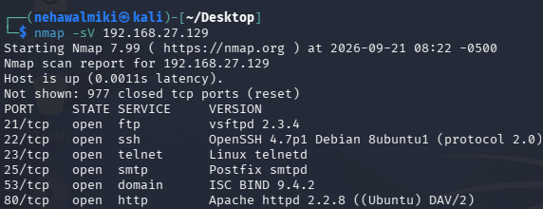

Finding | Before
FTP | Port 21 open
HTTP | Port 80 open
Telnet | Port 23 open

- Apply 3 Security Improvements
Disable FTP - sudo service vsftpd stop
Disable telnet - sudo service telnetd stop

Security Issue | Before | Action Taken | After | Improvement
FTP service exposed | 21/tcp – open – FTP | Disabled the FTP service | 21/tcp – closed | Removed unnecessary FTP exposure and reduced the attack surface
Telnet service exposed | 23/tcp – open – Telnet | Disabled Telnet service | 23/tcp – closed | Removed an unnecessary remote-access service

