2.

|  |  |  |
| --- | --- | --- |
| Symbol | Address | External |
| Main | 00400000 | No |
| In_string | n/a | Yes |
| Out_string | n/a | Yes |
| Fib | n/a | Yes |

3.

|  |  |
| --- | --- |
| Address | Entry |
| 0x00400004 | lui $a0, upper(in_string) |
| 0x00400008 | ori $a0, lower(in_string) |
| 0x00400024 | jal fib |
| 0x00400034 | lui $a0, upper(out_string) |
| 0x00400038 | ori $a0, lower(out_string) |

5.

|  |  |  |
| --- | --- | --- |
| Symbol | Address | External |
| epilogue | 0x00400064 | No |
| do_recurse | 0x0040002c | No |
| in_string | 0x10010000 | Yes |
| out_string | 0x1001000c | Yes |
| fib | 0x00400000 | Yes |

6.

|  |  |
| --- | --- |
| Address | Entry |
| 0x00400038 | Jal Fib |
| 0x0040004c | Jal Fib |

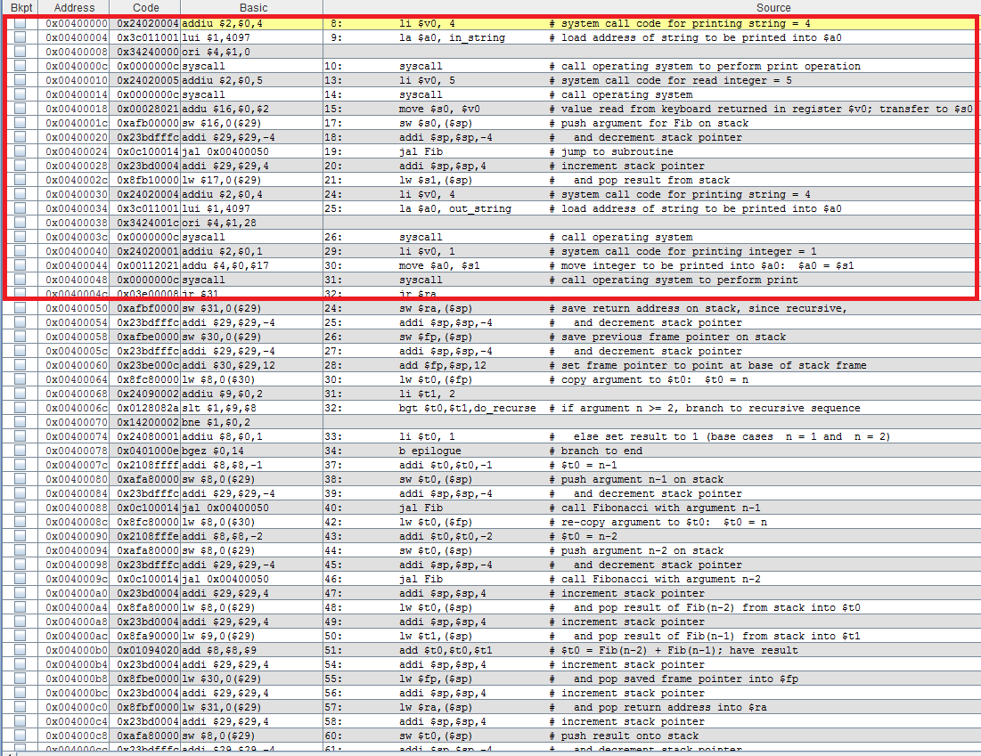

8.Those lines were the only thing that changed. What the assembler does is it concatenates the two programs together to create a new program. The first part comes from lab5part1 and the second part goes after that and thus all the addresses of the lab5-part2’s code gets offset by the length(part1)*4. The assembler also does this with the data section by combining the two data sections, but in lab5-part1.asm there’s nothing in there so the data section remains the same.

9.

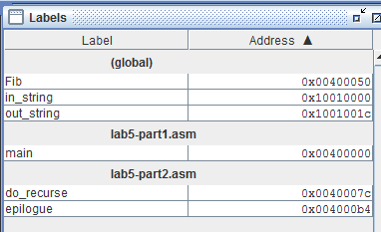

10.

|  |  |
| --- | --- |
| Address | Entry |
| 00400004 | Lui $1, 4097 |
| 00400008 | Ori $4,$1,0 |
| 00400024 | Jal Fib |
| 00400088 | Jal Fib |
| 0040009c | Jal Fib |
| 00400034 | Lui $1, 4097 |
| 00400038 | Ori $4,$1,28 |

11.

The two files could've been combined into one file. The makes it so that the linker doesn't have to do any work to link the files together and make it so that the two files are not interdependent.

12.

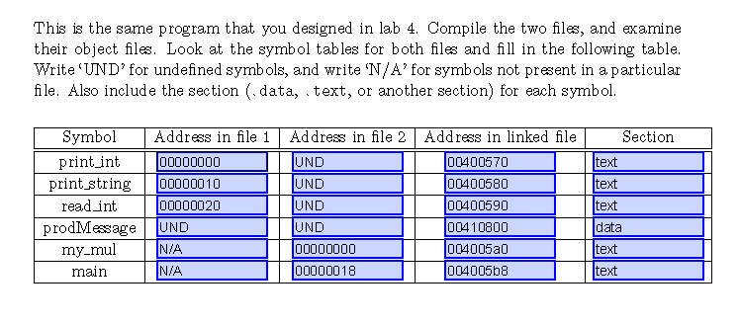

1.

The only instruction that changed was the j loop instruction. The native instruction changed because the nop instructions at the beginning offset the rest of the program because they took up addresses and thus the jump loop had to change to reflect the change in address of the jump. The la $t0, n didn't change because the nop instructions didn't affect the static data of the program.