# SlotEsp32 User Manual

The SlotEsp32 is an powerful Slot car controller based

Main features:

* Powerful ESP32 microcontroller: 1 core menu 1 core for trigger reading & motor control
* 40A protected Infineon automotive grade motor driver (no vintage fuses)
* Magnetic trigger Sensor with IC interface: accurate, no friction, no wear
* OLED display & Rotary Encoder open for upgrade
* Up to 10 model settings can be saved in the SlotEsp32 internal memory
* Open source firmware for endless parameter definitions
* Adjustable trigger travel and trigger tension

## Initial Calibration

## The SlotEsp32 has a magnetic trigger sensor and adjustable trigger travel, thereore the full pressed and full release trigger position has to be calibrated at first startup, or when the trigger travel is changed, or when the FW is updated.

## To perform the trigger calibration keep the rotary encoder knob pressed while powering the SlotEsp32, then the calibration screen appears. Fully press and release the trigger 2-3 times, then press the trigger again. To verify a proper calibration, check if th throttle is showing 0% whn fully released and 100% when fully pressed.

## Store setting before removing the supply

## The

## SENSI – sensitivity (minimum speed)

Sensitivity, indicates the power provided to the motor when the trigger is pressed just at the minimum. The sensitivity should be at least sufficient for the car to start moving. If the track is “fast” or the car is “heavy” then a higher sensitivity can be chosen. Sensitivity measurement unit is percent [%].

Example of typical setting: SENSI = 20% for 1/32 cars, SENSI = 40% for 1/24 cars.

## BRAKE - brake level

Brake level, indicates how strong the car will brake when the throttle is completely released. In order to perform the brake, the motor is shorted with a PWM and a duty cycle equal to the brake %. 100% means that the brake is max.



Example starting point: 90% - 95% is a typical starting point

## ANTIS – antispin (traction control)

Antispin is used to provide a smooth power ramp to the motor, even if the throttle is pressed abruptly. Antispin is expressed in milliseconds [ms]. It indicates how much time it takes for the motor to reach 100% power. If the Antispin is set to 150 ms for instance, and the trigger is pressed instantaneously, then the motor will receive a power ramp, that will take 150ms to reach the max power. The higher the number the softer is the power ramp applied.

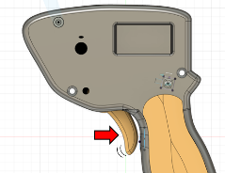 

Example of typical setting: ANTIS = 130ms for 1/32 cars, ANTIS = 0 ms for 1/24 cars.

## CURVE – trigger position TO motor power curve

The curve sets how much power is provided to the motor based on the trigger position. Standard controllers has 50% curve (linear). If you set curve >50% the car is more aggressive, if you set <50% the trigger response is more soft with push only at the end of the trigger travel.

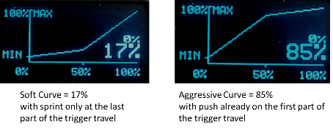

Example of typical setting: CURVE = 50% for most cars and pilots

## DRAGB – drag brake & anticipate brake

The Drag Brake applies some drag (soft brake) when the trigger is moving backward ( from pressed toward the brake position). So it anticipate the brake by reading the trigger movements. The drag is applied only during the release movement so it is very brief. Usually it is set to 100% so that all the % of throttle that is not pushed in to the motor , it is converted to brake during trigger release

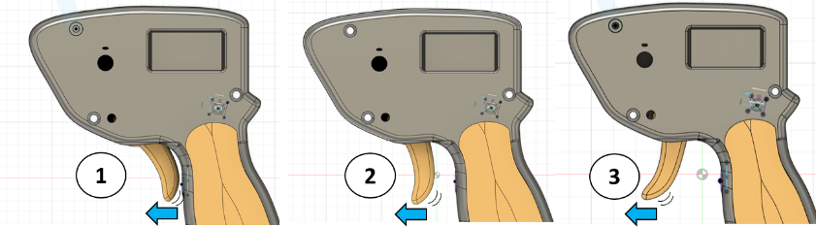

## PWM_F – motor PWM frequency

The Slotesp32, to control the motor speed uses a PWM (pulse width modulation). High PWM frequency (E.G. 4kHz) produces a softer response especially at low trigger positions. While a low PWM frequency (E.G. 1kHz) produces higher torque at minimum throttle and a more linear response (similar to a DC voltage).

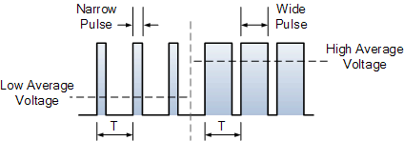 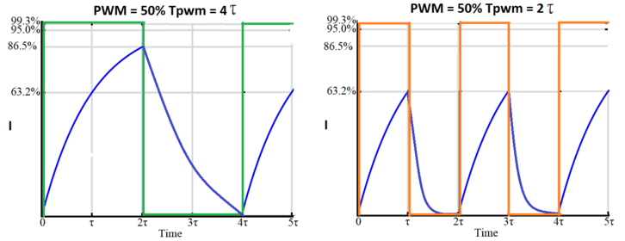

Example of typical setting: PWM_F = 3kHz