ESPEED32  
Slot Car Electronic Speed Controller

EN

## Introduction

The ESPEED32 is a powerful Slot Car Electronic Speed Controller based on the 32-bit ESP32 microcontroller.

## Calibration

The calibration of the trigger travel must be performed every time the trigger travel is changed, or the firmware is updated. To perform the trigger calibration, keep pressed the rotary selector while powering the ESPEED32, until the calibration screen appears. Fully press and release the trigger a few times, then press the rotary selector once. To verify a proper calibration, check if the throttle is showing 0% when the trigger is fully released, and 100% when the trigger is fully pressed.

## Navigating the screen

Rotate the rotary selector to scroll the settings in the main menu: the selected setting is highlighted. Press the selector once to change the value of the selected setting: the value is now highlighted. Rotate the selector to change the value of the selected setting, then press the selector again to confirm the value.

## Settings

* **SENSI – Sensitivity:** Indicates the power provided to the motor when the minimum detectable pressure is applied to the trigger. The sensitivity should be at least sufficient for the car to start moving. If the track is “fast” or the car is “heavy”, then a higher sensitivity can be chosen. SENSI measurement unit is percent [%] and ranges from 0% to 90%.
* **BRAKE – Brake level:** Indicates how strong the motor will brake when the trigger is completely released. In order to perform the brake, the motor is shorted with a PWM whose duty cycle is equal to the value of BRAKE. BRAKE measurement unit is percent [%] and ranges from 0% to 100% (100% means max brake is applied).
* **ANTIS – Antispin:** Antispin (traction control) is used to provide a smooth power ramp to the motor, even if the trigger is pressed abruptly. ANTIS is expressed in milliseconds [ms]. It indicates how much time it takes for the motor to reach 100% power with the trigger fully pressed. If ANTIS is set to 150 ms and the trigger is pressed instantaneously, then the motor will receive a power ramp that will take 150ms to reach the max power. The higher the number the softer is the power ramp applied. ANTIS possible value ranges from 0 ms to 250 ms. Typical ANTIS value: 130 ms for 1/32 cars; 0 ms for 1/24 cars
* **CURVE –** **Trigger-to-motor power curve:** the CURVE parameter allows to customize the mapping of the trigger position to the motor power output. A default value of 50% corresponds to a linear curve. If CURVE is <50% the response of the trigger will be more soft at the beginning of the travel and more aggressive at the end; vice versa if 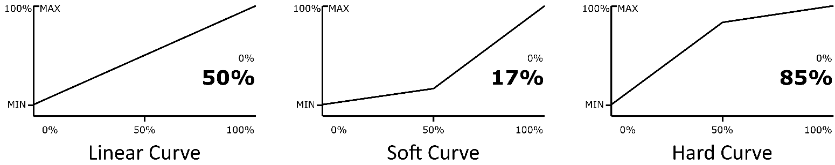CURVE is >50%. Ranges from 10% to 90%.

Figure 1 CURVE setting examples.

* **DRAGB –** **Drag Brake:** applies some drag (soft brake) when the trigger is being released. The drag is applied only during the release movement of the trigger, so it’s very brief. DRAGB measurement unit is percent [%] and its value indicate the percentage of the trigger currently not being pushed to the motor that is converted to brake during the trigger release. Ranges from 0% to 100%.
* **PWM_F – motor PWM frequency:** the frequency of the PWM (Pulse Width Modulation) used to control the motor. A higher frequency produces a softer response, especially at low trigger positions; a lower frequency produces higher torque with minimum throttle and more linear response. PWM_F measurements unit is Kilohertz [kHz] and ranges from 0.2kHz to 5.0kHz

Table 1 Settings overview

|  |  |  |  |  |
| --- | --- | --- | --- | --- |
| ****Setting**** | ****Recommended value**** | ****Range**** | | ****Unit**** |
| **Min.** | **Max.** |
| SENSI | 10 | 0 | 90 | % |
| BRAKE | 90 | 0 | 100 | % |
| ANTIS | 130 for 1/32 cars  0 for 1/24 cars | 0 | 250 | ms |
| CURVE | 50 | 10 | 90 | % |
| DRAGB | 100 | 0 | 100 | % |
| PWM_F | 3 | 0.2 | 5.0 | kHz |

## Electrical Specification

The parameters listed in this section represent the characteristics of the ESPEED32 Electronic Speed Controller and its requirements to ensure correct operation.

Table 2 Electrical specifications

|  |  |  |  |  |  |
| --- | --- | --- | --- | --- | --- |
| ****Setting**** | ****Symbol**** | ****Value**** | | | ****Unit**** |
| **Min.** | **Typ.** | **Max.** |
| Supply voltage | $$V_{DD}$$ |  |  |  | V |
| Input current | $$I_{VDD}$$ |  |  |  | mA |
| Operating temperature | $$t_{OP}$$ | -40 | - | 125 | °C |