ESPEED32  
Slot Car Electronic Speed Controller

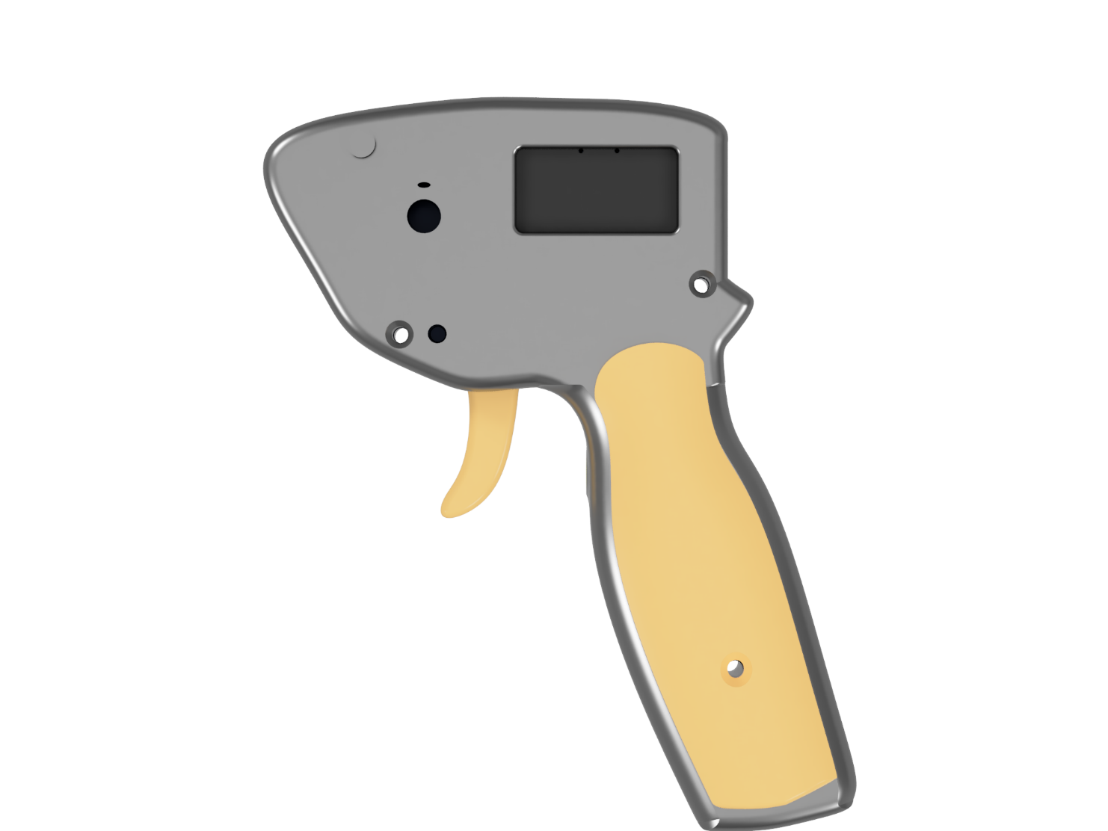

Table of contents

1 Introduction 2

2 How to use 2

2.1 Tips 2

2.2 Electrical Specification 3

# Introduction

This is a template for multiple pages documents, with a cover page and table of contents

# How to use the template

Use the defined styles!

This template uses a lot of Document Properties: to change them go to File 🡪 Info 🡪 Properties 🡪 Advanced Properties.

Here you can Edit the properties of the document, and the document will update automatically:

* Language: should be two capital letters (e.g., IT, EN, ecc…)
* Title: typically ESPEED32 (or whatever name we come up with)
* Subject: typically Slot Car Electronic Speed Controller
* DocTitle: the type of document (e.g. Quick Start Guide, User Manual, etc…)
* RevNumber: it’s the version (revision) number of the document, increment it every time you update the document (do not confuse with RevisionNumber)
* DateCompleted: the date of the last modification of the document (change it to the current date whenever you increase the RevNumber)
* ProductName: change it if we decide to change the name of the product (currently ESPEED32)

Sometimes the various fields must be updatr

Do not change the header and footer!

Use the Styles for the various part of the documents!

## Tips

When adding pictures always prefer scalable formats (.eps, .svg, etc…) and always add a caption **below** the picture

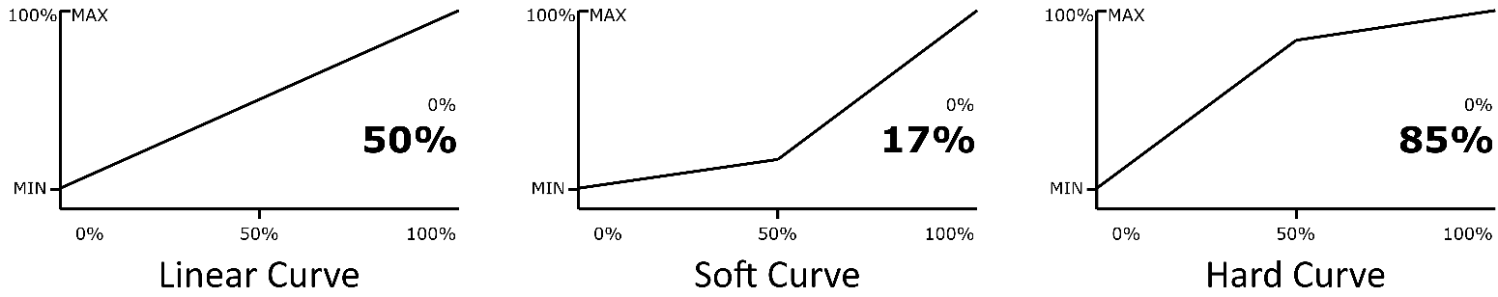

Figure 1 Example of a picture.

When adding a table use the custom format and make sure the table length stretches until the margins (use View 🡪 gridlines to make sure you reach the margin): in this way all the tables have the same length. Don’t forget to add a caption **above** the table. Also, try not to split table over multiple pages if possible.

Table 1 Settings overview

|  |  |  |  |  |
| --- | --- | --- | --- | --- |
| ****Setting**** | ****Recommended value**** | ****Range**** | | ****Unit**** |
| **Min.** | **Max.** |
| SENSI | 10 | 0 | 90 | % |
| BRAKE | 90 | 0 | 100 | % |
| ANTIS | 130 for 1/32 cars  0 for 1/24 cars | 0 | 250 | ms |
| CURVE | 50 | 10 | 90 | % |
| DRAGB | 100 | 0 | 100 | % |
| PWM_F | 3 | 0.2 | 5.0 | kHz |

## Electrical Specification

The parameters listed in this section represent the characteristics of the ESPEED32 Electronic Speed Controller and its requirements to ensure correct operation.

Table 2 Electrical specifications

|  |  |  |  |  |  |
| --- | --- | --- | --- | --- | --- |
| ****Parameter**** | ****Symbol**** | ****Value**** | | | ****Unit**** |
| **Min.** | **Typ.** | **Max.** |
| Supply voltage | $$V_{DD}$$ |  |  |  | V |
| Input current | $$I_{VDD}$$ |  |  |  | mA |
| Operating temperature | $$t_{OP}$$ | -40 | - | 125 | °C |