Building back ~~better~~ *Unbreakable*

Resilience depends on the speed and quality of recovery

Abstract: Tracking estimates of resilience is key to understanding the ability of countries to withstand natural shocks. Following on the World Bank’s Unbreakable report, this study provides an update to the resilience indicator based on the latest available data. Overall, it shows that countries have made some progress in building resilience since the previous estimates. Further, this report shows that by estimating this resilience indicator, the main drivers of vulnerability and resilience can be determined – and thus resilience building measures can be identified and prioritized. This report considers different measures under the “building back better” principle: Faster, more inclusive, and stronger reconstruction.

# Beyond asset losses: The well-being losses of natural disasters depend on people’s socio-economic resilience

Frequently, the estimated losses due to natural disasters focus only on damages to assets – including buildings, infrastructure, equipment, and production. Following such estimates, 2017 was the costliest year on record in terms of weather-related natural disasters. From hurricanes and wildfires to droughts and floods, global economic losses totaled more than $330 billion (Munich Re).

However, as highlighted in the *Unbreakable* report (Hallegatte et al., 2016), the focus on asset losses fails to inform us how disasters affect people’s well-being. The report highlighted that the overall well-being impact of a disaster depends critically on who experiences it. Clearly, a $1 loss means different things to a rich person than to a poor person. The same loss affects poor and marginalized people far more because their livelihoods depend on fewer assets, their consumption is closer to subsistence levels, they cannot rely on savings to smooth the impacts, their health and education are at greater risk, and they may need more time to recover and reconstruct.

To account for this important difference between asset and well-being losses, the *Unbreakable* report developed a new resilience metric measuring how natural disasters affect people’s well-being. It takes into account the ability of people to cope with a disaster, receive support, and recover and reconstruct – i.e. their socio-economic resilience (Figure 1). By examining well-being instead of asset losses, the report provided a deeper (and grimmer) view of natural disasters than does the usual reporting—indeed, this view takes better account of poor people’s vulnerability.

**Figure 1.** People's well-being losses due to a disaster depend on their resilience, i.e. their ability to cope, receive support, and recover.

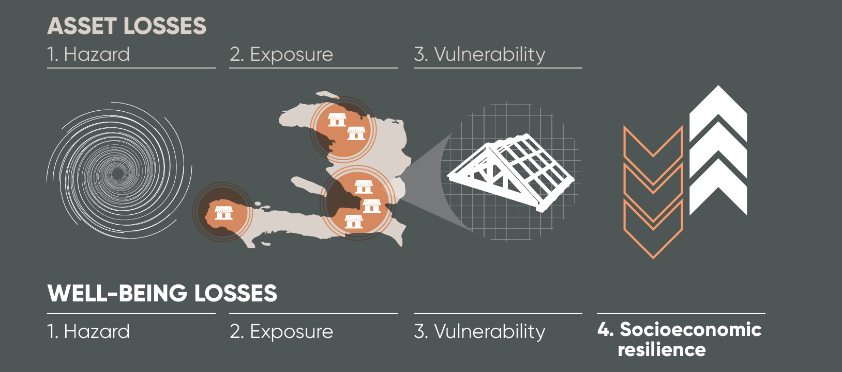

In all of the 117 countries studied in the report, well-being losses from natural disasters are larger than asset losses (Hallegatte, Bangalore, and Vogt-Schilb, 2016). According to the *United Nations Global Assessment Report on Disaster Risk Reduction*—the so-called GAR (UNISDR 2015)—total asset losses from natural disasters in these countries average $327 billion a year. Because disaster losses are concentrated on a small share of country populations, imperfectly shared, and affect more poor people (who have limited ability to cope with them), this report estimates that well-being losses in these countries are equivalent to consumption losses 60 percent larger than asset losses, or about $520 billion a year.

This study follows up on the *Unbreakable* report. Section 2 provides an update to the estimates of resilience based on the latest available data, and expands the analysis to 151 countries. It shows that many countries have been able to strengthen their socio-economic resilience in the past two years, while others have experienced a reduction in resilience. By focusing on the cases of four selected countries, this report also discusses the factors that determine changes in resilience. Section 3 provides an analysis of the role of ‘building back better’ – i.e. the way in which speed and quality of post-disaster recovery determines socio-economic resilience to disasters. For this purpose this report focuses on three aspects: Building back *faster*, *more inclusively*, and *stronger*.

# Resilience in 2017

Resilience to natural disasters is never constant and depends on a wide range of dynamic factors. Such factors include changing exposure due to population growth and rapid urbanization, intensifying hazards levels due to climate change, or strengthened ability to cope and recover due to effective disaster risk management. To understand how resilience to natural disasters is evolving in countries around the world these wide-ranging factors must be tracked and evaluated continuously. This section follows up on the Unbreakable report and updates the computation of its resilience indicator using the latest available data on socio-economic trends. More specifically, updated data include economic activity (GDP), urbanization, income inequality, level and coverage of social protection schemes, and sovereign credit ratings (which determine a country’s ability to access credit in the case of a contingency).

Of course, any indicator is only as good as the data it is based on, and the uneven pace at which new data becomes available implies that different variables in different countries are updated at different times. Measures of income inequality for instance are based on household surveys that are typically not conducted annually. While the updated resilience indicator in this report is based on the latest available data, not all variables in all countries will have been updated. Since data updates occur at different times for different countries, any comparison of across countries should be made with caution. The resilience indicator and its subsequent updates primarily serve the purpose of tracking the resilience of individual countries across time.

Based on the resilience model presented in the Unbreakable report, this update report calculates the risk to well-being by considering the four drivers of the loss in well-being as described above: natural hazards, exposure, vulnerability, and socio-economic resilience. Specifically, s*ocio-economic resilience* is defined as the ratio of *asset* losses to *well-being* losses:

$$\text{socio-economic resilience}=\frac{\text{asset losses}}{\text{well-being losses}}$$

Based on this definition, socio-economic resilience is considered a driver of the risk to well-being along with the three usual drivers: hazard (the probability an event occurs), exposure (the population and assets located in the affected area), and asset vulnerability (the fraction of asset value lost when affected by a hazard):

$$\text{risk to well-being}=\frac{\text{expected asset losses}}{\text{socio-economic resilience}}=\frac{\text{hazard * exposure * asset vulnerability}}{\text{socio-economic resilience}}$$

The *Unbreakable* report used this approach to quantify the risk to well-being in 117 countries, based on the latest available data in 2016. It calculated asset and well-being losses for multiple hazards, considering return periods from 2 to 1,500 years: River floods, coastal floods due to storm surge, windstorms, earthquakes, and tsunamis. Socio-economic resilience was then estimated as the ratio of expected asset losses to expected well-being losses.

Based on the same model, but using the latest available data in 2018, the updated estimated socio-economic resilience indicator displays a similar pattern to the earlier estimates (Figure 2). Countries with higher average incomes tend to be more resilient than lower income countries. At the same time, resilience levels in low-income countries have a large variance, thus indicating the importance of factors other than income in determining resilience. Risk to assets, expressed as a share of GDP, is also estimated to disproportionately affect low income countries (Figure 3). High-income countries tend to have risks to assets of below 1% of GDP, while for low income countries the variance increases to an upper bound of almost 10% of GDP.

The risk to well-being, measured as a share of GDP, is particularly high in low-income countries (Figure 4). Globally, annual average well-being losses are estimated to be US$ 560 bn for 150 countries.

**Figure 2**. Socio-economic resilience to natural disasters. Grey markers refer to 2015 data and orange to 2017.

**Figure 3** Risk to assets as a share of GDP. Grey markers refer to 2015 data and green to 2017.

**Figure 4** Risk to well-being as a share of GDP. Grey markers refer to 2015 data and blue to 2017.

## Country focus

**Figure 5** Percentage change in resilience and GDP per capita between 2015 and 2017

**Figure 6.** Parameter changes in Mauritania from 2015 to 2017.

# Resilient recovery: Building back better

Allowing no respite to people across the Caribbean in late 2017, Hurricane Irma was followed within few days by Hurricane Maria – both of which reached the highest intensity storm category. They wreaked destruction on numerous small islands, causing severe damages on islands like Barbuda or Saint Martin. The human cost of these disasters is immense. Many lives were lost, even though early warning systems and timely evacuations were able to save many more. And many survivors have lost lifelong savings, homes, and livelihoods. The destruction in the infrastructure and residential sectors are likely to exceed 100 percent of GDP on several islands. 70 to 80 percent of Dominica’s houses and buildings sustained major storm damages, ranging from ripped off roofs to total destruction. Entire regions have lost access to basic services, such as electricity and safe drinking water, and some remote communities were cut off completely for days. Returning to normalcy will take months, if not years, and for vulnerable people – especially children and elderly – the next months are a critical period, with the heightened risk of mortality and permanent effects on children’s education and health.

And the risk of further hurricanes remains high: The Caribbean hurricane season will not be over before the end of November. In addition, it is evident that these recent disasters took place in the context of increasingly frequent and intense extreme weather events – a trend that is by no means limited to the Caribbean, as other regions of the world, from Sierra Leone to Bangladesh, have been heavily affected in recent months. Continued urbanization and population growth, especially in coastal areas, as well as climate change are bound to magnify these trends in the next decades.

Considering these trends, the destruction caused by disasters highlights the need, but also the opportunity to *build back better*. Reconstruction offers an opportunity to build more resilient societies that are able to withstand future shocks and that recognizes the risks: With new buildings located outside flood zones and with structures designed to resist high winds; roads, bridges, and electric grids that are able to endure the next storm; and human settlements that provide a better quality of life and enable higher productivity.

In this section we focus on three key aspects of building back better. First, this section discusses the role of *building back faster*. It shows that shorter recovery and reconstruction periods mean that societies are ready for future disasters sooner. Especially in countries with frequent events faster recovery can significantly improve resilience and reduce well-being losses. Second, we consider the role of *building back inclusively,* i.e. ensuring that post-disaster support reaches all affected population groups without bias. This emphasizes the importance of providing recovery support to low-income households who are typically more exposed, more vulnerable, and less supported. Lastly, we consider how *building back stronger* can help to reduce well-being losses by ensuring that reconstructed infrastructure can resist more intense events in the future.

## Building back *faster*

By one rule of thumb, countries around the world take on average three years to fully recover from any significant natural disaster. In practice, this speed of recovery varies strongly depending on the level of preparedness and resources available for a quick and resilient recovery. Especially in countries that are hit frequently by natural shocks, a fast recovery is critical to ensure that people, assets, and infrastructure are prepared to withstand the next shock. This is the case, for instance, in small island states that experience intense tropical hurricane or cyclone seasons each year, and need to ensure that damages from one storm are repaired quickly enough to not compromise the ability to withstand the next.

The results presented in this section show that faster recovery can significantly reduce the average well-being losses due to natural disasters. Globally, at an average recovery speed of five years, global well-being losses would be US$ 631 bn. If the average recovery speed is reduced to one year, global well-being losses could be reduced by 23% to US$ 485 bn (Figure 11). In addition, Figure 7 shows the reduction in average well-being losses due to faster recovery for the ten countries with the largest absolute losses.

**Figure 7** Global reduction well-being losses associated with different recovery durations

**Figure 7** Reduction in average well-being loss due to faster recovery for the top ten countries in terms of losses: The top point refers to the well-being loss associated with a five year reconstruction period, while the bottom point refers to a one year reconstruction period. Percentages indicate the reduction in well-being losses by speeding up recovery from five years to one.

As suggested above, the importance of ‘building back faster’ differs across countries. Countries that experience high impact shocks at relatively low return periods – i.e. frequent large shocks – are bound to benefit most from accelerated recovery. Figure 8 presents the reduction in average well-being losses due to faster recovery for ten selected small island developing states. The reduction is 32% on average (compared to 23% globally). In several of these small island states, measures to accelerate recovery are highly effective at building resilience – they can halve the annual well-being losses (e.g. Trinidad and Tobago). Figure 9 presents the ten countries with the largest relative reduction in well-being losses due to faster recovery. In addition, Figure 10 provides a global overview illustrating that the countries that benefit most from faster reconstruction tend to be lower income developing countries.

**Figure 8**: Reduction in average well-being loss due to faster recovery for ten selected small island developing states: The top point refers to the well-being loss associated with a five year reconstruction period, while the bottom point refers to a one year reconstruction period. Percentages indicate the reduction in well-being losses by speeding up recovery from five years to one.

**Figure 9** Top ten largest reductions in average well-being losses due to faster recovery

**Figure 10** Percentage reduction of well-being losses associated with faster recovery (reduced from five years to one). Countries are sorted in quartiles (i.e. same number of countries for each colour).

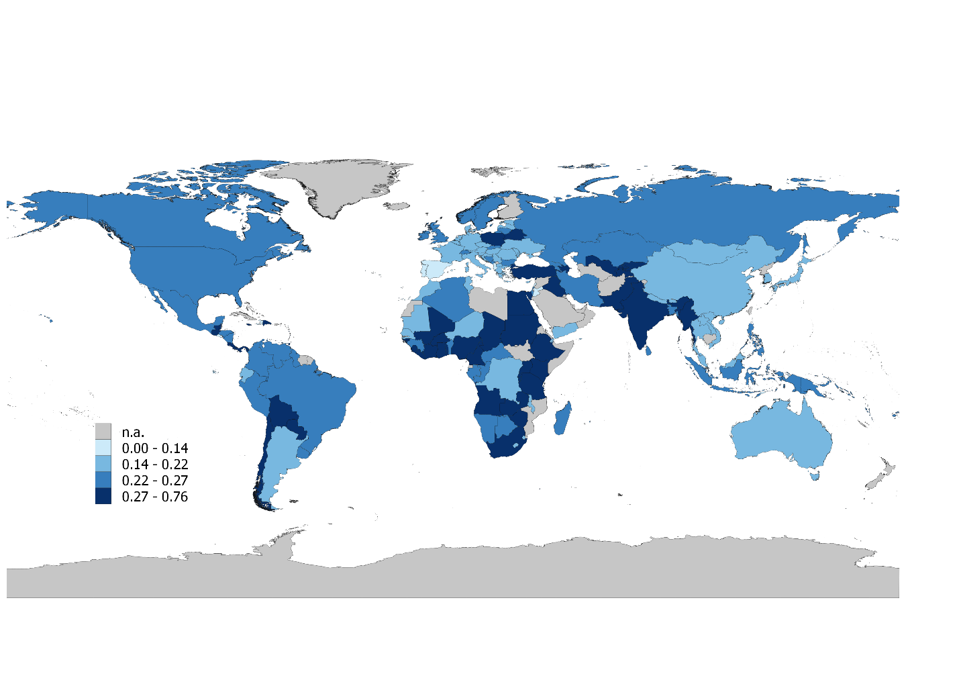

## Building back *more inclusively*

As the Unbreakable report has shown, poor people are not only more exposed and more vulnerable to natural hazards, but they also tend to have access to fewer post-disaster support mechanisms. As a consequence, they tend to experience larger losses relative to income and have relatively fewer means at their disposal to manage their recovery. Without dedicated actions to ensure that post-disaster support measures reach poor people, these support measures are likely to disproportionately benefit higher income recipients. One reason, for example, could be the lack of financial inclusion which means that poor people tend to lack access to bank accounts and thus formal channels of receiving cash transfers from social safety net schemes.

In this context, “building back *more inclusively*” means that recovery measures ensure that inequalities are reduced – especially with regards to the access to post-disaster support and social safety nets. This means that all affected population groups are supported, and that recovery support is ensured to be provided without excluding low-income households. Particularly in countries with high inequality, *more inclusive* recovery can increase overall resilience by ensuring that poor people – i.e. the most exposed, most vulnerable and least supported – have access to the post-disaster support they require. For instance, this could take the form of strengthened social safety nets with better targeting mechanisms.

For the sake of illustration, the estimates in this section assume that recovery measures result in “perfect inclusiveness”, i.e. that all affected households have access to post-disaster support regardless of their pre-disaster income level. The estimates suggest that if all countries rebuilt more inclusively, global well-being losses due to natural disasters could be reduced by 3.7% from US$ 560 bn to US$ 539 bn annually.

Figure 12 provides an overview of the countries in which more inclusive recovery would lead to the largest (and smallest) reduction in average well-being losses. The estimates show that inclusive recovery could reduce overall well-being losses due to natural disasters by up to 19%. Inclusive recovery tends to be particularly effective in lower-income developing countries, countries with high inequality, and countries with low sovereign credit ratings (which affects their ability to borrow and finance post-disaster support measures). However, in high-income countries more inclusive recovery shows little benefit – mainly because social protection systems are already relatively well-equipped to target and support even the lowest income groups. Moreover, Figure 13 shows that “building back *more inclusively*” tends to yield higher reductions in well-being losses in countries with high pre-existing inequality.

**Figure 12** Top 10 largest (left) and smallest (right) reductions in average well-being losses due to more inclusive recovery

**Figure 13** The benefits of more inclusive recovery depend on the level of pre-existing income inequality

## Building back *stronger*

As highlighted in the introduction to this study, natural disasters are frequently associated with heavy damages to assets and infrastructure, such as roads, bridges, and buildings. Their destruction can cause significant disruptions to economic activity and threaten the livelihoods of people who rely on them. Hence, “building back better” must not only mean *faster* and *more inclusive*, but also *stronger*. This principle refers in particular to resilient reconstruction that strengthens the ability of assets to withstand natural shocks. For instance, the large scale physical destruction experienced in 2017 by several Caribbean island states (including Dominica and Antigua & Barbuda) offers the opportunity to ensure that destroyed assets are reconstructed to more resilient standards – i.e. that they can withstand more intense events in the future.

To estimate the benefits of “building back *stronger*”, we assume that destroyed assets are reconstructed to a resilience standard that is able to withstand shocks up to a 50 year return period.[1] The estimates suggest that if all countries would “build back *stronger*”, global well-being losses due to natural disasters could be reduced by 11.7% from US$ 560 bn to US$ 494 bn annually. Figure 14 provides an overview of the countries in which *stronger* recovery would lead to the largest (and smallest) reduction in average well-being losses. The estimates show that *stronger* recovery could reduce overall well-being losses due to natural disasters by up to 44%.

**Figure 14** Top 10 largest (left) and smallest (right) reductions in average well-being losses due to "building back stronger".

These estimates illustrate that post-disaster reconstruction offers an opportunity for implementing resilience standards and reducing losses from future events. However, this also implies that the same argument applies to all new infrastructure construction, regardless of whether a disaster occurred recently. Especially developing countries are already in the process of rapidly developing their infrastructure in response to population growth, urbanization, and economic growth. In order to avoid increasing exposure and vulnerability, all of these infrastructure investments must take into account natural hazards and risks.

# Tracking progress in resilience

Regular updates will help to understand progress made and the prioritization of resilience building measures.

1. A time frame of 20 years is chosen for this purpose: Every asset destroyed by a natural disaster within a 20 year time frame is reconstructed to the new standard. The estimated reduction in well-being losses are the amount that can be achieved at the end of this time frame.