SIOPv2

Introduction
SIOP is an extension to OIDC (OpenID Connect). OIDC enables an user to use an OP (OpenID Provider) to release information to a RP (Relying Party). SIOP changes this directive to cut out the OpenID Provider service in the middle, by becoming this role itself, now being called Self-Issued OP. The DIDs, signing keys, and other identity information is now in the hands of the user.
Now, to make the information the user releases to the Relying party verifiable (= trustworthy), a separate protocol called “OpenID for Verifiable Presentations” (OIDC4VP) comes into play. It allows the Self-issued OpenID Provider to present verifiable claims in the form of a Verifiable Presentation (which itself contains Verifiable Credentials, oftentimes coming from external issuers).

SIOP Protocol flow
- The Relying Party sends an Authorization Request (SIOP Request) to the SIOP (the Self-Issued OpenID Provider of the user).
- The above-mentioned request is being authenticated and authorized with SIOP and user. Usually, this encompasses a modal dialog request being shown to the user, asking if they wish to share a specific Verifiable Credential with the Relying Party.
- If the request was successfully authenticated and authorized, the SIOP of the user will send a “Self-Issued ID Token” Token (SIOP Response) to the Relying Party. This ID token includes claims about the Authentication event, and could also encompass supplementary claims about the user.

Requests

Request transmission (Provider Invocation)
There are various ways how a SIOP request from a Relying Party may be transmitted to the users SIOP.
The most recent standard does currently not specify any options on how the request are supposed to reach the user. Furthermore, the standard indicates that there are currently absolutely no established or robust options for a Relying Party to determine where a users SIOP might be located, which one to use, or if there is even one installed at all. This means, that during a users first interaction with the Relying Party, according to the standard, the Relying Party would have to build a custom way to first and foremost find out the URL of the users SIOP where to direct the request to.
This has caused two options to be worth considering, both of which are valid and even mentioned in the standard:

1. Out-of-band request transmission (request without authorization_endpoint)
This option does not involve actually calling an endpoint of a users SIOP, in fact, it isn’t even possible, as the URL of the users SIOP is unknown.
This option involves encoding the request into e.g. an QR code for users to scan with their wallet, when it’s installed on their smartphone, or encoding it into a deep-link, which opens up the users wallet, when it is installed on the same (e.g. desktop) platform as they are browsing the Relying Partys site on.
Please keep in mind that QR codes and links have a maximum useable size. To not have to cross this size, most of the “large” parameters have a -_uri suffixed version, which allows to not have to embed large JSON objects into the QR code / links.
Of course in this case, it is not necessary for the Relying Party to determine the users SIOP URL. Thus, no authorization_endpoint (URL of the users SIOP, could also be a custom URI scheme or Universal Link/App link) parameter is required.

Example request
response_type=id_token
&client_id=https%3A%2F%2Fclient.example.org%2Fcb
&request_uri=https%3A%2F%2Fclient.example.org%2Frequest
&scope=openid
&nonce=n-0S6_WzA2Mj

2. In-band request transmission (request with authorization_endpoint)
On the contrary, the request would include the above-mentioned authorization_endpoint. The standard mentions two options on how to obtain it beforehand:

1. Pre-obtaining the authorization_endpoint
The standard does not specify how the Relying Party is supposed to gain the users SIOP Issuer identifier, however one could simply ask the user in a modal/dialog.
Nonetheless, it mentions pre-obtaining SIOP Discovery Metadata using one of the following options:

1. Using OpenID.Discovery (OpenID Connect Core 1.0 incorporating errata set 1).
This part of the specifications was (temporarily?) not accessible to the public, thus it could not be properly evaluated.
However, when OpenID.Discovery is used, the Relying Party has to fetch the metadata, comparable to the static set of SIOP metadata (but differing from the OpenID.Discovery specification, without jwks_uri), from the URL:
${siopIssuerIdentifier}/.well-known/openid-configuration

2. Using out-of-band mechanisms.

2. Using a static set of SIOP metadata
See “Statically obtained metadata”.

SIOP metadata
The standard shows the following examples for obtained SIOP metadata:

Statically obtained metadata
{
"authorization_endpoint": "openid:",
"response_types_supported": [
"id_token"
],
"scopes_supported": [
"openid"
],
"subject_types_supported": [
"pairwise"
],
"id_token_signing_alg_values_supported": [
"ES256"
],
"request_object_signing_alg_values_supported": [
"ES256"
],
"subject_syntax_types_supported": [
"urn:ietf:params:oauth:jwk-thumbprint"
],
"id_token_types_supported": [
"subject_signed"
]
}
Please note: - subject_syntax_types_supported might be removed in the future. - authorization_endpoint must use the custom URI scheme openid:. - The standard mentions that when using the above-mentioned custom URI scheme openid:, only native SIOP apps, but no web applications might open.

Dynamically obtained metadata
{
"authorization_endpoint": "https://wallet.example.org",
"issuer": "https://example.org",
"response_types_supported": [
"id_token"
],
"scopes_supported": [
"openid"
],
"subject_types_supported": [
"pairwise"
],
"id_token_signing_alg_values_supported": [
"ES256K",
"EdDSA"
],
"request_object_signing_alg_values_supported": [
"ES256K",
"EdDSA"
],
"subject_syntax_types_supported": [
"urn:ietf:params:oauth:jwk-thumbprint",
"did:key"
],
"id_token_types_supported": [
"subject_signed"
]
}

Metadata explanation
- authorization_endpoint
  - URL of the users SIOP, or
  - custom openid: URI scheme, or
  - Universal Link / App Link
- issuer
  - URL (with https scheme) of the users SIOPs Issuer Identifier
    - without any query
    - not including a fragment
    - same one that’s used to resolve ${siopIssuerIdentifier}/.well-known/openid-configuration
    - has to be identical to the iss claim in the ID token for the SIOP
- id_token_types_supported
  - JSON string-array listing ID tokens the OpenID Provider supports, being one of:
    - attester_signed (default)
      - ID token is issued by the controller of the OpenID Provider
      - (this is the classical ID token defined in OpenID.Core)
    - subject_signed
      - Self-issued ID Token
      - ID token is signed by the user
- response_types_supported
  - JSON stringarray of supported response types
  - simply has to be id_token
- scopes_supported
  - JSON stringarray of supported scopes
  - has to at least include openid
- subject_types_supported
  - JSON stringarray of supported subject types
  - Valid subject types include public and pairwise
- id_token_signing_alg_values_supported
  - JSON stringarray of the OpenID Providers supported JWS signing algorithms (for the ID Token to encode the Claims in a JWT)
  - Valid JWS signing algorithms (alg) include EdDSA (Ed25519), RS256 (RSASSA-PKCS1-v1_5 using SHA-256), ES256 (ECDSA using NIST P-256 and SHA-256), ES256K (secp256k1, often recommeded)
- request_object_signing_alg_values_supported
  - same as above, for signing of Request Objects instead of signing of ID Tokens
  - same as above, and addional none for no signing (not recommended, they will of course not be signed)
- subject_syntax_types_supported
  - JSON stringarray with supported URI schemes
  - for JWK Thumbprint, this parameter is urn:ietf:params:oauth:jwk-thumbprint
    - in this case, the sub claim has to be a base64url encoded JWK thumbprint of the key that’s in sub_jwk, and sub_jwk has to be included in the SIOP Response
  - for DIDs, the DID method has to be specified, e.g. did:web (no additional colon suffix shall be added, e.g. do not use did:web:)
    - as a catch-all, using did will indicate support for all DID methods (not recommeded, as this is usually never the case)
    - in this case, sub has to be a valid DID, and sub_jwk shall not be included in the SIOP response
Example for subject_syntax_types_supported:
{
"subject_syntax_types_supported": [
"urn:ietf:params:oauth:jwk-thumbprint",
"did:example",
"did:key"
]
}

Relying Party Metadata
Depending on whether the SIOP and the Relying Party have already had previously communicated, Relying Party Metadata obtention differs:

1. SIOP <-> RP have previously communicated and are pre-registered
When the Relying Party has pre-registered with the users SIOP - using OpenID.Registration, - or out-of-band the following demands have to be met:
- client_id has to be the client identifier (which the Relying Party obtained from the users SIOP during pre-registration)
- client_metadata must not be present in the request
- client_metadata_uri must not be present in the request
An example request in this case could be:
HTTP/1.1 302 Found
Location: https://client.example.org/universal-link
?response_type=id_token
&client_id=s6BhdRkqt3
&redirect_uri=https%3A%2F%2Fclient.example.org%2Fcb
&scope=openid%20profile
&nonce=n-0S6_WzA2Mj

2. SIOP <-> RP communicate for the first time or are not pre-registered
It is also possible to pass the metadata in the SIOP Authorization Request, but note, that this functions differently from registration (as the SIOP does not return a re-usable client_id to the Relying Party).
- Should the SIOP request be unsigned:
  - all client metadata has to be passed in client_metadata or client_metadata_uri
  - client_id has to be the redirect_uri
- Should the SIOP request be signed:
  - client_id of the Relying Party is resolved to the public key (which is used to verify the signature of the signed SIOP request)
  - the other Relying Party parameters have to be in either:
    - client_metadata in the SIOP request,
    - or in the OpenID Fed. 1.0 Automatic Registrations “Entity Statement”
  - client_id may not be redirect_uri
- client_metadata may not include redirect_uris (to prevent attackers from inserting malicious redirect URIs)
To specify: - The above-mentioned client_metadata is a JSON object, containing the Relying Party parameters. - The above-mentioned client_metadata_uri is a URI (with https scheme), resolving to a JSON object, containing the Relying Party parameters. - Either client_metadata or client_metadata_uri shall be used, however not both at the same time.
An unsigned not-pre registered request may look like this:
HTTP/1.1 302 Found
Location: https://client.example.org/universal-link
?response_type=id_token
&client_id=https%3A%2F%2Fclient.example.org%2Fcb
&redirect_uri=https%3A%2F%2Fclient.example.org%2Fcb
&scope=openid%20profile
&nonce=n-0S6_WzA2Mj
&registration=%7B%22subject_syntax_types_supported%22%3A
%5B%22urn%3Aietf%3Aparams%3Aoauth%3Ajwk-thumbprint%22%5D%2C%0A%20%20%20%20
%22id_token_signing_alg_values_supported%22%3A%5B%22RS256%22%5D%7D
A signed not-preregistered request using public key resolving with JWKS may look like this ("client_id": "https://client.example.org"):
HTTP/1.1 302 Found
Location: https://client.example.org/universal-link
?response_type=id_token
&client_id=https%3A%2F%2Fclient.example.org%2F
&redirect_uri=https%3A%2F%2Fclient.example.org%2Fcb
&scope=openid%20profile
&nonce=n-0S6_WzA2Mj
A signed not-preregistered request using public key resolving with DIDs may look like this ("client_id": "did:example:EiDrihTRe0GMdc3K16kgJB3Xbl9Hb8oqVHjzm6ufHcYDGA"):
openid://
?scope=openid%20profile
&response_type=id_token
&client_id=did%3Aexample%3AEiDrihTRe0GMdc3K16kgJB3Xbl9Hb8oqVHjzm6ufHcYDGA
&redirect_uri=https%3A%2F%2Fclient.example.org%2Fcb
&claims=...
&registration=%7B%22subject_syntax_types_supported%22%3A
%5B%22did%3Aexample%22%5D%2C%0A%20%20%20%20
%22id_token_signing_alg_values_supported%22%3A%5B%22ES256%22%5D%7D
&nonce=n-0S6_WzA2Mj

SIOP Authorization Request

SIOP Authorization Request Definition
- scope (Mandatory)
  - Same as in OpenID (see 3.1.2)
- response_type (Mandatory)
  - Has to be id_token (see response_types_supported)
- client_id (Mandatory)
  - Relying Partys identifier for the users SIOP
- redirect_uri (Mandatory)
  - URI where the SIOP Response will be sent to
- id_token_hint (Optional)
  - Same as in OpenID (see 3.1.2)
  - may have been encrypted to the Relying Party (in a previous transaction)
    - in this case, it is a Nested JWT, which has to be decrypted to retrieve the Self-issued ID Token
- claims (Optional)
  - Same as in OpenID (see 5.5)
- client_metadata (Optional)
  - In-request passing of information of the Relying Party to the users SIOP, see described above
  - exclusive to client_metadata_uri
- client_metadata_uri (Optional)
  - In-request passing of information of the Relying Party to the users SIOP, see described above
  - exclusive to client_metadata
- request (Optional)
  - Same as in OpenID (see 6.1)
  - may be encrypted to the users SIOP by the Relying Party
    - in this case, the subject sub of a previously issued ID Token for this Relying Party has to sent as the Key ID kid of the JWE
- request_uri (Optional)
  - Alternativly to passing the request object in request, it can be passed as a resolveable URI
- id_token_type (Optional)
  - String (not JSON list!) specifying the types of ID tokens the Relying Party is interested in, seperated by spaces, in descending order of preference
    - default is attester_signed
    - the other option is subject_signed
  - the Relying Party determines what ID token the users SIOP returned, by comparing the iss and sub claims.
Client metadata shall not be duplicated. Pass it in one of the following attributes exclusivly: - client_metadata - client_metadata_uri - request - request_uri
Make sure to always send a unique nonce parameter with every request. It is used for replay attack detection.

Example request
HTTP/1.1 302 Found
Location: openid://
?scope=openid
&response_type=id_token
&client_id=https%3A%2F%2Fclient.example.org%2Fcb
&redirect_uri=https%3A%2F%2Fclient.example.org%2Fcb
&id_token_type=subject_signed
&claims=...
&registration=%7B%22subject_syntax_types_supported%22%3A
%5B%22urn%3Aietf%3Aparams%3Aoauth%3Ajwk-thumbprint%22%5D%2C%0A%20%20%20%20
%22id_token_signing_alg_values_supported%22%3A%5B%22ES256%22%5D%7D
&nonce=n-0S6_WzA2Mj

Cross-Device SIOP Request specifics
- adds parameter response_mode, containing a HTTP endpoint
- adds response mode post
  - specifies, that the users SIOP shall deliver the authentication result to the endpoint at response_mode using HTTP POST
- authentication result is conveyed in standard redirect_uri
Usually (but not neccessarily always), cross-device SIOP Requests will have the SIOP run on a different device (e.g. a smartphone), than the one the user is accessing the site of the Relying Party with (e.g. a desktop computer).

Example request
openid://
?scope=openid%20profile
&response_type=id_token
&client_id=https%3A%2F%2Fclient.example.org%2Fpost_cb
&redirect_uri=https%3A%2F%2Fclient.example.org%2Fpost_cb
&response_mode=post
&claims=...
&registration=%7B%22subject_syntax_types_supported%22%3A
%5B%22urn%3Aietf%3Aparams%3Aoauth%3Ajwk-thumbprint%22%5D%2C%0A%20%20%20%20
%22id_token_signing_alg_values_supported%22%3A%5B%22ES256%22%5D%7D
&nonce=n-0S6_WzA2Mj

SIOP Authorization Response
The response depends on the value of the parameter response_type and the device flow: - in a same-device flow: - if the response_type is id_token - response parameters are returned as URL fragment - if the response_type is code - response parameters are returned in the HTTP POST response body (of the token response) - in a cross-device flow: - users SIOP sends a HTTP Post (with the Authorization Response) to an (previously specified) endpoint (of the Relying Party)
The response contains an ID Token and can be extended to include extension parameters, for example, an Verifiable Presentation (VP) Token (OIDC4VP).

Example responses

For same-device flows
for response_type = id_token:
HTTP/1.1 302 Found
Location: https://client.example.org/cb
#id_token=...
for response_type = code:
HTTP/1.1 200 OK
Content-Type: application/json
Cache-Control: no-store
Pragma: no-cache

{
"access_token": "SlAV32hkKG",
"token_type": "Bearer",
"expires_in": 3600,
"id_token": "..."
}}

For cross-device flow
Calls the Relying Partys endpoint specified in redirect_uri as application/x-www-form-urlencoded with the Authorization Response
POST /post_cb HTTP/1.1
Host: client.example.org
Content-Type: application/x-www-form-urlencoded

id_token=...

Self-issued ID Token in the Response

Definition
Claims: - iss (Mandatory) - for self-issued ID Tokens, this has to be the sub claim - sub (Mandatory) - if “Subject Syntax Type” is “JWK Thumbprint” - this value is base64url encoded of the key thumbprint in the sub_jwk field - thumbprint value is constructed by: SHA256( Octects of UTF8 ( minimal JWK ) ) - minimal JWK: only consisting of required fields, sorted alphabetically, without whitespace or linebreaks - e.g. - for kty = “RSA”: e, kty, n - for kty = “EC”: crv, kty, x, y - if “Subject Syntax Type” is “DID” (Decentralized Identifier) - this value is a DID - sub_jwk (Optional) - public key (to check signature of an ID Token) - only when “Subject Syntax Type” = “JWK Thumbprint” - bare key in JWK format (do not use a X.509 cert value) - do not use when “Subject Syntax Type” != “JWK Thumbprint” - not recommended when OpenID Provider is not Self-issued

Validation
The below-mentioned checks have to be conducted by the Relying Party:

Validation for self-issued ID Tokens
- Check if the ID Token was issued by the users SIOP.
  - it is self-issued if iss == sub (subject has issued it themselves)
- Check if the aud claim contains the value of client_id (which the Relying Party sent in the Authorization Request as an audience)
- Check which “Subject Syntax Type” is used
  - if sub == urn:ietf:params:oauth:jwk-thumbprint, “Subject Syntax Type” is “JWK Thumbprint”
  - if sub starts with did: or is did, “Subject Syntax Type” is DID (Decentralized Identifier)
- Check the signature of the ID Token
  - if “Subject Syntax Type” is “JWK Thumbprint”, validate according to JWS
    - that is: using the algorithm in alg and using the key in claim sub_jwk
      - check if alg is supported (in id_token_signing_alg_values_supported)
  - if “Subject Syntax Type” is DID (Decentralized Identifier), validate against the key in the DID document
    - the DID document is obtained by resolving the DID in sub
    - if verificationMethod contains multiple keys, use the key with identified according to the value of kid
- Check the sub value
  - if “Subject Syntax Type” is “JWK Thumbprint”
    - check that sub is the base64url encoded key thumbprint of the key in sub_jwk
  - if “Subject Syntax Type” is DID (Decentralized Identifier)
    - check that the DID in sub equals the DID in id in the DID document
- Check times
  - Check that the expiration time in exp has not be overrun
  - Check that the issued-at time in iat is not in the future
- Replay attack detecion
  - Check that the claim nonce is present and is equal to the one in the Authorization Request.
  - Check if the nonce has been reused.

Validation for cross-device self-issued ID Tokens
Apply all above-mentioned checks, and additionally check for unqiueness of the nonce claim (it should not have appeared previously).

Example Validation
For “Subject Syntax Type” = “DID”:
{
"iss": "did:example:NzbLsXh8uDCcd6MNwXF4W7noWXFZAfHkxZsRGC9Xs",
"sub": "did:example:NzbLsXh8uDCcd6MNwXF4W7noWXFZAfHkxZsRGC9Xs",
"aud": "https://client.example.org/cb",
"nonce": "n-0S6_WzA2Mj",
"exp": 1311281970,
"iat": 1311280970
}

Example ID Token
Example of a base64 url decoded Self-Issued ID Token when using the JWK Thumbprint Subject Syntax Type:
{
"iss": "NzbLsXh8uDCcd-6MNwXF4W_7noWXFZAfHkxZsRGC9Xs",
"sub": "NzbLsXh8uDCcd-6MNwXF4W_7noWXFZAfHkxZsRGC9Xs",
"aud": "https://client.example.org/cb",
"nonce": "n-0S6_WzA2Mj",
"exp": 1311281970,
"iat": 1311280970,
"sub_jwk": {
"kty": "RSA",
"n": "0vx7agoebGcQSuuPiLJXZptN9nndrQmbXEps2aiAFbWhM78LhWx4cbbfAAt
VT86zwu1RK7aPFFxuhDR1L6tSoc_BJECPebWKRXjBZCiFV4n3oknjhMstn64tZ_2W
-5JsGY4Hc5n9yBXArwl93lqt7_RN5w6Cf0h4QyQ5v-65YGjQR0_FDW2QvzqY368QQ
MicAtaSqzs8KJZgnYb9c7d0zgdAZHzu6qMQvRL5hajrn1n91CbOpbISD08qNLyrdk
t-bFTWhAI4vMQFh6WeZu0fM4lFd2NcRwr3XPksINHaQ-G_xBniIqbw0Ls1jF44-cs
FCur-kEgU8awapJzKnqDKgw",
"e": "AQAB"
}
}

The different error codes of a SIOP Response
- User errors:
  - user_cancelled
    - User denied or cancelled the Authorization Request of the Relying Party
- Unsupported errors:
  - registration_value_not_supported
    - Users SIOP does not support a specific parameter in the request of the Relying Party
  - subject_syntax_types_not_supported
    - Users SIOP does not support any of the provided Subject Syntax Types (subject_syntax_types_supported) in the request of the Relying Party
- Invalid data errors:
  - invalid_registration_uri
    - client_metadata_uri in the SIOP request cannot be accessed or resolves to invalid data
  - invalid_registration_object
    - client_metadata contains a Relying Party object that is not valid

OIDC4VP
OIDC4VP enables the presenation of claims, which take the form of VCs (Verifiable Credentials).

Requesting Presentations
Verifiable Presentations (VPs) are requested by extending the Authorization Request by the parameter presentation_definition.

Definition

response_type
When using OIDC4VP, one will use the value vp_token to have the Authorization Server return only a VP Token in the Authorization Response.

scope
Optional.
Wallets can support requesting credential presentations with scope values, such a scope value is supposed to map to a Presentation Definition, however, the standard does not define this in more detail.

Scope request example
GET /authorize
?response_type=vp_token
&client_id=https%3A%2F%2Fclient.example.org%2Fcb
&redirect_uri=https%3A%2F%2Fclient.example.org%2Fcb
&scope=com.example.healthCardCredential_presentation
&nonce=n-0S6_WzA2Mj HTTP/1.1

presentation_definition
A definition complying with the specification DIF Presentation Exchange 2.0.0
Use either presentation_definition or presentation_definition_uri, not both at the same time.

Simple constraint example
{
"id": "vp token example",
"input_descriptors": [
{
"id": "id card credential",
"format": {
"ldp_vc": {
"proof_type": [
"Ed25519Signature2018"
]
}
},
"constraints": {
"fields": [
{
"path": [
"$.type"
],
"filter": {
"type": "string",
"pattern": "IDCardCredential"
}
}
]
}
}
]
}}

Selective disclosure example
{
"id": "vp token example",
"input_descriptors": [
{
"id": "id card credential with constraints",
"format": {
"ldp_vc": {
"proof_type": [
"Ed25519Signature2018"
]
}
},
"constraints": {
"limit_disclosure": "required",
"fields": [
{
"path": [
"$.type"
],
"filter": {
"type": "string",
"pattern": "IDCardCredential"
}
},
{
"path": [
"$.credentialSubject.given_name"
]
},
{
"path": [
"$.credentialSubject.family_name"
]
},
{
"path": [
"$.credentialSubject.birthdate"
]
}
]
}
}
]
}

Alternative credential request example
{
"id": "alternative credentials",
"submission_requirements": [
{
"name": "Citizenship Information",
"rule": "pick",
"count": 1,
"from": "A"
}
],
"input_descriptors": [
{
"id": "id card credential",
"group": [
"A"
],
"format": {
"ldp_vc": {
"proof_type": [
"Ed25519Signature2018"
]
}
},
"constraints": {
"fields": [
{
"path": [
"$.type"
],
"filter": {
"type": "string",
"pattern": "IDCardCredential"
}
}
]
}
},
{
"id": "passport credential",
"format": {
"jwt_vc": {
"alg": [
"RS256"
]
}
},
"group": [
"A"
],
"constraints": {
"fields": [
{
"path": [
"$.vc.type"
],
"filter": {
"type": "string",
"pattern": "PassportCredential"
}
}
]
}
}
]
}

presentation_definition_uri
Use the presentation_definition_uri if you do not want to send the whole presentation_definition in the URL (keep in mind size limitations of URLs in browsers and other components). It will be retrieved through a single, parameterless GET.
Use either presentation_definition or presentation_definition_uri, not both at the same time.

Request
The parameter value https://server.example.com/presentationdefs?ref=idcard_presentation_request will producte the following HTTP GET request:
GET /presentationdefs?ref=idcard_presentation_request HTTP/1.1
Host: server.example.com

Response
HTTP/1.1 200 OK
...
Content-Type: application/json

{
"id": "vp token example",
"input_descriptors": [
{
"id": "id card credential",
"format": {
"ldp_vc": {
"proof_type": [
"Ed25519Signature2018"
]
}
},
"constraints": {
"fields": [
{
"path": [
"$.type"
],
"filter": {
"type": "string",
"pattern": "IDCardCredential"
}
}
]
}
}
]
}}

nonce
Mandatory. Is used for replay attack detection and prevention, and functions exactly like in standard OpenID.Core

Responding to requests

Definition

response_type
- if response_type is only vp_token, only the VP Token is provided in the Authorization Response
- if response_type is vp_token and id_token, only the VP Token and the ID Token are provided in the Authentication Response
- else in all other cases, if vp_token is not used, but the parameter presentation_definition is present, the VP Token will be provided in the Token Response
- response_type parameter containing vp_token shall never include anything else except for optionally id_token

presentation_submission
A VP Token can either contain a list of VPs, or inline a single VP as a string.

Examples

HTTP Response example
HTTP/1.1 302 Found
Location: https://client.example.org/cb
#presentation_submission=...
&vp_token=...

Single inlined VP example
VP Token example
{
"@context": [
"https://www.w3.org/2018/credentials/v1"
],
"type": [
"VerifiablePresentation"
],
"verifiableCredential": [
{
"@context": [
"https://www.w3.org/2018/credentials/v1",
"https://www.w3.org/2018/credentials/examples/v1"
],
"id": "https://example.com/credentials/1872",
"type": [
"VerifiableCredential",
"IDCardCredential"
],
"issuer": {
"id": "did:example:issuer"
},
"issuanceDate": "2010-01-01T19:23:24Z",
"credentialSubject": {
"given_name": "Fredrik",
"family_name": "Str&#246;mberg",
"birthdate": "1949-01-22"
},
"proof": {
"type": "Ed25519Signature2018",
"created": "2021-03-19T15:30:15Z",
"jws": "eyJhbGciOiJFZERTQSIsImI2NCI6ZmFsc2UsImNyaXQiOlsiYjY0Il19..PT8yCqVjj5ZHD0W36zsBQ47oc3El07WGPWaLUuBTOT48IgKI5HDoiFUt9idChT_Zh5s8cF_2cSRWELuD8JQdBw",
"proofPurpose": "assertionMethod",
"verificationMethod": "did:example:issuer#keys-1"
}
}
],
"id": "ebc6f1c2",
"holder": "did:example:holder",
"proof": {
"type": "Ed25519Signature2018",
"created": "2021-03-19T15:30:15Z",
"challenge": "n-0S6_WzA2Mj",
"domain": "https://client.example.org/cb",
"jws": "eyJhbGciOiJFZERTQSIsImI2NCI6ZmFsc2UsImNyaXQiOlsiYjY0Il19..GF5Z6TamgNE8QjE3RbiDOj3n_t25_1K7NVWMUASe_OEzQV63GaKdu235MCS3hIYvepcNdQ_ZOKpGNCf0vIAoDA",
"proofPurpose": "authentication",
"verificationMethod": "did:example:holder#key-1"
}
}
Corresponding presentation_submission example
{
"id": "Selective disclosure example presentation",
"definition_id": "Selective disclosure example",
"descriptor_map": [
{
"id": "ID Card with constraints",
"format": "ldp_vp",
"path": "$",
"path_nested": {
"format": "ldp_vc",
"path": "$.verifiableCredential[0]"
}
}
]
}

Multi VP example
VP Token example
[
{
"@context": [
"https://www.w3.org/2018/credentials/v1"
],
"type": [
"VerifiablePresentation"
],
"verifiableCredential": [
{
"@context": [
"https://www.w3.org/2018/credentials/v1",
"https://www.w3.org/2018/credentials/examples/v1"
],
"id": "https://example.com/credentials/1872",
"type": [
"VerifiableCredential",
"IDCardCredential"
],
"issuer": {
"id": "did:example:issuer"
},
"issuanceDate": "2010-01-01T19:23:24Z",
"credentialSubject": {
"given_name": "Fredrik",
"family_name": "Str&#246;mberg",
"birthdate": "1949-01-22"
},
"proof": {
"type": "Ed25519Signature2018",
"created": "2021-03-19T15:30:15Z",
"jws": "eyJhbGciOiJFZERTQSIsImI2NCI6ZmFsc2UsImNyaXQiOlsiYjY0Il19..PT8yCqVjj5ZHD0W36zsBQ47oc3El07WGPWaLUuBTOT48IgKI5HDoiFUt9idChT_Zh5s8cF_2cSRWELuD8JQdBw",
"proofPurpose": "assertionMethod",
"verificationMethod": "did:example:issuer#keys-1"
}
}
],
"id": "ebc6f1c2",
"holder": "did:example:holder",
"proof": {
"type": "Ed25519Signature2018",
"created": "2021-03-19T15:30:15Z",
"challenge": "n-0S6_WzA2Mj",
"domain": "https://client.example.org/cb",
"jws": "eyJhbGciOiJFZERTQSIsImI2NCI6ZmFsc2UsImNyaXQiOlsiYjY0Il19..GF5Z6TamgNE8QjE3RbiDOj3n_t25_1K7NVWMUASe_OEzQV63GaKdu235MCS3hIYvepcNdQ_ZOKpGNCf0vIAoDA",
"proofPurpose": "authentication",
"verificationMethod": "did:example:holder#key-1"
}
},
{
"presentation":
"eyJhbGciOiJSUzI1NiIsInR5cCI6IkpXVCIsImtpZCI6ImRpZDpleGFtcGxlOmFiZmUxM2Y3MTIxMjA0
MzFjMjc2ZTEyZWNhYiNrZXlzLTEifQ.eyJzdWIiOiJkaWQ6ZXhhbXBsZTplYmZlYjFmNzEyZWJjNmYxY
zI3NmUxMmVjMjEiLCJqdGkiOiJodHRwOi8vZXhhbXBsZS5lZHUvY3JlZGVudGlhbHMvMzczMiIsImlzc
yI6Imh0dHBzOi8vZXhhbXBsZS5jb20va2V5cy9mb28uandrIiwibmJmIjoxNTQxNDkzNzI0LCJpYXQiO
jE1NDE0OTM3MjQsImV4cCI6MTU3MzAyOTcyMywibm9uY2UiOiI2NjAhNjM0NUZTZXIiLCJ2YyI6eyJAY
29udGV4dCI6WyJodHRwczovL3d3dy53My5vcmcvMjAxOC9jcmVkZW50aWFscy92MSIsImh0dHBzOi8vd
3d3LnczLm9yZy8yMDE4L2NyZWRlbnRpYWxzL2V4YW1wbGVzL3YxIl0sInR5cGUiOlsiVmVyaWZpYWJsZ
UNyZWRlbnRpYWwiLCJVbml2ZXJzaXR5RGVncmVlQ3JlZGVudGlhbCJdLCJjcmVkZW50aWFsU3ViamVjd
CI6eyJkZWdyZWUiOnsidHlwZSI6IkJhY2hlbG9yRGVncmVlIiwibmFtZSI6IjxzcGFuIGxhbmc9J2ZyL
UNBJz5CYWNjYWxhdXLDqWF0IGVuIG11c2lxdWVzIG51bcOpcmlxdWVzPC9zcGFuPiJ9fX19.KLJo5GAy
BND3LDTn9H7FQokEsUEi8jKwXhGvoN3JtRa51xrNDgXDb0cq1UTYB-rK4Ft9YVmR1NI_ZOF8oGc_7wAp
8PHbF2HaWodQIoOBxxT-4WNqAxft7ET6lkH-4S6Ux3rSGAmczMohEEf8eCeN-jC8WekdPl6zKZQj0YPB
1rx6X0-xlFBs7cl6Wt8rfBP_tZ9YgVWrQmUWypSioc0MUyiphmyEbLZagTyPlUyflGlEdqrZAv6eSe6R
txJy6M1-lD7a5HTzanYTWBPAUHDZGyGKXdJw-W_x0IWChBzI8t3kpG253fg6V3tPgHeKXE94fz_QpYfg
--7kLsyBAfQGbg"
}
]
Corresponding presentation_submission example
{
"id": "Selective disclosure example presentation",
"definition_id": "Selective disclosure example",
"descriptor_map": [
{
"id": "ID Card with constraints",
"format": "ldp_vp",
"path": "$[0]",
"path_nested": {
"format": "ldp_vc",
"path": "$[0].verifiableCredential[0]"
}
},
{
"id": "Ontario Health Insurance Plan",
"format": "jwt_vp",
"path": "$[1].presentation",
"path_nested": {
"format": "jwt_vc",
"path": "$[1].presentation.vp.verifiableCredential[0]"
}
}
]
}

OIDC4VP Metadata
There is some extra metadata allowing Server & Client to negotiate supported VC & VP formats, proof types and algorithms.

Server Metadata

vp_formats_supported
Object listing Key-Value pairs, keys being a supported credential format, value being an alg_values_supported list, which contains supported cryptographic algorithm suite names.

JSON example
vp_formats_supported": {
‌ "jwt_vc": {
‌ "alg_values_supported": [
‌ "ES256K",
‌ "ES384"
‌ ]
‌ },
‌ "jwt_vp": {
‌ "alg_values_supported": [
‌ "ES256K",
"EdDSA"
‌ ]
‌ }
}

Client Metadata
Similar to SIOP, metadata can be provided - either with Dynamic Registration, - or out-of-band.
As with SIOP, there is: - client_metadata - JSON object of Relying Party Registration Metadata - client_metadata_uri - URL resolving to a JSON object of Relying Party Registration Metadata They are mutually exclusive and cannot be used at the same time.
The client_metadata may contain: - vp_formats: Mandatory - Relying Party declares what Verifiable Presentation formats it supports (e.g. jwt_vc, ldp_vc, jwt_jp, ldp_vp)

JSON example
Request example:
HTTP/1.1 302 Found
Location: https://client.example.org/universal-link
?response_type=vp_token
&client_id=https%3A%2F%2Fclient.example.org%2Fcb
&redirect_uri=https%3A%2F%2Fclient.example.org%2Fcb
&presentation_definition=...
&nonce=n-0S6_WzA2Mj
&client_metadata=%7B%22vp_formats%22:%7B%22jwt_vp%22:%
7B%22alg%22:%5B%22EdDSA%22,%22ES256K%22%5D%7D,%22ldp
_vp%22:%7B%22proof_type%22:%5B%22Ed25519Signature201
8%22%5D%7D%7D%7D
Relying Party registered with OpenID Dynamic Client registration:
{
"client_id": "s6BhdRkqt3",
"redirect_uris": [
"https://client.example.org/callback",
"https://client.example.org/callback2"
],
"client_name": "My Example",
"token_endpoint_auth_method": "client_secret_basic",
"application_type": "web",
"response_types": "code",
"grant_types": "authorization_code",
"vp_formats": {
"jwt_vp": {
"alg": [
"EdDSA",
"ES256K"
]
},
"ldp_vp": {
"proof_type": [
"Ed25519Signature2018"
]
}
}
}
Sending the metadata in with a presentation request:
{
"client_id": "s6BhdRkqt3",
"redirect_uris": [
"https://client.example.org/callback"
],
"client_name": "My Example (SIOP)",
"application_type": "web",
"response_types": "id_token",
"registration": {
"vp_formats": {
"jwt_vp": {
"alg": [
"EdDSA",
"ES256K"
]
},
"ldp_vp": {
"proof_type": [
"Ed25519Signature2018"
]
}
}
}
}

OIDC4VP Verifier-initiated cross-device protocol flow
This flow is similar to the SIOP cross-device flow. Most of therein mentioned applies the same here.

Authorization Request
Similar to the SIOP request flow, the request has to e.g. be encoded into a QR code, rendered and displayed to the user to scan.
Please keep in mind that QR codes and links have a maximum useable size. To not have to cross this size, most of the “large” parameters have a -_uri suffixed version, which allows to not have to embed large JSON objects into the QR code / links. In this case, this would correspond to request_uri.

Authorization Response
As with the SIOP cross-device flow, the special response_mode called post is used. When used, as with the SIOP cross-devic flow, the Authorization Result will be transmitted to the URL in the parameter redirect_uri.
Request object example with response_mode post:
{
"client_id": "https://client.example.org/post",
"redirect_uris": ["https://client.example.org/post"],
"response_types": "vp_token",
"response_mode": "post"
"presentation_definition": {...},
"nonce": "n-0S6_WzA2Mj"
}
This request object can be used in a request URL like this:
https://wallet.example.com?
client_id=https%3A%2F%2Fclient.example.org%2Fcb
&request_uri=https%3A%2F%2Fclient.example.org%2F567545564
This would be used either directly, or as an QR code.
Which would in turn result in this POST response to the verifier:
POST /post HTTP/1.1
Host: client.example.org
Content-Type: application/x-www-form-urlencoded

presentation_submission=...
&vp_token=...

Combining both SIOPv2 and OIDC4VP

Request example
GET /authorize
?response_type=id_token
&scope=openid
&id_token_type=subject_signed
&client_id=https%3A%2F%2Fclient.example.org%2Fcb
&redirect_uri=https%3A%2F%2Fclient.example.org%2Fcb
&presentation_definition=...
&nonce=n-0S6_WzA2Mj HTTP/1.1
Host: wallet.example.com

Response example
HTTP/1.1 302 Found
Location: https://client.example.org/cb
#id_token=
&presentation_submission=...
&vp_token=...
The above-mentioned presentation_submission contains both a SIOP id_token and a OIDC4VP vp_token. Such an id_token may look like the following:
{
"iss": "did:example:NzbLsXh8uDCcd6MNwXF4W7noWXFZAfHkxZsRGC9Xs",
"sub": "did:example:NzbLsXh8uDCcd6MNwXF4W7noWXFZAfHkxZsRGC9Xs",
"aud": "https://client.example.org/cb",
"nonce": "n-0S6_WzA2Mj",
"exp": 1311281970,
"iat": 1311280970
}

Diagrams

SIOP VC presentation flow
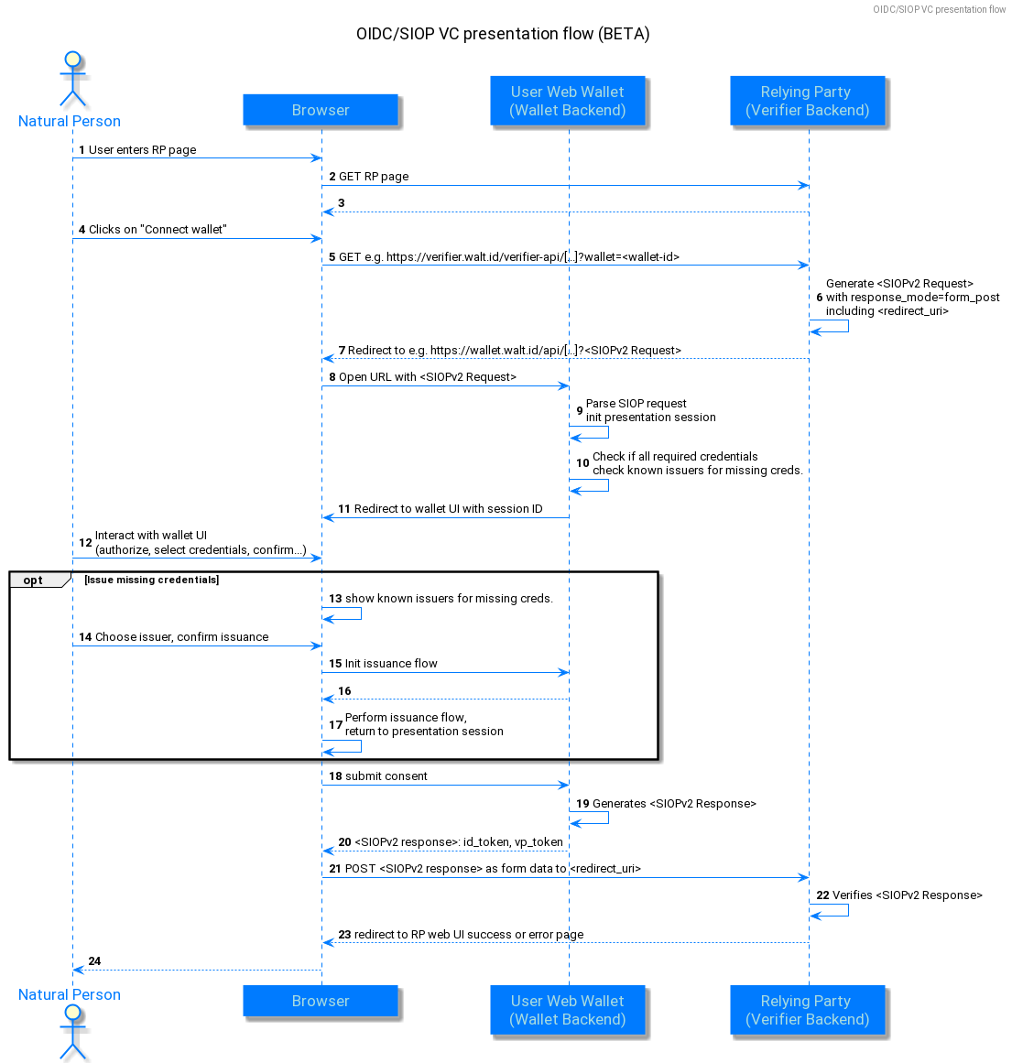
siop-vc-presentation.png

Issuance by Presentation
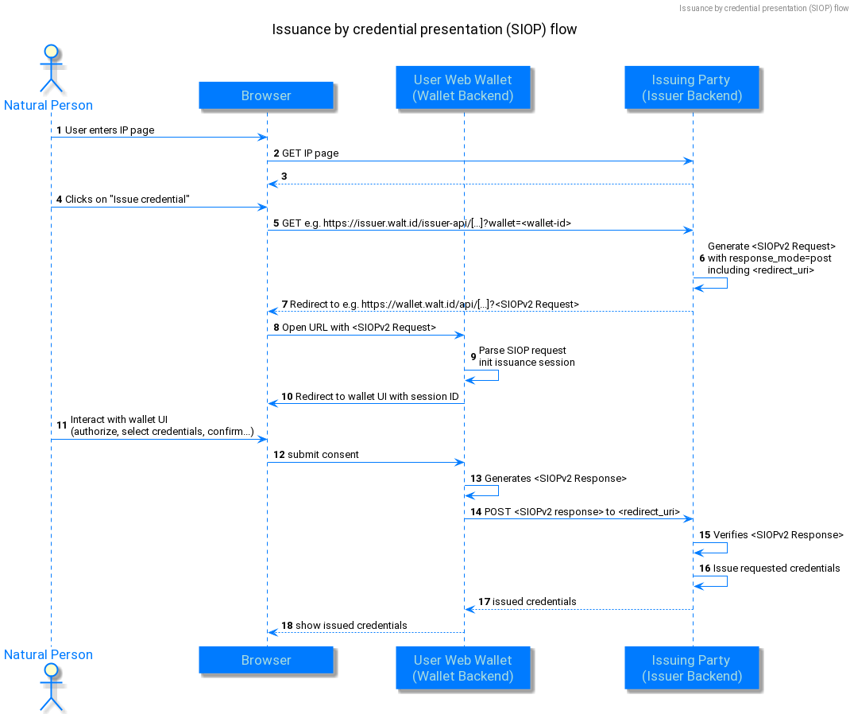
issuance-by-presentation.png

OIDC for Credential Issuance
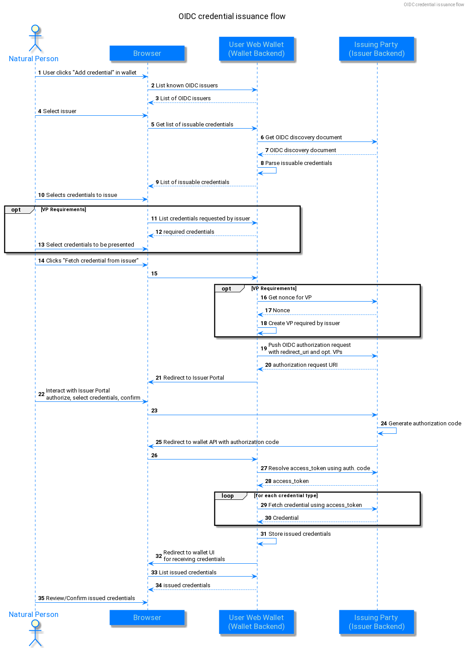
oidc-credential-issuance.png

