

Automotive Chaos Testing Framework
Proposal

Client Name

Proposal prepared by | Walter Capers
Contact email | wcapers64@gmail.com
Preparation date | November 10, 2025

Project Overview and Requirements

The Deterministic Stress and Reliability Testing Framework is a lightweight, command-line tool for stress-testing Android applications while monitoring their stability under randomized conditions. Unlike many commercial test frameworks that require complex setup, this solution is simple to deploy, easy to configure, and cross-platform.
The tool uses Android Debug Bridge (ADB) to communicate with an emulator or a physical Android device. It executes randomized system events—such as toggling Wi-Fi, clearing cache, or forcing low-memory conditions—while continuously monitoring the target application. Tests run for a set duration or until a crash, ANR, or hang occurs. When a failure is detected, the framework stops execution, logs diagnostics, and records the random seed used, allowing engineers to reproduce the failure exactly.
Test definitions are stored as JSON objects describing the scripts to run, the scripting engine to use (Bash, Python, or Windows batch), and rules for execution such as event frequency or order. This makes the framework flexible—new tests can be added or tuned by editing JSON files instead of code.
Existing tools such as MonkeyRunner, UIAutomator, Appium, and Android Monkey can perform similar tasks but introduce unnecessary complexity:
- MonkeyRunner requires Jython and provides limited process monitoring.
- UIAutomator needs full instrumentation builds and XML layout access.
- Appium depends on Node.js, Selenium, and driver layers that take hours to configure.
- Android Monkey is fast but non-deterministic and cannot reproduce event sequences.
This framework fills the gap between power and simplicity. It provides deterministic, JSON-driven stress testing that is reproducible, easy to maintain, and cost-effective—expected to cost under 3,000 total.

Resources and Costs

https://www.jetbrains.com/idea/download

https://developer.android.com/studio

https://developer.android.com/studio/command-line/adb

Amazon was used for other costs associated with hardware.

Schedule

Hourly break down:

Phase | Calendar Range | Active Effort (hrs) | Outcome
1. Requirements & Architecture Review | Completed prior to Nov 11 | 0 | Base design and technical approach finalized.
2. ADB Interface & Communication Tests | Nov 11 – Nov 17 | 3 | Tool connects to emulator/device; initial ADB command flow validated.
3. Randomization & Seed Logging Engine | Nov 18 – Nov 24 | 4 | Random event generator and seed persistence implemented.
4. JSON Parser & Rule Engine | Nov 25 – Dec 1 | 3 | JSON structures interpreted; scripts executed per defined rules.
5. Application Monitoring & Failure Detection | Dec 2 – Dec 8 | 4 | Continuous monitoring logic for ANRs, crashes, and hangs.
6. Logging & Report Generation | Dec 9 – Dec 12 | 2 | Log capture, test summary generation, and reproducibility data.
7. POC Demonstration Prep | Dec 13 – Dec 18 | 2 | Demo version packaged, tested, and documentation completed.
Total Active Development Effort | Through Dec 18, 2025 | ~18 hrs | POC completed and presented.
8. Extended Validation & Hardware Testing (Optional)** | Dec 19 – Jan 13, 2026 | ~2 hrs | Optional post-term testing and refinement.

Performance Measures and Quality Plan

Performance and quality will be tracked using measurable and repeatable indicators:
- Reproducibility Accuracy: 100% of failures must reproduce when the same JSON test definition and random seed are reused.
- Failure Detection Accuracy: ≥ 98% accurate detection of crashes, ANRs, or hang states.
- Execution Stability: The tool must sustain at least five hours of continuous operation without interruption.
- Data Security and Privacy: All logs and test results are stored locally and exclude sensitive data such as authentication tokens or user identifiers. A checksum verification method will ensure logs are not altered post-capture, maintaining data integrity.
- Configuration Flexibility: New test scenarios can be added through JSON without modifying the source code.
To evaluate financial performance, a Return on Investment (ROI) model is used to compare the one-time automation cost against the recurring cost of manual testing. Manual validation of stress conditions typically requires about 30 hours of QA effort per cycle, including setup, event execution, observation, and retesting. At an average labor rate of $50/hour, this results in approximately $1,500 per test cycle in manual testing cost.
The initial development cost of this proof of concept—including 20 hours of engineering labor at $89/hour and hardware expenses—is estimated at $2,343. While the first use of the tool reflects a negative ROI due to development startup costs, the model becomes cost-effective with reuse.
Manual vs. Automated Cost Comparison
Cost Category | Basis / Description | Estimated Cost (USD)
Manual Testing | 30 hrs × $50/hr per test cycle | $1,500 per cycle
Automation Development | 20 hrs × $89/hr + equipment | $2,154 (one-time)
Break-Even Point | Occurs after 2 test cycles | ROI ≈ 0%
ROI After 3+ Cycles | Reuse across 3 or more runs | ROI > 100%

$$ROI=\frac{(ManualTestingCost-AutomationToolCost)}{AutomationToolCost}×100$$
Because the development effort is a one-time investment, ROI becomes positive after the second test cycle and exceeds 100% by the third or fourth.
The chart below illustrates cumulative ROI progression across successive test runs.

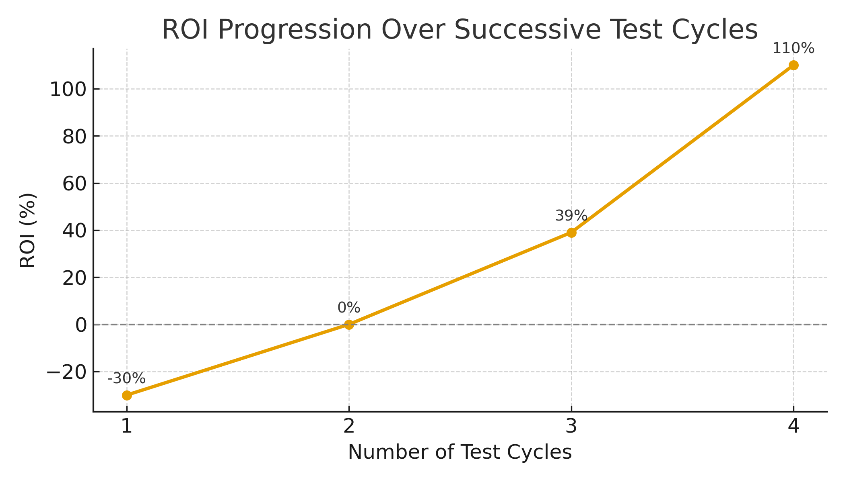
Figure 1, ROI Progression Over Successive Test Cycles
The graph shows how the framework’s ROI progresses with each successive test cycle. The first cycle shows a negative ROI due to one-time development costs. By the second cycle, the cost is fully recovered, reaching the break-even point. Beyond this, each reuse of the tool yields measurable labor savings. By the fourth cycle, the ROI exceeds 100%, demonstrating that the framework more than doubles its return relative to the original investment. This trend confirms that automation provides long-term cost efficiency and operational consistency compared to manual testing.
By automating repetitive stress testing and enabling deterministic replays, this framework reduces QA effort, shortens validation time, and provides measurable cost recovery over multiple cycles of use.

Risk Management Plan

Risk | Impact | Mitigation / Contingency | Level
Triple Constraint Shift (time/scope/cost) | Reduced MVP functionality or schedule delays | Prioritize completion of the core CLI and JSON-driven test execution before feature expansion | Medium
ADB Communication Loss | Interrupted tests or incomplete data capture | Implement retry logic, connection watchdogs, and session verification | High
Monitoring False Negatives | Missed detection of crashes or ANRs | Include process polling, event cross-validation, and log replay testing | Medium
Invalid JSON or Script Errors | Inconsistent test behavior or early termination | Validate JSON schema at load time and add structured error handling | Low
Data Security Exposure | Possible leakage of sensitive logs or device identifiers | Encrypt locally stored log files, restrict file access to the executing user, and remove personally identifiable information from captured data | Medium

