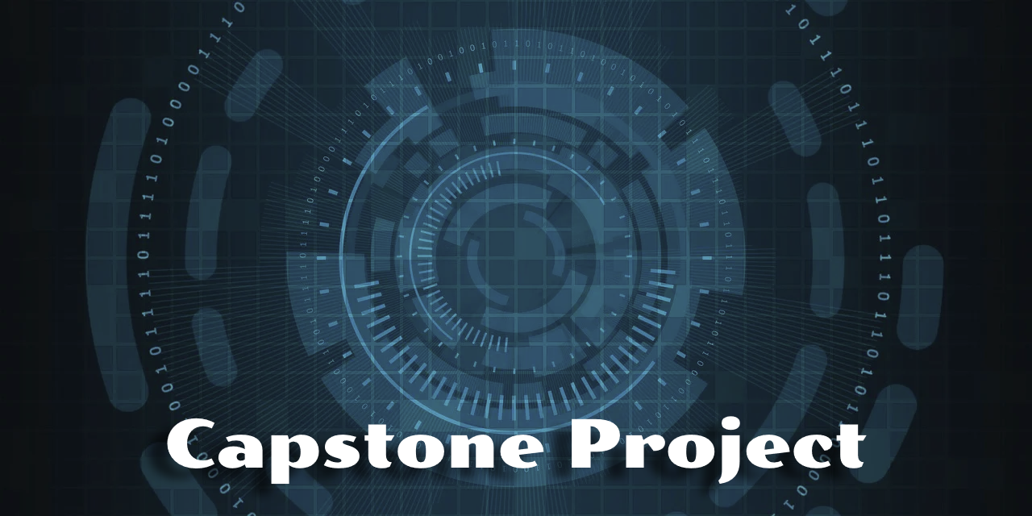

OrcaTestEngine – A Deterministic Orchestration Framework for Android Stress & Reliability Testing
Week 7 Updates

GM

Proposal prepared by | Walter Capers
Contact email | Wcapers64@gmail.com
Preparation date | December 10, 2025

Project Overview

Purpose
The OrcaTestEngine project was created to deliver a deterministic, script-driven stress-testing framework capable of executing randomized but fully reproducible sequences of system events against Android environments. The purpose was to provide a flexible and transparent tool that developers can use to discover stability issues earlier, reduce manual testing, and support repeatable automation workflows. A secondary purpose was to establish a foundation that could eventually extend into broader test ecosystems, including emulator-based CI pipelines and web-driven automation scenarios.
Scope, Goals, and Objectives
The scope of Orca encompassed the architecture, system inspector interfaces, JSON-based test specification loader, logger framework, deterministic event engine, and a mock mode to allow repeatable validation without requiring external hardware. The primary goals were to ensure fully reproducible executions through seed-based generation, simplify the onboarding of new test types, and decouple inspectors from the engine so that any platform-specific behavior could be replaced through factories. Key objectives included ensuring clear narrative output, extensibility, and support for long-running test scenarios without sacrificing determinism or clarity.
Risk Management
Risk management played a significant role in shaping the project. Several early risks centered on hardware availability and the potential exposure of proprietary or unreleased automotive systems. Because GM’s internal restrictions prohibit demonstrating or referencing non-public hardware, the risk strategy relied on isolating Orca from automotive dependencies by shifting to Android emulators. Additional risks included architectural gaps discovered during documentation, potential intellectual-property considerations around deterministic stress generation, and ensuring that no GM-restricted materials were included in the open-source repository. These risks guided a more modular and compartmentalized design.
Other Concerns
Additional concerns arose from the evolving nature of the project. Early assumptions about inspector behavior, test-state tracking, and edge-case handling required rework late in the design process. The need to build a narrative-level logger and a system for capturing both machine-readable and human-readable output required several redesigns. There were also ethical and professional concerns tied to releasing an open-source tool while ensuring it did not inadvertently reveal internal capabilities or suggest access to corporate-sensitive hardware. These concerns influenced the decision to include mock inspectors, safer configuration defaults, and improved documentation for reproducibility.

Accomplishments

Budget Performance
The project stayed within its expected budget because its primary resources were time, existing development tools, and open-source components. By avoiding commercial testing frameworks, cloud hardware costs, or proprietary simulation systems, the financial footprint remained minimal. GitHub served as the hosting location, Gradle and IntelliJ were already available to me, and mock-based testing avoided reliance on paid infrastructure. The only overruns involved additional hours needed to address gaps discovered during architecture reviews, but these did not translate into monetary overages.
Scheduling Performance
Scheduling performance was mixed. Early phases of the project progressed ahead of schedule due to the clarity of the initial architecture and the familiarity I already had with Kotlin and system-level tooling. However, delays emerged once deeper documentation uncovered architectural misalignments that required redesign, particularly around inspector abstraction, logging design, and deterministic behavior. Additionally, the shift away from automotive hardware—because of GM’s restrictions—required rethinking several dependencies, pushing certain milestones back. Despite those setbacks, the core deliverables for the capstone were completed within the overall program timeline.
Final Deliverables
The final deliverables include the OrcaTestEngine source code, system inspector interfaces, the mock system inspector used for testing, the narrative-level logger, the deterministic event-execution engine, a sample configuration, and supporting documentation. Together, these components demonstrate reproducible test execution, an extensible JSON schema for defining test scenarios, and a logging approach that captures both machine-readable events and clear human-readable narratives. The full project is hosted on GitHub, where the source code, sample assets, and documentation can be accessed: https://github.com/waltcapers/OrcaTestEngine. The repository includes installation instructions, usage examples, and a demonstration configuration to illustrate how deterministic stress scenarios are created and replayed. While the documentation is still being finalized, it will be completed by the end of the week. The final Git commit for this release will also be completed within that timeframe and will include all remaining source code updates. All documentation is located in the documentation folder of the project.

Lessons Learned

One of the most significant lessons learned was the impact of architectural gaps that emerged during documentation rather than during initial coding. Several assumptions about inspector responsibilities, event scheduling, and state transitions required late-stage revisions. Additionally, relying on GM hardware—even indirectly—posed legal and ethical risks because of restrictions on referencing pre-release systems. This forced a redesign around emulator-only environments, adding time and complexity but ultimately protecting the project. If I were to repeat this process, I would place earlier emphasis on validating documentation against architecture and confirming all environmental assumptions before committing to design decisions.
On the positive side, the modularity of Orca proved to be a major strength. Decoupling inspectors from the engine made it easier to adapt the project when hardware access constraints emerged. The deterministic structure of the engine also worked exceptionally well; seed-based reproducibility validated that tests could be re-run identically, which is a key differentiator for this type of tool. The narrative logger, though refined several times, ultimately produced a clear and useful output that enhances both debugging and reporting. These successes reinforce the value of modular design, early emphasis on reproducibility, and incremental refinement based on real-world constraints.

Recommendations for Future Projects

Future enhancements for Orca should focus on expanding the instruction set, improving visualization of execution flows, and integrating statistical analysis of failures across repeated runs. There is also strong potential for incorporating generative AI to propose likely failure scenarios, derive behavioral patterns from logs, or generate new stress scripts based on historical issues. Additionally, the architecture lends itself to extensions outside Android; with minimal adjustments, Orca could support browser-based automation frameworks, IoT simulation environments, or CI-driven stress pipelines across multiple platforms. These enhancements would allow it to evolve into a multi-domain testing ecosystem.
For similar future projects, I recommend validating assumptions early—especially those involving hardware, licensing, and organizational constraints. Architectural documentation should be treated as a living component and reviewed at every milestone to catch misalignments before they create downstream delays. It is also beneficial to design with modularity in mind from day one, since it makes pivoting far easier when requirements or risks shift. Finally, maintaining a clear narrative layer in logging or reporting dramatically improves communication with stakeholders, especially when explaining deterministic systems or replaying failure scenarios.

Github Repository

https://github.com/waltcapers/OrcaTestEngine

