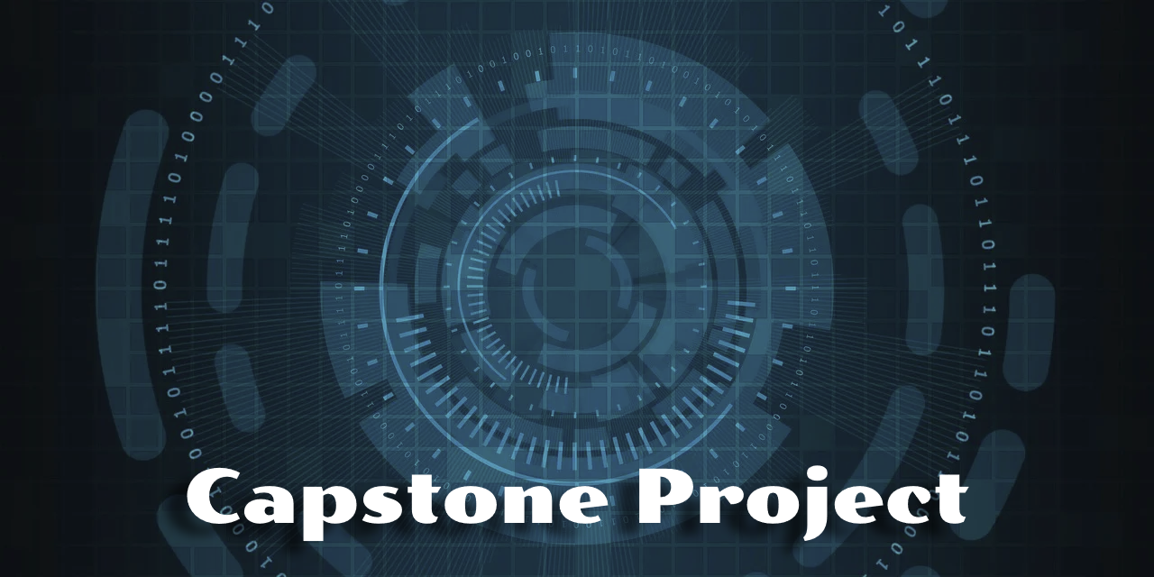

OrcaTestEngine – A Deterministic Orchestration Framework for Android Stress & Reliability Testing
Week 5 Updates

Client Name

Proposal prepared by | Walter Capers
Contact email | wcapers64@gmail.com
Preparation date | November 17, 2025

Scope Update

The scope of the OrcaTestEngine is consistent with the original design: a deterministic, JSON-driven stress testing framework capable of executing reproducible event sequences against Android applications via ADB. The system includes replay capabilities, reboot recovery, script-driven events, conditional triggers, and automated log collection. A modification to the scope occurred after General Motors requested that unreleased hardware and software not be used in academic work. To accommodate this, the project will incorporate a lightweight, purposely flawed sample Android application for testing. This adjustment does not change the architectural goals but may introduce minor delays during week 8.

Costs Update

There are no changes to project costs at this time. OrcaTestEngine continues to operate without external licensing requirements and relies on free, developer-standard tools such as Android Studio, ADB, Kotlin, and IntelliJ (community edition). No commercial software or cloud services have been added. Future costs may arise if the scope expands to include automated device farms, CI-based load testing, or commercial profiling tools. These would be optional enhancements rather than core requirements.

Schedule Update

Below is the updated timeline covering completed milestones an upcoming work for the remaining weeks. Progress has been fairly steady with most of the foundational architecture completed, including the deterministic engine, reboot recovery, script pipeline, and the logging system. The remaining work focuses on system integration (ADB inspector), Script-Runner consolidation, metrics subsystem development, documentation, a flawed Android application, and preparation for final delivery.

Week & Dates | Status | Milestone / Deliverable | Notes
Week 1 — Oct 5–11 | Completed | Project kickoff, initial objectives defined | Core purpose established, JSON-driven configuration approach selected.
Week 2 — Oct 12–18 | Completed | Base model layer | Implemented StressEvent, RetryPolicy, Preconditions, and related enums.
Week 3 — Oct 19–25 | Completed | Engine architecture | Deterministic RNG, event selection, retry logic, state machine, summary system.
Week 4 — Oct 26–Nov 1 | Completed | Script execution system | Multi-language handlers (Shell, Python, Node, Batch, PowerShell, Ruby).
Week 5 — Nov 2–8 | Completed | Replay system, reboot recovery, logcat management | Added replay_state.json, reboot detection, crash monitoring, and summary reporting.
Week 6 — Nov 9–15 | In Progress | ScriptRunner unification + ADB SystemInspector + Metrics subsystem | First major integration milestone.
Week 7 — Nov 16–22 | Upcoming | CLI wrapper, JSON validation, examples | Prepare user workflow; add schema validation.
Week 8 — Nov 23–29 | Upcoming | Documentation + Visio diagrams + Sample flawed Android app | Required due to GM’s restriction on emulator usage. May introduce delays.
Week 9 — Nov 30–Dec 6 | Upcoming | Testing, stability improvements, integration refinements | End-to-end test pass, process checks, metric accuracy validation.
Week 10 — Dec 7–14 | Upcoming | Final packaging and capstone submission | Produce final deliverables, final repo cleanup, and walkthrough documentation.

Legal, Ethical, Social, and Global Implications

- Legal Concern: The system was originally planned to run against unreleased GM applications and emulators. GM later determined this posed a risk of exposing confidential hardware or software. To avoid legal/IP violations, a custom sample app will now be used. Established a dual-license agreement that provides General Motors with unrestricted rights while imposing stricter limitations on all non-GM users. The dual-license structure introduces legal considerations around license enforcement and compliance tracking.
- Ethical Concern: Automated stress testing can reduce human oversight, raising ethical concerns about unintended errors being overlooked or misinterpreted due to over-reliance on automation.
- Social Concern: Introducing a highly automated tool may shift testing responsibilities and impact team roles, requiring retraining and carful communication to avoid workflow disruptions.
- Global Concern: International Android builds may impose different restrictions on ADB access, logcat visibility, and debugging interfaces. In addition, any log data produced by the tool may fall under GDPR or other regional privacy regulations when used outside the United States. These laws cover information that can directly or indirectly identify a person—such as IP addresses, usernames, email addresses, device identifiers (including vehicle VINs), location data, phone numbers, and account IDs. General Motors enforces strict privacy controls on its infotainment and mobile solutions, so log handling must comply with these requirements when the tool is used in global environments.

Communication

This letter provides an update on the OrcaTestEngine project, a deterministic framework built to stress-test Android applications and evaluate their stability under controlled conditions. I am sending this to keep all stakeholders informed of where the project stands and what remains ahead. Most of the core foundation is already in place, including the engine structure, script execution pipeline, replay logic, and reboot-handling workflow. The next phase will focus on integrating full ADB-based device support, adding documentation, and completing final validation. The project remains on track and is expected to be finished by the end of the term on December 14.

Diagram(s)

Content here

Additional Proof of Progress

https://github.com/waltcapers/OrcaTestEngine

