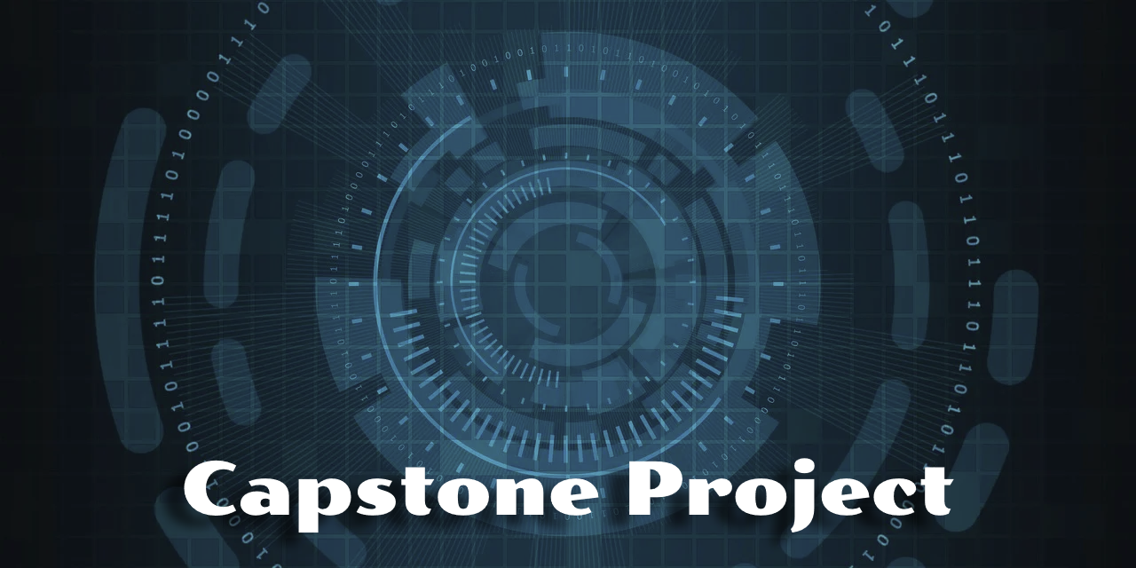

OrcaTestEngine – A Deterministic Orchestration Framework for Android Stress & Reliability Testing
Week 7 Updates

GM

Proposal prepared by | Walter Capers
Contact email | Wcapers64@gmail.com
Preparation date | November 17, 2025

Scope Update

The scope of the OrcaTestEngine remains aligned with the original goal of delivering a deterministic, JSON-driven stress-testing framework capable of orchestrating reproducible event sequences against Android applications. Since Unit 5, the only scope refinement involves addressing several functional gaps discovered during documentation work. These include enhanced logging for clearer execution tracing and additional configuration flexibility for defining tests. These refinements strengthen the framework’s long-term usability without expanding the project beyond its planned boundaries.

Costs Update

There are no cost changes at this stage. The OrcaTestEngine continues to rely entirely on free and commonly available development tools such as Android Studio, Kotlin, ADB, and GitHub. No commercial dependencies or paid services have been introduced. While the current project scope requires no new expenditures, optional post-project enhancements—such as automated device-farm execution, CI-based stress pipelines, or commercial telemetry suites—could introduce additional costs if future expansion is approved.

Schedule Update

Progress during this period focused on stabilizing the core engine and addressing functionality gaps found during schema documentation. Logging improvements, configuration-model adjustments, and the CLI workflow were completed. Integration of full ADB-based device support begins next, along with test validation and documentation. The project remains on schedule for completion by December 14. Full milestone details appear in the accompanying schedule table, including tasks marked as completed through Week 7 and upcoming work planned for Weeks 8–10.

Week & Dates | Status | Milestone / Deliverable | Notes
Week 1 — Oct 5–11 | Completed | Project kickoff, initial objectives defined | Core purpose established, JSON-driven configuration approach selected.
Week 2 — Oct 12–18 | Completed | Base model layer | Implemented StressEvent, RetryPolicy, Preconditions, and related enums.
Week 3 — Oct 19–25 | Completed | Engine architecture | Deterministic RNG, event selection, retry logic, state machine, summary system.
Week 4 — Oct 26–Nov 1 | Completed | Script execution system | Multi-language handlers (Shell, Python, Node, Batch, PowerShell, Ruby).
Week 5 — Nov 2–8 | Completed | Replay system, reboot recovery, logcat management | Added replay_state.json, reboot detection, crash monitoring, and summary reporting.
Week 6 — Nov 9–15 | Completed | ScriptRunner unification + ADB SystemInspector + Metrics subsystem | First major integration milestone.
Week 7 — Nov 16–22 | Completed | CLI wrapper, JSON validation, examples | Prepare user workflow; add schema validation.
Week 8 — Nov 23–29 | Dropped due to timing | Documentation + Visio diagrams + Sample flawed Android app | Required due to GM’s restriction on emulator usage. May introduce delays. There is insufficient time to develop a sample Android application, instead I am able to mock the interactions.
Week 9 — Nov 30–Dec 6 | In progress | Testing, stability improvements, integration refinements | End-to-end test pass, process checks, metric accuracy validation.
Week 10 — Dec 7–14 | Upcoming | Final packaging and capstone submission | Produce final deliverables, final repo cleanup, and walkthrough documentation. (Ended up having to mock the Android interface due to time constraints

Legal, Ethical, Social, and Global Mitigations

Legal Concern:
Use of unreleased GM software originally posed intellectual-property and confidentiality risks.
Mitigation: Shift execution to a controlled, generic sample application and apply the dual-license structure restricting all non-GM use while granting GM unrestricted rights.
Ethical Concern:
Automation may lead to over-reliance on tool output, increasing the risk of misinterpreting system failures.
Mitigation: Require human review of stress logs, enforce validation checkpoints, and document tool limitations clearly for end-users.
Social Concern:
Automated stress tools may reshape team responsibilities and require retraining.
Mitigation: Provide user-friendly documentation, training guidance, and phased transition recommendations to support successful adoption.
Global Concern:
ADB behavior, log visibility, and privacy regulations (e.g., GDPR) differ across regions and may restrict data captured by the tool.
Mitigation: Ensure logs are anonymized, document region-specific ADB constraints, and require compliance with local data-handling policies before tool deployment.

Responsibilities

Work on the OrcaTestEngine continues to advance steadily. The deterministic engine, script execution pipeline, replay logic, logging system, and reboot-handling workflow are all operational. Recent improvements include enhanced logging clarity, adjustments to the test-configuration schema, and a refined command-line interface. ADB-level device interaction is actively being integrated. Due to time constraints and GM’s restrictions on unreleased hardware, interactions with Android systems are currently mocked, but the structure allows seamless replacement with live interfaces. Final validation, documentation, and packaging will be completed in the remaining project weeks. Additional progress is visible in the project repository at:

Proof of Progress

Content here:
https://github.com/waltcapers/OrcaTestEngine

