Nodebucket

TECHNICAL DESIGN DOCUMENT

|  |  |
| --- | --- |
| **Author** | Walter McCue |
| **Last Updated** | 3/21/2023 12:21 AM |
| **Version Number** | 3.0.1 |

**Version History**

|  |  |  |  |
| --- | --- | --- | --- |
| Name | Date | Reason for Change | Version |
| Krasso, Richard | 10/17/2019 | New document format | 3.0.0 |
| McCue, Walter | 03/19/2023 | Web-450 Week 1 Update | 3.0.1 |
|  |  |  |  |
|  |  |  |  |
|  |  |  |  |
|  |  |  |  |
|  |  |  |  |
|  |  |  |  |
|  |  |  |  |
|  |  |  |  |

Table of Contents

SECTION 1: INTRODUCTION 3

1.1. Purpose 3

1.2. Terminology 4

1.3. User Personas 5

1.4. User Stories 7

1.5. Time Estimations 8

SECTION 2: PROCESS DESIGN 9

2.1. Prototypes 9

2.2. ORD (Object Relational Diagram(s) 14

2.3. NoSQL Document Diagram 15

2.4. NoSQL Data Structure 16

SECTION 3: QA TESTING 17

3.1. QA Test Plan 17

3.2. Unit Tests 18

SECTION 4: REFERENCES 19

# SECTION 1: INTRODUCTION

## Purpose

The purpose of the nodebucket project is to allow authorized users the ability to create a to-do list, modify the list, move items to a done category, or delete items from the lists altogether. The chosen theme will be represented by the Hufflepuff House from the Harry Potter series. The application will be built using multiple technologies such as MongoDB, Angular, Node, and a few others. This document outlines the specific technologies used in table 1.2. This document also outlines the types of users we expect to use this application and the development schedule over the coming weeks.

## Terminology

|  |  |
| --- | --- |
| **Name** | **Comments** |
| MEAN Stack | MongoDB, Express, Angular, and Node.js |
| VS Code | Development IDE |
| SoapUI | API testing tool |
| MongoDB Compass | Database development IDE |
| Angular Material | <https://material.angular.io/> |
| Flex-layout | <https://github.com/angular/flex-layout> |
| primeNG | https://www.primefaces.org/primeng/#/ |
| Courses GitHub repository | https://github.com/buwebdev |
| Slack | Collaboration |
| Zoom | Virtual meetings |
| Trello | Task management software |
| OneDrive | Document sharing |
| GitHub | Source control |
| Blackboard | LMS (Learning Management System) |
| Office 365 | Email client |
| Git training | https://www.atlassian.com/git/tutorials/comparing-workflows/gitflow-workflow |
| Regular expression cheat sheet | http://web.mit.edu/hackl/www/lab/turkshop/slides/regex-cheatsheet.pdf |
| Regular express training | https://regexr.com/ |

## User Personas

# Persona 1: Rebecca Turner

## Age: 31

## Gender: F

## Job Title: Accountant

## Marital Status: S

## Short Bio: Rebecca is a full-time accountant and has very poor organizational skills. She currently relies on hundreds of sticky notes plastered all over her work space to remind her of tasks, deadlines, and client callbacks. While she does have a method to her madness it is complete an udder chaos to everyone else, including her secretary. As such, when she meets in person with a client, she typically schedules a meeting at a nearby coffee shop. Moving from her office to the coffee shop and back throughout the day is not an efficient workflow. The nodebucket application would provide her a secure way to organize tasks and help remove her dependency on sticky notes. Then she could begin holding meetings in her office without losing time traveling back and forth a few times a day.

# Persona 2: Marge Simpson

## Age: 42

## Gender: F

## Job Title: Housewife

## Marital Status: M

## Short Bio: Marge is a stay-at-home wife and mother to three beautiful children. She does all the cooking, cleaning, and caretaking around the house so her husband can provide financially for their needs. She has the overall schedule memorized for when her husband leaves for work and when the two elementary aged children leave for school. What she needs is a way to set up a list of chores and tasks to be done throughout the week, prioritizing bigger tasks when she has alone time with the baby. She would like some way to delegate tasks to her husband and children too, but the important features are the ability to create and update tasks as needed.

# Persona 3: Michael Dickerson

## Age: 41

## Gender: M

## Job Title: Crypto Trader

## Marital Status: Divorced

## Short Bio: Michael lives in a persistent state of high-level-stress and perceives almost everything as a threat against him in some way, including his mother as he lives in her basement. His only means of decompression is smoking marijuana and trading cryptocurrency. He has an entire room dedicated to mining cryptocurrencies as well as his main workstation that is used to make larger trades and move different parts of his operation around. He believes that his bank and the authorities are trying to shut down his operation and take his hard-earned virtual currency away from him. He would like an application such as nodebucket to help him securely manage a list of tasks that he has to complete on a daily and hourly basis. He wants to be able to log out so if he was to ever leave his workstation unlocked, his mother would not be able to walk in and see how he manages his operation.

## User Stories

**Rebecca Turner**

|  |  |
| --- | --- |
| Story | Points |
| As an accountant, I need to see a to-do list to prioritize my time | 3 |
| As an accountant, I need to be able to delete tasks if the client cancels | 1 |
| As an accountant, I need to make a list of financial products to buy, so that I can increase my client net worth | 3 |
| As an accountant I need the ability to log in to see my to-do list to keep them secure | 5 |
| As an accountant I need this to-do list for my team to stay on track | 3 |

**Marge Simpson**

|  |  |
| --- | --- |
| Story | Points |
| As a housewife, I need to access the application on a mobile device so I can manage my list on the go | 5 |
| As a housewife I need to be able to move my done to-do items to a done column so I can see what I've accomplished | 3 |
| As a housewife, I need a to do list to get chores done around the house, so they are all completed on time | 3 |
| As a housewife, I need my husband to see the updated list, so he doesn't forget to-do things | 3 |
| As a housewife, I need a to-do list so my children can do their chores. | 3 |

**Michael Dickerson**

|  |  |
| --- | --- |
| Story | Points |
| As a crypto trader, I need to be able to reorganize my to-do list to I can see what is more important to me. | 5 |
| As a crypto trader, I need to be able to log in, so my trading to-do list is secure | 5 |
| As a crypto trader I need to see what is done, so I can keep track of my clients | 3 |
| As a crypto trader, I need to bold important items, so I don't forget to trade crypto | 1 |
| As a crypto trader, I need to sign-out, so my information is secure. | 3 |

## Time Estimations

Development for the nodebucket project is expected to take 5 weeks.

**Week 1:** Planning, Prototyping, and initial project set-up.

**Week 2:** Sprint 1 [ Ord structure, MongoDB set-up, API set-up, log-in feature, log-out feature, UI set-up]

**Week 3:** Sprint 2 [ API refining, to-do feature set-up, UI refining ]

**Week 4:** Sprint 3 [ API finalization, to-do feature refining, UI finalization ]

**Week 5:** Testing, Deployment, Deliverable

**Backlog:** Additional features if time allows [ Mobile Friendly, !important items listed in bold ]

# SECTION 2: PROCESS DESIGN

## 2.1. Prototypes

<https://marvelapp.com/prototype/878c2j0>

1. Log In Screen
2. Log In Error
3. Home Screen (shows added tasks)
4. Tasks moved around
5. Delete Task
6. About
7. Contact
8. Sign Out
9. 404 Error

## 2.2. ORD (Object Relational Diagram(s)

## 2.3. NoSQL Document Diagram

N/A

## 2.4. NoSQL Data Structure

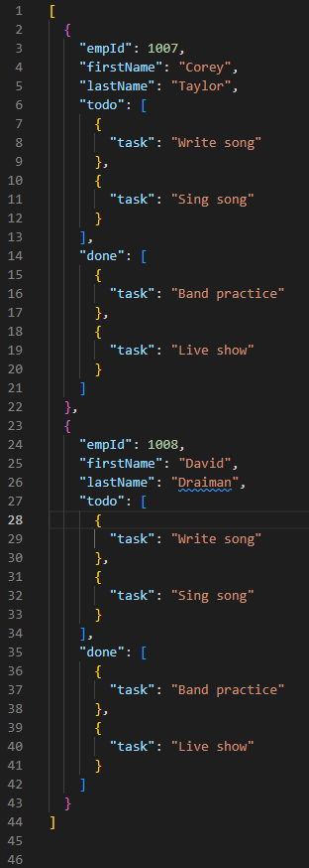

# SECTION 3: QA TESTING

## 3.1. QA Test Plan

[Weekly Test Cases]

## 3.2. Unit Tests

# SECTION 4: REFERENCES

[APA Reference List]