SBB-Uhr
QR-Codes
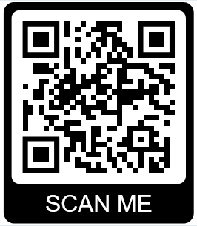
SBB-Uhr-01
http://SBB-Uhr-01:5001/

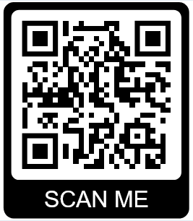
SBB-Uhr-02
http://SBB-Uhr-02:5001/

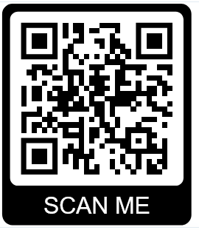
SBB-Uhr-03
http://SBB-Uhr-03:5001/

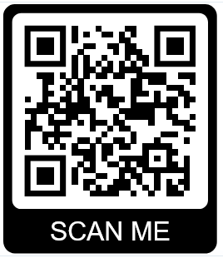
SBB-Uhr-04
http://SBB-Uhr-04:5001/
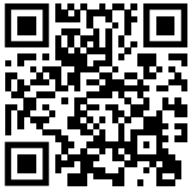
SBB-Uhr-07
http://SBB-Uhr-07:5001/

Pin-Belegung

