**Aufgaben-Sammlung**

JOINS

Last Changes: Walter Rothlin / Dec, 24th 2019

F:\_Daten\Hochschule Zurich\Meine_SlideSammlung_Golden_Source\Aufgabensammlung_DB-Join_yyyy_mm_dd.docx

## Joins

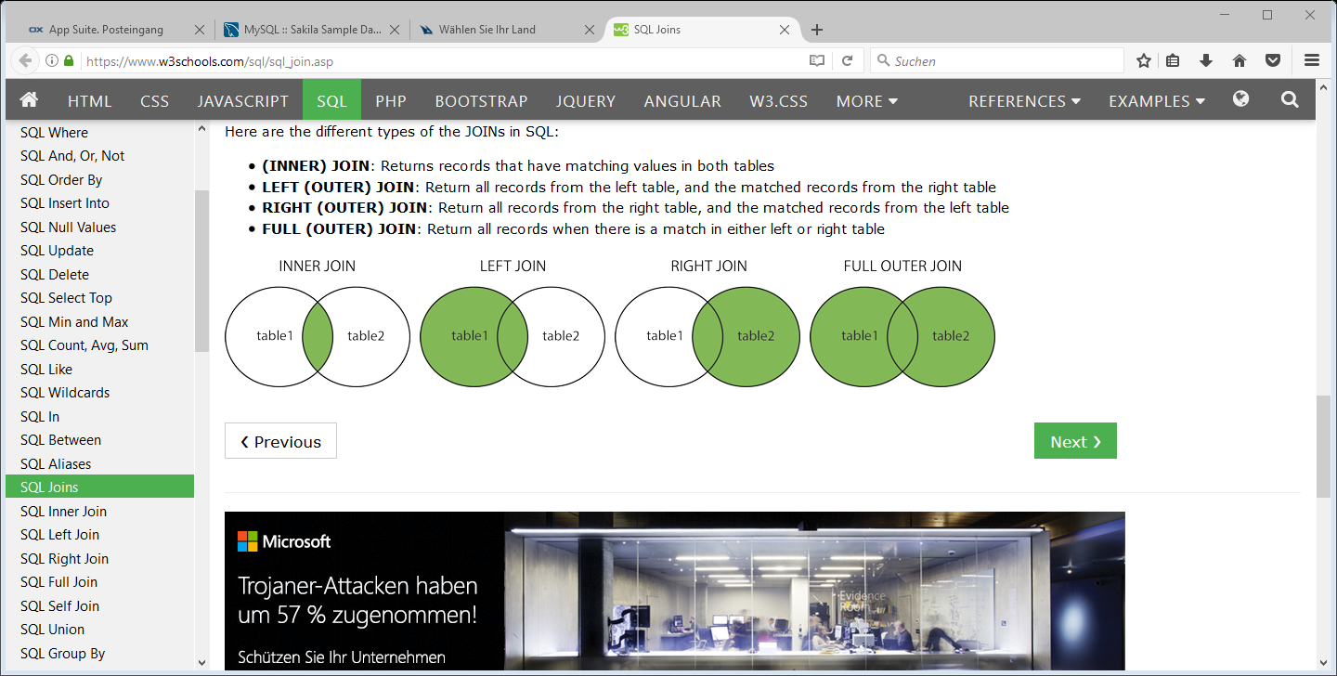

-- Inner join

-- ========

select

table1.field_1,

table2.field_3

from

table1

inner join table2 on table1.fk = table2.pk

-- left outr join

-- ==========

select

table1.field_1,

table2.field_3

from

table1

left join table2 on table1.fk = table2.pk

-- right outr join

-- ===========

select

table1.field_1,

table2.field_3

from

table1

rigth join table2 on table1.fk = table2.pk