**Aufgaben-Sammlung**

MySql / Databases

DDL (ERD 🡪 Create / Drop..)

Last Changes: Walter Rothlin / Dec, 24th 2019

F:\_Daten\Hochschule Zurich\Meine_SlideSammlung_Golden_Source\Aufgabensammlung_DB_ERD_DDL_yyyy_mm_dd.docx

Index

DDL (Data Definition Language) 3

Create a model (ERD) 3

Draw a model (ERD) 4

Bedeutung der Konstraints 4

Generate script from ERD-Model 5

Use script to create DB Objects 6

Attribute-Types 7

# DDL (Data Definition Language)

## Create a model (ERD)

In Workbench: File 🡪 New Model

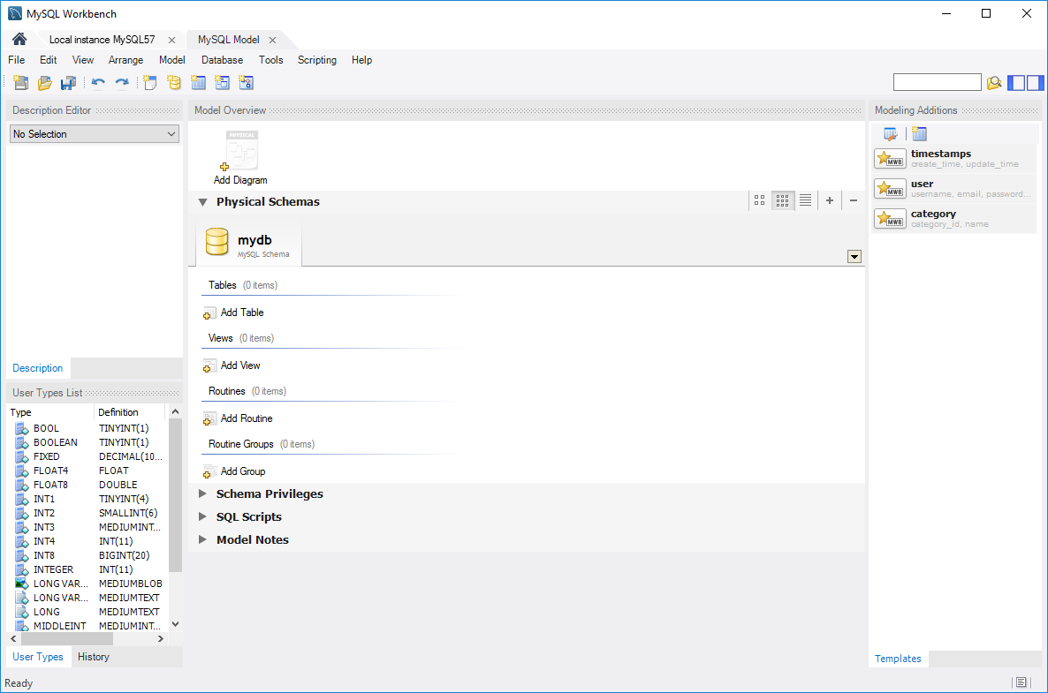

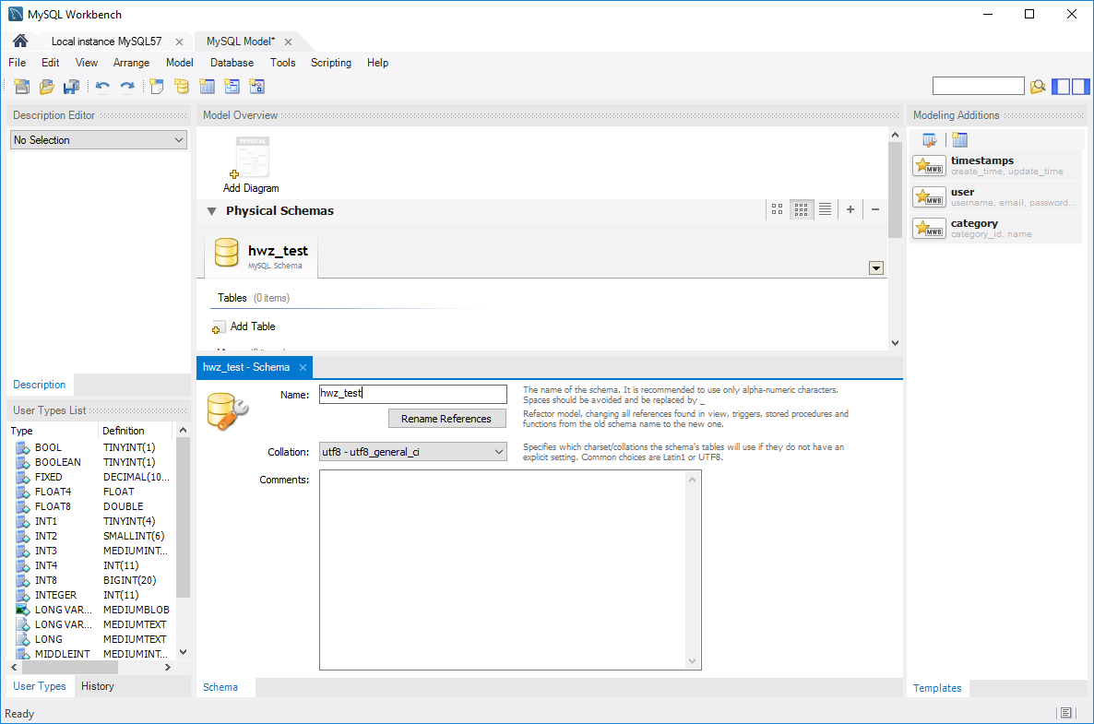

hwz-test

## Draw a model (ERD)

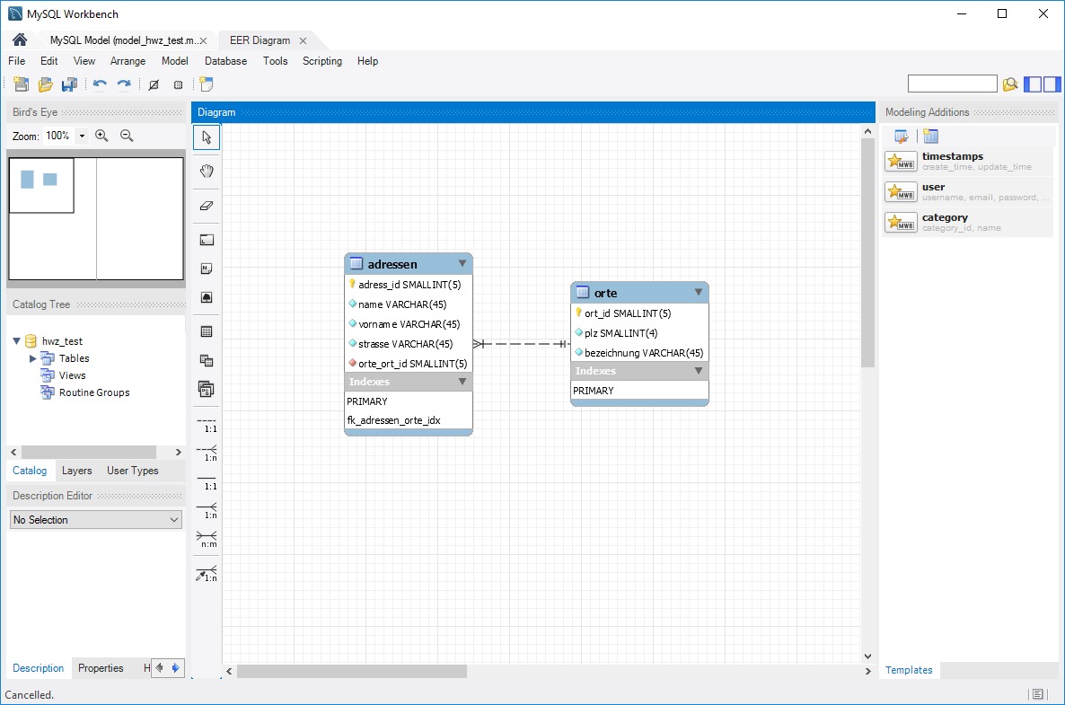

Doppel-Click **adressen**:

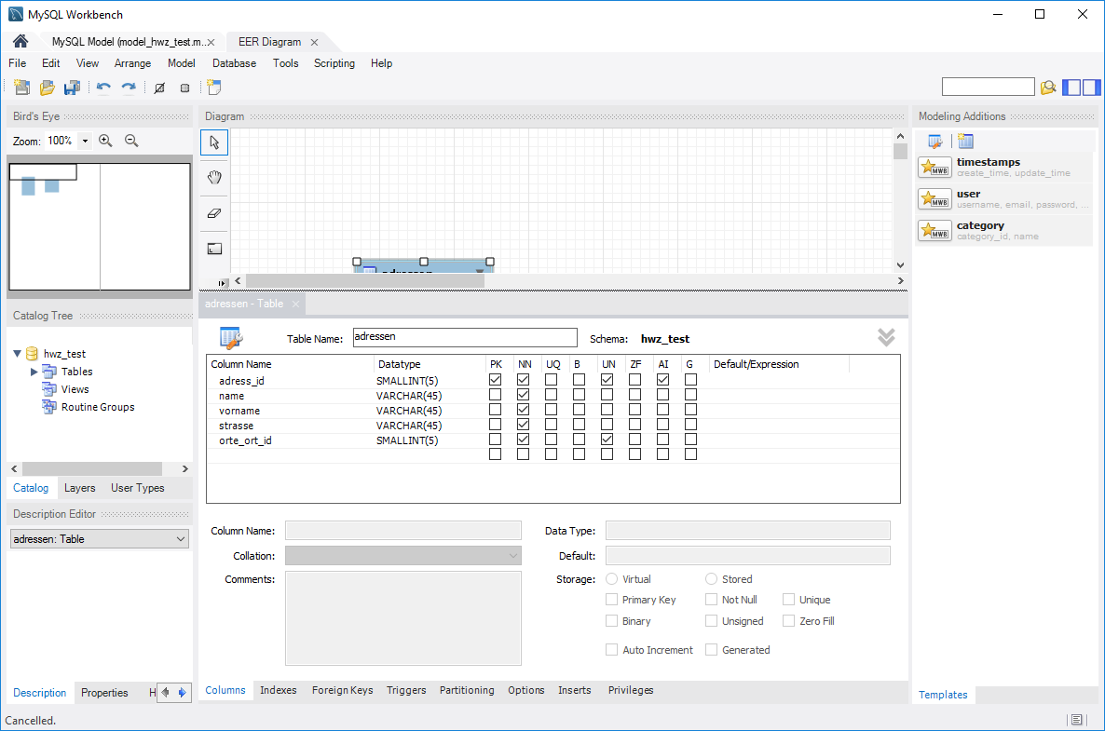

Doppel-Click **orte**:

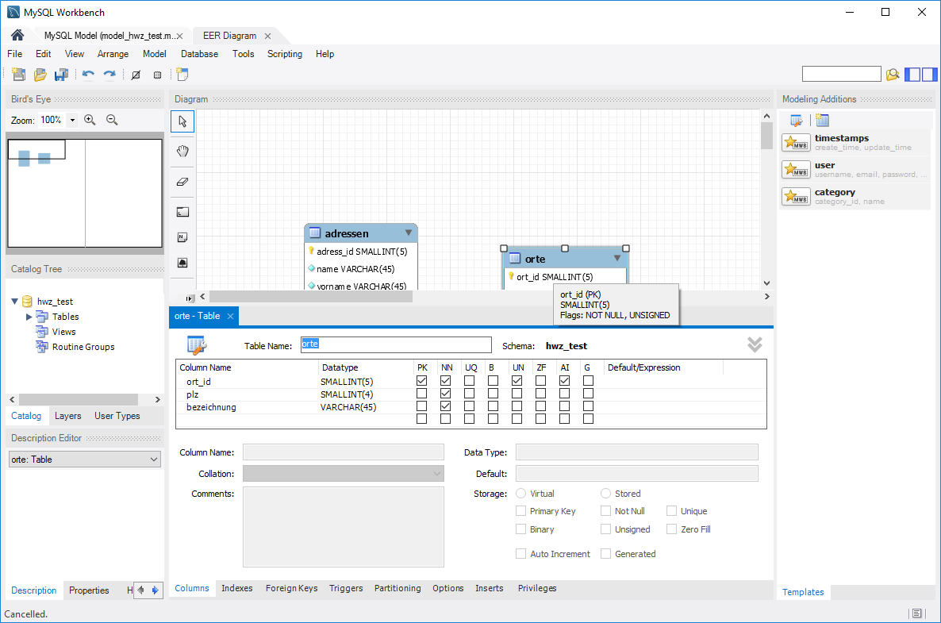

File 🡪 Save Model As…. Model_hwz_test

## Bedeutung der Konstraints

|  |  |
| --- | --- |
| PK | Primary Key |
| NN | NOT NULL |
| UQ | Unique |
| B | Binary Data |
| UN | Unsigned |
| ZF | Zero Fill (Default O falls Numeric) |
| AI | Auto Increment |
| G | Generated |

## Generate script from ERD-Model

File 🡪 Export 🡪 Forward Engineer SQL…

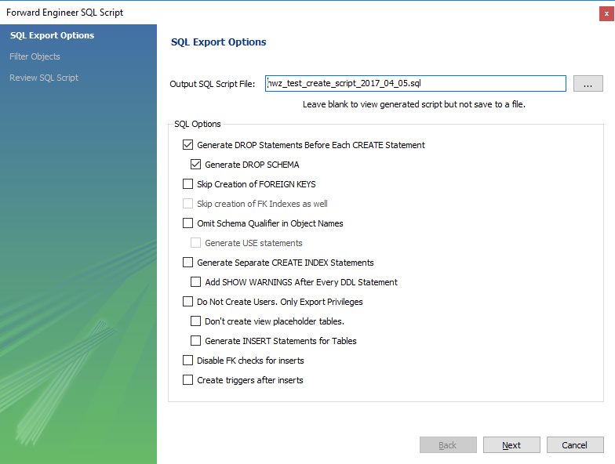

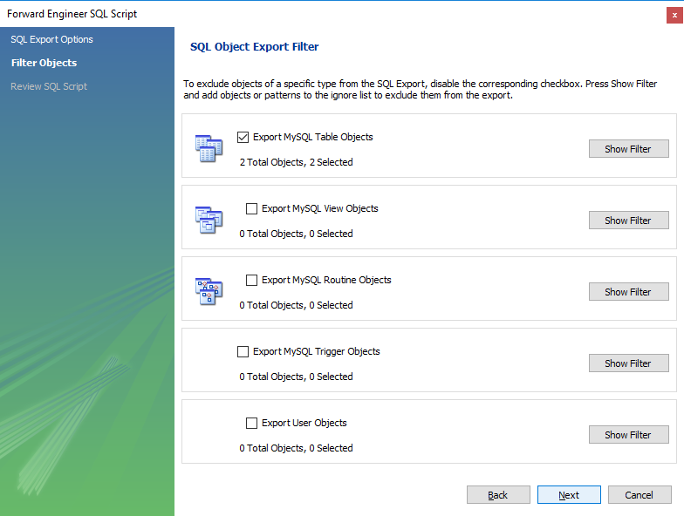

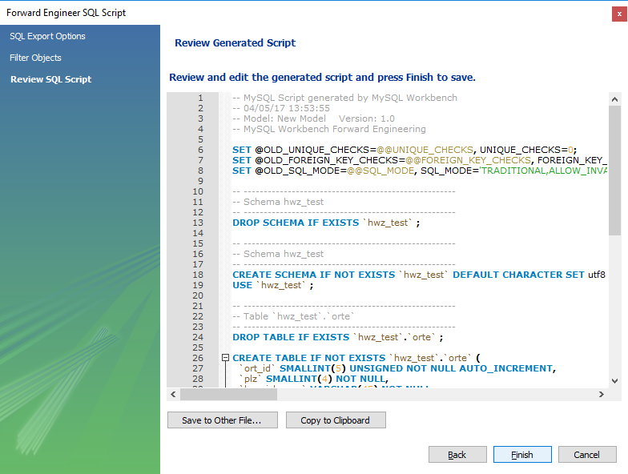

## Use script to create DB Objects

File 🡪 Open SQL script

Execute script and refresh schema view

## Attribute-Types

