**Aufgaben-Sammlung**

MySql / Databases

DDL (Create / Drop..)

Last Changes: Walter Rothlin / April, 5th 2017

F:\_Daten\Hochschule Zurich\Meine_SlideSammlung_Golden_Source\Aufgabensammlung_DB_yyyy_mm_dd.docx

Index

DDL (Data Definition Language) 3

Create a model (ERD) 3

Draw a model (ERD) 4

Generate script from ERD-Model 5

Use script to create DB Objects 6

Attribute-Types 7

# DDL (Data Definition Language)

## Create a model (ERD)

In Workbench: File 🡪 New Model

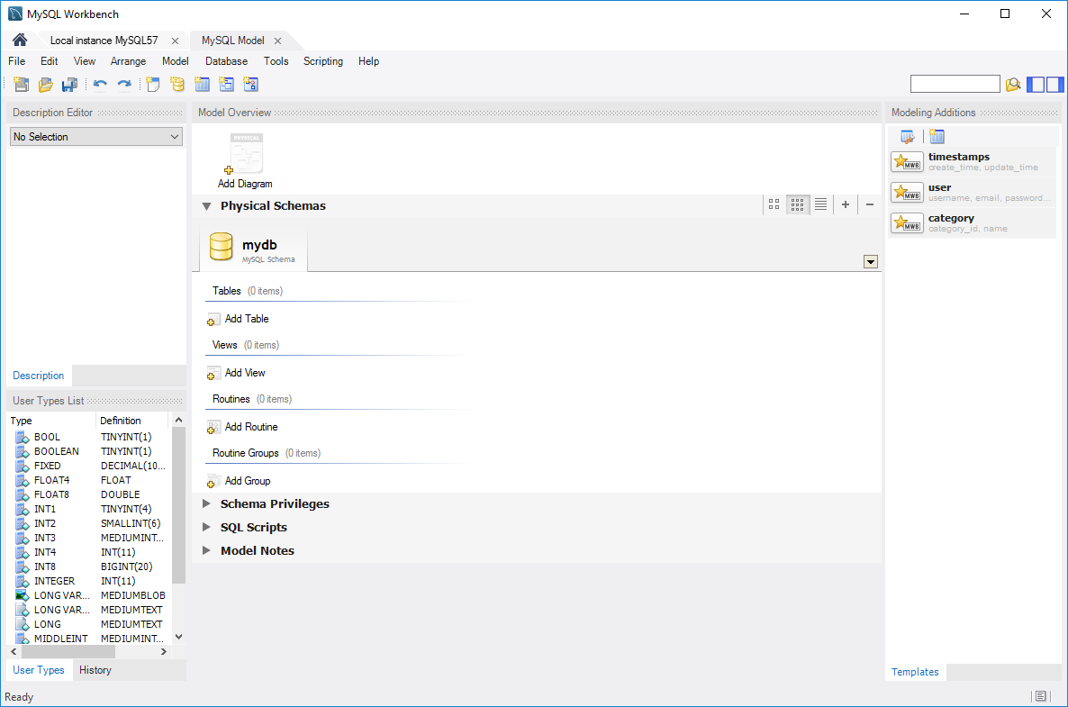

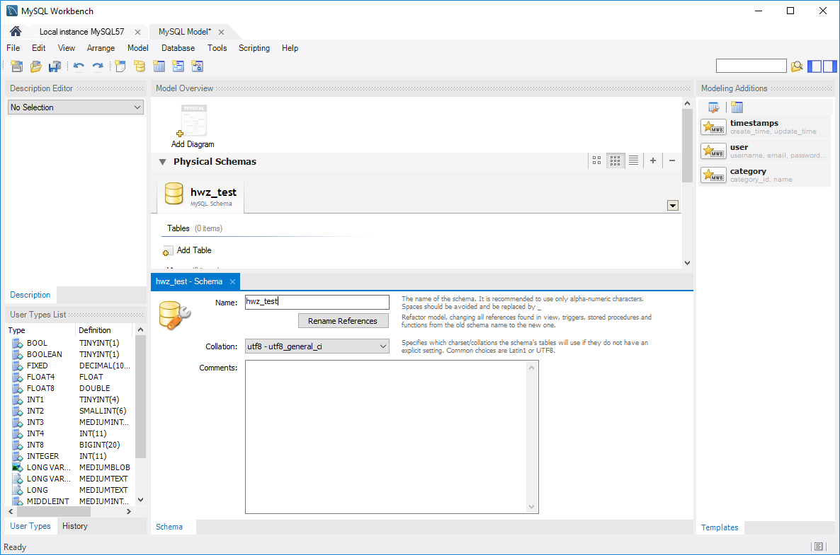

hwz-test

## Draw a model (ERD)

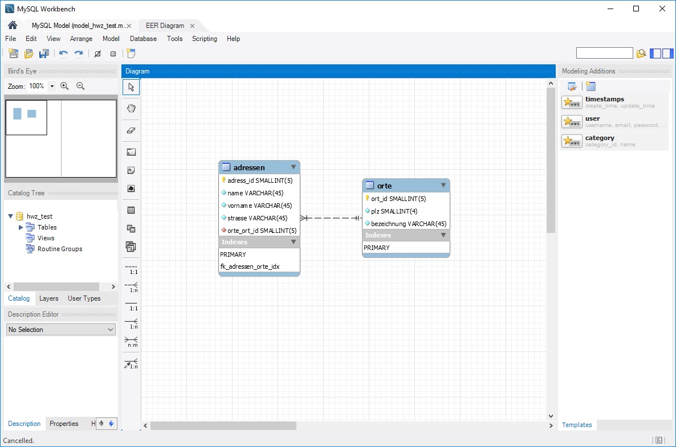

Doppel-Click **adressen**:

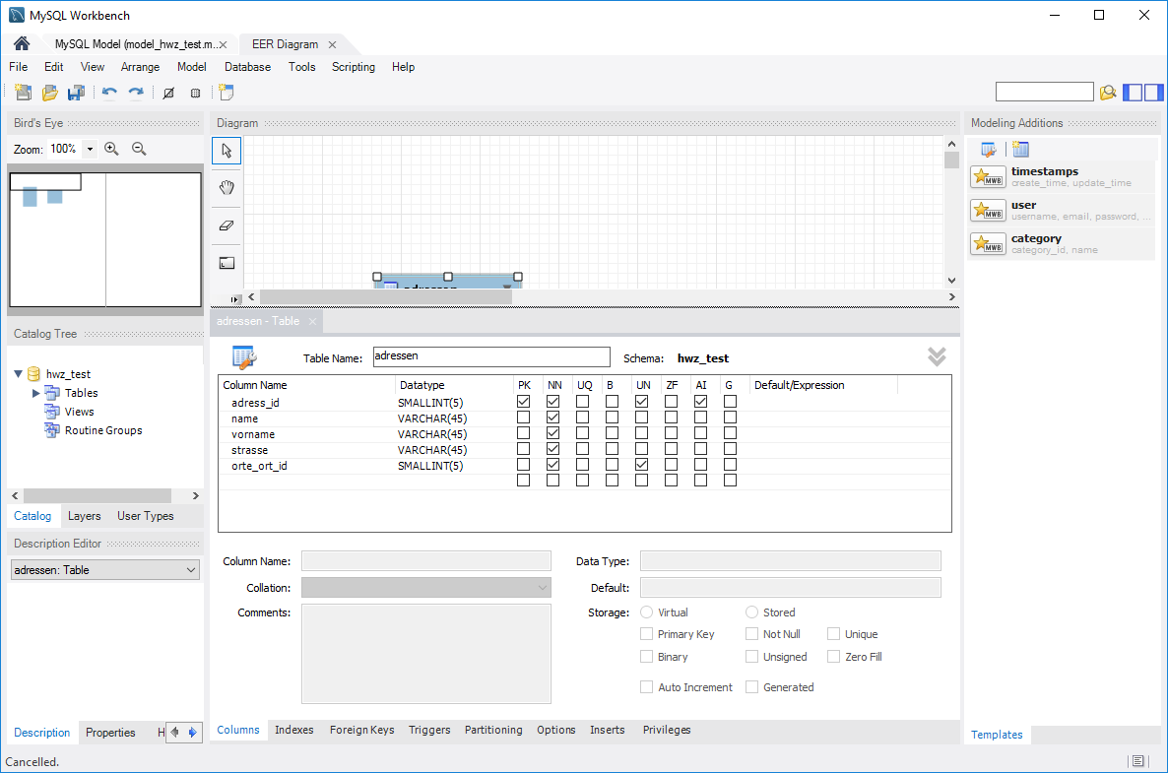

Doppel-Click **orte**:

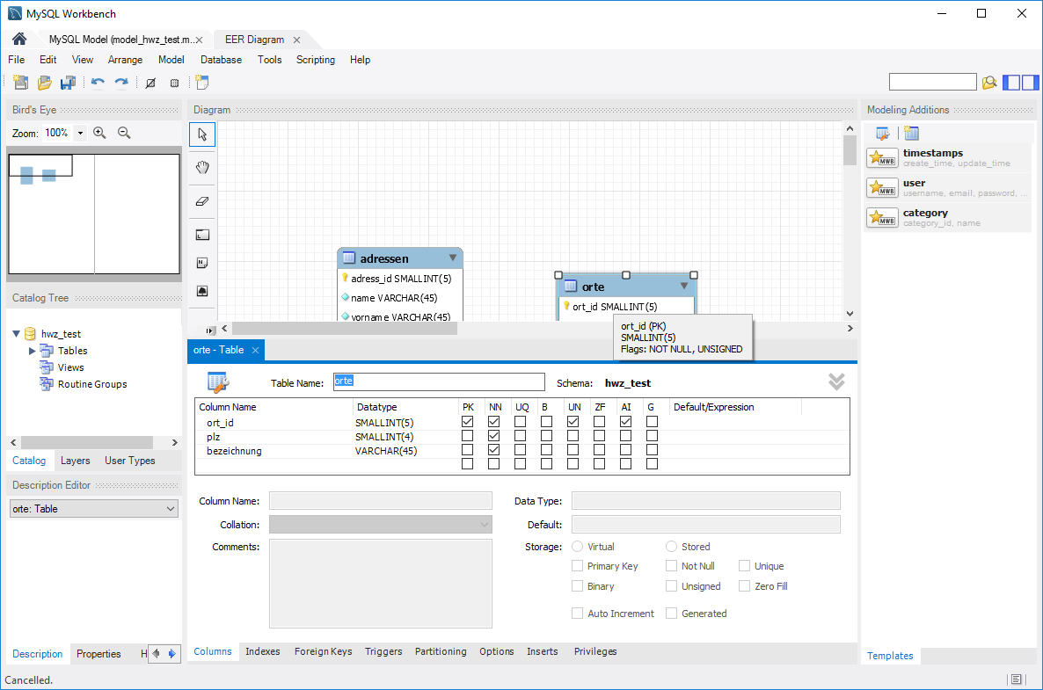

File 🡪 Save Model As…. Model_hwz_test

## Generate script from ERD-Model

File 🡪 Export 🡪 Forward Engineer SQL…

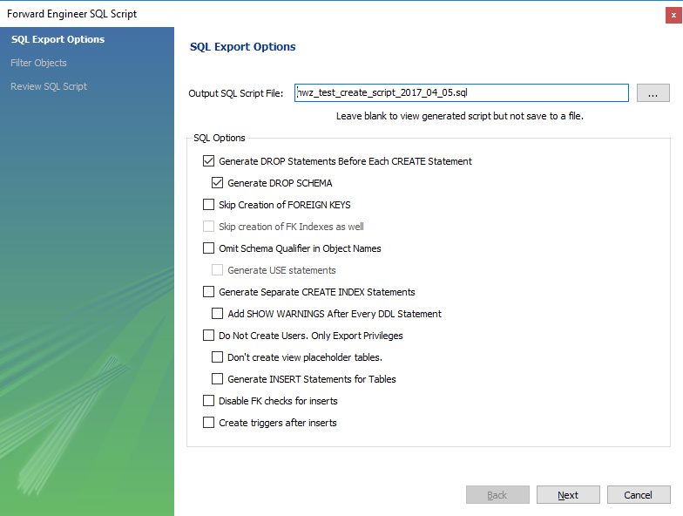

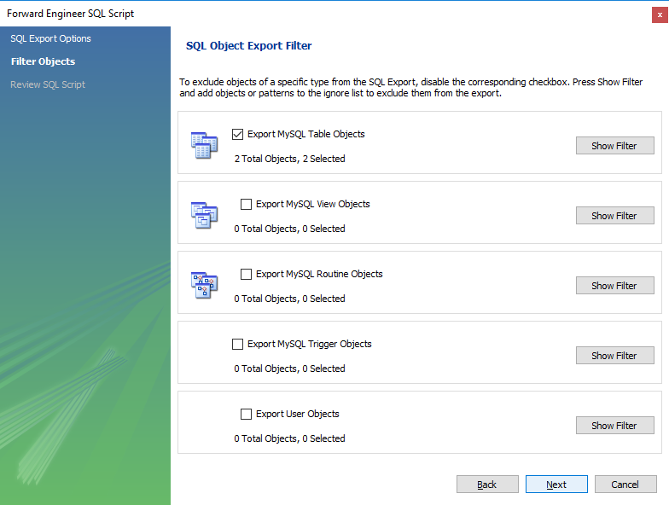

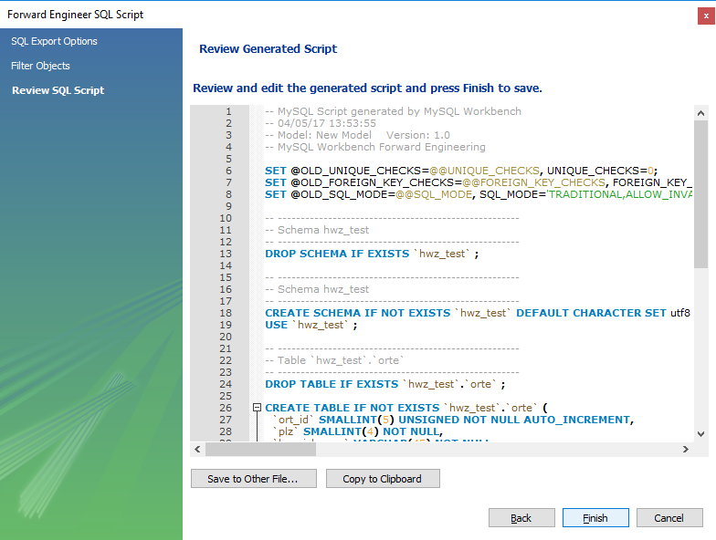

## Use script to create DB Objects

File 🡪 Open SQL script

Execute script and refresh schema view

## Attribute-Types

