Commercial HVAC Installation
Google Search launch pack · Ambient Cooling - Live · 2401959466 · September 10, 2026
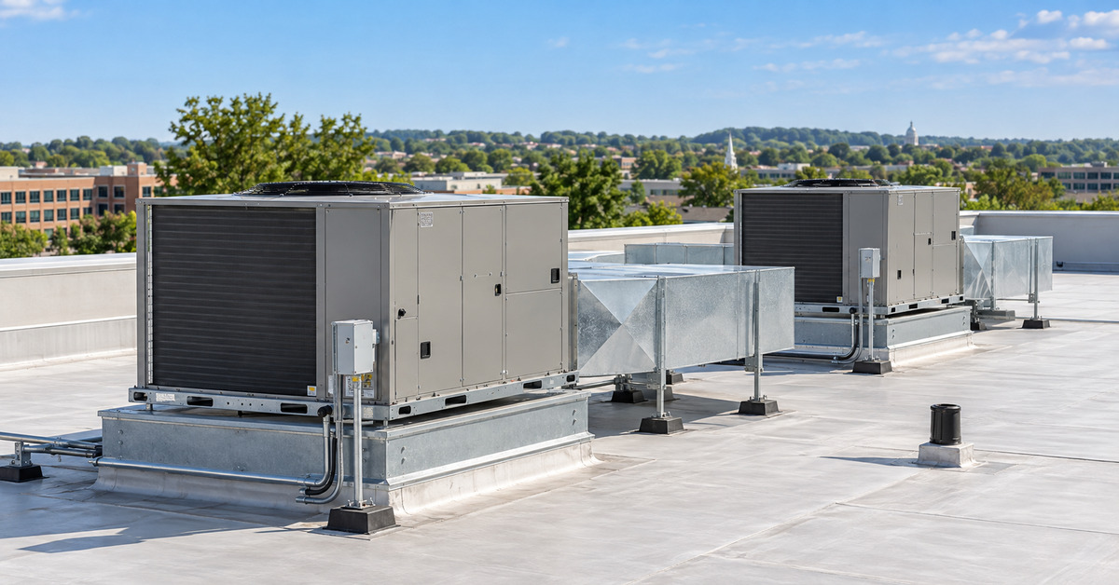
Illustrative commercial HVAC imagery; do not present as an Ambient project photograph.
LAUNCH DECISION
Build one new ad group inside the existing HVAC Installation campaign. Start with one BOFU theme in Phrase and Exact, two paused RSAs, a dedicated paid landing page, and the existing $30 Maximize Clicks ceiling. Do not enable until browser, tracking, conflict, and readback gates pass.

Account | Campaign | New ad group | Budget scope
Ambient Cooling - Live  2401959466 | HVAC Installation  24132507747 | SKAG | Commercial HVAC Installation | $13,000 hard maximum  Google Search only

This pack excludes Local Services Ads. It also intentionally excludes the claim Licensed & Insured from all proposed copy, assets, and page content.

1. Decisions at a glance
Workstream | Decision | Why
Two disapproved ads | Appeal the false Consumer Finance classification; keep the ads paused | Approved replacements already serve, so no delivery gap exists
CPC control | Keep $25 / $25 / $30; add $25 Boiler and $30 Replacement after exact approval | Only four valid capped clicks exist; values are protective, not proven optimal
Gas Boiler | Heading fixed; complete mobile, form, DNI, and duplicate-ID QA | Copy gate passes, but functional tracking gate is not complete
Commercial HVAC | Create a dedicated ad group and landing page | Commercial intent requires its own relevance, routing, copy, and economics
Headlines | RSA A: three H1 pins; RSA B: unpinned control | Preserves a keyword-first opener while retaining a comparison
Budget | Never exceed $13,000 Search-only; do not force unprofitable spend | Qualified lead economics outrank spend utilization

2. The two disapproved ads
The operational problem is already contained. Both ads were paused on September 10, and both affected ad groups retain two enabled, approved responsive search ads.
Ad ID | Campaign / ad group | Policy state | Action
820900825434 | HVAC Installation  202339087634 | Consumer Finance  Reviewed · Fully limited | Dispute decision; keep paused
820944944368 | HVAC Replacement  200159223798 | Consumer Finance  Reviewed · Fully limited | Dispute decision; keep paused

LIKELY CAUSE
Google appears to have classified ordinary HVAC ads as Consumer Finance. That policy restricts ZIP-code targeting, while Ambient legitimately targets Maryland ZIP codes. Because approved ads use the same HVAC destinations, removing ZIP targeting would solve the wrong problem.

- Read the full policy evidence and constraints for the exact ad IDs through the API and the Google Ads Policy details column.
- If Consumer Finance is the only cited topic and there is no real lending, credit, or financing content, appeal with Dispute decision.
- Do not select Made changes to comply unless Google identifies a specific finance-related item that was actually changed.
- Keep both ads paused after approval; the serving replacements remain the controlled production ads.
- If the appeal fails, preserve the evidence, wait at least 24 hours, and prepare a Support case rather than repeatedly appealing.
Policy Manager cleanup should include the four other paused legacy ads with the same label: 820900825428, 820900825431, 820900825437, and 820944944371.

3. CPC control plan
The September 4 caps sharply reduced delivery, but the settled capped window contains only four valid clicks and zero conversions. That is too little evidence to call any ceiling optimal. The correct near-term move is controlled protection plus measured, single-variable tests.
Campaign | Current | Recommendation | Decision basis
AC Repair | $25 | Keep $25 | Historical CPQL $1,028 vs $150 target; raising bids is not the first fix
HVAC Repair | $25 | Keep now; consider $35 later | A $35 test has limited historical support, but attribution/sample are incomplete
HVAC Installation | $30 | Keep $30 | Do not change while launching the commercial ad group
HVAC Replacement | Uncapped | Set $30 | Five clicks averaged $30.50; no qualified leads
Gas Boiler Repair | Uncapped | Set $25 | Protective discovery cap; no valid-click history

VALIDATED PACKAGE
AMB-0910-CPC-CAP-1 · 7EA6922309EB · 2 operations. It changes only Gas Boiler Repair to $25 and HVAC Replacement to $30. It still requires the exact approval line before execution.

Measurement and rollback rules
- Split uncapped and capped results at the exact September 4 change time; never blend the regimes.
- Use valid clicks and reconciled WhatConverts qualified leads. Resolve ambiguous Google leads with click IDs, UTMs, landing URL, referrer, and tracking number.
- Collect exact-location Keyword Planner forecasts and August campaign/ad-group Auction Insights before a new cap proposal.
- Require at least 20 valid clicks and preferably three unique qualified leads before declaring a cap permanent.
- Change one variable at a time and move a ceiling by no more than 20% per test.
- Check at 24 and 72 hours for faults; judge performance after 14 settled days, excluding conversion-lag days.
Campaign | Incremental stop-loss without a qualified lead
AC Repair | $150
HVAC Repair | $250
HVAC Installation | $280
HVAC Replacement | $280
Gas Boiler Repair | $250

4. Auction Insights collection
The supplied screenshot is valid for Ambient, but it uses July 15–September 9 and pools all five campaigns. It is not the requested last-month, per-ad-group evidence.
CHROME PROFILE
The screenshot shows the Chrome profile label Work. Claude should use it only if the live Google Ads header confirms Ambient Cooling - Live / 240-195-9466. If more than one connected browser is ambiguous, ask which visible profile to select; never request credentials or profile files.

- Exact date: August 1–31, 2026; Search only.
- Export five campaign reports, five ad-group reports, and one optional pooled baseline.
- Keep Display URL, impression share, overlap, position above, top, absolute top, and outranking share.
- Preserve <10% exactly. Record minimum-activity failures as unavailable, not zero.
- Use Auction Insights with Quality Score, lost impression share, valid CPC, BOFU terms, and qualified leads; never use it alone to set bids or negatives.
Visible pooled competitor | Overlap | Position above | Top | Absolute top
sila.com | 9.32% | 22.26% | 54.56% | 14.92%
serviceexpertsnow.com | 7.07% | 42.79% | 61.93% | 33.72%
lentheplumber.com | 4.75% | 17.04% | 59.17% | 15.76%
horizonservices.com | 7.03% | 30.00% | 61.97% | 21.15%
constellationhome.com | 9.46% | 36.06% | 78.21% | 30.77%
boothehvac.com | 6.12% | 37.93% | 69.20% | 32.37%
beltwayheatingandair.com | 5.52% | 59.87% | 83.94% | 63.99%
ars.com | 6.12% | 25.29% | 53.11% | 21.01%

5. Gas Boiler page status
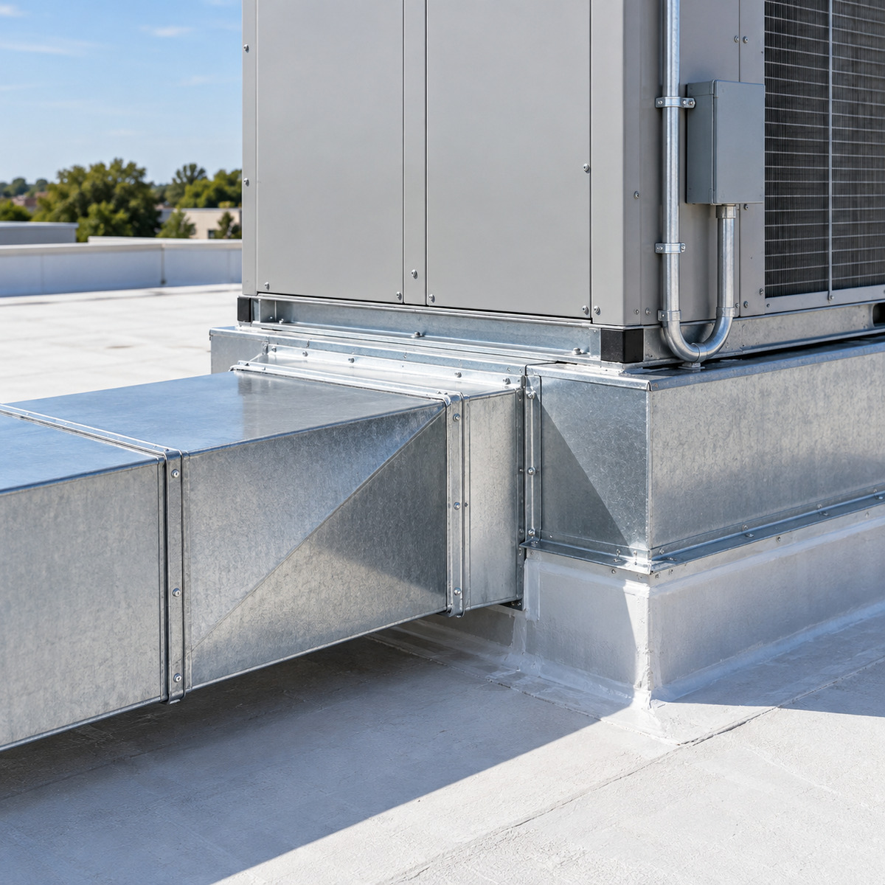
Illustrative equipment detail. The live Gas Boiler page itself has separate browser evidence.
The original developer defect is fixed. The live page now displays Your Gas Boiler Repair in 3 Simple Steps, and the old HVAC Replacement wording is absent from the page HTML. The title, H1, canonical, boiler-specific CTAs, paid phone number, GTM container, and WhatConverts markup are present.

Remaining launch gate
- Recheck desktop and mobile rendering.
- Test every distinct form through an approved non-production/test path and confirm one successful lead and one Google Ads conversion per submission.
- Test DNI with controlled paid-click parameters; confirm (410) 705-6354 and its link swap correctly and (410) 761-0932 never flashes or becomes clickable.
- Fix the three duplicate form IDs (all currently gform_1) or prove the duplication does not break validation, accessibility, submission, or tracking.
- Revalidate the Boiler keyword package after the page and account pass. Supersede it if any before-state changed.
KEYWORD INTENT
The intended live change remains one Exact keyword, [boiler repair], in ad group 202339087594. Do not add Phrase, Broad, or speculative negatives in the same launch.

6. Commercial HVAC ad-group architecture
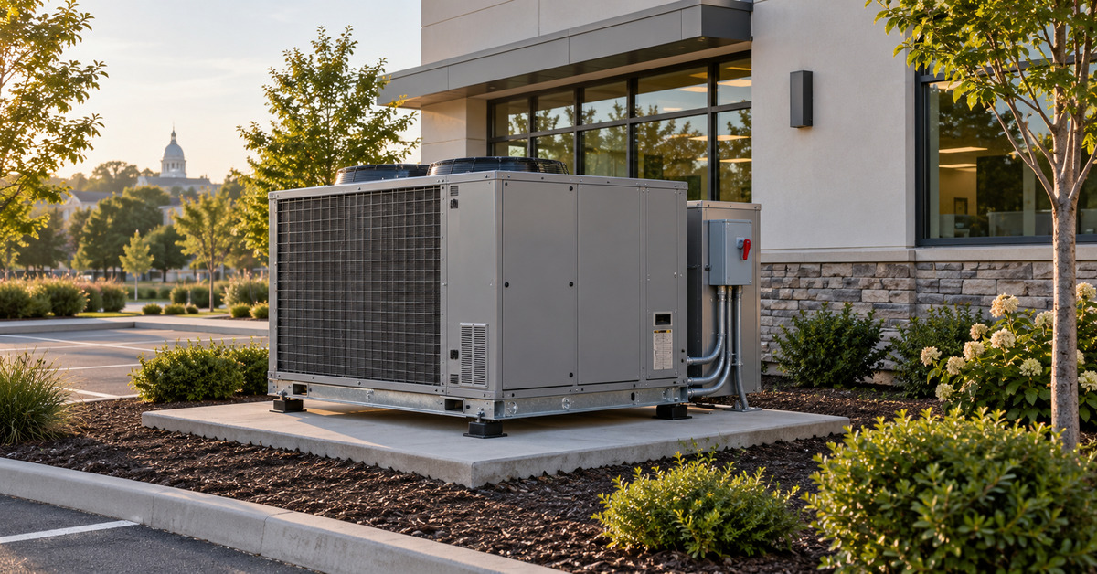
Illustrative commercial installation image; not evidence of an Ambient project.
Field | Build specification
Campaign | Search | NonBrand | HVAC Installation | Central MD | BOFU | 2026-08
Campaign ID | 24132507747
New ad group | SKAG | Commercial HVAC Installation
Final URL | https://offer.ambientcoolingandheating.com/commercial-hvac-installation/
Bidding | Inherit Maximize Clicks with current $30 CPC ceiling
Location | Inherit the existing 75 Maryland Presence-only targets
Schedule / tracking | Inherit approved schedule, conversions, tracking template, and call asset
Initial status | Create paused; separate approval required to enable

Ambient's official site supports this scope: it explicitly serves homes and businesses and offers HVAC installation, replacement, rooftop/packaged systems, heat pumps, central air, ductwork, ventilation, and controls. A dedicated commercial paid landing page does not currently exist, so it must be built before the ad group can serve.

7. BOFU keyword and routing plan
Launch with one canonical commercial-installation theme. No Broad positive keywords.
Match | Keyword
Phrase | "commercial hvac installation"
Exact | [commercial hvac installation]

New commercial ad-group negatives — Broad
Broad negative | Broad negative
residential | homeowner
house | diy
job | jobs
career | careers
salary | salaries
training | course
courses | school
schools | parts
used | rental
rent | wholesale
supplier | supply

Residential installation routing
Add commercial as a Broad negative to the existing residential SKAG | HVAC Installation only after the new commercial landing page, ad group, keywords, and ads are enabled and eligible. Never place commercial at campaign or account level.
Preserve manufacturer names, location names, free, quote, estimate, cost, pricing, building, and property manager. Do not add repair or maintenance as negatives until a commercial repair-routing decision exists.

8. Responsive search ad A — keyword-first
PINNING DECISION
Pin three distinct service-led headlines to Headline 1. This guarantees a relevant opener while still allowing Google to rotate among three alternatives. Leave all other headlines unpinned.

Headline | Characters | Pin
Commercial HVAC Installation | 28 | H1
Commercial HVAC Installers | 26 | H1
HVAC Installation for Business | 30 | H1
Free Commercial HVAC Quote | 26 | —
Rooftop Unit Installation | 25 | —
Commercial RTU Installation | 27 | —
Commercial AC Installation | 26 | —
Commercial Heat Pump Install | 28 | —
Systems Built for Businesses | 28 | —
Central Maryland HVAC Team | 26 | —
Plan Around Your Operations | 27 | —
Transparent Commercial Pricing | 30 | —
Flexible Project Scheduling | 27 | —
Ambient Cooling & Heating | 25 | —
Request a Commercial Quote | 26 | —

Descriptions
Description | Characters
Request a free commercial HVAC installation quote for your Central Maryland property. | 85
Install rooftop units, packaged systems, heat pumps, or central air for your business. | 86
Plan equipment, ductwork, ventilation, and controls around your building and operations. | 88
Get clear options, transparent pricing, and scheduling designed around your business. | 85

9. Responsive search ad B — unpinned control
Leave all headlines unpinned. Google may prefer this ad unevenly, so it is a practical control, not a guaranteed 50/50 experiment.
Headline | Characters
HVAC Systems for Businesses | 27
Central MD Commercial HVAC | 26
Commercial System Installation | 30
Replace Aging HVAC Equipment | 28
Rooftop & Packaged Systems | 26
Business Heating & Cooling | 26
Commercial HVAC Planning | 24
Free Installation Quote | 23
HVAC Options for Your Building | 30
Schedule a Site Evaluation | 26
Keep Business Comfort in Mind | 29
Professional HVAC Installation | 30
Central Air for Your Business | 29
Heat Pumps for Businesses | 25
Request Your HVAC Quote | 23

Descriptions
Description | Characters
Replace or install commercial HVAC equipment with a plan built around your property. | 84
Request a free consultation for rooftop, packaged, central air, or heat pump systems. | 85
Ambient serves Central Maryland businesses with clear pricing and flexible scheduling. | 86
Discuss building needs, equipment options, ductwork, controls, and project timing. | 82

Paths for both ads: commercial-hvac / installation. Final URL: https://offer.ambientcoolingandheating.com/commercial-hvac-installation/

10. Assets
Asset type | Copy
Callouts | Free Consultation · Flexible Scheduling · Transparent Pricing · Commercial HVAC Team · Central Maryland Service · Multiple System Options
Structured snippet — Types | Rooftop Units · Packaged Systems · Heat Pumps · Central Air · HVAC Replacement
Call | Use the existing paid call asset and (410) 705-6354 behavior

Sitelinks should stay within the paid-funnel domain once matching pages exist. Until then, use only verified relevant destinations and do not imply that an educational article is a commercial service page.
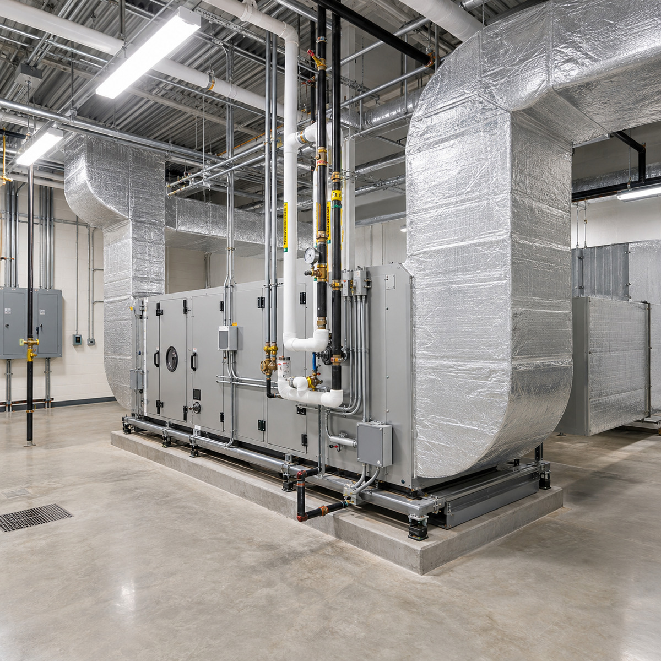
Square mechanical-room asset. Illustrative image; no logos, people, or claims.

Image files
- ambient-commercial-rooftop-hvac-installation-1200x628.jpg
- ambient-commercial-ground-unit-installation-1200x628.jpg
- ambient-commercial-mechanical-room-1200x1200.jpg
- ambient-commercial-rtu-ductwork-1200x1200.jpg
Treat all four as illustrative generated imagery. Do not call them completed Ambient projects. Replace them with verified, Ambient-owned project photos when available.

11. Landing-page copy
Element | Copy
SEO title | Commercial HVAC Installation | Ambient Cooling & Heating
Meta description | Request commercial HVAC installation or replacement for your Central Maryland property from Ambient Cooling & Heating.
H1 | Commercial HVAC Installation in Central Maryland
Primary CTA | Request a Free Commercial HVAC Quote
Secondary CTA | Call (410) 705-6354

Hero
Plan a commercial HVAC system around your building, operations, and budget. Ambient Cooling & Heating installs rooftop units, packaged systems, heat pumps, central air, and other commercial HVAC equipment for Maryland businesses and property managers.

Commercial HVAC Planned Around Your Property
Every commercial building has different comfort demands, operating schedules, ventilation requirements, and equipment constraints. Ambient evaluates the existing system, building layout, heating and cooling needs, ductwork, controls, and project goals before presenting installation options.

Commercial HVAC Systems We Install

Rooftop and Packaged Units
Plan a rooftop or packaged HVAC system suited to the building's available space, operating needs, and comfort requirements.

Commercial Air Conditioning
Plan a commercial AC installation with equipment selected for the property's layout and operating needs.

Commercial Heat Pumps
Explore heating and cooling options that can support year-round comfort and energy-efficiency goals.

Ventilation, Ductwork, and Controls
Review airflow, duct condition, ventilation needs, thermostats, controls, and scheduling as part of the overall system plan.

12. Landing-page process and conversion section

Your Commercial HVAC Installation in 3 Steps
Step | Copy
1. Request a Consultation | Tell us about the property, existing equipment, comfort concerns, and project timeline.
2. Evaluate the Building | Ambient reviews the building requirements, equipment options, ventilation, ductwork, and controls.
3. Review the Plan and Schedule | Review recommended options and transparent pricing, then choose an installation schedule that works for your operation.

Why Businesses Choose Ambient
- Commercial installation planning
- Flexible project scheduling
- Transparent pricing
- Rooftop, packaged, central air, and heat-pump options
- Service throughout Central Maryland

Request Your Commercial HVAC Consultation
Tell Ambient about your property and project. A team member will review the details and contact you to discuss the next step.

Recommended form fields
Required | Optional / qualifying
Company Name  Contact Name  Phone  Email  Property Address | Property Type  New Installation or Replacement  Current System Type  Preferred Project Timeline  Project Details

Tracking and technical requirements
- Paid phone number (410) 705-6354 and correct tel: link
- GTM-PQTPQ436 and WhatConverts preserved
- GCLID, GBRAID, WBRAID, UTM, and lead ID capture
- One confirmed Google Ads conversion per successful form submission
- Unique DOM IDs, valid labels, keyboard access, and clear error messages
- Canonical, Privacy, Terms, thank-you route, and mobile layout verified

13. Launch sequence and acceptance criteria
- Build the commercial landing page on staging using this copy and the image assets.
- Run desktop and mobile visual QA, claim QA, form tests, DNI tests, and conversion debugging.
- Publish only after source, staging, backup, and deploy authority are confirmed.
- Create the ad group, two keywords, two RSAs, and reviewed negatives in PAUSED status.
- Run exact conflict testing against every positive keyword, converting search term, account/shared/campaign/ad-group negative, manufacturer, and location name.
- Run validate-only with partial_failure=false; fingerprint the exact operations.
- Read back every resource and prove unrelated resources unchanged.
- Request one exact enable approval. Enable only after the landing page and tracking are live and the commercial routing negative can be added safely.
- Monitor 24 hours and 72 hours for faults and search-term quality; evaluate CPC, CTR, qualified leads, and CPQL after 14 settled days.
SUCCESS DEFINITION
A lower CPC or higher CTR is not success by itself. Success is more unique qualified commercial installation leads at or below the $280 CPQL guardrail, without breaching the $13,000 Search-only maximum.

14. Source notes
- Google: Responsive search ads and pinning
- Google: Maximize Clicks and CPC limits
- Google: Fix or appeal a disapproved ad
- Ambient: HVAC services
- Ambient: AC installation
Prepared from the supplied account reports, live-page evidence, the September 10 audit state, and official Google Ads and Ambient sources. All proposed Google Ads resources remain subject to fresh identity, drift, validation, fingerprint, approval, and readback gates.

