Rapid Start-Up Checklist for Pillar 1 Emergency Response Activations (ERA)
This checklist is designed to support Pillar 1 activations during the initial emergency response and proposal drafting process. Please include CI focal points according to their area of support.
What to submit and when (link to last page)

Key Focal Points (CI)
Area | Focal Point | Alternate
General – Act as our connection to the GOR (Grants Officer Representative). Will be responsible for submitting the proposal package to DHR | Yolanda Martinez  Ymartinez@sv.ci.org  +503-78555136
Technical Advisors – Support technical design and proposal development. Should be included in all communication | Matt Ellingson  Mellingson@us.ci.org  +1-360-201-0083 | Leena Hill  Lhill@us.ci.org  +1-202-255-9833
MEAL – Support MEAL related tasks and submissions. Include in proposal communication to support on indicator collection | Laura Wheeler Lwheeler@us.ci.org  +1-865-266-4395 | Jdhymi Dulaurier  Jdulaurier@us.ci.org
Finance – Support with Budget development and submission. Include in all communication around budget development | Virginia Murillo Eslinger  vmurilloeslinger@us.ci.org  +1-501-231-9602 | Alma Alegria  aalegria@us.ci.org
Legal & Compliance – Contact for all questions about compliance and risk. | See table (last two pages) for portfolio distribution:  Barbara Doggett  Bdoggett@us.ci.org  Elizabeth Lagrava  Elagrava@us.ci.org  WV point of contact –  Tae Symons  tsymons@worldvision.org
Safeguarding and Protection – Contact for all communication around safeguarding or PSEA | Beth Drevlow  bdrevlow@us.ci.org | Babs Yonli  byonli@us.ci.org

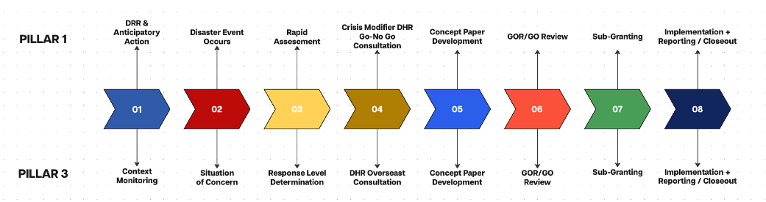

1. Program Management & Operations

Initial Assessment
☐ Consult DHR field staff / regional point of contact before submitting.
☐ Consult Needs Assessment Guidance
☐ Verify disaster impact and priority humanitarian needs
☐ Review available secondary data and situation reports
☐ Conduct rapid needs assessment if required
☐ (within 72 hours to 14 days after the shock)
☐ Set up coordination chats that include key CI focal points
☐ No participant personal data to be shared via Whatsapp (data protection)
☐ Register with relevant government coordination mechanisms
☐ Participate in cluster/sector meetings

Project Set-Up
☐ Use RISE Proposal Template P1 Activation format
☐ Establish implementation plan and start-up workplan
☐ Establish coordination mechanisms with partners
☐ Document the subrecipient-versus-contractor decision for each responder organization (200.331).
☐ Review DHR Technical Standards and ensure proposal design is aligned.
☐ Set up regular internal coordination meetings with key CI focal points
☐ Draft and share distribution plans
☐ Check restricted commodities and waivers.

2. Finance & Budget Management

Financial Set-Up
☐ Use Rapid Response Budget Template
☐ Apply indirect costs at the de minimis rate, up to 15% of modified total direct costs (MTDC), not of total direct costs. Equipment, rent, participant support costs, and any part of a subaward above USD 50,000 are excluded from MTDC.
☐ Budget any item costing USD 10,000 or more per unit as Equipment. Items under USD 10,000 go under Supplies.
☐ Confirm the applicable authorization is effective and the proposed activities and costs are permitted. effective dates, approved budget, authorized activities, and applicable restrictions
☐ Note: Don’t hold the proposal for a perfect budget. Submit your best estimate on time; DHR allows revisions within 10 days of submission, coordinated through CI.

Financial Controls
☐ Spending authority matrix established
☐ Procurement thresholds communicated
☐ Procurement procedures, competition requirements, conflict of interest safeguards, and purchasing approval are defined and communicated.
☐ Cash management procedures reviewed
☐ Petty cash established (if applicable)
☐ Advance management process communicated
☐ Plan for currency conversion and a documented exchange rate method.
☐ Separation of duties, transaction initiation, approval, payment processing, recording, and reconciliation to the extent practicable.
☐ Personnel costs are reasonable, supported, allocated consistently with actual work performed, and charged in accordance with applicable requirements.

Budget Monitoring
☐ Budget tracking template established
☐ Quarterly Financial Review
☐ Complete variance analysis between budget and actual spending, including explanations for over or under spending and corrective actions.
☐ Complete burn rate monitoring to identify accelerated spending, delayed implementation, or potential underspending.

3. Compliance & Risk Management

Donor Compliance
☐ Confirm the responder organization is fully vetted (RISE Subs DRR or ROA)
☐Conduct initial screening and vetting process for new partner organizations
☐ Issue and execute an Emergency Response Activation Subaward agreement to existing or new RISE responder partners after DHR/GCO’s approval of technical narrative and Budget.

Risk Management
☐ Review if existing documents from organization or NO need to be updated contextually or created for this response
☐ Security assessment or Risk Register
☐ Incident reporting procedures
☐ Screen all sub-partners, vendors, and contractors against sanctions lists before contracting, and keep a record of each check.
☐ Complete the diversion risk section of the proposal (Section 11): say what risk you assess and how you will mitigate it.
☐ Report any suspected diversion, fraud, or misconduct as applicable within 24 hours of becoming aware of it. RISE will notify DHR.

Documentation
☐ Ensure that documentation systems are in place including
☐ Project filing structure
☐ Grant documentation storage
☐ HR, procurement, finance, and program files
☐ Data protection procedures
☐ Situation Reports (SitRep) [Separate guidance will be provided]

4. MEAL (Monitoring, Evaluation, Accountability and Learning)

Monitoring Framework
☐ Review RISE Indicator Menu
☐ Draft ITT using the RISE ITT Template
☐ Draft M&E plan using the RISE M&E Plan Template

Data Collection
☐ Decide if you are using the RISE consortium Kobo and LMMS tool or if you are using your own systems
☐ Communicate any need to change existing Kobo tools
☐ Ensure budget for enumerators, tablets, training and accountability
☐ Enumerators trained (if applicable)

5. Accountability to Affected Populations (AAP)

Information Sharing
☐ Inform communities about:
☐ Project objectives
☐ Beneficiary eligibility criteria
☐ Assistance package
☐ Publicly display contact information
☐ Information materials adapted to local language(s)

Feedback & Complaints Mechanism
☐ Feedback mechanism selected and operational (minimum 2)
☐ Hotline
☐ Suggestion box
☐ Community focal points
☐ WhatsApp/SMS
☐ Complaints handling SOP established
☐ Confidential channels established for sensitive complaints
☐ PSEA-specific reporting channels available
☐ Feedback log established

Community Engagement
☐ Engage with community leaders
☐ Conduct community consultations including children, young people and marginalized groups
☐ Review feedback regularly
☐ Acknowledge all feedback and complaints within 3 working days, and resolve non-sensitive cases within 30 calendar days (RISE indicator C08). Send sensitive cases, including SEA and safeguarding, to the safeguarding focal point right away. They are handled separately and don’t count toward C08.

6. Safeguarding and Protection for new partner organizations / new locations

Existing policies and procedures
Review if existing policies from organization or national office need to be updated contextually for this response (partner due diligence)
☐ Training provided annually on safeguarding policies and procedures to ALL relevant staff, volunteers, etc. This includes PSEA and Child Safeguarding policies and procedures
    - Code of Conduct signed by every staff, volunteer, affiliate, etc.
    - Must include component regarding no unsupervised one-on-one contact with children and rules for consent regarding photos and story collection
☐ Safe, ethical, and confidential data management protocols in place (that restrict access to only those who need to know for sensitive data)
☐ Processes for handling and responding to complaints and allegations established
☐ Referral pathways in place
☐ HR policies include appropriate SEA and misconduct towards children vetting/referral checks and zero tolerance for SEA clauses in contracts, along with termination procedures in place if allegations substantiated
☐ Internal reporting/whistleblowing channel in place for staff/volunteers
☐ Safeguarding considerations included in all risks assessments and mitigation planning

Information Sharing
☐ Inform communities and beneficiaries about:
☐ Their rights as beneficiaries
☐ What are violations of those rights (SEA, etc.)
☐ How to report concerns (the multiple confidential and accessible CFMs established)
☐ The responsibilities of the organization to Safeguarding and confidential handling of reports
☐ See AAP section above for fuller details on ensuring information sharing is accessible to all members of the community

Reporting and Investigations
☐ Safeguarding focal points established (within the staff/volunteers, and within senior management)
☐ Reporting pathways established and risk rating criteria established to guide response times and processes
☐ Investigations protocols and connections/contracts established (agreements with third party investigators as needed)
☐ Report all safeguarding and SEA allegations to the CI Safeguarding focal point of receipt. CI will escalate to WV and DHR as required.
☐ Record keeping set up for case tracking

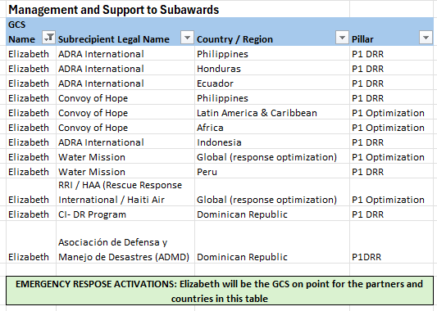
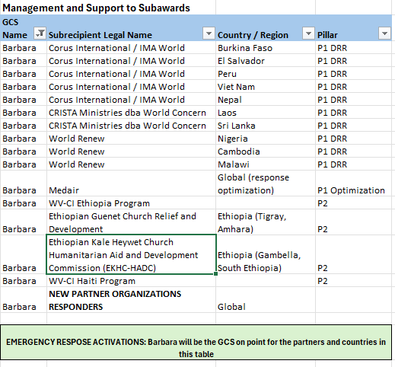
What to submit and when
Pillar 1 Emergency Response Activations
Timings in bold are fixed by DHR. Timings in [brackets] are set by CI for each activation. Use the focal points listed below for each area.
Step | Who | When
1. Before submitting
Consult DHR field staff & the GOR on the planned response. | CI (General focal point) | Before the proposal goes in (DHR SOP)
Run a rapid needs assessment. Start with secondary data & collect primary data only to fill gaps. See the Needs Assessment Guidance. | Partner, w/ CI MEAL | Within 72 hours to 14 days after the shock (DHR Technical Standards)
Join government coordination mechanisms and cluster meetings. Create a coordination chat with CI focal points. | Partner | As soon as the response starts
Review DHR Technical Standards, including restricted commodities needing technical approval or a waiver. | Partner, w/ CI Technical Advisors | Before designing activities
Confirm that sanction vetting has been performed // Not full due diligence for sub-partners under the pre-approved RISE subs | CI Compliance | Before proposal submission
Choose data systems: e.g. RISE Kobo & LMMS tools. | Partner, w/ CI MEAL | Before building the budget (affects M&E costs)
2. Submit with the proposal
Rapid Activation Proposal, including indicator selection (C00, C07 & C08 are required), risk register, & diversion risk section. | Partner drafts; CI reviews & submits to DHR | With the proposal
Budget on the RISE Pillar 1 budget template, with a short budget narrative. | Partner drafts; CI Finance reviews | With the proposal. Revisions within 10 days of submission, with notice to the GOR (DHR SOP)
Distribution plan. | Partner | With the proposal
3. After DHR approval
Issue subaward mod (existing RISE partners) or new subaward (new partners), each with a SOW & budget. | CI | After DHR/GO approval
Indicator Tracking Table (ITT) on the RISE ITT template. | Partner, w/ CI MEAL | Before implementation
M&E Plan Brief on the RISE template. | Partner, w/ CI MEAL | Before implementation
Financial controls in place: spending authority, procurement, cash and advances, exchange rate method, budget tracking. | Partner, w/ CI Finance | Before first spending
4. First 30 days after start
Accountability, safeguarding & registration in place (see Sections 5 and 6): at least two feedback channels, communities informed, safeguarding for new partners or locations, registration & baseline where required. | Partner, with CI MEAL and Safeguarding | Before first distribution. Acknowledge complaints within 3 working days; resolve non-sensitive cases within 30 calendar days (C08)
Security policy | Partner, with CI Compliance | Before Implementation
Sources: DHR Technical Standards for Rapid Onset Responses (July 2026); DHR External SOP for Management of Global Awards (October 2026); RISE Indicator Menu. Version 1.0, [date].

