**Soil moisture conditions**

**Background:**

A first step in the water balance calculation is to know different moisture conditions of the soil where the crop is growing. Thus, soil water content at field capacity (FC) and permanent wilting point (PWP) are necessary to calculate the available water content (AW) and the water content level at the critical threshold (CT), value below which crop growth is assumed to be restricted by water availability. The FC and PWP could be measured by the retention curve method but usually, this information is not available, thus an estimation of these soil characteristics could be necessary.

**Objective:**

Estimate some soil moisture conditions and variables (FC, PWP, AW, and CT) from texture and organic matter content.

**Outcomes:**

Create a model to calculate different soil moisture conditions and variables from some soil characteristics.

**Diagram:**

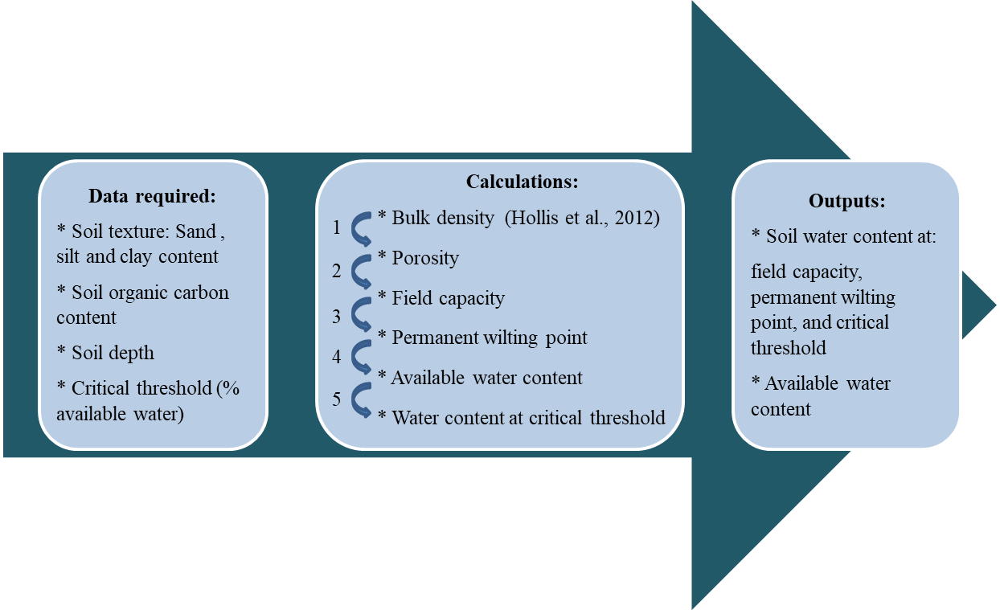

1. Bulk density (BD) will be calculated as suggested by [1] for cultivated topsoils (Eq. 1) and will be assumed constant through all the soil profile. Total soil porosity will be calculated following Eq. 2, assuming a particle density of 2.65 g cm-3.

BD (g cm-1) = 0.80806 + (0.823844 * exp(-0.27993 * %OC) + 0.0014065 * %sand) – (0.0010299 * %clay) (Eq. 1)

Porosity = 1 – (BD / 2.65 g cm-3) (Eq. 2)

1. Field capacity (FC) will be assumed as a 50% of the porosity (saturation water content) [2].
2. Permanent wilting point (PWP) will be assumed as a 50% of field capacity [2].
3. Available water content (AW) will be calculated at the difference between FC and PWP.
4. Soil water content at the critical threshold (CT) will be calculated from the AW and critical threshold (%).

**References:**

[1] HOLLIS, J.M.; HANNAM, J.; BELLAMY, P.H. 2012. Empirically-derived pedotranfer functions for predicting bulk density in European soils. Eur J Soil Sci 63:96-109.

[2] USDA –NIFA. Online: <http://passel.unl.edu/pages/informationmodule.php?idinformationmodule>

=1130447039&topicorder=10&maxto=10