Universidade da Região de Joinville - UNIVILLE
Departamento de Informática - Curso de Bacharelado em Sistemas de Informação
Disciplina: APC - Algoritmos e Programação de Computadores - Série: 1ª - Noturno
Aluno: _______________________________________________________________________
Aluno: _______________________________________________________________________
Aluno: _______________________________________________________________________
Aluno: _______________________________________________________________________
Aluno: _______________________________________________________________________
Aluno: _______________________________________________________________________

Experimento 02 – Comunicação Serial e Integração com Twitter
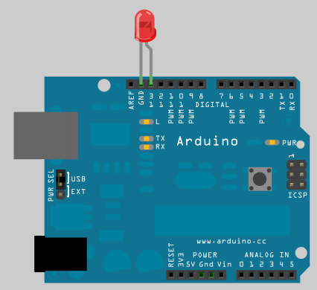

Componentes:
- Arduino
- LED
Código fonte Arduino:
int ledPort = 13;
int inByte = 0;

void setup() {
pinMode(ledPort, OUTPUT);
digitalWrite(13, LOW);
Serial.begin(9600);
}

void loop() {
if (Serial.available() > 0) {
inByte = Serial.read();
if(inByte == 'l'){
digitalWrite(ledPort, HIGH);
}else{
digitalWrite(ledPort, LOW);
}
}
delay(10);
}

Código fonte Python:
import serial
import twitter
import time
ser = serial.Serial(port = 'COM10', baudrate=9600, timeout = None)
api = twitter.Api()
while True:
pass
statuser = api.GetUserTimeline("@waltercoan")[0]
print statuser.text
if statuser.text.find("ligado") == -1:
ser.write('d'.encode('ascii'))
else:
ser.write('l'.encode('ascii'))
print "rodando...\n"
time.sleep(10)

Anotações: Objetivo, fundamentação teórica (conceitos utilizados), metodologia do experimento, processo experimental, apresentação e análise dos resultados.

_________________________________________________________________________________________

_________________________________________________________________________________________

_________________________________________________________________________________________

_________________________________________________________________________________________

_________________________________________________________________________________________

_________________________________________________________________________________________

_________________________________________________________________________________________

_________________________________________________________________________________________

_________________________________________________________________________________________

_________________________________________________________________________________________

_________________________________________________________________________________________

_________________________________________________________________________________________

_________________________________________________________________________________________

_________________________________________________________________________________________

_________________________________________________________________________________________

_________________________________________________________________________________________

_________________________________________________________________________________________

_________________________________________________________________________________________

_________________________________________________________________________________________

_________________________________________________________________________________________

_________________________________________________________________________________________

_________________________________________________________________________________________

_________________________________________________________________________________________

_________________________________________________________________________________________

_________________________________________________________________________________________

_________________________________________________________________________________________

_________________________________________________________________________________________

_________________________________________________________________________________________

