Universidade da Região de Joinville - UNIVILLE
Departamento de Informática - Curso de Bacharelado em Sistemas de Informação
Disciplina: APC - Algoritmos e Programação de Computadores - Série: 1ª - Noturno
Aluno: _______________________________________________________________________
Aluno: _______________________________________________________________________
Aluno: _______________________________________________________________________
Aluno: _______________________________________________________________________
Aluno: _______________________________________________________________________
Aluno: _______________________________________________________________________

Experimento 03 – LDR (Light Dependent Resistor – Photoresistor)
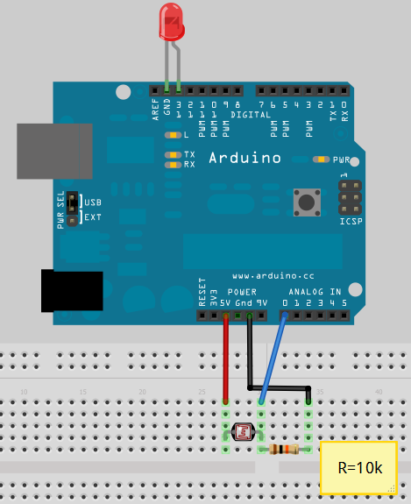
Componentes:
- Arduino
- LDR 10k ohm
- Resistor 10k ohm
- LED
- 3 Jumpers

Código Fonte:
const int ledPin = 13; // LED connected to digital pin 13
const int sensorPin = 0; // connect sensor to analog input 0

void setup()
{
pinMode(ledPin, OUTPUT); // enable output on the led pin
Serial.begin(9600); // Serial velocity comunication
}
void loop()
{
int rate = analogRead(sensorPin); // read the analog input
Serial.println(rate);
rate = map(rate, 200,800,300, 1000); //convert to blink rate
digitalWrite(ledPin, HIGH); // set the LED on
delay(rate); // wait duration dependent on light level
digitalWrite(ledPin, LOW); // set the LED off
delay(rate);
}

Anotações: Objetivo, fundamentação teórica (conceitos utilizados), metodologia do experimento, processo experimental, apresentação e análise dos resultados.

_________________________________________________________________________________________

_________________________________________________________________________________________

_________________________________________________________________________________________

_________________________________________________________________________________________

_________________________________________________________________________________________

_________________________________________________________________________________________

_________________________________________________________________________________________

_________________________________________________________________________________________

_________________________________________________________________________________________

_________________________________________________________________________________________

_________________________________________________________________________________________

_________________________________________________________________________________________

_________________________________________________________________________________________

_________________________________________________________________________________________

_________________________________________________________________________________________

_________________________________________________________________________________________

_________________________________________________________________________________________

_________________________________________________________________________________________

_________________________________________________________________________________________

_________________________________________________________________________________________

_________________________________________________________________________________________

_________________________________________________________________________________________

_________________________________________________________________________________________

_________________________________________________________________________________________

_________________________________________________________________________________________

_________________________________________________________________________________________

_________________________________________________________________________________________

_________________________________________________________________________________________

_________________________________________________________________________________________

_________________________________________________________________________________________

_________________________________________________________________________________________

_________________________________________________________________________________________

_________________________________________________________________________________________

