Universidade da Região de Joinville - UNIVILLE
Departamento de Informática - Curso de Bacharelado em Sistemas de Informação
Disciplina: APC - Algoritmos e Programação de Computadores - Série: 1ª - Noturno
Aluno: _______________________________________________________________________
Aluno: _______________________________________________________________________
Aluno: _______________________________________________________________________
Aluno: _______________________________________________________________________
Aluno: _______________________________________________________________________
Aluno: _______________________________________________________________________

Experimento 04 – LM35 (Sensor de Temperatura)

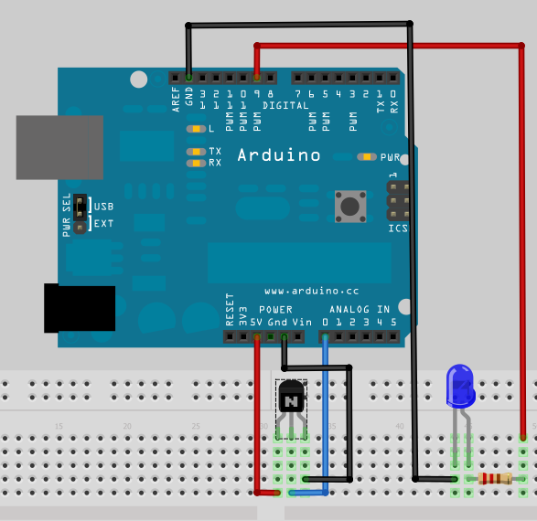
Componentes:
- Arduino
- Resistor 220 ohms
- Circuito Integrado LM35
- LED azul
- 5 Jumpers

Código Fonte:
const int inPin = 0; // analog pin
const int ledPin = 9; // analog pin
void setup()
{
Serial.begin(9600);
pinMode(ledPin,OUTPUT);
}
void loop()
{
int value = analogRead(inPin);
float millivolts = (value / 1024.0) * 5000;
float celsius = millivolts / 10; // sensor output is 10mV per degree Celsius
int rate = map(celsius,20,30,0,255);
analogWrite(ledPin,rate);
delay(500); // wait for one second
Serial.println(celsius);
delay(500); // wait for one second
}

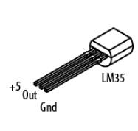

Anotações: Objetivo, fundamentação teórica (conceitos utilizados), metodologia do experimento, processo experimental, apresentação e análise dos resultados.

_________________________________________________________________________________________

_________________________________________________________________________________________

_________________________________________________________________________________________

_________________________________________________________________________________________

_________________________________________________________________________________________

_________________________________________________________________________________________

_________________________________________________________________________________________

_________________________________________________________________________________________

_________________________________________________________________________________________

_________________________________________________________________________________________

_________________________________________________________________________________________

_________________________________________________________________________________________

_________________________________________________________________________________________

_________________________________________________________________________________________

_________________________________________________________________________________________

_________________________________________________________________________________________

_________________________________________________________________________________________

_________________________________________________________________________________________

_________________________________________________________________________________________

_________________________________________________________________________________________

_________________________________________________________________________________________

_________________________________________________________________________________________

_________________________________________________________________________________________

_________________________________________________________________________________________

_________________________________________________________________________________________

_________________________________________________________________________________________

_________________________________________________________________________________________

_________________________________________________________________________________________

_________________________________________________________________________________________

_________________________________________________________________________________________

_________________________________________________________________________________________

_________________________________________________________________________________________

