**Chapter 1**

**March 2023**

**13 - Work organization**

In bioinformatics and computational biology it is extremely important to organize your

files, scripts, reports, among others. In table 1.1, I mention the most important aspects

that should be addressed in your organization and helpful tools.

In summary, you need an adequate tool for each aspect, say latex or word for project

documentation, and a backup and/or version control tool, say GIT or a cloud option for

project documentation.

Table 1.1: Aspects of organization and respective tools.

| **Aspect** | **Tools and backup** |
| --- | --- |
| Project documentation | Latex & GIT; word & cloud; google docs |
| Scripts | GIT; cloud |
| Papers, reports and presentations | Latex & GIT; word & cloud; google docs |
| Bibliography | Latex; Citavi, etc. |

**Learning Latex**

|  |
| --- |
| - Working folder: path  - Source: <https://github.com/waltercostamb/Lab-Book> |

Latex is a high-quality typesetting system, available as free software, which allows to produce scientific or technical documents [ProjectLaTex, 2017]. I am using Latex to create a Bioinformatics Lab Book. To compile my Lab Book, I can use command lines (pdflatex and bibtex). Afterwards I can visualise the produced .pdf file with evince or another reader. Alternatevily, I can use a Latex editor, such as TexWorks (https: //www.tug.org/texworks/), which allows me to write the code and control the pdf file in the same environment (Figure 1.1).

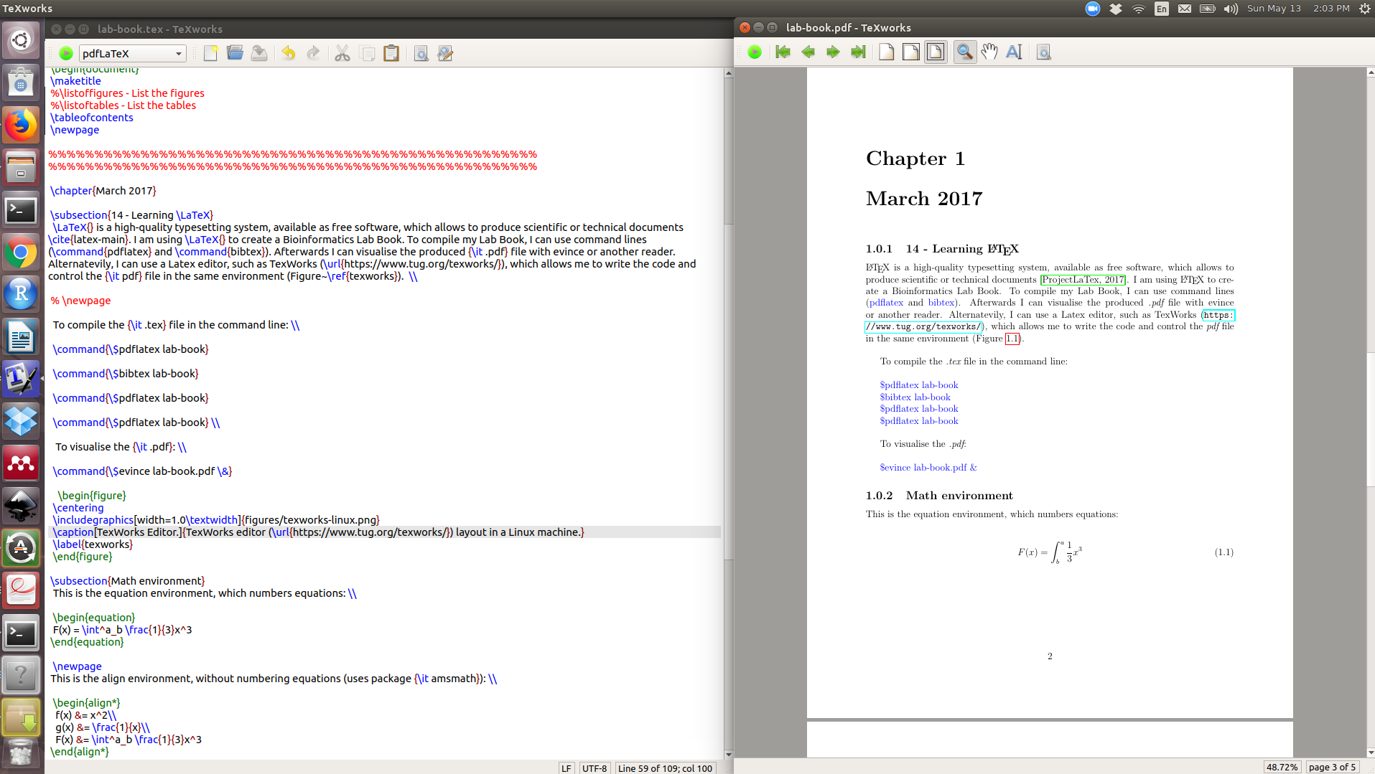Figure 1.1: TexWorks editor (<https://www.tug.org/texworks/>) layout in a Linux machine.

**13 – Project proposal**

Some text here.

• First numbered list item

• Second numbered list item