Lab 11: The Age of the Earth

**1. Introduction**

Many kinds of nuclei are radioactive: randomly, over time, they change into other kinds, spitting out high-energy nuclear radiation as they do so. We think of radioactivity as something artificial, but there are many kinds of naturally-radioactive things in our world. For instance, carbon-14 (written 14C) is produced in the atmosphere; over thousands of years it decays into nitrogen-14, spitting out electrons. It is impossible to know exactly when any one atom will decay. All I can talk about are probabilities: I can say, for instance, that “after a few thousand years, there is a 50% chance that this one atom will have decayed to nitrogen-14.” But, since atoms are so small, if I have a large amount of carbon-14, it will decay at a steady rate. Other radioactive isotopes will decay more or less quickly. Uranium-238 decays into lead-238 far more slowly; it takes 4.5 billion years for half of a sample of 238U to decay into 238Pb.

**1.1 Isotopes**

Wait ... radioactive carbon? As you remember from your high school chemistry class, the nucleus of an atom is made of both protons and neutrons. Only the number of protons matters for the chemical properties of an atom – things like what kind of compounds it forms and what role it plays in living things. All of our element names tell you only how many protons are in the nucleus: for instance, carbon has six protons per atom; uranium has 92. However, the nuclear properties also depend on how many neutrons are in the nucleus. For instance, “ordinary” carbon has six protons and six neutrons, but the radioactive carbon described above has six protons and eight neutrons. Forms of an element with different numbers of neutrons are called isotopes, and are named based on their total number of protons plus neutrons. So ordinary carbon is called “carbon-12” (12C), and radioactive carbon is called “carbon-14” (14C). When a 14C atom decays, one of the neutrons changes into a proton plus an electron. The proton stays in the nucleus, and the electron is kicked out of the atom at high speed. This is how carbon can change into nitrogen: it gets an extra proton in the decay. The key things for you to know are:

* The same chemical element (e.g. carbon) can have multiple isotopes with different nuclear properties
* Those isotopes have the same chemical properties: for instance, 14C is used by the body in the same way as 12C.
* Some of those isotopes may be radioactive, and decay over time to other elements

**2. Half-life**

In this lab, we’ll see how the rate of radioactive decay can be used to measure the age of materials. Every radioactive isotope decays at a unique rate, but that decay is always *exponential*. This means that it has a fixed half-life: the amount of time that it takes half of the remaining material to decay. For instance, the decay of carbon-14 proceeds like this:

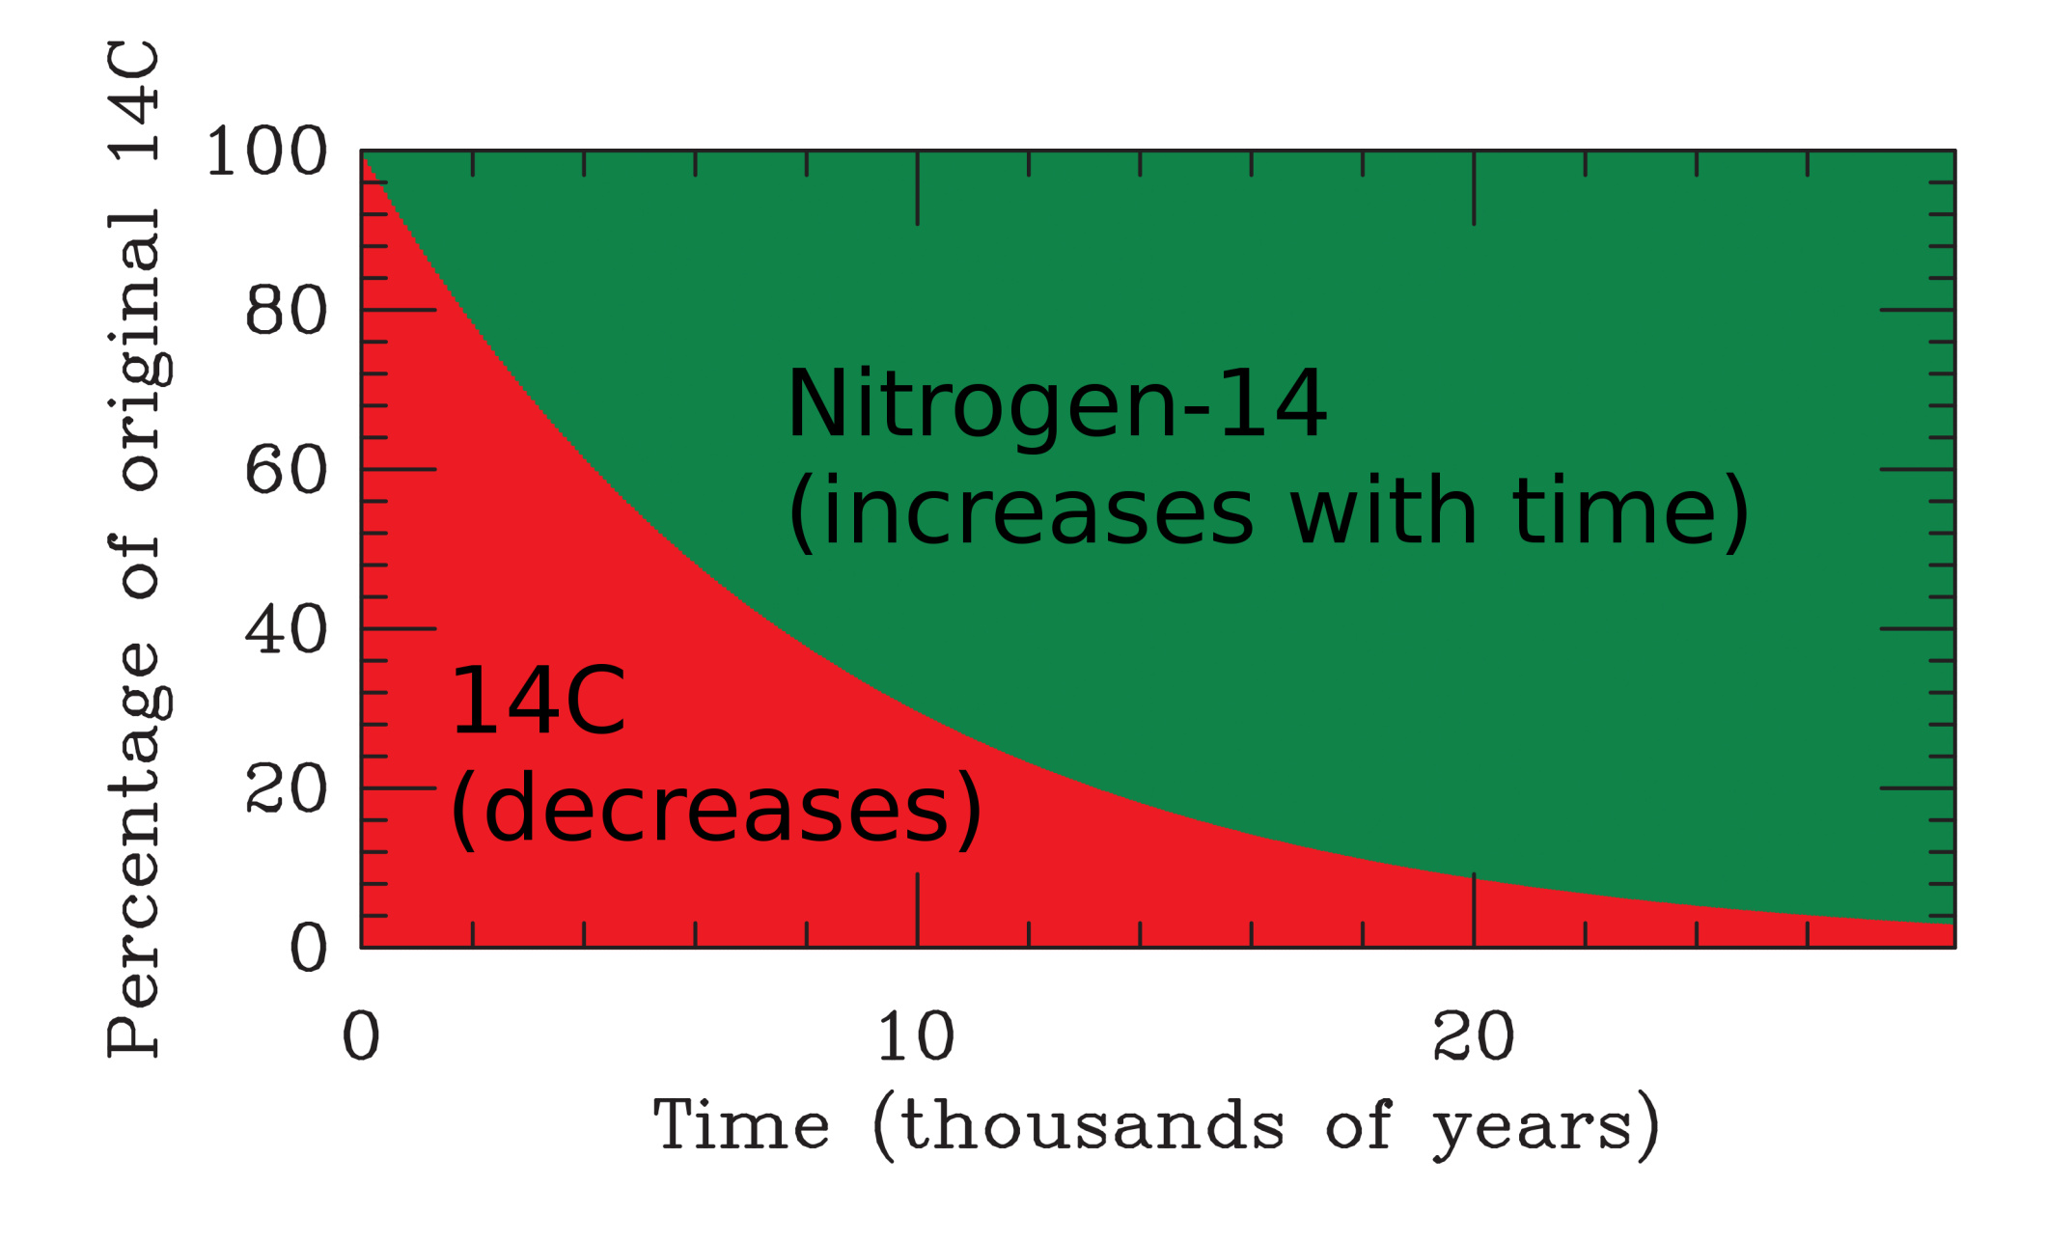

**Question 1.** From the graph, how long did it take for half of the 14C to turn into 14N? This time is the *half-life*.

|  |
| --- |
|  |

**Question 2:** How long will it be until only 1/4 of the original sample is made of 14C? How many “half-lives” is this?

|  |
| --- |
|  |

**Question 3:** How long will it be until only 1/8 of the original sample is made of carbon-14? How many “half-lives” is this?

|  |
| --- |
|  |

**Question 4:** Suppose you have a sample that is almost completely gone. You measure it and see that only 1/32 of the original 14C atoms are left. How old is it? This is the principle behind carbon dating: by determining the fraction of the original 14C that is left, we can estimate how old something is.

|  |
| --- |
|  |

**3. Simulating radioactive decay**

One of the more counterintuitive ideas here is that the decay of individual atoms is random, but the rate of decay of large collections of atoms can be very predictable.

To simulate this, we will look at rolling dice. The process is:

* Count how many dice you have, then roll them all
* Remove all of the ones that come up 1, then roll them again
* Repeat this process until (almost) all the dice are gone

Since we can’t use real dice because of the pandemic, we will use an online dice rolling program. The best one to use is Google’s -- see <https://www.google.com/search?q=dice+roller> . If you cannot use it, use <https://rolladie.net/> .

Add 120 six-sided dice to your simulated bucket of dice. Then, repeat the above, rolling them all and removing the ones that come up 1.

You should record your results two different ways: both on a graph and a data table. (The table is two pages down in this document.)

It is everyone’s responsibility to make sure that they are accurate and to help take data! One person should do the actual dice rolling and count the dice. The second person should watch the “dice rolling” and help count; notice that Google rearranges the dice in rows of different sizes as they are depleted. They should then update the data table on the next page of this document.

Then, one person should be in charge of graphing the data and sharing the graph with the others in the group. If it would be useful, there is a blank piece of graph paper at <https://walterfreeman.github.io/ast101/graphpaper.pdf> . You have several options for graphing:

* Use a touchscreen device to draw on top of the graph paper at <https://walterfreeman.github.io/ast101/graphpaper.pdf> , then save the result and share it with your group
* Print that page and draw on it with a pencil
* Generate your own graph using Excel, Google Sheets, or your favorite spreadsheet program
* Draw your own graph by hand

Regardless of which you choose, whoever maintains the graph should share it with their group, and you should all inspect it to make sure that there aren’t any errors and that it matches the data table.

Once you’re finished (all the dice are gone), connect the dots on your graph with straight lines. (If you are using a computer graphing program, it may do this for you.) This will let you determine the half-life of your dice with more precision. For instance, if you started with 120 dice, and there were 65 left after 3 rolls and 55 after 4 rolls, the line between these two points would cross the “60” line between 3 and 4. Thus you might conclude that half of the dice “decayed” after 3.5 rolls. This procedure of connecting the dots to get more precise estimates is called “interpolation” in mathematics. Once you have your graph and your interpolated halflife, show it to your TA. Then include that graph in this document -- you may take screenshots of a spreadsheet, photograph a graph on paper, etc.

|  |  |
| --- | --- |
| Number of Rolls | Dice Remaining |
| 0 |  |
| 1 |  |
| 2 |  |
| 3 |  |
| 4 |  |
| 5 |  |
| 6 |  |
| 7 |  |
| 8 |  |
| 9 |  |
| 10 |  |
| 11 |  |
| 12 |  |
| 13 |  |
| 14 |  |
| 15 |  |
| 16 |  |
| 17 |  |
| 18 |  |
| 19 |  |
| 20 |  |

**Question 5:** How many rolls did it take for your dice to decay from 120 to 60? This will give you an estimate of the half-life of your dice. Remember, based on your interpolation, your answer may be a decimal.

|  |
| --- |
|  |

**Question 6:** How many rolls did it take for your dice to decay from 60 to 30? This will give you another estimate of the half-life of your dice.

|  |
| --- |
|  |

**Question 7:** How many rolls did it take for your dice to decay from 30 to 15? This will give you another estimate of the half-life of your dice.

|  |
| --- |
|  |

**Question 8:** If you were to quote to someone the half-life of your dice in “rolls”, what would you tell them? How did you determine this based on your answers to the preceding three questions?

|  |
| --- |
|  |

**Question 9:** Is the decay of your dice smooth and predictable when there are many of them left? What about for the last few? How does this limit the maximum age of objects that can be dated with carbon dating?

|  |
| --- |
|  |

**Question 10:** Suppose someone gives you a bin of dice and asks the following question: *“I started with 200 dice. Now I have only 60 of them left. I’ve forgotten how many times I’ve rolled them, though, but I did the same thing you did – I rolled them and removed all the 1’s. All I know is that I started with 200 and I only have 60 left now. Can you help me figure out about how many times I’ve rolled them all?”* What would you tell them?

|  |
| --- |
|  |

**4. The Age of the Earth**

In order to date the Earth, we need isotopes with much longer half-lives. Two of these are uranium-235 (which decays into lead-207) and potassium-40 (which decays into argon-40). The age of the Earth has been measured with these radioactive decays, as well as others. First, let’s think about the decay of uranium-235 into lead-207 with a half-life of 710 million years. A type of rock called zircon sometimes forms with uranium atoms included in it, but does not include lead.

**Question 12:** Geologists have found zircon crystals all around the world like this. Suppose that you find such a crystal, and there are fifteen lead-207 atoms for every uranium-235 atom inside the zircon. How long ago did this rock form? If you are stuck on this problem, retrace the history of the uranium-235 and lead-207 in this crystal in the following table. I’ve filled out the first two rows for you:

|  |
| --- |
|  |

|  |  |  |  |  |
| --- | --- | --- | --- | --- |
| Half-lives | Years elapsed | 235U fraction | 207Pb fraction | Schematic of atoms |
| 0 | 0 | 16/16 | 0/16 | UUUUUUUUUUUUUUUU |
| 1 | 710 million | 8/16 | 8/16 | LLLLLLLLUUUUUUUU |
| 2 |  |  |  |  |
| 3 |  |  |  |  |

**Question 13:** The oldest zircon crystals that we find have around sixty-three lead-207 atoms for every uranium-235 atom; in other words, the composition of these two atoms, taken together, is 63/64 lead-207 and 1/64 uranium-235. About how old are they? This gives us an estimate of the age when the Earth’s surface cooled enough to form rocks like zircon. (It is actually a few hundred million years older than this; I rounded off to a 63:1 ratio to make it easier to do the math.)

|  |
| --- |
|  |

**Question 14:** When we apply radioactive dating to the Earth, asteroids that fall to Earth, rocks from the Moon, and the surface of Mars (using robots), we get the same value: around 4.5 billion years old. What does this tell you about the formation of the Earth, the Moon, asteroids, and Mars?

|  |
| --- |
|  |

**5. A Natural Nuclear Reactor?**

As we discussed earlier, uranium is made of two isotopes: 235U and 238U. 238U cannot be used to sustain a nuclear chain reaction, but 235U can. These isotopes are always found mixed together in nature.

To produce a nuclear chain reaction (as in a power plant), uranium must be mixed with another substance called a *moderator*.

If a mixture contains more than 2% or so of 235U mixed with water, it will “go critical”, like a nuclear power plant, and produce lots of heat.

However, natural uranium is only 0.5% 235U and 99.5% 238U, so we cannot build a nuclear reactor out of natural uranium and water.[1]

In the previous part, you discovered that 63/64 of the 235U that was present when the Earth was formed has decayed. However, the half-life of 238U is much longer; it is about 6 times longer (4.5 billion years rather than 710 million years).

Fire up the Google dice roller again, and add lots of 20-sided dice (d20’s) and lots of 4-sided dice (d4’s). Roll them many times, removing all of them that come up “1”. As you may have guessed, the d20’s represent one isotope of uranium, and the d4’s represent the other.

Which type of die represents atoms of the long-lived isotope (238U) and which represents the short-lived one (235U)?

|  |
| --- |
|  |

Over time, how does the fraction of 235U in the remaining pool of uranium atoms change?

|  |
| --- |
|  |

**Question 15:** Around two billion years ago, geologists believe that a “natural nuclear reactor” formed in what is now Oklo, Gabon, in Central Africa. At that time (about three half-lives of 235U ago), was the 235U percentage of Earth’s uranium higher, lower, or the same as it is now (0.5%)? Estimate that percentage. *(Remember, both isotopes of uranium are radioactive, but 238U has a much longer half-life. You don’t have the tools to calculate exactly how much the 238U has decayed in two billion years; you should estimate this given that two billion years is about one-half of its half-life.)*

|  |
| --- |
|  |

1. Nuclear reactors use either very pure carbon or deuterium oxide as moderators, which are more efficient, or uranium that is “enriched” to 3-5% 235U.