Lab 8: Spectroscopy (I)

**Instructions:** You will either need to complete this lab on a printed copy with a pencil, or annotate this document electronically. You may do this either by drawing on it with your mouse (with Google Docs’ “drawing” feature) or a stylus and touchscreen, using a tablet computer or any other device you have.

**2. Introduction**

In the next few labs, we’ll be studying the properties of light – specifically, how different objects interact with different colors of light, and how we can learn about the composition and temperature of objects by examining their wavelength. Wavelength is associated with color. For instance, the shortest-wavelength light that we can see appears blue or purple, and the longest-wavelength light that we can see appears red. But there are other “colors” of light – other wavelengths – that we can’t see. For instance, x-rays have very short wavelength and radio waves have very long wavelength, but they are both types of light. This range of wavelengths is called the *electromagnetic spectrum* and is sometimes visualized like this:

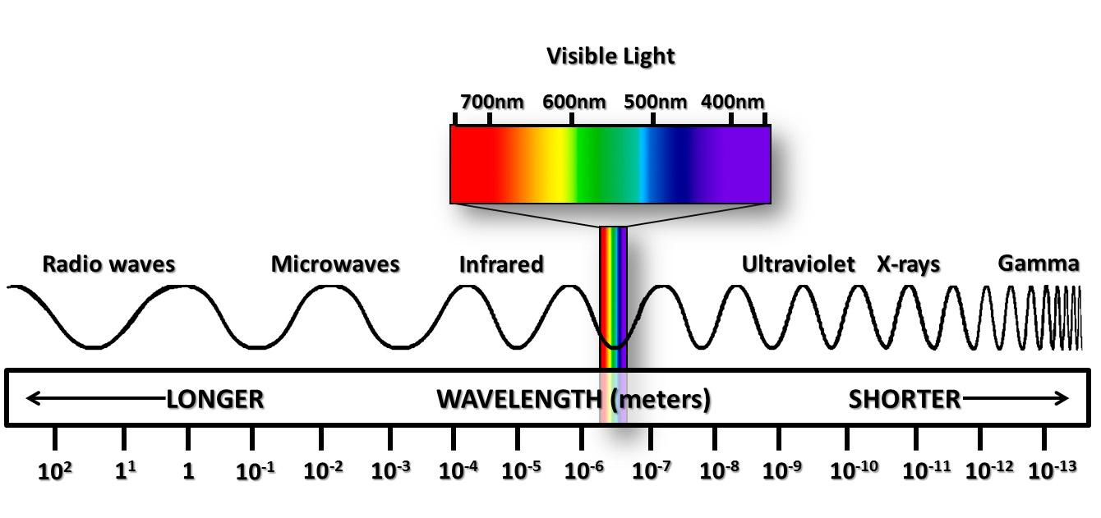

For this prelab, we'll focus mostly on those colors that we can see. One of the difficulties in this business is the very limited way that our eyes see color. You may have learned that there are “three primary colors” -- red, green, and blue. However, these colors are not special; they are simply that the eye can detect. When we are exposed to yellow light, for instance, its wavelength lies between red and green, and thus stimulates both the red and green receptors in our eyes. Our brain says ``Aha! This must be yellow!'' So our eyes are not the best tool around for perceiving color: we can't tell, for instance, whether we are looking at a mix of red and green light, or whether we are looking at actual yellow light. We will later use an instrument called a *spectroscope* that will let us do better than our eyes. But for this part, there may be multiple plausible answers, because of how our eyes work. That's okay.

Since a great way to visualize things is to make a graph, we often make graphs of “how much light” vs. “color of light”. Later we'll label color with numerical values for wavelength, but for now we'll just use the names of colors. The light reflected from the greenish-yellow grass outside, for instance, might look like this:

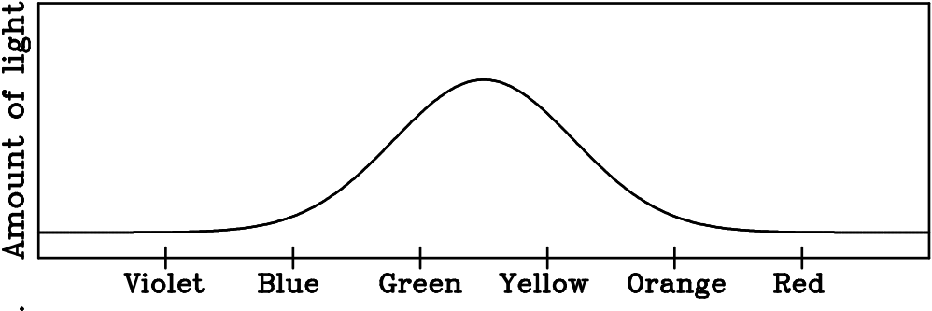

You could read this as “lots of green and yellow light, and a little bit of other colors”.

Note that light that appears white is a fairly equal mixture of all colors of visible light; you know this because white light can be split into a rainbow (containing all those colors) in various ways.

**2. Drawing spectra**

Draw spectra that depict the colors of the following in the blank graphs below:

A clear sky with no clouds:

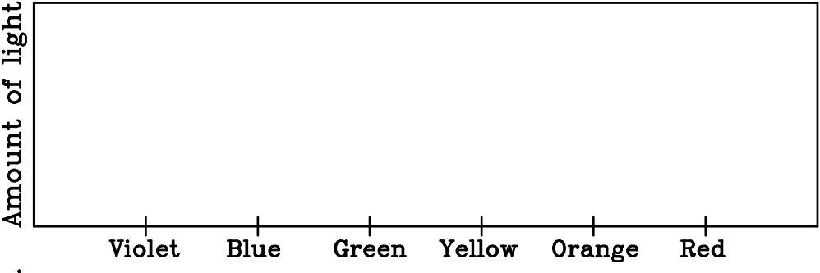

The color shirt you are wearing right now (write what color that is below):



The color of a sunset:



**3. Incandescence, also called thermal radiation**

One of the most common sources of light in the Universe is the glow of hot objects, like stars. This phenomenon is called *incandescence.* Light from incandescence tends to produce broad spectra: the Sun doesn't just emit a single color of light, it emits light of many different nearby wavelengths. The hotter it is, the shorter the wavelength it emits.

As you may know, if you heat an object up, it will first appear red (“red hot”), then begin to turn orange, yellow, and white, as the colors of light that it emits shift to shorter and shorter wavelengths.

Given this, draw spectra that depict the colors of the following. (They should obviously reflect your experience with these objects!)

The Sun, which has a temperature of about 5000 degrees C:



A candle flame, which has a temperature of about 1200 degrees C:



The burner of an electric stove, heated enough that it just barely begins to glow (around 600 degrees C)



Imagine the last example -- the stove burner, heated up enough that it just starts to glow. Imagine that you turn the power off so that it cools down to 450 degrees, so you can no longer see it glow. Is it still emitting light? If not, explain why not. If so, draw its spectrum below.

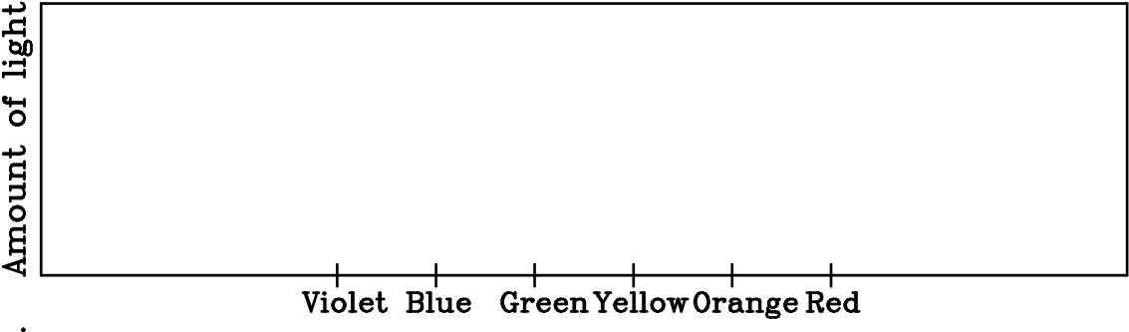

**4. Spectra from Different Sources**

Here are two pictures of spectra (taken with my camera through a diffraction grating like the one you saw in class). One is from a hot object; the other is from a tube of diffuse gas excited with an electric current. Below them, draw graphs similar to the ones you drew above. Then tell which one is which, and how you know.

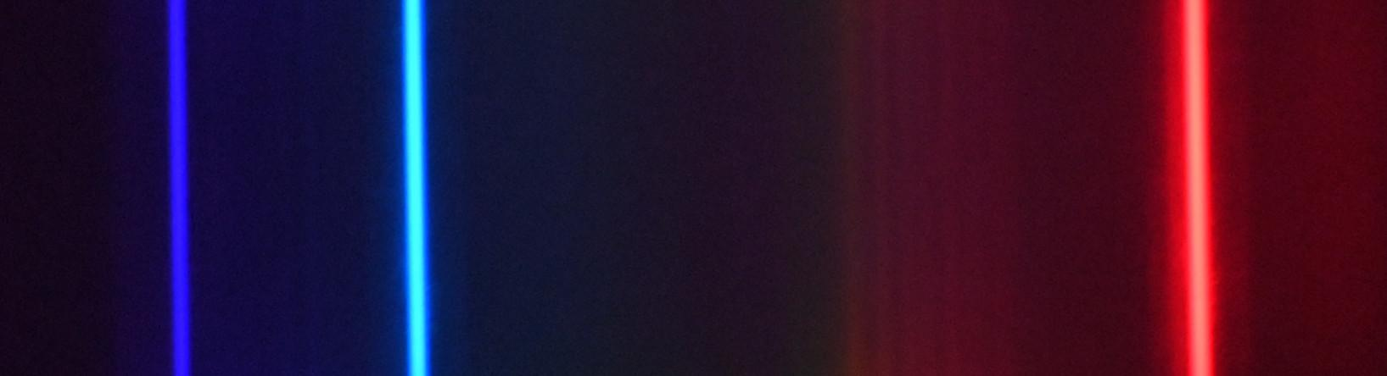



One day, I turned off all of the lights in the Physics Building basement, and closed the door to one room that had a light on, so that only a thin crack of light emerged from the door. There was a little stray light coming from the other side of the hallway.

There are multiple types of lights that we use that all look the same to our eyes. Incandescent lights create light from a hot object; fluorescent lights create a spectrum from a tube of diffuse gas with electricity running through it (like the discharge tube in class). However, both types look yellow-white to white.

I then photographed the cracked door through the diffraction grating. Here’s the picture:

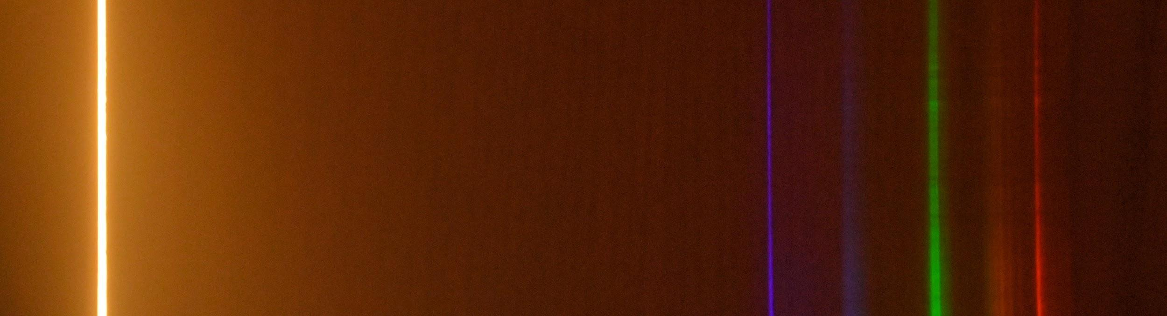

Was this room lit by incandescent light or fluorescent light? How do you know?

**5. The Blackbody Radiation Simulator** (“Blackbody radiation” is another name for incandescence.)

Go to the webpage <https://phet.colorado.edu/sims/html/blackbody-spectrum/latest/blackbody-spectrum_en.html>. It has a simulator like the one I wrote for class that will let you simulate the thermal radiation from objects of different temperature.

The horizontal axis indicates the wavelength of the emitted light and the vertical axis indicates the amount of energy per second (power) emitted by one square meter of the object at a particular wavelength.

To start with, set the temperature to 5800 K. Either move the slider or type the numbers in the temperature box. 5800 K is approximately the temperature of the Sun.

Note that the horizontal axis specifies the emitted wavelengths λ in units of micrometers, µm. One micrometer equals 1000 nanometers. (1µm = 1000 nm.) For example, look at the visible spectrum. The longest wavelength of the visible spectrum is approximately 0.7µm = 0.7x1000nm or 700nm.

Observe the peak of the curve. The Sun emits the most energy at this wavelength. We will label this wavelength λpeak – the wavelength where the curve is at its peak. What color corresponds to λpeak? What color is the Sun?

What wavelength, numerically, is λpeak? Give your answer both in nm (the units we usually use) and µm (the units used by the simulator).

Now, change the temperature to 7500 K, to simulate the thermal radiation from a hotter star. You’ll again need to rescale the axes to make the graph fit on the screen. In what two ways does this peak differ from that of the Sun?

Suppose that you had a star with a temperature of 7500 K that was the same size as the Sun. How would its color and brightness differ from the Sun? Explain based on what you see in the simulator.

The incandescent light we saw in my office on Thursday in the classroom is connected to a switch that lets me control the amount of heat it generates. Here are pictures of that light at low power (with a lower temperature) and high power (with a higher temperature). The black horizontal lines in the spectrum on the right are *not* part of the spectrum; they are the effect of structures in the lamp that physically block some of the light.

Draw graphs of their spectra below.

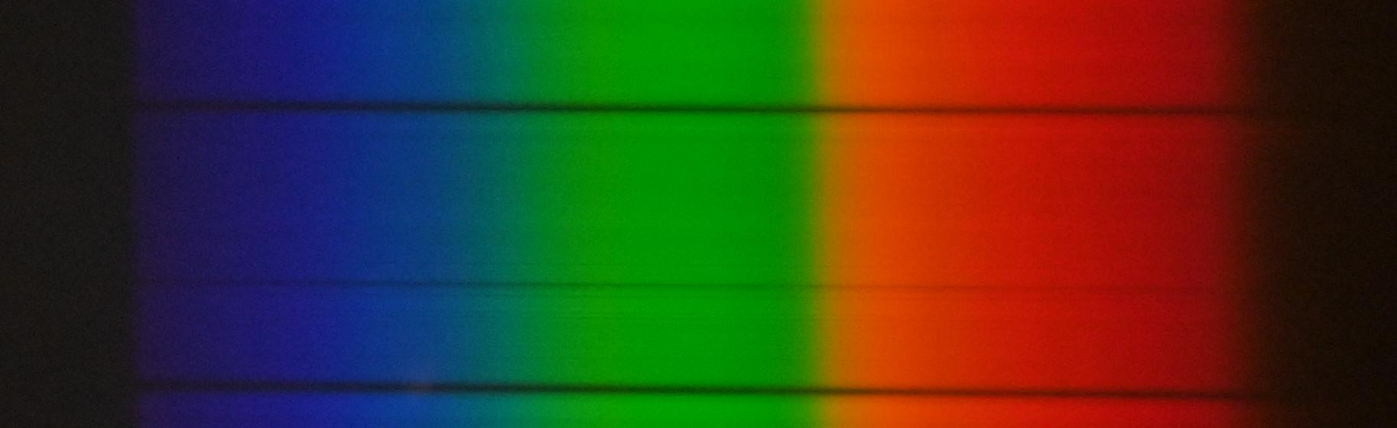



One of these is at high temperature and one is at low temperature. Play around with the Blackbody Spectrum simulator online and look at how the curve it produces depends on temperature, and then estimate the temperature of each one. ***NOTE:*** The photograph at low temperature was exposed for a much longer time and a higher sensitivity, since it produced much less light.

Betelgeuse is a red giant star that is only 3600 K, compared to the Sun which is around 5700 K. However, it’s extremely bright – around 100,000 times brighter than the Sun, when viewed from the same distance away. How could a cooler star be brighter than the Sun? Explain.

Gradually reduce the temperature in the simulator. While you do, rescale the graph using both the “zoom in/out” controls to change the wavelength range, and the “+ / -” controls you used before to change the intensity range. Go down to 300 K – the temperature of things around us. What range of wavelengths do they mostly emit? (Give your answer in both µm and nm.) How does this compare to the visible-light spectrum?

**6. Colored Lines and Filters**

“Colored objects” -- like tinted glass -- can’t produce any wavelengths that aren’t already present. Instead, they *block* certain wavelengths and let others pass through.

Here are two more spectra. Both of these look pink/purple to our eyes. However, one of them is a hot object seen through tinted glass; the other is light from an electrified tube of gas. Draw spectra for them below.

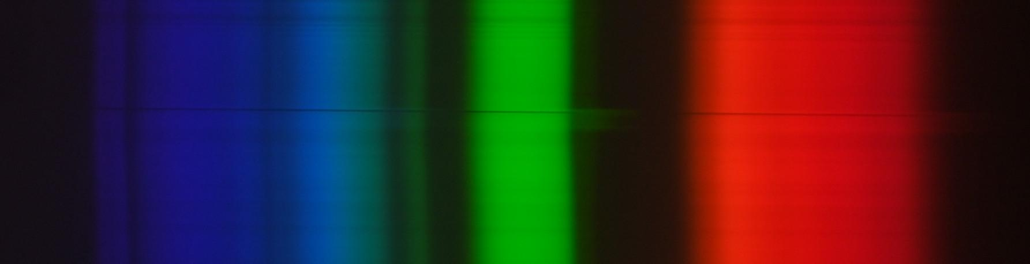



Which one is which, and how do you know?

**7. The Solar Spectrum**

Here is an image of the Sun’s spectrum -- lower resolution than the one we used in class.



What process do you think causes the Sun to emit light? Is it thermal radiation from a hot object, or is it some other process similar to the gas discharge tube? How do you know?

What features of the Sun’s spectrum do *not* match other light sources of the type that you identified in the previous question? What causes those features? Are they similar to anything else you have seen in this lab?

**7. Wrapping Up**

As you’ve seen, different objects produce a different mix of wavelengths of light. Discuss the information you get about the wavelengths of light from your eye alone vs. the information you can get from a spectroscope like the one I have used to make these pictures. Is there any information you *cannot* get with this type of spectroscope about the wavelengths of light produced by an object?

**8. Spectral Lines and Energy**

Here’s a warmup for next week’s lab.

Suppose you have an atom with energy levels of 0 eV, 1.9 eV, and 4.3 eV. If you put a diffuse gas of this element in a tube and run current through it, it will emit light.

What *photon energies* will it emit, and how do you know?

On the next page there is a continuous spectrum, this time labeled with both wavelengths (in nm), photon energy, and color. Indicate (by drawing lines on top of the image) what colors of light this tube will emit.

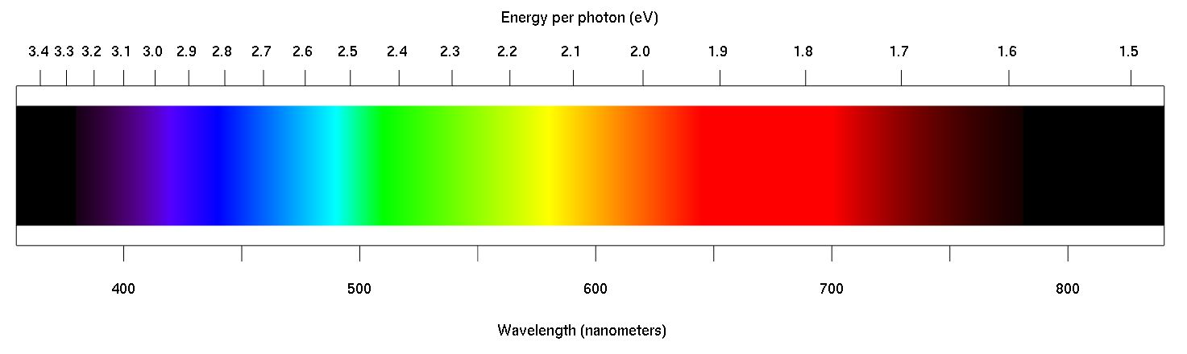

What color do you expect this tube to glow (as seen by the eye)? Could you produce something that *appeared* to be this color with a different combination of wavelengths?

Are there any *other* colors that are invisible to our eyes that this tube would produce? Which ones?