AST101: Our Place in the Univrse

Lab 2: The Phases of the Moon

Version for Groups Meeting in Person

*(Your group should import this document as a shared document into either Microsoft Office365 or Google Docs. Then your whole group should edit it together. If one member of your group is not present, list their name and write “absent” beside it.)*

|  |  |  |  |
| --- | --- | --- | --- |
| **Group Number and Name:** | |  | |
| **Member Name #1:** |  | **Email #1:** |  |
| **Member Name #2:** |  | **Email #2:** |  |
| **Member Name #3:** |  | **Email #3:** |  |
| **Member Name #4:** |  | **Email #4:** |  |
| **Lab Time and Date:** |  | | |
| **Collaboration Method (in-person, online on Collaborate, etc.)** |  | | |

*If someone in your group does not show up and did not tell you why, write “unexpected absence” by their name. If someone does not show up and has a good reason, write “expected absence” by their name, and describe what happened below.*

|  |
| --- |
|  |

Last week, we studied the Sun, at great length. This week, we turn our attention to the next

most prominent celestial object in our sky; the Moon. Unlike many of the objects we see, the

Moon appears to change both its location and its nature, appearing at times as a tiny sliver and at

others as a filled circle, and everything in between. Ancient societies used this transient nature of

the Moon to mark the passage of time in their calendars, and to denote the beginning of special

festivals. Our own Gregorian calendar has a remnant of this: our months are approximations of

the lunar cycle. We will study the Moon, and the cause for its phases, in detail today.

This lab will involve a lot of “pointing at the sky” with your fingers and thinking about how the Moon would look if the Moon and Sun were at those points. Take this seriously; it’s the best way to figure out how the Moon will look.

Since the Moon is on the same plane as the Earth’s orbit and the Sun, it follows the same path in the sky. So it will rise in the East, move up in the southern sky, and then set in the West.

If the Moon is visible in your sky, it will lie along this path, called the *ecliptic*. Look in your sky (when you are doing this lab) along the ecliptic. Do you see the Moon there? If you do, describe where in the sky you see it. If you don’t, then that’s okay; skip to the next part.

Describe where in the sky you found the Moon, and also where the Sun currently is. (If the Sun is not currently visible, use what you know about the motion of the Sun to predict where it is.) Also, describe its appearance. Is it half lit? Fully lit? A thin crescent?

|  |
| --- |
|  |

Get your laptop out and fire up *Stellarium,* and set it to the current date and time. If you were able to see the Moon in your sky, describe whether *Stellarium* correctly predicts the place you found it. If you were not able to see the Moon, turn off the ground temporarily in *Stellarium*, and describe where the Moon and Sun are. (They might be above the horizon but hidden by clouds; they might be below the horizon. Your answers here will depend on what day and time your lab is.)

|  |
| --- |
|  |

Speed up time in Stellarium and watch the Sun and the Moon over one day. Notice that they move in the sky as follows:

* They both rise in the East
* … move high in the southern sky
* … set in the West
* … and then travel from West to East *under the northern horizon*, until they rise in the East again the next day
* Over one day, the angle between the Sun and Moon stays almost constant – they follow the same path at nearly the same rate.

Now, set the date on *Stellarium* to September 1. Press Ctrl-F (on Mac it may be Cmd-F) and search for the Moon. This was the most recent full moon before this lab.

Discuss with your group: at what time of day do you expect the full moon to be highest in the sky? Why?

|  |
| --- |
|  |

Now, find the time when the Moon is highest in the sky on September 1. Were you right? What time is this?

|  |
| --- |
|  |

At this time, where is the Moon in the sky? Where is the Sun? *(Hint: You can’t see the Sun at this time, but you can figure out where it should be in your sky.)*

|  |
| --- |
|  |

Everyone in your group should point with one arm toward the Sun and the other arm toward the Moon. What is the angle between your two arms?

|  |
| --- |
|  |

Now, we’re going to take a tour through the moon phases as the Moon gets progressively less full during half a month – advancing by one-half week each time. Describe the Moon phases as follows:

* **Full** (or nearly full)
* **Gibbous**: more than half full
* **Half:** About half full
* **Crescent:** less than half full
* **New:** not visible

Describe the location of the Sun using terms like the following: below the northern horizon, low in the southeastern sky, on the western horizon, etc.

You’ll fill out this chart as you go. Fill out the first row for September 1.

|  |  |  |  |  |
| --- | --- | --- | --- | --- |
| **Date** | **Moon Phase** | **Time when Moon is highest** | **Location of Sun at this time** | **Angle between Sun and Moon** |
| September 1 |  |  |  |  |
| September 5 |  |  |  |  |
| September 9 |  |  |  |  |
| September 12 |  |  |  |  |
| September 16 |  |  |  |  |
| Today’s date |  |  |  |  |

Now, let’s think about what happens on September 5. Since the Moon moves counterclockwise around the Earth when seen from above, we can predict what’s going on with a diagram showing the Moon’s position in its orbit, along with the parts of the Moon you can see from Earth.

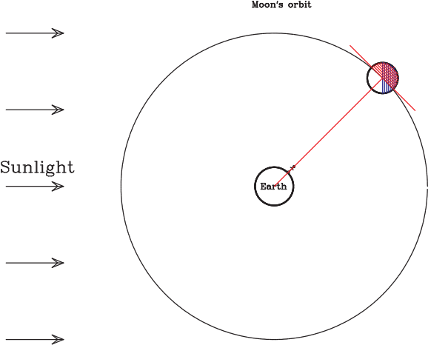

In this diagram:

* you’re looking down on Earth from above the North Pole
* the red line represents the observer’s sight line toward the Moon
* the portion of the Moon shaded blue can’t be seen because it is not lit by the Sun
* the portion of the Moon shaded red can’t be seen because it is not facing the Earth
* the stick figure is drawn at a time of day where this moon phase is highest in the sky.

Without using *Stellarium,* predict what phase of the Moon this represents.

|  |
| --- |
|  |

What time of day is shown here? At this time of day, where is the Sun? (Describe this generally, like “below the western horizon” or “high in the sky”). You’ll need to figure out which direction on the horizon is East and which direction is West.

|  |
| --- |
|  |

Now, set *Stellarium* to this time. Were you correct?

You and your group should again stand up and point with your arms in the sky. One arm should point to the position of the Moon when it is highest in the sky; the other arm should point to the position of the Sun at this time. (One of your arms might be pointing below the horizon; that’s okay!)

Estimate the angle between your arms, then go back up and fill out the September 5 row in the table.

Now, let’s move another half-week further in time, to September 9.

Here is a diagram showing the position of the Moon in its orbit on September 9, with the observer again in a position showing the Moon at its highest point. This time, I haven’t colored anything in.

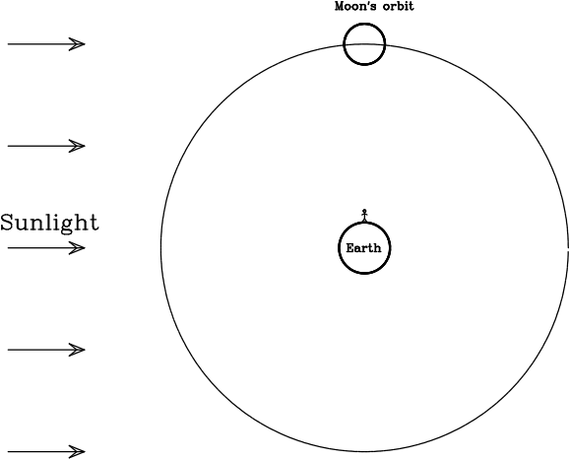

As always, half of the Moon will be lit by the Sun, and half will be dark. Which half will be lit by the Sun? (You can answer relative to the diagram, e.g. “the top half” or “the right half”.)

|  |
| --- |
|  |

Which half will be visible from Earth?

|  |
| --- |
|  |

Of the part of the Moon visible from Earth, how much is lit by the Sun? This tells you the moon phase you’re currently looking at.

|  |
| --- |
|  |

This diagram depicts the time of day when this phase of the Moon is highest in the sky. What time of day is this? Where would you look to find the Sun?

|  |
| --- |
|  |

Check your results with *Stellarium.* Everyone in your group should again point with one arm toward an imaginary Moon and with the other toward an imaginary Sun at this time. What’s the angle between them? Record your findings in the table earlier.

Let’s move forward another half-week, this time to September 12. The Moon has moved another eighth of the way around its orbit, and is now at this position:

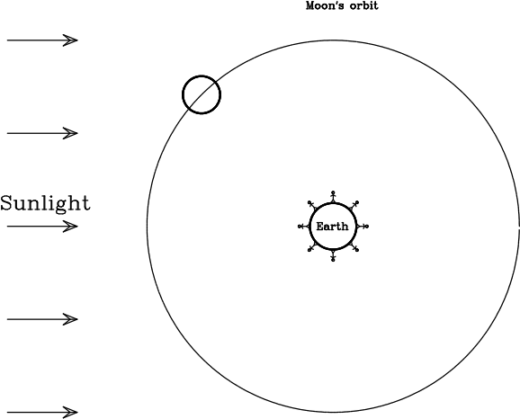

As you have probably guessed, this is a crescent moon. In this diagram, you’re looking down at Earth from above the North Pole. The stick figure is on the Equator, but imagine for now that you are located in the Northern Hemisphere. Would the left side or the right side of the Moon be bright? Talk to your group and reason through this with them, thinking about this diagram. Which side is bright, and how do you know?

|  |
| --- |
|  |

Here I’ve drawn eight different stick figures representing different times of day: midnight, 3:00, 6:00, 9:00, 12:00, 15:00, 18:00, and 21:00. Which of these stick figures is the one who would see this Moon highest in their sky? What time is it for them, and where would the Sun be?

|  |
| --- |
|  |

Again, everyone in your group should again point with one arm toward an imaginary Moon and with the other toward an imaginary Sun at this time. (If you’re not sure, call a coach over to discuss with you.) What’s the angle between them? Record your findings in the table earlier.

**Part 3: Rising and Setting**

Once you’re done recording your findings, let’s think about how the Moon and the Sun rise and set. Go back to the time from the previous part where the Moon was highest in the sky. Everyone should again point one arm at the Moon and the other arm at the Sun at this time.

Remember that the Earth, Moon, and Sun don’t move very much in space over one day; thus, the apparent motion of the Moon and Sun over one day is only because of the rotation of Earth. That means that the Moon and Sun will rotate counterclockwise around the North Celestial Pole, just like all the stars.

Do this with your arms. “Advance time” by rotating both of your arms counterclockwise slowly. (The angle between them should stay the same.) Keep doing this until the Moon “sets” over the western horizon. When this happens, where is the Sun? What time of day is it?

|  |
| --- |
|  |

Here’s the diagram again.

This time, get a blank piece of paper to serve as your “horizon”. Hold the paper against your computer screen vertically so it obscures the left half of the diagram. Then rotate it counterclockwise to represent the passage of time. Notice that at some point the Moon will appear above the horizon. Label the side of the horizon that the Moon appeared over “East”; the other side is “West”.

When the horizon is in this position, what time is it? (Remember that the horizon is parallel to the observer’s feet, separating the world below their feet that they can’t see from the world above their head that they can.

This is the time that the crescent moon will rise above the eastern horizon. Keep rotating; eventually you will get to the time when the Moon sets.

Did this result roughly agree with your previous result? Talk with your group: if you need to figure out something about the rising and setting times of different moon phases, which would be more helpful – the diagram or the method with your fingers in the air? Why?

|  |
| --- |
|  |

**Part 4: Putting it All Together: One Month**

Look back at the table on Page 3. You’ve filled out everything except for the “September 16” line.

e sky, where is the Sun, and what is the angle between the Sun and Moon? You should be able to figure out the pattern. Fill that in on the table.

You’re out of rows on the table, but you should still complete the month.

Go through all eight phases of the Moon this way: new moon, waxing crescent, waxing half, waxing gibbous, full, waning gibbous, waning half, waning crescent. For each phase, point to the Moon (at its highest point) and to the Sun (you’ll need to figure out where it will be!). You should notice a clear pattern between the *angle between the Sun and Moon*, and the *phase of the Moon*. What is that pattern?For each phase, point to the Moon (at its highest point) and to the Sun (you’ll need to figure out where it will be!). You should notice a clear pattern between the *angle between the Sun and Moon*, and the *phase of the Moon*. What is that pattern?

|  |
| --- |
|  |

Remember that the Sun and the Moon rise in the East, move up in the southern sky, set in the West, and then move from West back to East below the northern horizon. This path is called the *ecliptic* – the path of the Sun (and Moon) over one day.

Each of you should take turns. One person should point to an imaginary spot on the ecliptic for the Sun and another for the Moon. Then the other people in the group should discuss, and decide how full the Moon is, what time of day it is, and what time that phase of the Moon will set. (Determining the moon-set time can be done by just “passing time” with your arms, rotating them counterclockwise around the North Celestial Pole until the Moon “sets”.) If you can do this, you can figure out anything you want about the Moon! I’ve done one for you.

|  |  |  |  |  |  |
| --- | --- | --- | --- | --- | --- |
| Person | Position of Sun | Position of Moon | Phase | Time of day | Moon set time |
| Walter | Directly below the northern horizon | Southwestern sky | Gibbous (waxing) | Midnight | 3AM |
|  |  |  |  |  |  |
|  |  |  |  |  |  |
|  |  |  |  |  |  |
|  |  |  |  |  |  |

*When you are done with your lab, make sure your document is still set to the sharing option “Anyone with the link can view”. Then email a link to your shared document to* [*suast101labs@gmail.com*](mailto:suast101labs@gmail.com)*. The subject line in your email should be “Lab 2 – Group #### – <your names>”.*