Project 2: The Seasons, the Sun, and the Moon

Variant A: Astrophotography

Due at the end of the day Wednesday, September 23

|  |  |  |  |
| --- | --- | --- | --- |
| **Group Number and Name:** | |  | |
| **Member Name #1:** |  | **Email #1:** |  |
| **Member Name #2:** |  | **Email #2:** |  |
| **Member Name #3:** |  | **Email #3:** |  |
| **Member Name #4** |  | **Email #4:** |  |
| **Collaboration Time and Date:** |  | **Evaluating Group Number:** |  |
| **Collaboration Methods (in-person, Zoom, etc.)** |  | | |

In this project, you’ll think through the planning of a very special night sky photograph.

Suppose you have two friends who are getting married, and have asked you to take engagement photos for them. They fell in love while hiking and camping in the Adirondack Mountains, and want you to take a picture of them to memorialize that. They’ve asked you for something very special: a photograph of them standing together with Mt. Marcy in the background (the tallest mountain in New York State), with the Milky Way coming up behind Mt. Marcy. They want you to do this picture with only natural light, and without any Photoshop tricks[1].

The brightest portion of the Milky Way lies roughly on the same plane as Earth’s orbit, called the *ecliptic.* Thus, its path through the sky during the day is roughly the same as the Sun’s.

At first, this seems impossible! You will need very dark skies to see the Milky Way – which means their faces will be dark, and you won’t be able to see them! But, after thinking about it, you realize that you can use *moonlight* to light their faces. But the full moon will be too much light: you need a moon that is half full or less, low on the horizon.

They’re not getting married for a while, so you can take your picture at any time of year.

You need the following things to make your photograph:

* The brightest part of the Milky Way visible in the sky. (This lies between Sagittarius and Scorpio.)
* No sunlight visible in the sky. This means that it has to be dark – at least an hour and a half after sunset and an hour and a half before sunrise.
* *Some* moonlight to show their faces and to cast a little light on the slopes of Mt. Marcy, but not so much that it makes it impossible to show the Milky Way: the Moon, no more than half full, visible slightly above the horizon.

Your group’s task is to figure out how to do this. You’ll need to plan four things.

* the time of year (what month)
* the time in the lunar cycle (the date of that month)
* where, relative to Mt. Marcy, you want them to stand, so that the Milky Way is visible behind them
* the time of day

They want you to show them three things:

1. A description of how you know that your chosen date, location, and time will work. This description can take any form you want, but should involve a diagram you create showing the Earth, your location on the Earth, the Moon, and the Milky Way (remember, it’s between Sagittarius and Scorpio). You’ll need to convince them that the Moon will be low in the sky and no more than half full, the Sun will be below the horizon, and the Milky Way will be high in the sky.  
     
   There is a diagram on the next page, showing the alignment of the Zodiac with the seasons, that you can base yours on. You’ll need to specify where in its orbit the Earth will be, and where on the surface of the Earth you will be, of course!

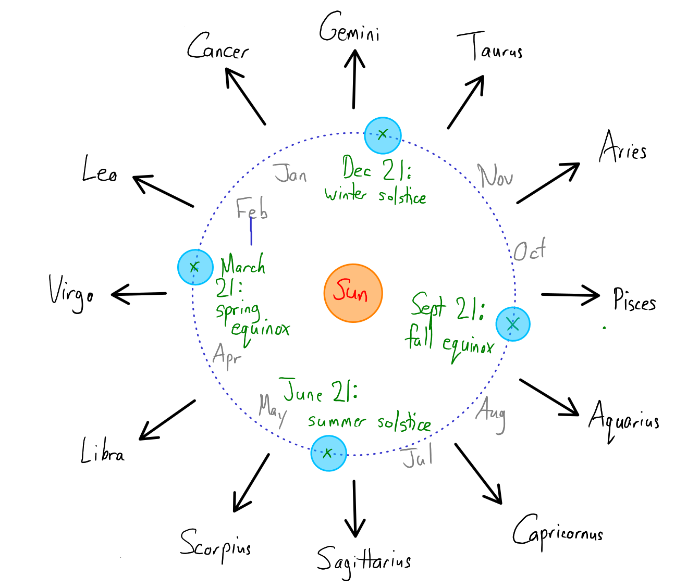

1. A diagram seen from above showing Mt. Marcy, where you want them to stand, and where in the sky the Milky Way and the Moon will be. This diagram can be very simple – just a mark representing Marcy, a mark representing the people, and arrows pointing to the Milky Way and the Moon.
2. A zoomed-out screenshot from *Stellarium*, showing what they will see in the night sky at that time. You should zoom out far enough that you can see the whole night sky.

*A note:* This project is based on a true story! Two friends – one of them a former SU Physics coach – have asked me to shoot engagement photos for them in the Adirondacks soon, and I suggested that we do them at night by moonlight or the light of a campfire. I won’t be able to get the Milky Way in the shot (why?), but under other conditions, this is possible!

I *did* take a photo at the right time of night a few years ago, though. This picture is entirely done with natural light: the trees are lit by the first rays of the rising crescent moon behind me. Even that amount of light created “light pollution” in the sky.

I was in a wilderness area in Canada and planned this shot in advance during the daytime, knowing at what time the Moon would rise above the horizon, and where I needed to stand in order to get the Milky Way, pond, and trees lined up and lit by the Moon behind me.

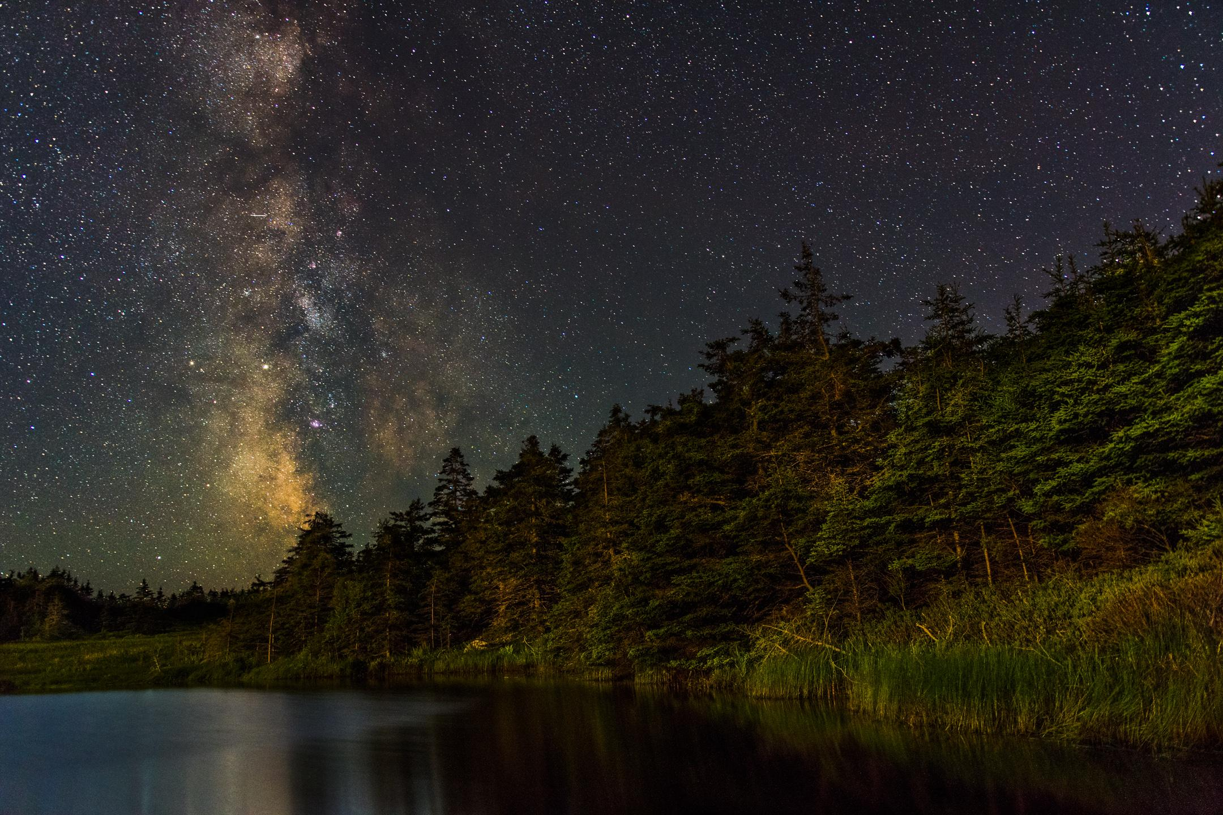

*When your group is done, one person should send a link to your shared Google or Microsoft document by email to* [suast101projects@gmail.com](mailto:suast101projects@gmail.com)*.You should cc: both your other group members and the group members of the group that will evaluate you. This means that ordinarily you will be emailing six different addresses:* [suast101projects@gmail.com](mailto:suast101projects@gmail.com)*, the other two members of your group, and three members of another group. (Of course, if one of those groups has only two people, then this will be different.)*

*See* <https://walterfreeman.github.io/ast101/project2instructions.html> *to see what group is evaluating you, what to put in the subject line of your email, what their email addresses are, and what their group number is.*

*Make sure you fill out the information at the top about who you worked with and how you worked together.*

1. For the photography folks out there: You let them know that since it will be so dark, you will be shooting your lens at f/1.4, its maximum aperture, and so you’ll need to do focus stacking, combining one shot where the sky and terrain is in focus and another where their faces are in focus. They’re okay with that. But you can’t take two pictures at different times of day and combine them.