Project 5 -- Rocket Science, or

*So You Want to Go to the Stars?*

*We will not be doing peer evaluation for this group project; you will submit it directly to us. It is due by Monday, November 23.*

*You should email this document, with all the figures and text you have added to it, to* [*suast101projects@gmail.com*](mailto:suast101projects@gmail.com) *and cc: your group members. We need only one submission per group. The subject line should be “Project 5 Group ####”.*

|  |  |  |  |
| --- | --- | --- | --- |
| **Group Number:** | |  | |
| **Member Name #1:** |  | **Email #1:** |  |
| **Member Name #2:** |  | **Email #2:** |  |
| **Member Name #3:** |  | **Email #3:** |  |
| **Member Name #4** |  | **Email #4:** |  |
| **Collaboration Time and Date:** |  | **Collaboration Methods (in-person, Zoom, etc.)** |  |

In this project, you’ll see how big of a rocket is required to get people to the Moon and back, then explore a few other possible missions.

**Introduction -- How does a Rocket Work?**

As we discussed in class on November 17, a rocket is a machine that pushes **propellant** backwards to accelerate itself.[1] In rocketry, the amount that a rocket accelerates its cargo is called ΔV (pronounced “delta-V”).

The amount of propellant a rocket needs depends on three things: the *exhaust speed of the propellant*, the *mass that the rocket is carrying,* and the *amount that the rocket must accelerate that mass*.

There is a simple formula called the *Rocket Equation* that tells you how big of a rocket you need:

$Total mass of rocket =mass rocket is carrying ×exp (\frac{ΔV}{exhaust velocity})$

“exp” here refers to the *exponential function:* for instance, exp(2.5) means *e*2.5, where *e* is a number around 2.78. Any online calculator (or your graphing calculator) understands this, so you can type “exp(5)” into Google Calculator and it will do the right thing. Try typing “exp(4)” into Google Calculator or an equivalent. What do you get? Then type “exp(40)”. What do you get then?

|  |
| --- |
|  |

**Part 1: Using the Rocket Equation**

As an example of how to use the rocket equation, let’s calculate how big of a rocket you need to launch a spacecraft with enough speed to leave Earth’s gravity entirely. This speed is the *escape velocity*, which is 11,000 meters per second (40,000 km/hr!)

Rockets that use solid fuel are easier to build. The exhaust velocity of a solid-fueled rocket is 2,500 meters per second. If you’re using a solid-fueled rocket, how many tons of rocket fuel do you need to launch one ton into space? *(As a check, you should get an answer around 80 tons.)*

|  |
| --- |
|  |

Rockets that use liquid fuel are harder to build, but the best can achieve exhaust velocities of 4,500 meters per second. How massive must a liquid-fueled rocket be to launch one ton into space?

|  |
| --- |
|  |

**Part 2: Using the “Subway Map” to Get to the Moon**

In order to get from one place in the Solar System to another, spacecraft must execute a series of rocket “burns”. Fans of the computer game/simulator *Kerbal Space Program* and others have made maps -- like subway maps -- showing the required ΔV for each step.

Let’s first think about a flight to the Moon. To get to the Moon, we need to:

* Travel to the Moon:
  + Launch a rocket from Earth to “low-Earth orbit”
  + Fire the rocket motor again to leave Earth orbit and head to the Moon
  + Fire the rocket again once we get to the Moon, to transfer into an orbit around the Moon
  + Use the rocket one more time to transfer from lunar orbit to the Moon’s surface, using the rocket’s thrust to make a “soft landing” on the Moon’s surface
* Do whatever you want to do on the Moon
* Return to Earth:
  + Use the rocket again to leave the Moon’s surface and return to lunar orbit
  + Use it one more time to return to Earth
  + *Use Earth’s atmosphere to slow you down on the way back (no more rocket fuel required for a soft landing!)*

This may seem complicated -- but it’s really not so bad! This map shows you the ΔV needed for each step to “move around” the Solar System.

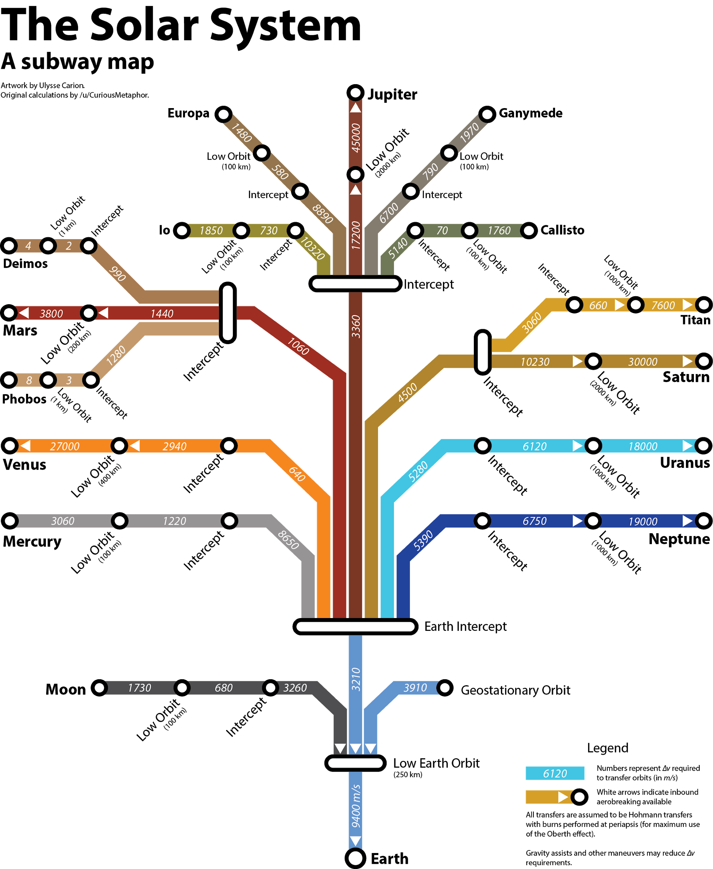

Map by Reddit user u/ucarion, posted to r/space at<https://www.reddit.com/r/space/comments/29cxi6/i_made_a_deltav_subway_map_of_the_solar_system/>

Notice the little white arrows pointing downward from “Intercept” to “Low Earth Orbit” and then from “Low Earth Orbit” to Earth. This means that you can use friction from the atmosphere to slow yourself down coming back to Earth, and don’t need to use any more rocket fuel.

If you’re trying to make a trip to the Moon, just add up the ΔV requirements to go there and back! (Remember, don’t count the ΔV for the last two steps back to Earth, where you can “aerobrake”.)

How much ΔV is required to go to the Moon?

|  |
| --- |
|  |

How much ΔV is required to come *home* from the Moon?

|  |
| --- |
|  |

How much ΔV is required for a there-and-back trip to the Moon?

|  |
| --- |
|  |

The parts of the spacecraft used for the *Apollo 11* mission that traveled all the way to the Moon and back. Using liquid fueled rockets (exhaust velocity 4,130 meters per second), how massive of a rocket would we need to *take to the Moon’s surface* in order to bring the astronauts safely home? *(Your answer should be a few dozen tons; you will wind up multiplying 12 tons by* exp(ΔV/Vexhaust).

|  |
| --- |
|  |

How massive of a rocket would we need to launch from Earth in order to deliver this much mass to the Moon’s surface? *(Instead of using 12 tons, you will multiply here by your answer to the previous part, since this is how much mass you must bring to the Moon.)*

|  |
| --- |
|  |

This should give you a result of around a thousand tons. This is remarkable -- it means that we needed to depart Earth with around a thousand tons in order to get twelve tons of spacecraft to the Moon and back.

In actual history, the rocket had somewhat more mass than that. The true value was 2800 tons. This extra was required to:

* overcome air friction while departing Earth
* lift even more mass off of Earth, since the rocket carried around 170 tons of “extra” mass -- basically, two empty fuel tanks and the six engine attached to them -- near Earth before heading to the Moon

Keep this in mind during the next few parts. Our calculations just tell us the *absolute ideal lightest possible rocket* that could make the trip; real rockets will be several times as massive.

**Part 3: Going to Mars**

Looking at the “subway map”, determine the delta-V required to travel to Mars and to return home. (Remember: lines with incoming “white arrows” don’t count, since you can use atmospheric friction to slow down. So, for instance, you have to burn fuel to get *away* from Earth, but not to slow yourself down when you get back.)

|  |  |  |
| --- | --- | --- |
| ΔV to go to Mars | ΔV to return from Mars | Total ΔV for round trip |
|  |  |  |

The *Curiosity* rover, along with the complicated system used to land it safely on Mars’ surface, has a mass of 3 tons.

Assuming an ideal hydrogen/oxygen rocket (exhaust velocity 4400 m/s), how massive of a rocket would be needed to deliver *Curiosity* to Mars? *(This is an underestimate because of the same factors as with the Moon mission.)*

|  |
| --- |
|  |

Suppose instead that we wanted to send *humans* to Mars. Humans require life support systems to keep them alive; imagine that instead of 3 tons of payload, we’d need 50 tons of crew + food + habitat during their mission on Mars.

However, humans also want to come home! By adding up all of the ΔV required to travel to Mars and back, determine how big of a rocket we’d need to build on Earth to get humans to Mars and back.

|  |
| --- |
|  |

Because of all the same factors involved in the Moon mission (air friction when leaving Earth, plus the mass of empty early-stage fuel tanks), this value is again going to be an underestimate. The actual mass required would be several times this.

Compare the size of the rocket required to send humans to Mars and back with the cost of sending *Curiosity*. What are the benefits of sending robots to explore Mars? What are the drawbacks? Is it feasible to send humans to Mars this way? *(Remember, we built a 2800 ton rocket to get to the Moon. For a more realistic estimate of how big of a rocket you’d need to get to Mars, multiply by 4 or 5.)*

|  |
| --- |
|  |

**Part 4: Mars Direct-style missions**

One old proposal to send people to Mars, called “Mars Direct”, involves sending *two* missions to Mars:

* The first rocket sent to Mars is a robot that will use materials on Mars, plus energy from a nuclear reactor, to produce propellant for a return trip to carry people back to Earth
* Once the robot has produced enough fuel for a return trip, then and *only then* will we send the humans. They will go to Mars, do whatever they are doing there, and then return using the propellant produced by the first robot with its nuclear reactor.

Suppose that the robot carrying the nuclear reactor has a mass of 40 tons. How big of a rocket do we have to use to send the robot to Mars? *(It does not need to carry fuel for the return trip, since it can produce its own once it gets to the Martian surface.)*

|  |
| --- |
|  |

Suppose that the rocket carrying the humans also needs to carry a payload of 40 tons (the crew plus the things needed to keep them alive). *(It also is not coming home.)*

How does the total mass of the two rockets in this mission compare to the one rocket in the “there-and-back” mission? Which sort of mission is more feasible?

|  |
| --- |
|  |

**Part 5: Exploring the Stars**

Suppose that we wanted to send a robotic mission to Alpha Centauri, the nearest star system outside our Solar System. The issue with this is that it is so far away! The ΔV required to escape the Solar System isn’t that large -- but, once the rocket escapes the Solar System, it needs to be traveling fast enough to get to Alpha Centauri within a reasonable amount of time.

The history of “human civilization” -- roughly, from the development of agriculture to the present -- spans about 10,000 years. Suppose that we want our robotic mission to get to Alpha Centauri around 10,000 years in the future. To do this, we would need a ΔV of 100,000 m/s -- around ten times the ΔV required to escape Earth’s gravity.

The best chemical rockets, again, have an exhaust velocity of 4400 m/s. Using the rocket equation, calculate how many tons of rocket fuel we would need to send one ton to Alpha Centauri. *(You should get a large number!)* Is such a mission feasible?

|  |
| --- |
|  |

There are a few technologies that can deliver higher exhaust velocities. One involves using a conventional nuclear reactor, of the type that we use on Earth to generate electricity, to heat propellant rather than chemical reactions. This sort of rocket would allow for an exhaust velocity around 10,000 m/s.

With this sort of engine, what mass of rocket would be required to send one ton of payload to Alpha Centauri? Would this sort of mission be feasible?

|  |
| --- |
|  |

A radical design for a rocket, but one that could be built with known technology, is *nuclear pulse propulsion* -- essentially, building a spacecraft with a large steel plate behind it, then detonating nuclear explosives behind it. While this sounds dangerous and radical, remember that space is *very* big, and this would not be happening anywhere near Earth! The best-developed design for a rocket like this is “Project Orion” -- see <https://en.wikipedia.org/wiki/Project_Orion_(nuclear_propulsion)> if you want to read details.

This sort of rocket might have an effective exhaust velocity of 60,000 m/s. Using this sort of design, what mass of rocket would be required per ton delivered to Alpha Centauri in 10,000 years? *(The answer might surprise you!)*

|  |
| --- |
|  |

There are other technologies being developed to provide high exhaust velocities for rockets -- things like ion engines, fission fragment engines, and many other exotic technologies. Based on your experience with this project, and with the exponential function that appears in the rocket equation, why are rocket scientists so focused on increasing the exhaust velocity of propellant, rather than just trying to make bigger rockets?

|  |
| --- |
|  |

1. In many rockets, the propellant serves as both the matter being pushed backwards and the energy source to do the pushing. For instance, the best chemical rockets use hydrogen and oxygen as propellant. Mixing these produces steam at very high temperature and pressure, which then flies out the back of the rocket.