Lab 9: Spectroscopy (II)

Instructions: You will either need to complete this lab on a printed copy with a pencil, or annotate this document electronically. It would be best for you to do this either by drawing on it with your mouse or a stylus and touchscreen.
Reference spectra

You will find these reference spectra helpful. Note that hydrogen is not on here -- you’ll determine what the hydrogen spectrum looks like on your own.

 | Sodium under high pressure. The very dark stripe in the middle of the yellow is from absorption. This is a more complex spectrum than we see from the diffuse gases, but it is one you might encounter later in the lab!
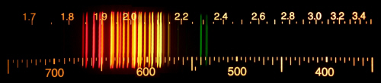 | Neon
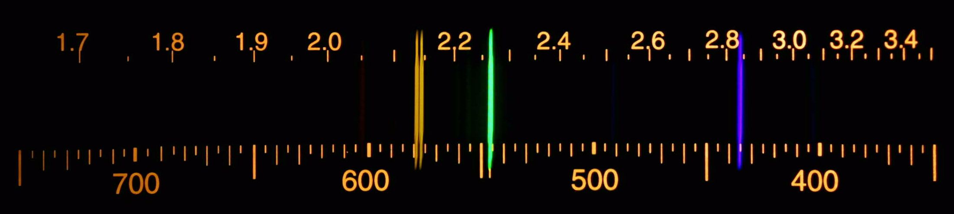 | Mercury
 | Iron
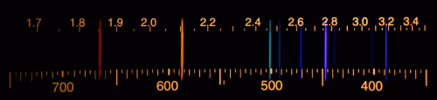 | Helium
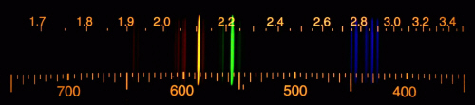 | Krypton
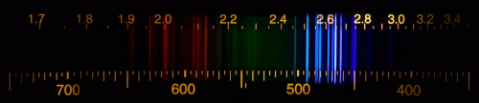 | Xenon
Not pictured -- you’ll need to discover it! | Hydrogen

Important Note on Reference Spectra

It is very difficult to show on a computer image (and even harder on a printout) to show which lines are brighter than others. So the brightness you see on the references may not match the brightness on the images we have taken.

Part 1: Our Spectrometer (sort of)

Normally, we give astronomy students an opportunity to look through spectrometers on your own that are designed for you to use with your eye. We can’t do that over the ocean, though! Instead, we’ve built one that I can hold up to a camera, and have taken pictures through one of various objects. These pictures look like this:
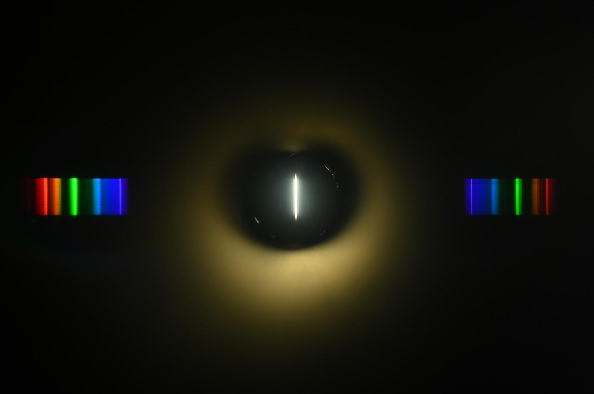

Here, the very bright line in the center is the light coming directly through the slit on the front. The light that you see spread out on either side is the spectrum, “sorted” by color. There is some stray light bouncing around in our crude spectrometer that is visible.

The spectroscopes we have in the laboratory give you three pieces of information about the light you see:

- The color it appears to your eye (or to the camera)
- Its wavelength (measured in nanometers)
- The energy of the photons that comprise it (measured in electron volts, eV)

Here, I’ve produced an electronic version of the spectroscope “scale” and used an image editor to superimpose it on the image I’ve taken. This gives you something like this:

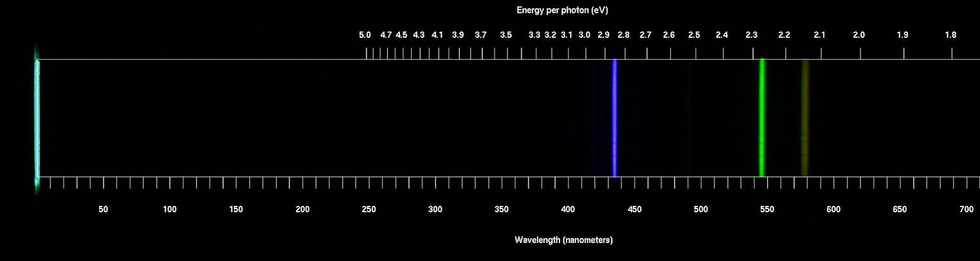

While we can see a little past 750 nm into deep red, this is out of the frame of the lens I have used -- and the camera can’t see it anyway! We can see a little further into deep reds than this camera can. (Of course, this source doesn’t generate any red light to begin with.)

A question for you: This is a pretty crude instrument -- it’s made out of a fifty-cent piece of “grating” (the thing that separates light into colors), a metal tube with a little hole cut in the front, and an ordinary camera. I expect that in the best case the positions of the lines should be accurate to 3-5 nm, and in the worst case to 10-15 nm. (There are sometimes issues with the grating being wrinkled.)

How do you think this compares with your eye’s ability to determine the wavelength of light alone? That is, given a light source of a single wavelength, how well do you think you could estimate it, given the reference below?

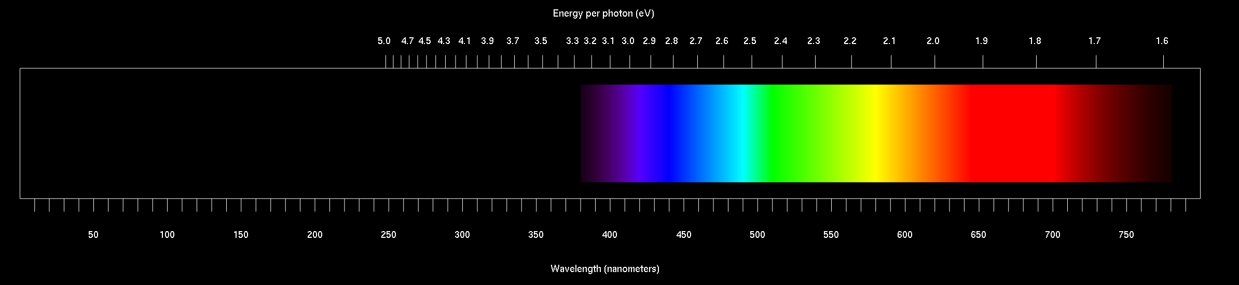

Part 2: Identifying Elements and Sources

Here are spectra from several fluorescent tube lamps, like the ones I used in class. (I took these pictures using different tubes in the same machine). By comparing them with the reference spectra, determine what element they are. One of them will be hydrogen, which is not one of the references. You won’t know the hydrogen spectrum yet; that’s okay! Label the one that doesn’t match, and come back to it later once you figure out what the hydrogen spectrum is.

One of these isn’t a fluorescent lamp -- you’ll tell what it really is when you get to it.
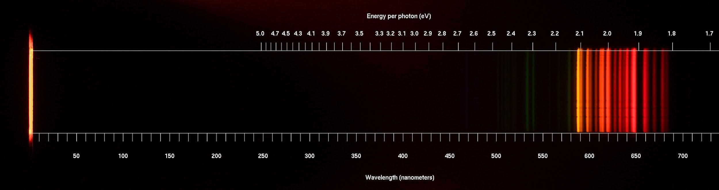

What element is this? If it’s not a fluorescent lamp, what is it? | What are some identifying features you could use to recognize it later?
 | “There is a pair of orange lines around 590 nm, and many closely-spaced red lines from 600-680 nm. There are two dimmer green lines around 535 nm.”

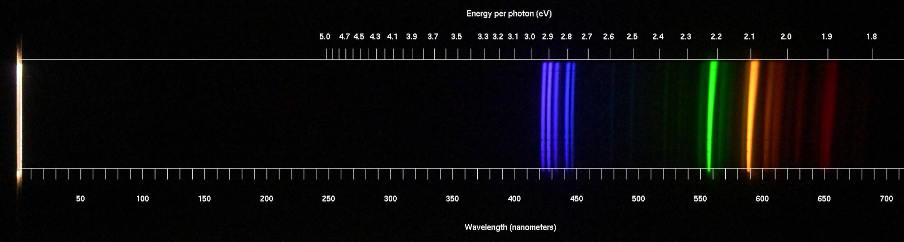
I think the flexible piece of diffraction grating was crinkled when I shot this. The “bending” of the longest-wavelength lines is a result of that.

What element is this? If it’s not a fluorescent lamp, what is it? | What are some identifying features you could use to recognize it later?

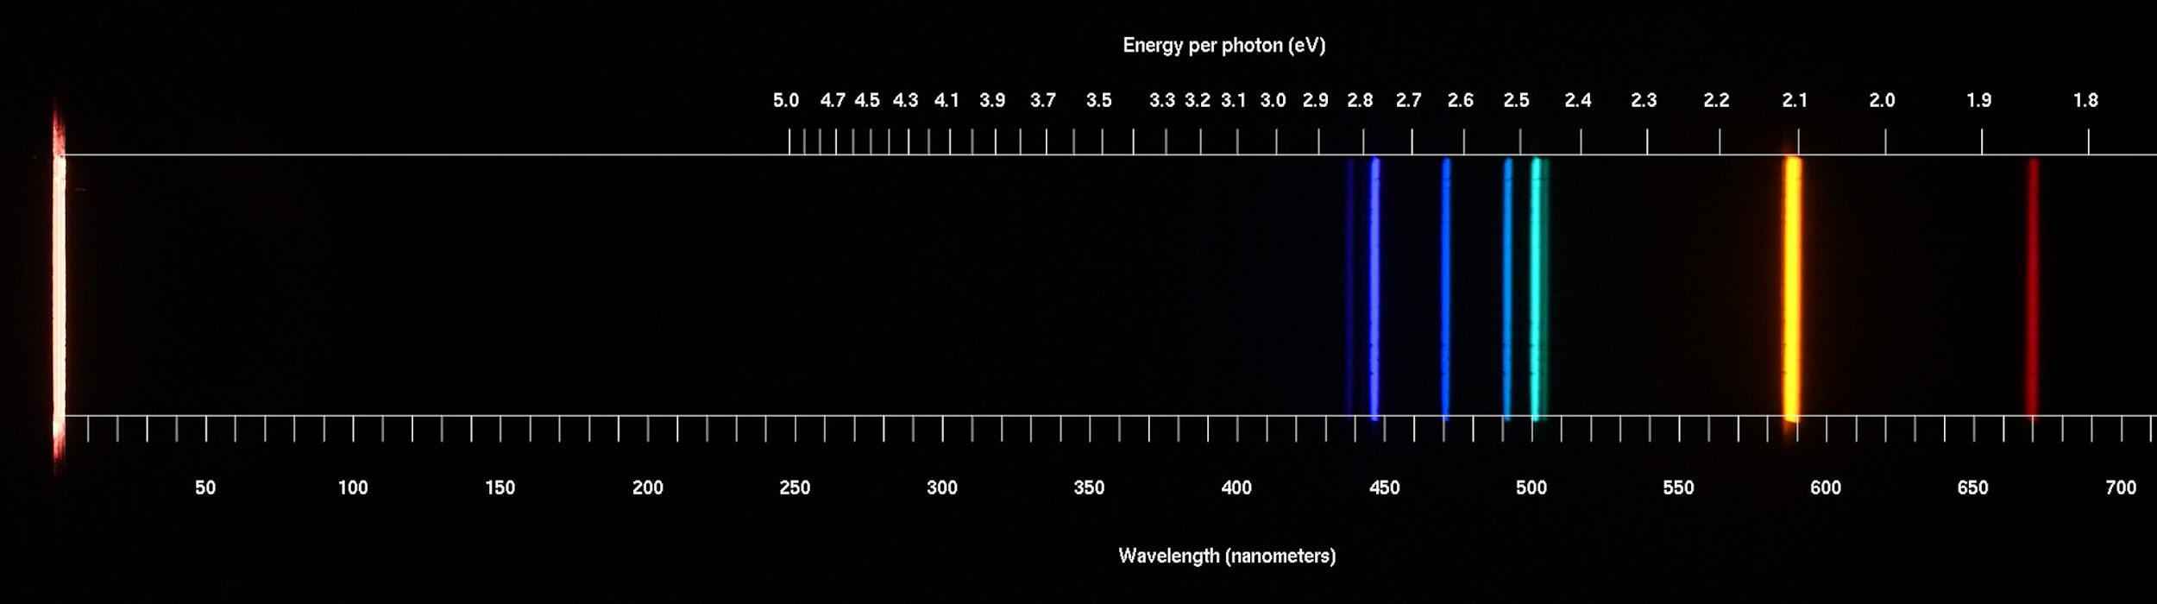

What element is this? If it’s not a fluorescent lamp, what is it? | What are some identifying features you could use to recognize it later?

What element is this? If it’s not a fluorescent lamp, what is it? | What are some identifying features you could use to recognize it later?

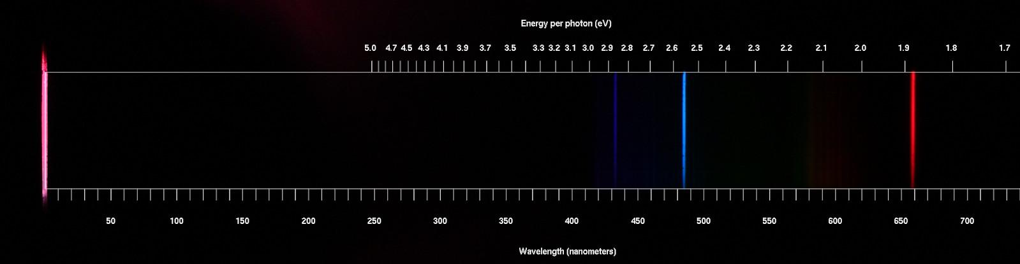

What element is this? If it’s not a fluorescent lamp, what is it? | What are some identifying features you could use to recognize it later?
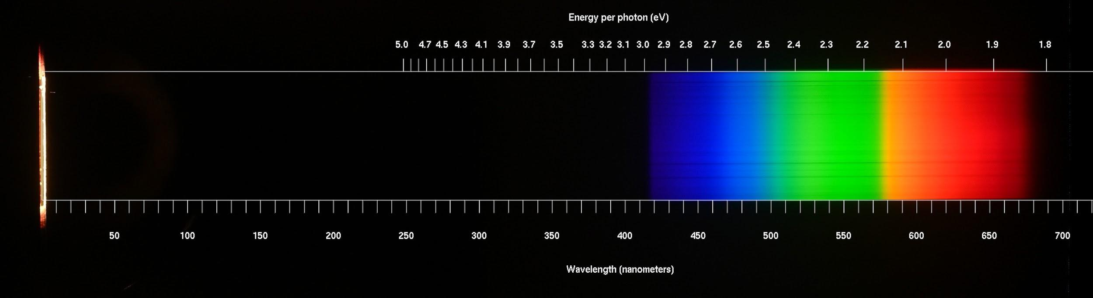

What element is this? If it’s not a fluorescent lamp, what is it? | What are some identifying features you could use to recognize it later?

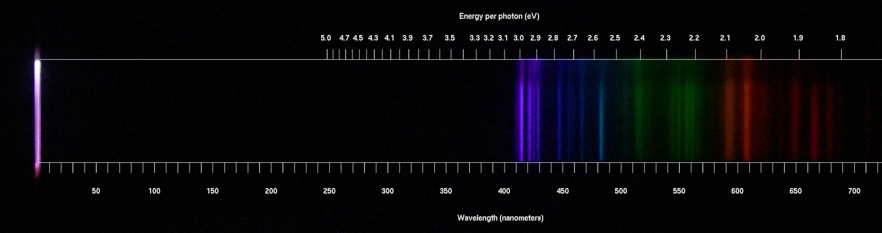

What element is this? If it’s not a fluorescent lamp, what is it? | What are some identifying features you could use to recognize it later?

Here are spectra from some other fluorescent lights on campus. These can be a little more complicated.

Some fluorescent lights in rooms have phosphors in them that absorb some of the ultraviolet light produced by the gas. They then re-emit light of other wavelengths -- sometimes in bands, sometimes in other narrow lines. However, you will still be able to clearly recognize the emission lines you saw in the previous part. Others have gas under high pressure which produces broad bands of color and some absorption (dark) lines, like you can see in the reference for sodium.

Here are the fluorescent lights in the hallway:

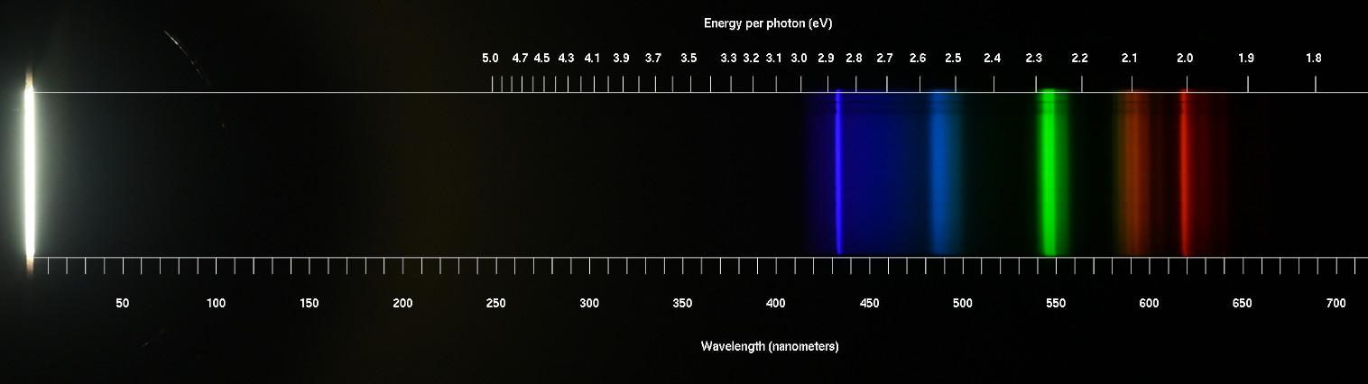

What element is this? Which components of the spectrum are added by the phosphors? How does this differ from a “plain” emission spectrum of this element?

Here are the yellow streetlights. What element is in them? (The stray light is because some snow landed on the spectroscope while I was using it.)

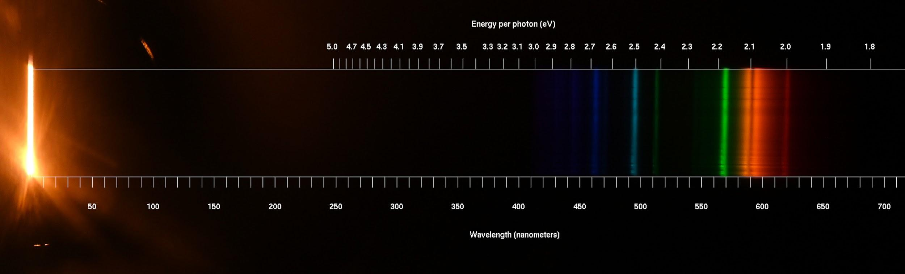

What element is this?

Here are two more spectra. One is sunlight; the other is from an incandescent lamp. Which one is which, and how do you know?
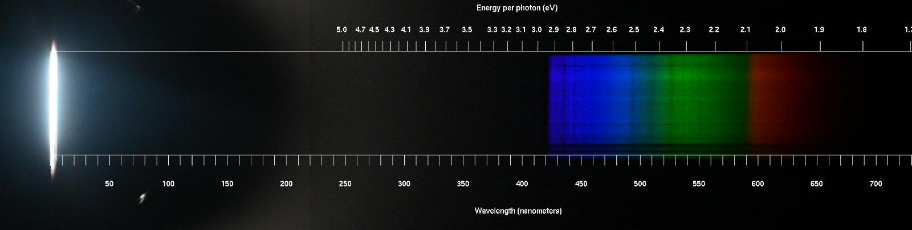
Note that the horizontal dark bands come from debris in the little slit in the spectrometer, but vertical dark bands represent wavelengths that are missing from the spectrum.

Part 2: Predicting the Colors of Hydrogen

In class we learned about atomic energy levels.

In general, the formula for the energy levels of atoms is very complicated (and there are lots of them!)

But hydrogen is simple. Its energy levels follow a pattern:

Energy of level n = electron volts (eV).

We name these levels by writing n = and then a number. So n = 1 is the lowest, n = 2 is the next one, and so on. An “electron volt” is just a very small amount of energy useful for talking about atoms. (There are 2.6 × 10²²) eV in a food-Calorie.)

The law of conservation of energy tells us how atoms changing energy levels will relate to light:
- If an atom jumps to a higher energy level, it needs to take energy from something, and so it must absorb a photon with energy equal to the difference
- If an atom jumps to a lower energy level, it needs to give energy to something, and so it must produce a photon with energy equal to the difference

Remember that each color goes with photons of a specific energy. So this means:

If you know the energy levels of an atom, you can figure out its emission spectrum by calculating all the different differences between them!

On the next page, I’ve calculated the energies for the first five energy levels of hydrogen. (You won’t need to use the formula above; I’ve done it for you.)
Below, I’ve given you the amounts for the first five energy levels of hydrogen. You can fill out the table and predict the colors that hydrogen can emit and absorb. Label those colors on the spectrum below... then go back and find the hydrogen spectrum from the first part of this lab and see if it matches!

Higher energy level (on the right) | n=5  13.06 eV |  | n=4  12.75 eV |  | n=3  12.09 eV |  | n=2  10.20 eV
Lower energy level (below) | Energy | Color | Energy | Color | Energy | Color | Energy | Color
n=1, 0 eV | 13.06 - 0 = 13.06 | Ultraviolet
n=2, 10.20 eV |  |  |  |  |  |  | ---------- | ----------
n=3, 12.09 eV |  |  |  |  | ---------- | ---------- | ---------- | ----------
n=4, 12.75 eV | 13.06 - 12.75 = 0.31 | Infrared | ---------- | ---------- | ---------- | ---------- | ---------- | ----------

E > 3.2 eV:  ultraviolet | 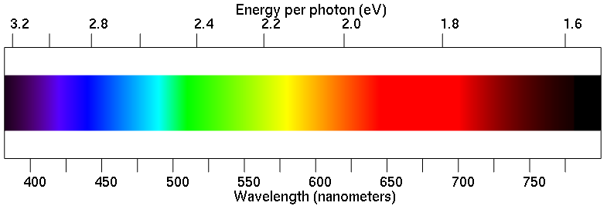 | E < 1.6 eV:  infrared
Draw lines on this spectrum at the places where you expect to see emission lines from hydrogen. Now you can go find the hydrogen spectrum from earlier and label it. Are the spectral lines in the places that you’ve calculated they should be?

Part 3: What’s In The Sign?

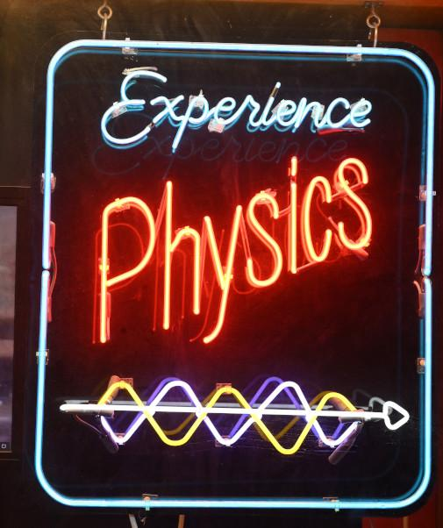
The “Experience Physics” sign outside the auditorium in the Physics Building has five different colors: blue, red, white, purple, and yellow. Now you’ll go do some detective work to figure out what they are.

Remember: Some of the tubes use phosphors that generate broad bands of color in addition to the narrow spectral lines produced by the gas itself. Don’t get distracted by these: look only at the thin lines in the spectrum.

Notice that the wavelength scale is not quite the same on these images -- this is because I can’t hold a camera level. :) You’ll need to actually read the wavelength numbers and compare them to what you saw earlier. In particular, the yellow one cuts off a bit earlier as you get into the highest wavelengths.

Part of sign | Spectrum | What gas is it?
“Experience”, and the blue border | 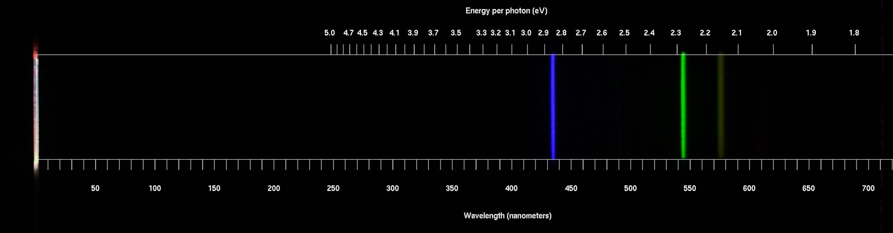
“Physics” -- the bright red | 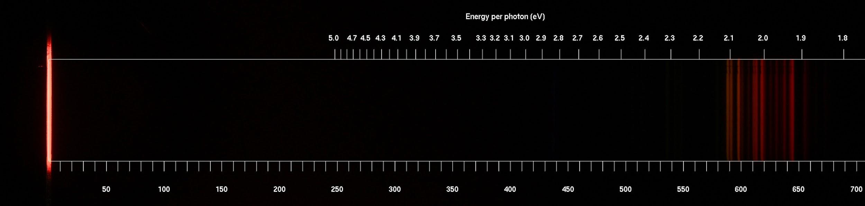
Yellow (in the arrow) | 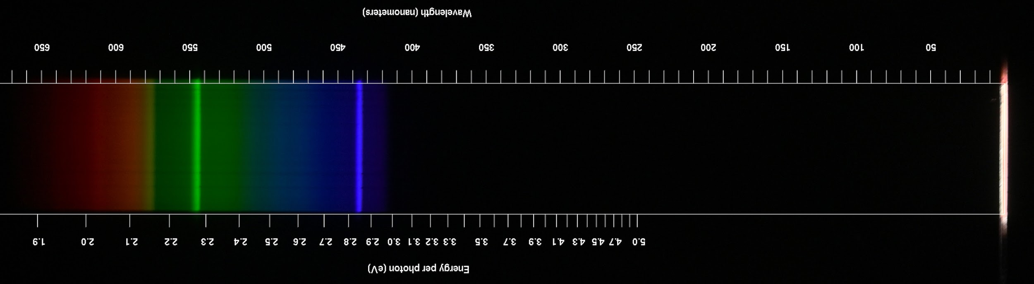
White (in the arrow) | 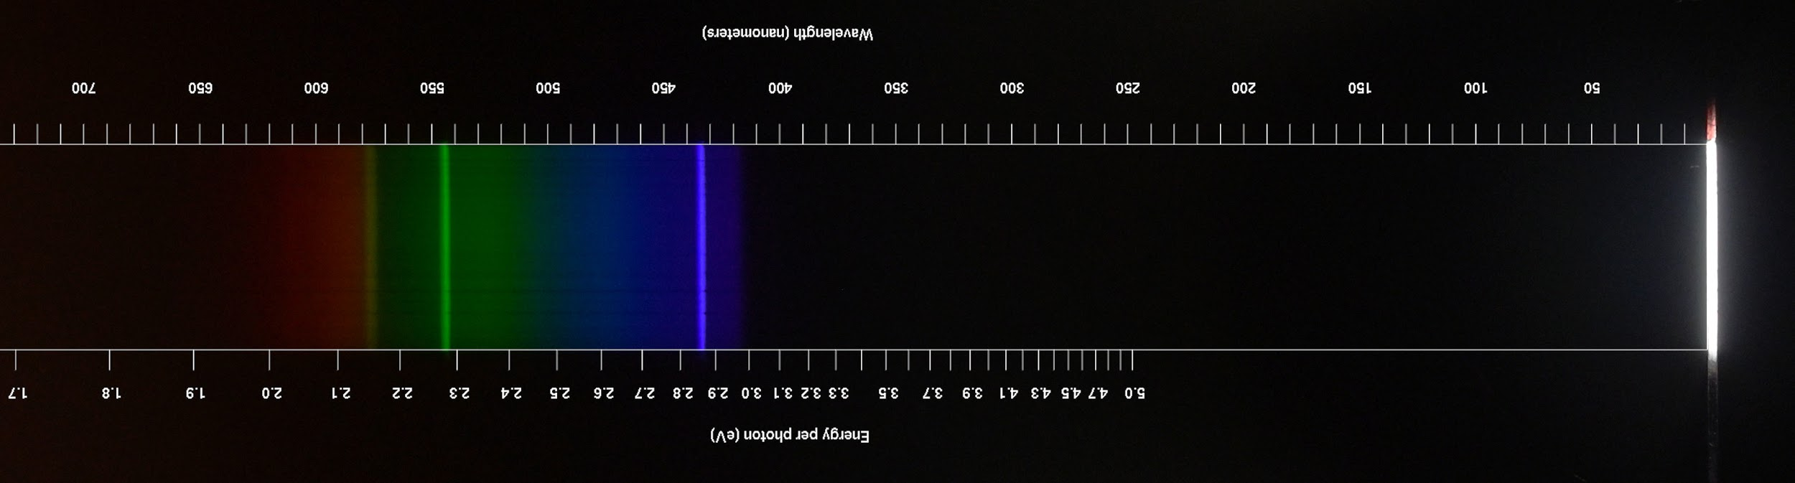
Purple (in the arrow) | 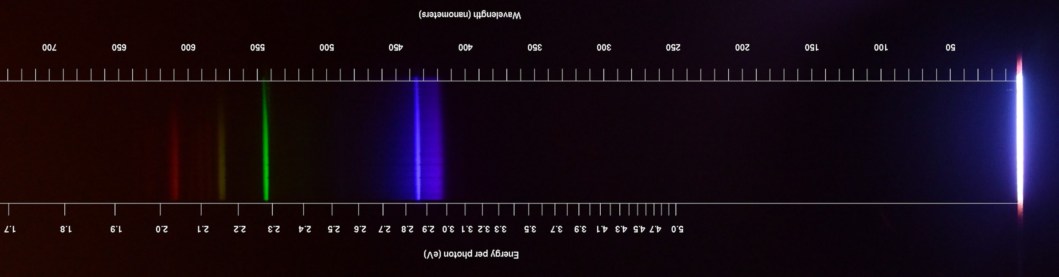

Part 4: The Solar Spectrum

Here’s a very detailed version of the solar spectrum. Corresponding wavelengths (in nm) and energies (in eV) are listed on the right. (Because of calibration and rounding, they may be off by 0.01 eV.)

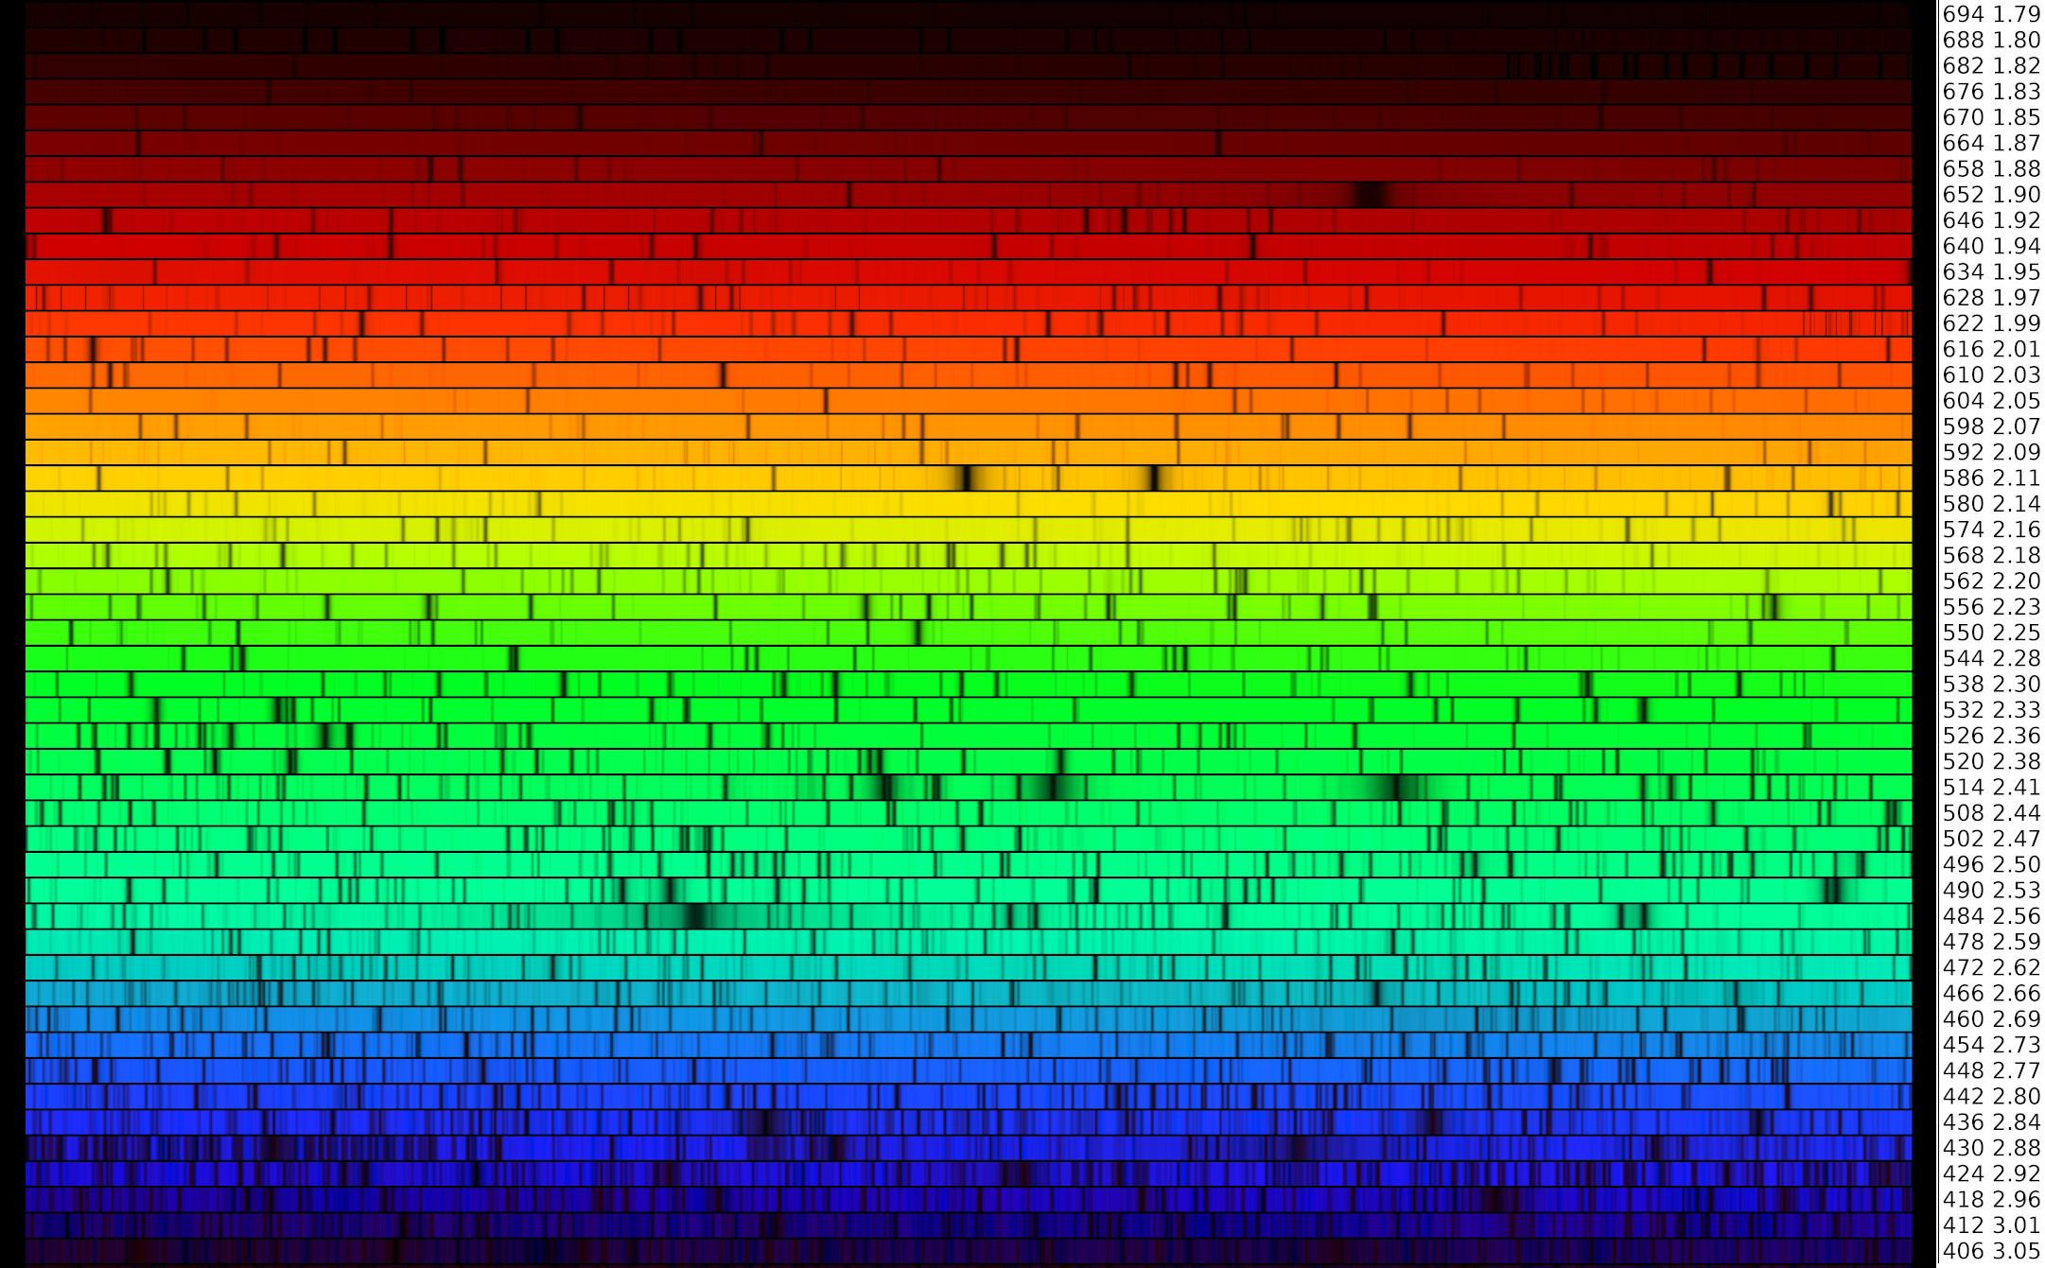
On the spectrum on the previous page, find and mark:

- The line corresponding to the n=3 -> n=2 transition in hydrogen
- The line corresponding to the n=4 -> n=2 transition in hydrogen
- Two strong nearby yellow lines, which are part of the absorption spectrum of sodium

You’ll also notice that there are lots of absorption lines in the green and blue. These lines come from the absorption spectrum of iron, telling us that there is a lot of iron in the Sun. We also know that there is a lot of iron in the Earth.

Given that the Sun and the Earth both formed from the remnants of a massive star that exploded long ago, scattering the elements that it created by nuclear fusion, why might we expect there to be a lot of iron in the Solar System?

