AST101: Our Place in the Universe
Lab 2: The Phases of the Moon
Version for Groups Meeting Online

Last week, we studied the Sun, at great length. This week, we turn our attention to the next
most prominent celestial object in our sky; the Moon. Unlike many of the objects we see, the
Moon appears to change both its location and its nature, appearing at times as a tiny sliver and at
others as a filled circle, and everything in between. Ancient societies used this transient nature of
the Moon to mark the passage of time in their calendars, and to denote the beginning of special
festivals. Our own Gregorian calendar has a remnant of this: our months are approximations of
the lunar cycle. We will study the Moon, and the cause for its phases, in detail today.

This lab will involve a lot of “pointing at the sky” with your fingers and thinking about how the Moon would look if the Moon and Sun were at those points. You will also need some scrap paper to draw diagrams and will need to show those to your groupmates using a webcam or cellphone.

Since the Moon is on the same plane as the Earth’s orbit and the Sun, it follows the same path in the sky. So it will rise in the East, move up in the southern sky, and then set in the West.

If the Moon is visible in your sky, it will lie along this path, called the ecliptic. Look in your sky (when you are doing this lab) along the ecliptic. Do you see the Moon there? If you do, describe where in the sky you see it. If you don’t, then that’s okay; skip to the next part.

Describe where in the sky you found the Moon, and also where the Sun currently is. (If the Sun is not currently visible, use what you know about the motion of the Sun to predict where it is.) Also, describe its appearance. Is it half lit? Fully lit? A thin crescent?

If members of your group are at different geographic locations, compare what you see in your sky. (For instance, someone in Shanghai may see the Moon at a time when someone in New York does not.)

Get your laptop out and fire up Stellarium, and set it to the current date and time. If you were able to see the Moon in your sky, describe whether Stellarium correctly predicts the place you found it. If you were not able to see the Moon, turn off the ground temporarily in Stellarium, and describe where the Moon and Sun are. (They might be above the horizon but hidden by clouds; they might be below the horizon. Your answers here will depend on what day and time your lab is.)

Speed up time in Stellarium and watch the Sun and the Moon over one day. Notice that they move in the sky as follows:

- They both rise in the East
- … move high in the southern sky
- … set in the West
- … and then travel from West to East under the northern horizon, until they rise in the East again the next day
- Over one day, the angle between the Sun and Moon stays almost constant – they follow the same path at nearly the same rate.

Now, set the date on Stellarium to September 21. Press Ctrl-F (on Mac it may be Cmd-F) and search for the Moon. This will be the next full moon.

Discuss with your group: at what time of day do you expect the full moon to be highest in the sky? Why?

Now, find the time when the Moon is highest in the sky on September 21. Were you right? What time is this?

At this time, where is the Moon in the sky? Where is the Sun? (Hint: You can’t see the Sun at this time, but you can figure out where it should be in your sky.)

Everyone in your group should point with one arm toward the Sun and the other arm toward the Moon. What is the angle between your two arms? Describe to each other which way you are pointing. Where is the Sun? Where is the Moon?

Now, we’re going to take a tour through the moon phases as the Moon gets progressively less full during half a month – advancing by one-half week each time. Describe the Moon phases as follows:

- Full (or nearly full)
- Gibbous: more than half full
- Half: About half full
- Crescent: less than half full
- New: not visible

Describe the location of the Sun using terms like the following: below the northern horizon, low in the southeastern sky, on the western horizon, etc.

You’ll fill out this chart as you go. Fill out the first row for September 21.

Date | Moon Phase | Time when Moon is highest | Location of Sun at this time | Angle between Sun and Moon
September 21
September 25
September 28
October 1
October 5
Today’s date

Now, let’s think about what happens on September 25. Since the Moon moves counterclockwise around the Earth when seen from above, we can predict what’s going on with a diagram showing the Moon’s position in its orbit, along with the parts of the Moon you can see from Earth.

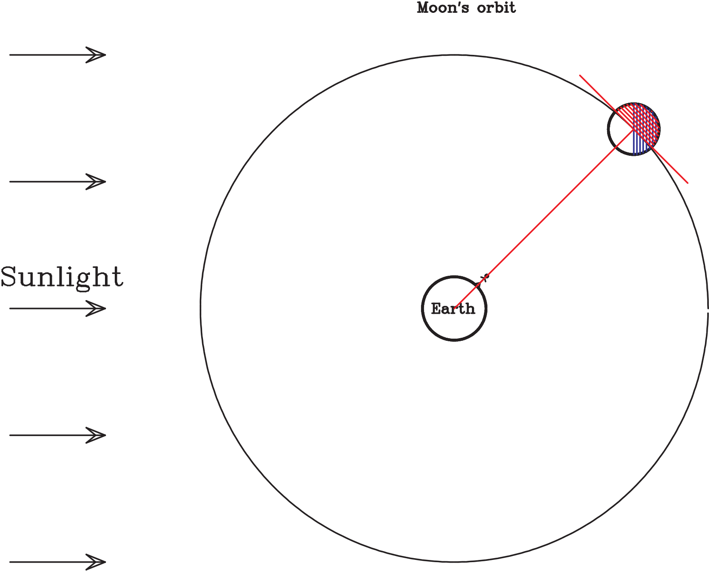

In this diagram:

- you’re looking down on Earth from above the North Pole
- the red line represents the observer’s sight line toward the Moon
- the portion of the Moon shaded blue can’t be seen because it is not lit by the Sun
- the portion of the Moon shaded red can’t be seen because it is not facing the Earth
- the stick figure is drawn at a time of day where this moon phase is highest in the sky.

Without using Stellarium, predict what phase of the Moon this represents.

What time of day is shown here? At this time of day, where is the Sun? (Describe this generally, like “below the western horizon” or “high in the sky”). You’ll need to figure out which direction on the horizon is East and which direction is West.

Now, set Stellarium to this time. Were you correct?

Using Stellarium, set the view so that you can see both the Sun and the Moon at the same time. You can do this either by advancing time so that both objects are visible in the sky, or by pressing “g” to toggle the horizon on and off so you can see through the ground.

Estimate the angle between the Sun and the Moon, then go back up and fill out the September 25 row in the table. It will help in estimating the angle to point with your fingers – one arm to the Sun, the other to the Moon.

Now, let’s move another half-week further in time, to September 28.

Here is a diagram showing the position of the Moon in its orbit on September 28, with the observer again in a position showing the Moon at its highest point. This time, I haven’t colored anything in.

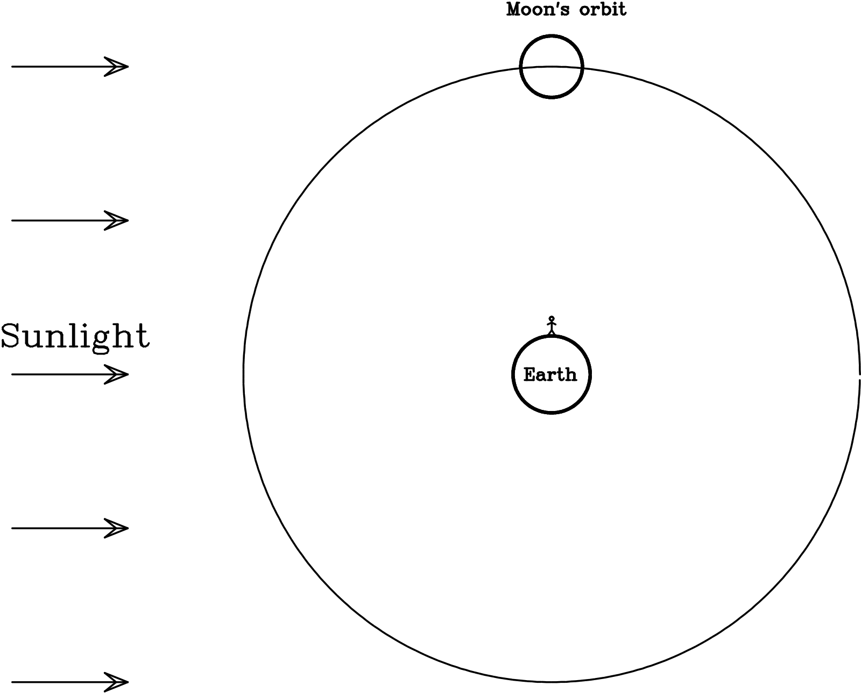

As always, half of the Moon will be lit by the Sun, and half will be dark. Which half will be lit by the Sun? (You can answer relative to the diagram, e.g. “the top half” or “the right half”.)

Which half will be visible from Earth?

Of the part of the Moon visible from Earth, how much is lit by the Sun? This tells you the moon phase you’re currently looking at.

This diagram depicts the time of day when this phase of the Moon is highest in the sky. What time of day is this? Where would you look to find the Sun?

Check your results with Stellarium. What’s the angle between them? Record your findings in the table earlier.

Let’s move forward another half-week, this time to October 1. The Moon has moved another eighth of the way around its orbit, and is now at this position:

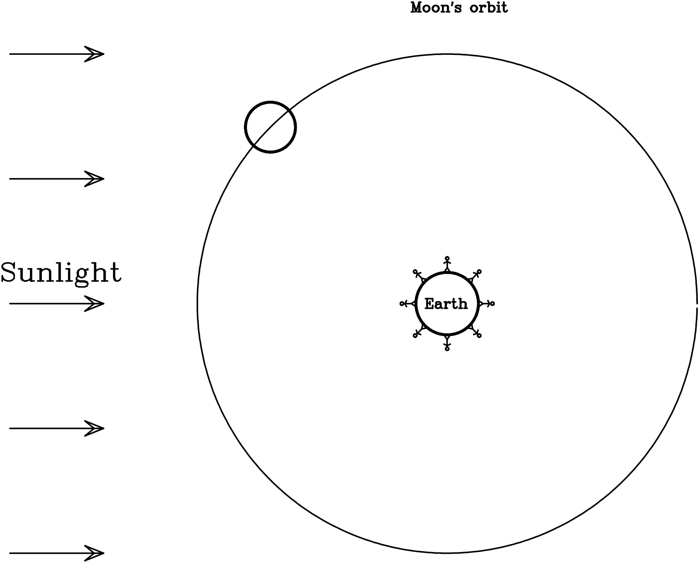

As you have probably guessed, this is a crescent moon. In this diagram, you’re looking down at Earth from above the North Pole. The stick figure is on the Equator, but imagine for now that you are located in the Northern Hemisphere.

Each member of the group should draw a copy of this diagram on a piece of paper. Shade in the part of the Moon that is not lit by the Sun (you can’t see that), and then shade in the part of the Moon that isn’t visible from Earth (you can’t see that, either).

Of the portion of the Moon that you can see from Earth, would the left side or the right side be bright? Talk to your group and reason through this with them, thinking about this diagram. Which side is bright, and how do you know?

In the figure I’ve drawn eight different stick figures representing different times of day: midnight, 3:00, 6:00, 9:00, 12:00, 15:00, 18:00, and 21:00. Which of these stick figures is the one who would see this Moon highest in their sky? What time is it for them, and where would the Sun be?

Set Stellarium to this time and date, as before. What’s the angle between the Sun and Moon? Record your findings in the table earlier.

Part 3: Rising and Setting

Once you’re done recording your findings, let’s think about how the Moon and the Sun rise and set. Go back to the time from the previous part where the Moon was highest in the sky. Everyone should again point one arm at the Moon and the other arm at the Sun at this time.

Remember that the Earth, Moon, and Sun don’t move very much in space over one day; thus, the apparent motion of the Moon and Sun over one day is only because of the rotation of Earth. That means that the Moon and Sun will rotate counterclockwise around the North Celestial Pole, just like all the stars.

Do this with your arms. “Advance time” by rotating both of your arms counterclockwise slowly. (The angle between them should stay the same.) Everyone should do this and compare the results they get. Keep doing this until the Moon “sets” over the western horizon. When this happens, where is the Sun? What time of day is it?

Retrieve the drawing you made earlier – a copy of the diagram to the right, but with the parts of the Moon you can’t see shaded. (There should only be a little slice of the Moon that is visible: a thin crescent.) This time, get a blank piece of paper to serve as your “horizon”. Hold the paper against your computer screen vertically so it obscures the left half of the diagram. Then rotate it counterclockwise to represent the passage of time. Notice that at some point the Moon will appear above the horizon. Label the side of the horizon that the Moon appeared over “East”; the other side is “West”.

When the horizon is in this position, what time is it? (Remember that the horizon is parallel to the observer’s feet, separating the world below their feet that they can’t see from the world above their head that they can.

This is the time that the crescent moon will rise above the eastern horizon. Keep rotating; eventually you will get to the time when the Moon sets.

Did this result roughly agree with your previous result? Talk with your group: if you need to figure out something about the rising and setting times of different moon phases, which would be more helpful – the diagram or the method with your fingers in the air? Why?

Part 4: Putting it All Together: One Month

Look back at the table on Page 3. You’ve filled out everything except for the “September 16” line.
e sky, where is the Sun, and what is the angle between the Sun and Moon? You should be able to figure out the pattern. Fill that in on the table.

You’re out of rows on the table, but you should still complete the month.

Go through all eight phases of the Moon this way: new moon, waxing crescent, waxing half, waxing gibbous, full, waning gibbous, waning half, waning crescent. Each one will be three or four days apart in Stellarium. (The = key advances one day.) You should notice a clear pattern between the angle between the Sun and Moon, and the phase of the Moon. What is that pattern?

