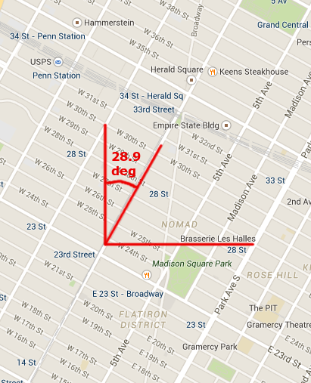
The streets in Manhattan are laid out in a grid, but that grid is aligned with the island, rather than along the compass directions. Avenues run 28.9 degrees east of north, while streets run 28.9 degrees north of west.

This means that there are two sensible coordinate systems in Manhattan:

- North/South/East/West, aligned with the compass

- Uptown/Downtown/Crosstown, aligned with the streets.

(In this map and the next one, “up” is due north.)

1) The staff astronomer at the Natural History Museum walks from Penn Station to the Natural History Museum, going 3.3 km north along Eighth Avenue. How far east and how far north did she walk?

2) Here is the displacement vector pointing from the Metropolitan Opera to Carnegie Hall.

Draw:

a) its component in the direction of the Manhattan avenues;
b) its component perpendicular to them;
c) its component along the North-South axis;
d) its component along the East-West axis.

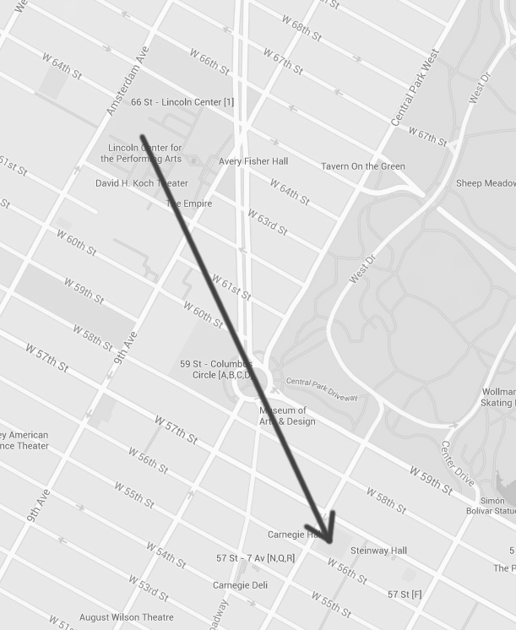
3) A hiker in the forest walks 5 km due north and then 2 km due east, and then wants to return to his original spot by the shortest route possible.

a) Draw the hiker's path.

b) Which direction should he walk, and for how far?

4) Now our hiker walks 3 km due north, then 4 km at an angle 30 degrees south of east, and then finally 5 km at an angle 45 degrees north of west. He then wants to return to his starting point, as before. Which direction should he travel in, and for how far? Draw the hiker's path.

5) A swimmer can swim 5 km/hr in still water. She wants to swim directly across a river. However, there is a current in the river, with a speed of 2 km/hr. If she swims directly across, she will drift downstream due to the current. Thus, in order to get where she wants to go, she needs to angle herself upstream.

a) There are three interesting vectors in this problem: the velocity of the current, her velocity relative to the current, and her velocity relative to the shore. How do they relate? State this both mathematically (for instance, “this vector plus that vector equals this other vector”), and geometrically (draw a picture).

b)At what angle must she try to swim in order to proceed directly across the river?

c) If the river is 200 m across, how long will it take her to cross?

