

# FACULTY OF BUSINESS MANAGEMENT SCIENCES AND ECONOMICS UNIVERSITY OF ZIMBABWE BUSINESS SCHOOL

**DISSERTATION PROGRESS REPORT**

STAGE: Chapter 4: Results and Discussions Student:Reg No: R151680Y

Supervisor: Dr Benny Nyambo

# Purpose of the meeting

To evaluate findings presentation, interpretation, and linkage to objectives and literature.

# Action required By Student:

* Ensure all figures and tables have clear explanations.
* Strengthen discussion by linking findings back to literature review and theory.
* Highlight Zimbabwe-specific insights clearly

# Action required By Supervisor:

* Provide feedback on depth of analysis and whether discussions sufficiently answer research questions.
* Suggest areas for clearer linkage between findings and recommendations.

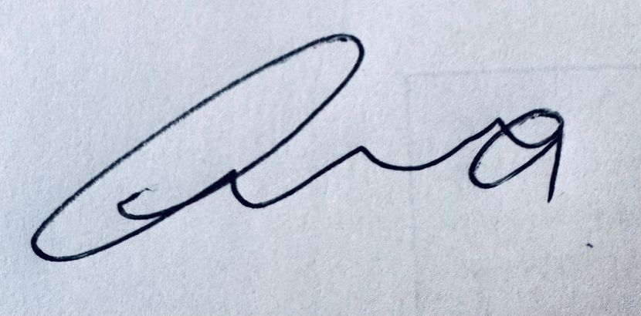Date of Next meeting 29 November 2024

Signed (Supervisor) Signed………………………………….. (Student)…………………………..