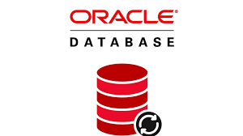

visualcrossing

API

GET

POST

PUT

DELETE

**User Id=system;Password=xxxx;Data Source=localhost:1521/ORCLPDB1;**

**WeatherDB**

**BACK-END**

**FRONT-END**

Infrastructure Layer

Angular 18.2.12 / Typescript

NET Core 9.0 / C#

UI: Weather

**HTTP Request**

t

**HTTP Response Models**

t

Models

Services

**DB**

API: Weather

Core Layer

API Layer