This application is purely for learning, but the idea is to register workers and categories or areas. Using Angular for the Frontend part and NET Core for the backend part.

**Roles:**

Administrator: Can register workers and categories.

User: Can register workers exclusively

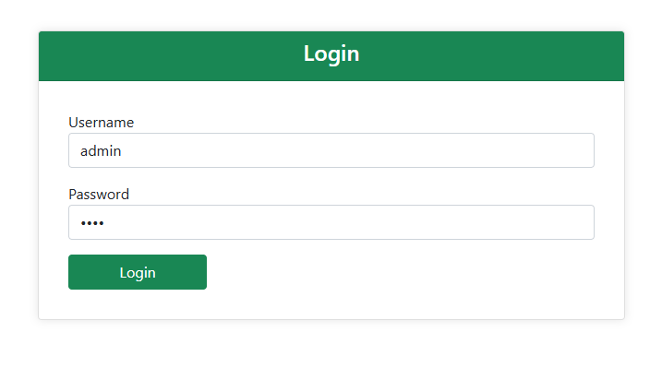

**Login:**

Simply enter your username and password and click on login:

If you mistype the data it will give an error: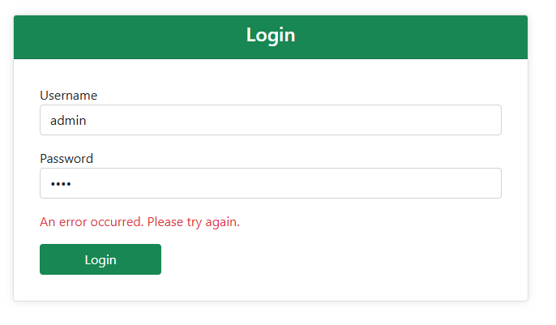

If you enter your details correctly, it will allow you to log in to the system:

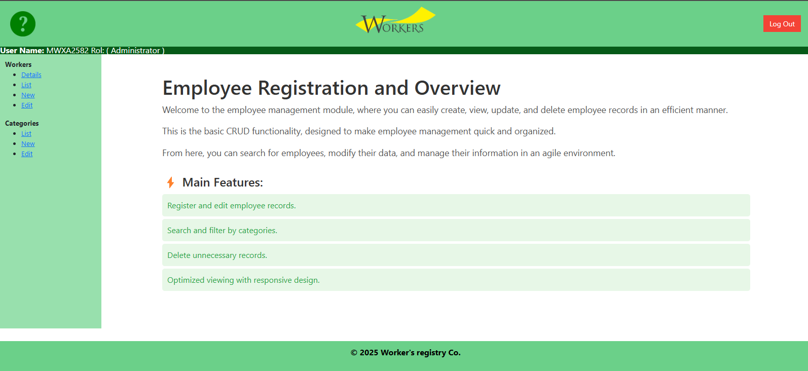

You can log out and exit the app at any time.

**Workers:**

Details:

It will show the list of workers 1 by 1, where you can view their data, go to the first, go to the last, go to the next or previous and delete:

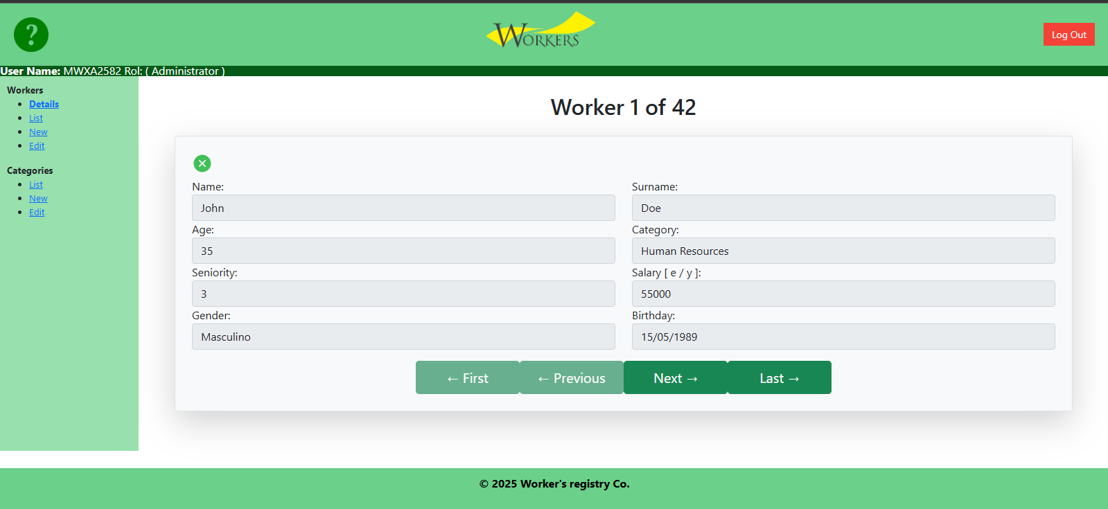

List

It will show the complete list of workers, where you can view their data, delete workers.

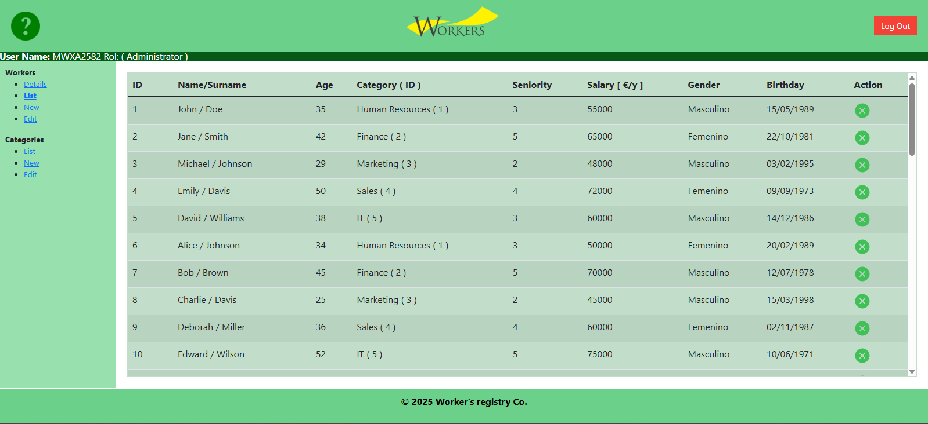

New:

It will allow the registration of a new worker

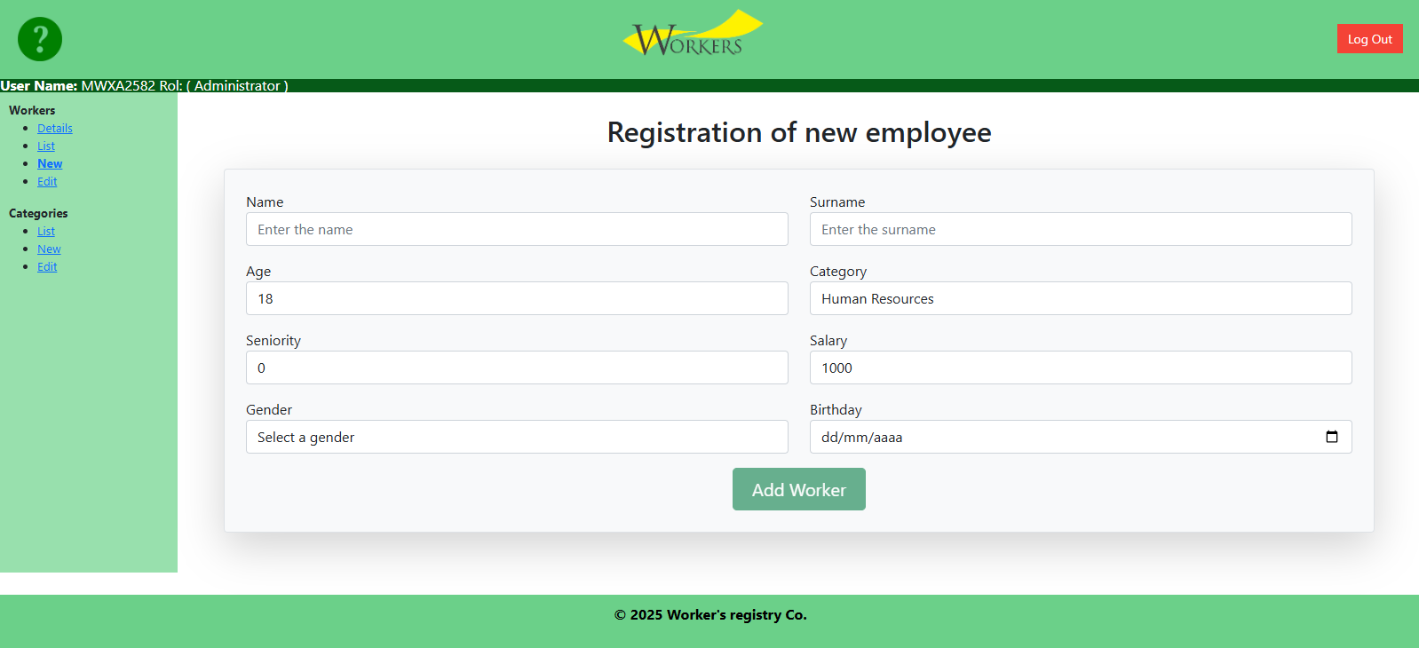

Edit:

It will allow an existing worker to be upgraded:

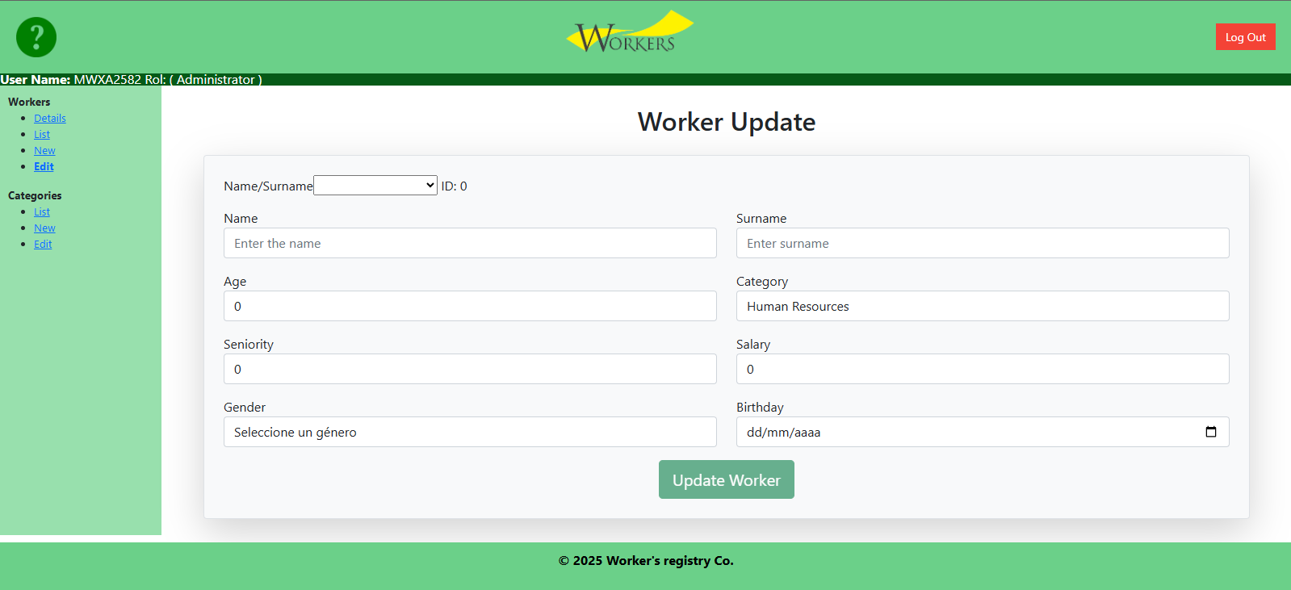

**Categories:**

This module can only be viewed by users with Administrator role.

List:

Allows you to list categories:

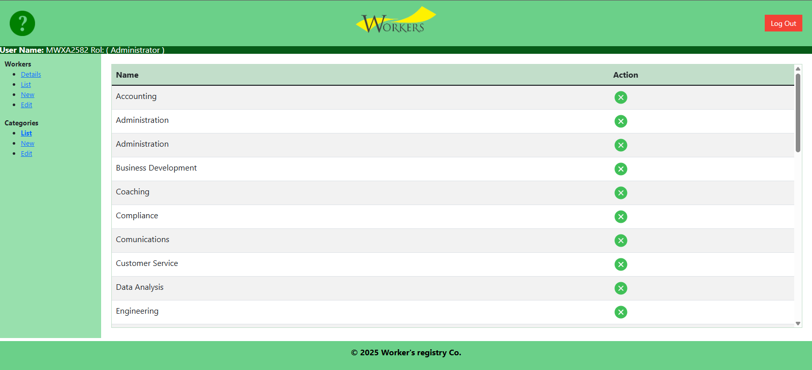

New:

Add new category:

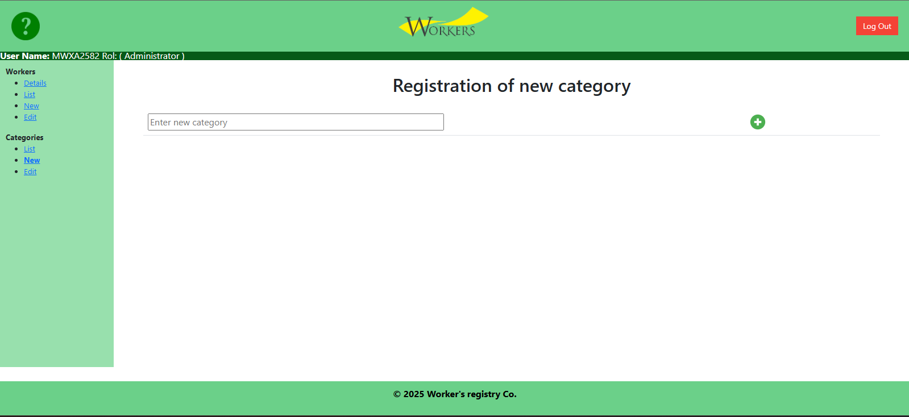

Edit:

Update an existing category:

