Creative Hacktivism: part II

DISRUPTION NETWORK LAB

Creative Hactivism Part II

Cooperate & Collaborate with Convivial Technologies

What is a Hacker? And what does a Hacker do?
- unpeel layers: to see what lies behind the smooth surface of technologies (try ctrl-u on a webpage on your brower if you run windows or linux, or command-u on OSX)
- notice details. Details are important, for example, from the details in an sender email address you may easily understand if it’s a spam mail.
- use an oblique gaze: observe you behaviour when you are in relationship with the machine
- share and collaborate: to foster the creation of new knowledge is important to share what we notice or discover.
Hacking is finding and building your own path, your own way to deal with digital worlds.
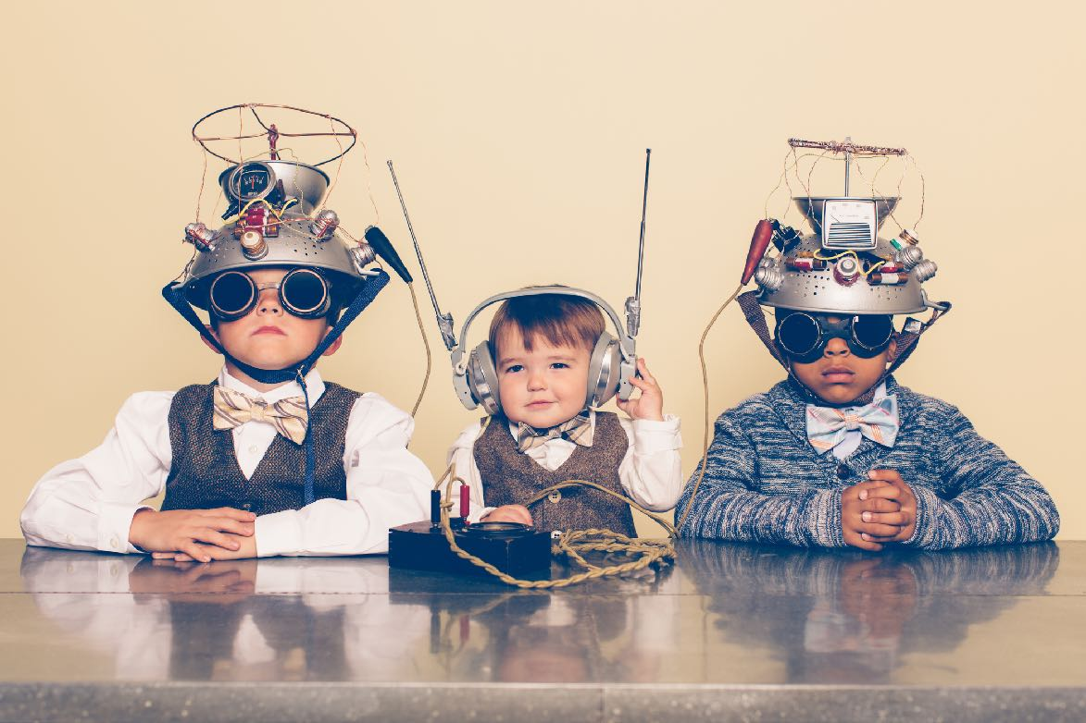

Technologies of Domination

Is it really up to you?
We love to use digital tools, each tool gives us a special power but the way we uses these powers is not up to us.
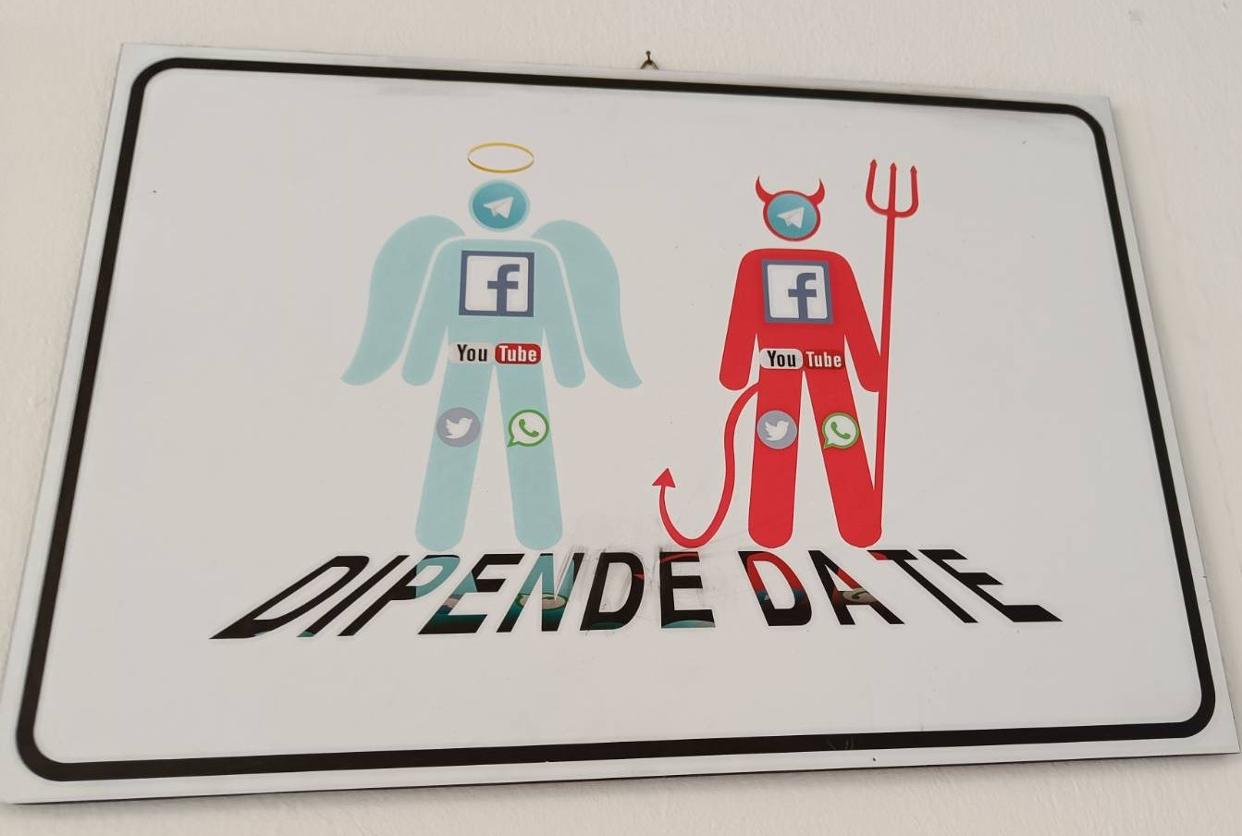 Figure 1: Image seen in a secondary school in the north of Italy. Translation: It’s up to you
Zoom, Telegram, Facebook, YouTube, Tiktok… Each platform is designed in a certain way…
- Reproduces the culture of those who created it
- Has certain limitations and features embodied to the technical resource: Affordance (https://en.wikipedia.org/wiki/Affordance)
- Exercises a gentle push (conscious): Nudge (Nudge: Improving Decisions About Health, Wealth, and Happiness, by behavioral economist Richard Thaler and legal scholar Cass Sunstein
- Influences and affects how we think and behave

Figure 3: Affordance

Figure 4: Nudge: the fly in the urinator

..
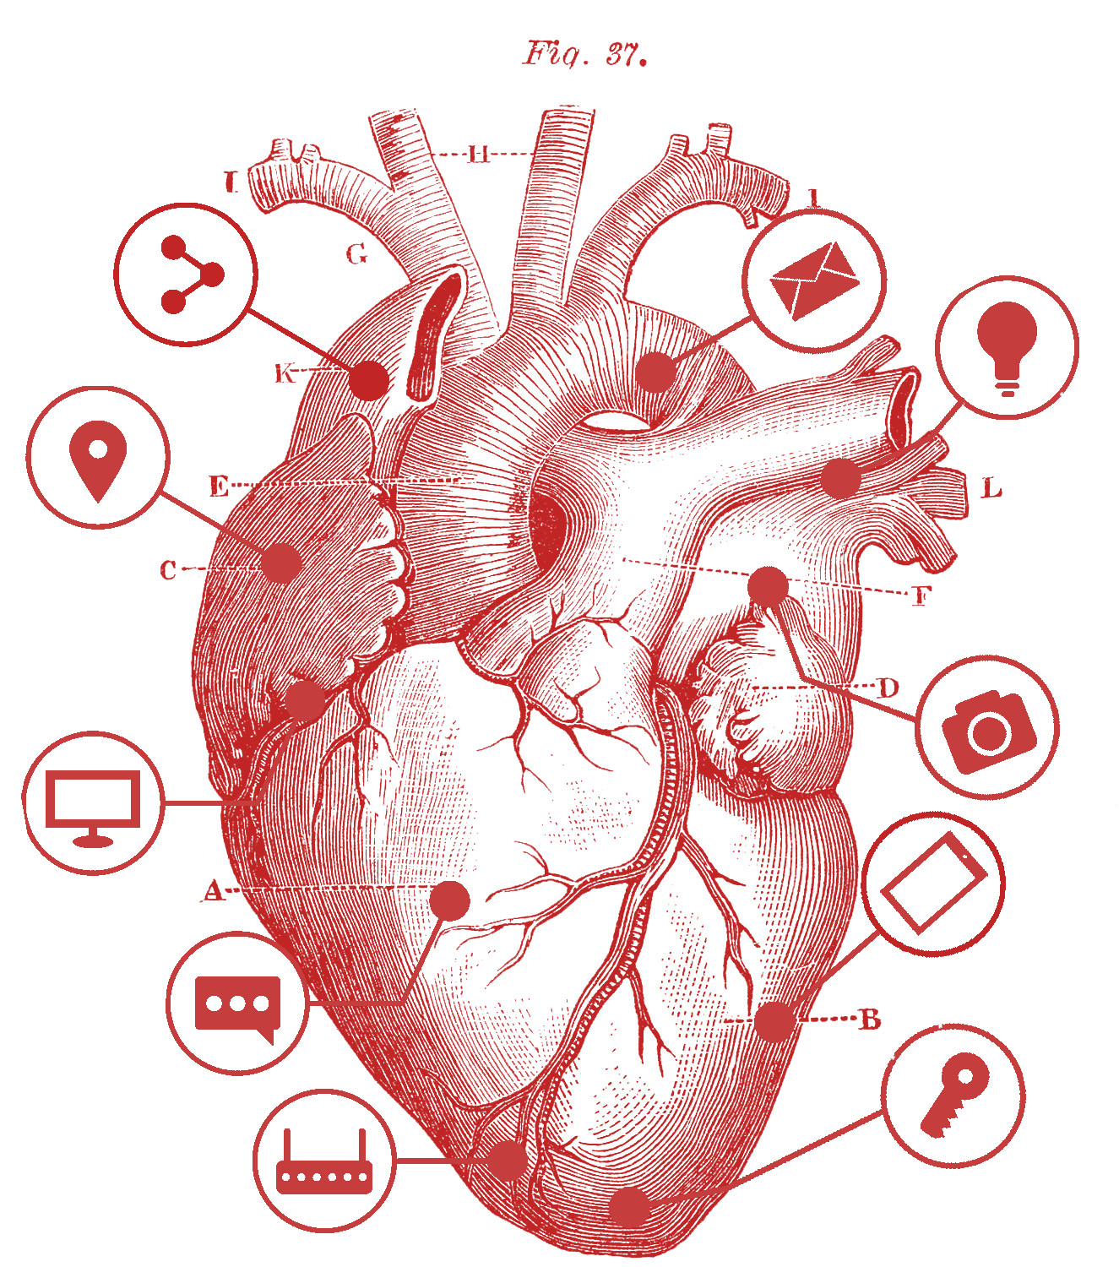
"Technologies are tools, not data. They are ways of relating, realizations of worldviews, processes in the making. They depend heavily on interactions, that is: all technologies embody, incorporate and tend to evolve and take to the extreme the ideologies of the people who created them. "
From: https://ima.circex.org/en/stories/6-conclusion/index.html Agnese Trocchi ~ Internet Mon Amour ~ CC 4.0 (BY-NC-SA)

Convivial Technologies

What is conviviality?
Conviviality is:
- dynamic, plural and changeable
- neither chaos nor order written in a rigid schedule
- not done in solitude
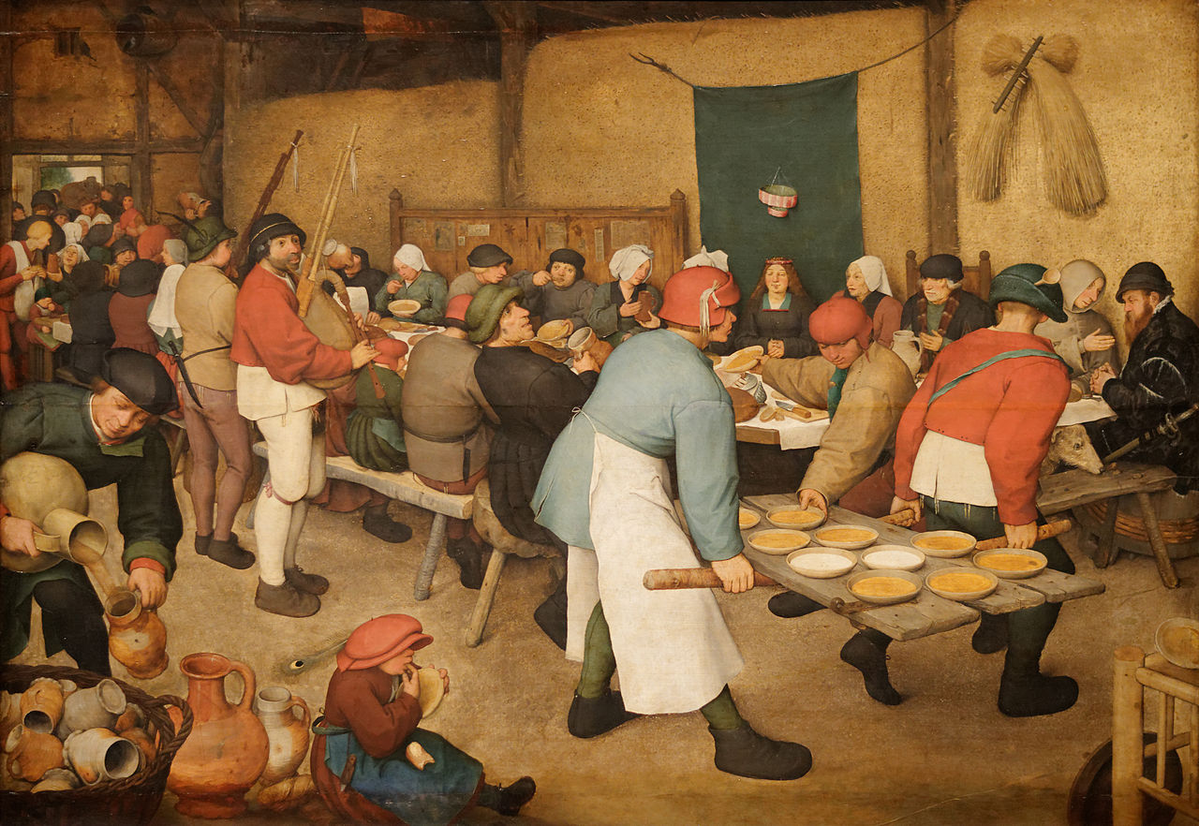 Figure 6: Pieter Bruegel the Younger, The Wedding Feast

What is a Convivial Technology?
A Convivial Technology:
- It's situated: assume and declare it's situated position in the world
- It tends to fair and equally distribution of the shares
- It's FREE as Free Software: everyone can modify and improve, it belongs to the lineage of freedom

“[. . . ] but above all, we need to devise methods of convivial collaboration that are concrete and easy to implement. To do this, we must learn to select the appropriate characteristics to develop conviviality, both in human beings and in technical beings.” From: https://tc.eleuthera.it Carlo Milani, Elèuthera, 2023


Can we do the things that we like to do with the most common app and software with convivial technologies?

TAKE ACTION

Creative Hacktivism on Social Media
Be aware of Social media affordances. Protect yourself, your contents and your community.
- You don't own the platform. Other forces control it, their goals are not your goals, your profile or your posts could be deleted any time or they may not being delivered to the people.
- It's not easy to become viral.

Good Practices
When you start a social media campaign:
- Create a website (it's under your control), all your communications should converge there
- Automate the posting using a bot: let the bots do the work
- Always make a backup of all your contacts (FB backup doesn't work)

Friendly servers for email, blogs & other services:
- https://riseup.net/en
- https://noblogs.org/

Another social is possible
- Mastodon (social) https://joinmastodon.org/
- Gancio (events) https://gancio.cisti.org/
- Blob (network) https://zecche.org/
- PeerTube https://joinpeertube.org/

Organize and collaborate
- Nextcloud https://nextcloud.com/sign-up/
- Pad: https://github.com/ether/etherpad-lite/wiki/Sites-That-Run-Etherpad
- Protectedtext - https://www.protectedtext.com
Learn more on security when using your mobile phone:
https://telefonisicuri.noblogs.org/files/2023/08/mobile-phone-security-1.pdf

Communicate
- Jitsi https://framatalk.org/abc/it/
- Jitsi: https://vc.autistici.org/
RESOURCES FOR EVERYTHING
https://degooglisons-internet.org/en/

Bibliography:
- Martino Morando, Padology https://march.international/constant-padology/
- Agnese Trocchi, Internet, Mon Amour https://ima.circex.org/en
- Carlo Milani, Tecnologie Conviviali, https://tc.eleuthera.it (Italian only)
- Critical Engineering Manifesto: https://criticalengineering.org

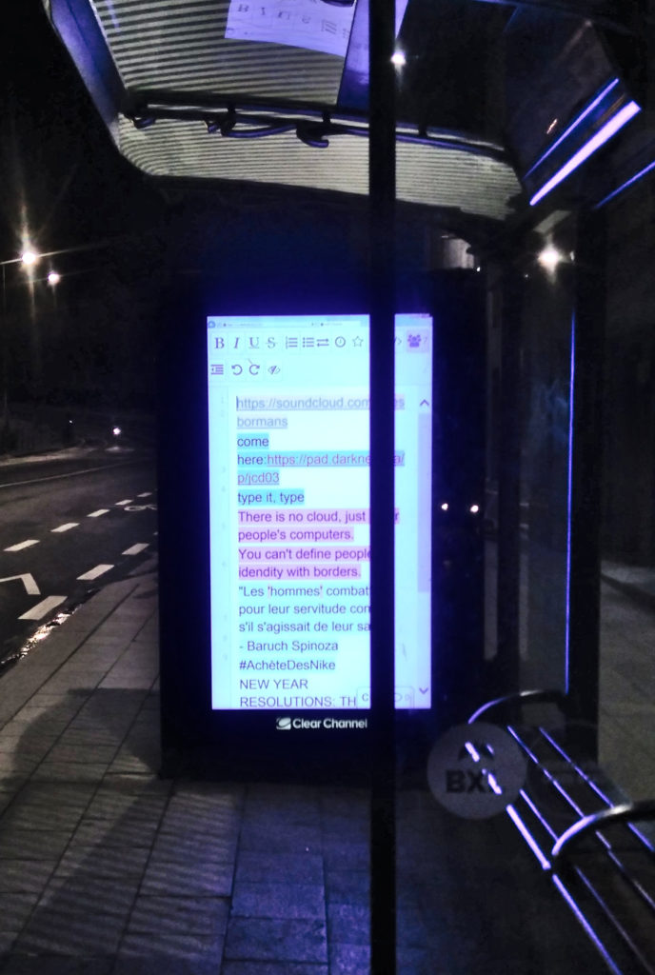 Figure 1: Etherpads in the streets of Brussels, 2020 (Indymedia Brussels)
"Inside every black-box dispositive there is a computer that can be profaned, its normal way of functioning suspended, its inter-connection converted to spread inoperativity to the other nodes of the network." Indymedia Brussels

agnese@disruptionlab.org
https://disruptionlab.org
https://circex.org/en

