**QGIS WORKSHOP, GRAPHICAL WEB CONFERENCE, 30 August**

**John Walton, @walt_jw**

**1. HOW TO PLOT X,Y POINTS IN QGIS**

Recreating a map from the BBC website - <http://www.bbc.com/news/world-africa-27498598>

**1a) Opening a shp file**

Firstly let’s open a map. Go to the pull down menu “Layer/Add vector layer…

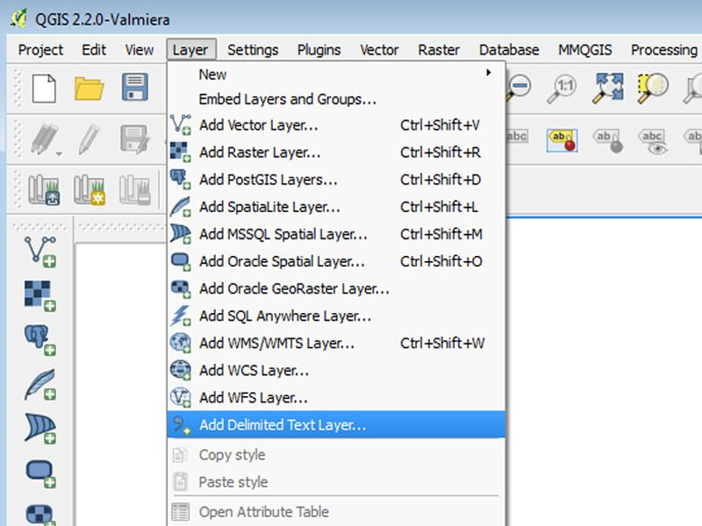

In the “Source” section, click on “Browse” and select the shp file (often pronounced “shape”) you’re interested in - in this case it’s “world_borders.shp”. Click “Open”.

The shp file is sourced to http://geospatialdesktop.com/

You should now have a map of the world visible in the application, and in the “Layers” pane on the bottom left of the screen, you’ll be able to see that the open shp file is now listed.

If you look at the icons at the top of the application you can see a selection of different options to help navigate around the map

Options include using the zoom functions, “+” and “-” and the grab hand, as well as the “Zoom Full” function. Clicking this reveals the full extent of the file you’re working on. Another thing that’s particularly useful when getting familiar with QGIS is to use the “Zoom Last” and “Zoom Next” icons - they take you back to the most recent option you’ve selected, meaning you should never really get too lost when you’re clicking about.

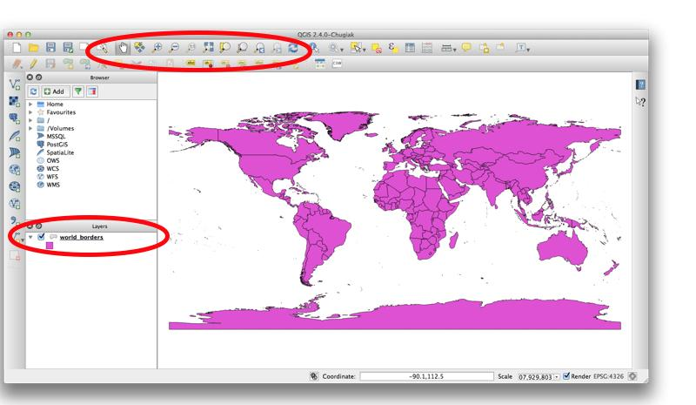

Now we’ve orientated ourselves with how to move around the map, let’s combine it with some data. The data we’re using is similar to the set of data we used to produce a map on the BBC site showing fatal terrorist attacks in Nigeria. <http://www.bbc.com/news/world-africa-27498598>

**1b) Adding data to a map**

Now lets go back to the “Layer” pull down menu and select “Add delimited text layer…”

In the dialogue “Create a Layer From a Delimited Text File” you can now browse to and select the file “GW_boko_1.csv”. Because there are two column headers in this file, helpfully labelled “Longitude” and “Latitude” QGIS has already worked which column is concerned with plotting x values and which column is concerned with plotting y values. Click “OK”.

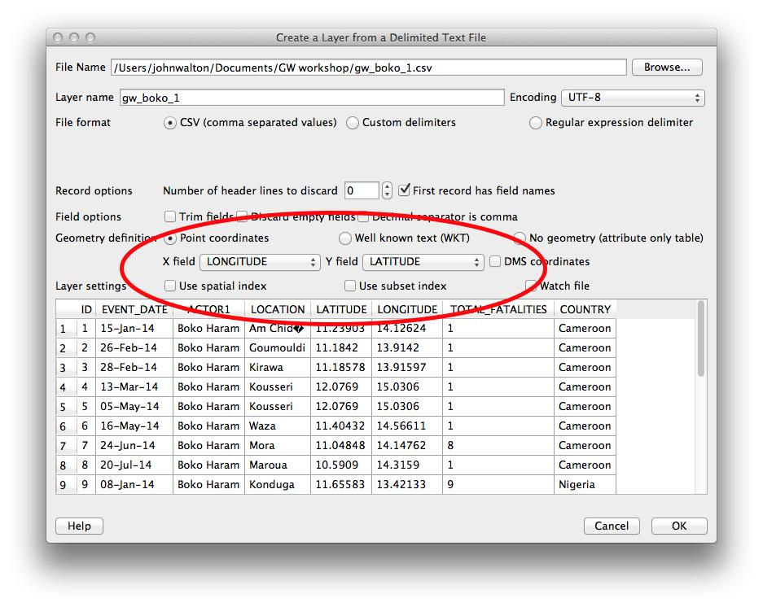

In the next dialogue box; “Coordinate Reference System Selector” the coordinate reference system should be set to “WGS84”. Click “OK”. The data will now appear on your map, and the file will be listed in the “Layers” pane on the right hand side of the screen. Zoom into the map to take a look.

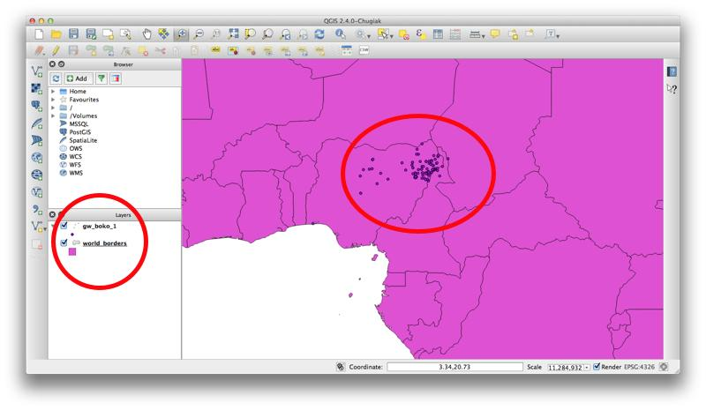

TIP: If you happen to be working with a file where QGIS doesn’t automatically select the correct values for longitude and latitude, you can manually set which columns you would like QGIS to read as the x and y values by using the drop down menus next to the x and y fields.

**Don’t forget Longitude represents X values and Latitude represents Y values.**

The data we are plotting is sourced to the Armed Conflict Location and Event Data Project http://www.acleddata.com/data/

**1c) Introducing the attribute table**

If you right-click on the filename “gw_boko_1” in the “Layers” pane and select “Open Attribute Table” you can now see all the original data from the CSV file displayed within QGIS.

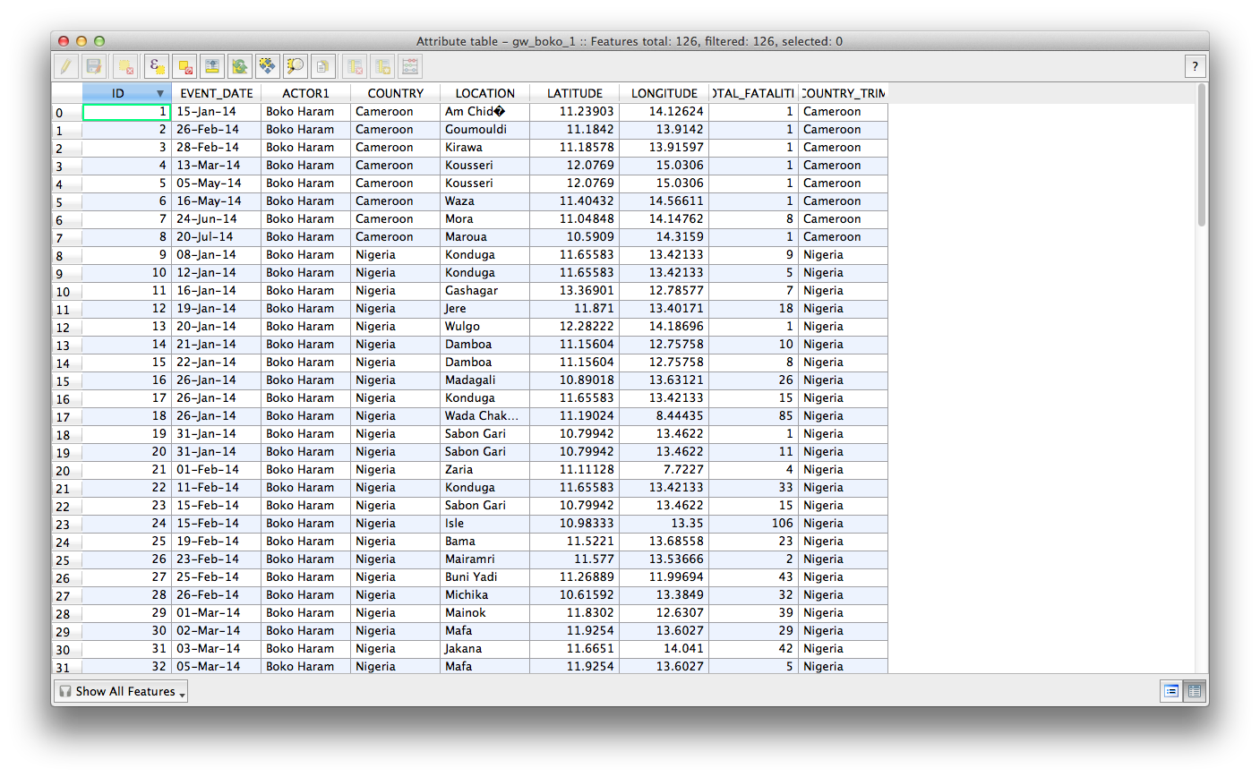

The “world_shp” file also has an attribute table which can be selected in the same way. As you become more familiar with QGIS, the attribute table’s usefulness as a place where you can query or filter the data displayed in your maps, will become a central part of your work flow. Opening it here just serves the purpose of introducing it to new users of QGIS.

**1d) Querying the data in our map**

Let’s imagine that we only want to show incidents that have occurred in Nigeria. From the attribute table for “gw_boko_1” we can see that there are a handful of incidents that have taken place in Cameroon. We can remove them in our map by running a very simple query.

Make sure “gw_boko_1” is highlighted in the “Layers” window. Select “Layer” from the pulldown menu and then click on “Query…”. The “Query Builder” dialogue box is now open and is already populated with a list of the fields from our file.

“Query Builder” works a little bit like an SQL query, if you are familiar with this.

Double click on “COUNTRY” in the list of fields. “Country” will now appear in the panel at the bottom of the “Query Builder”. Next, with “COUNTRY” highlighted in the “Fields” pane, click on “All” at the foot of the “Values” pane. This will bring in the two countries mentioned in the original CSV, Nigeria and Cameroon.

Now, go to the “Operators” pane and click on “=” and then double click on “Nigeria” from the “Values” window.

You will now have the filter query “COUNTRY”= ‘Nigeria’ visible in the filter expression window.

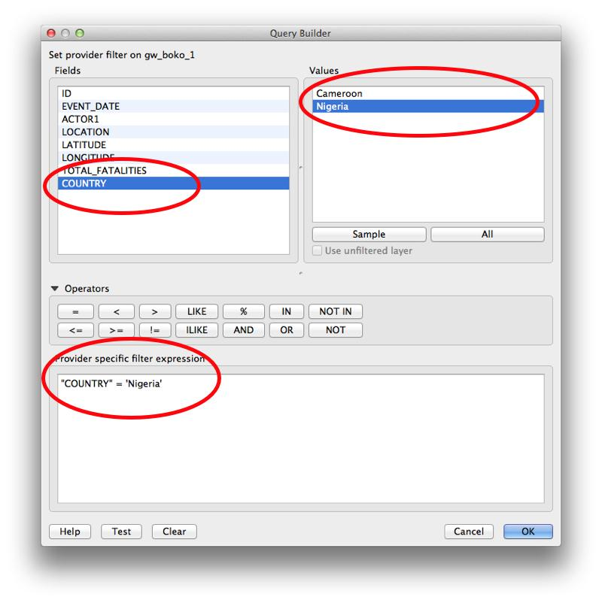

Click “OK” and now you should see that the incidents from Cameroon should have been removed from the map.

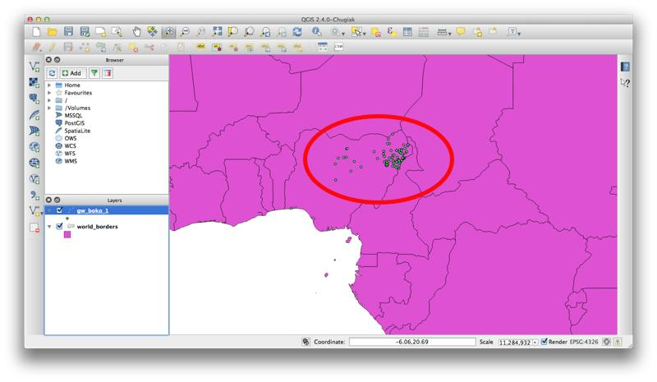

**1e) Visualising the data**

If we step back for a moment and take a look at the data we can see that a lot of incidents have taken place in the same location. Plotting them as points on our map means that a lot of our data is being obscured - this is no good!

But, we can tackle this by using the using the “Size scale” tool.

Right click on the “gw_boko_1” in the “Layers” pane. Select “Properties” and then the “Style” tab. Or, you can double click on the icon in the layer pane.

On the right of the window choose the “Advanced” button and then “Size scale field”, check “Total_fatalities” and “Scale_area”, click “OK”.

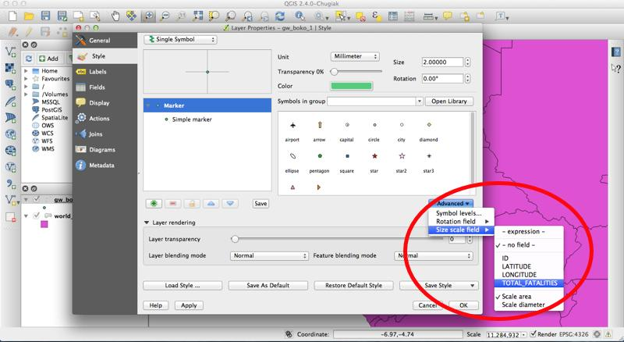

We can now see the relative size of the different attacks, but we still have the problem that some attacks are obscuring others.

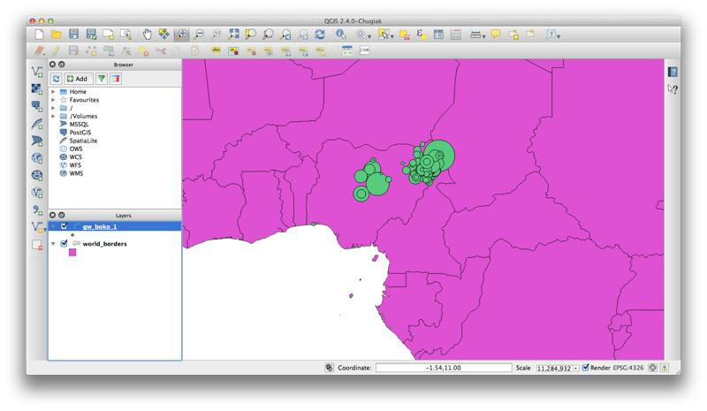

So, we can tweak the map a little by altering the opacity. Return to the “Style” section of the “Properties” tab. Set “Transparency” to 60%. Click “OK”. We now have a map where we can see that the most attacks are represented in the locations with the strongest colour.

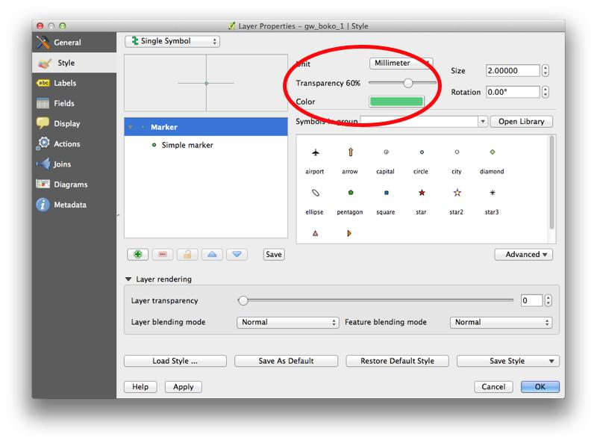

**1f) Editing the map’s colours**

This is very simple to do. Just click on the colour block or symbol of the layer you would like to edit (in the Layer pane), this will bring up the “Style” tab within “Properties”. Click on “Color” and make your selection.

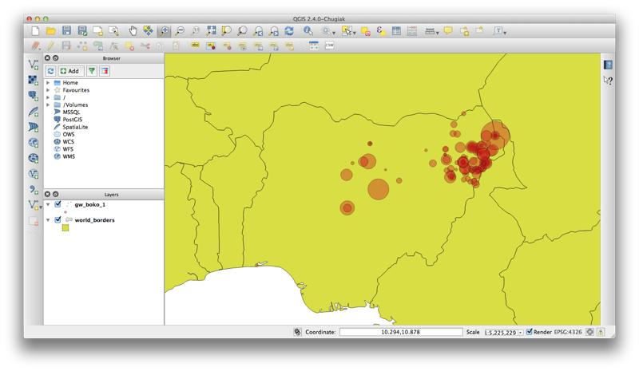

TIP: If you need to work to a specific RGB value you can select the “Color Sliders” option mentioned in “Color” above and then change the default from “Grayscale sliders” to “RGB sliders” and enter your particular values.

**1g) Exporting the final map as an SVG**

This is useful if you want to edit the map in Illustrator before publication. Navigate the map to the desired view. Then select the “Project” pull down menu and “New Print Composer”. In the next dialogue box give your file a name.

Now go to the “Layout” pulldown and “Add Map”. Now drag the crosshair from the top left of the canvas, to the maximum extent, to bottom right. The map should now appear in the print preview canvas. Back to the pulldown menu and select “Composer” and “Export as SVG…” and then save the file.

