ADLT 703: ADVANCED QUANTITATIVE STUDIES IN ADULT EDUCATION

Q5. a). i. When there is heteroscedasticity, or when all the variances do not align uniformly along the line of best fit, it is required to use the Logistic Regression methodology because of the inherent flaws in the Ordinary Least Squares (OLS) method.
Given that the residuals are not normally distributed, there will be a need for a non-linear transformation of the variables when y and x do not have a linear connection, and this is when the logistic regression approach is helpful.

ii. The characteristics of Blocks 0 and 1 are all results of computations made in order to do a logistic regression analysis. Block 0 represents the result for the null model, and Block 1 represents the output for the fully described model.

ii. Explanations of each sections:
The number of cases in each category, including those "included in the analysis," missing cases, the proportion of cases, and the overall number of cases recorded are displayed under the case processing summary table. The number and percentage of cases that were included in the analysis are now displayed in the Included in Analysis row. The data set mentioned above has no missing information.
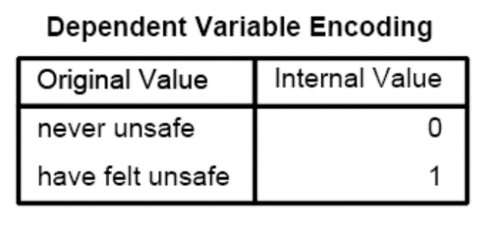
This section shows the value label given to each dichotomous variable. Where the first dependent variable, ‘never unsafe’ is = 0 and the other dependent variable, ‘have felt unsafe’ is = 1.
A representation of the observed, expected, and overall percentage values is located under this section. First, the observed values highlight the dependent variable's observed values of "never felt unsafe" and "have felt unsafe." The tabulated output has still projected that all situations are "never unsafe = 0" on the dependent variable under this null model. The overall percentage, which indicates the proportion of instances for which the dependent variables was successfully predicted, thus (939/1542) by 100, reveals 60.9.

The constant B, which is also referred to as the intercept in the provided null model, is shown as the coefficient for the constant in the "variables in the equation" table. The S.E., or standard error around the coefficient for the constant, is displayed in the following column beneath the same table. The Wald, df, and Sig come next. The null hypothesis that the constant equals "0" is now put to the test using the Wald chi-square test. Because the p-value in the Sig column is less than the threshold p-value of 0.05, the H0 in this case is rejected. As there is only one predictor in the model, there is only one degree of freedom for the Wald chi-square test. The odds ratio, which is 603/939=0.642, is represented in the last column as Exp(B), which is the exponentiation of the B coefficient.

This section displays Step 1, the first step or the initial model with predictors, under Block 1. The complete model that was mentioned in the logistic regression command is contained in this section. Because stepwise logistic regression or blocking have not been utilized, the results for Step, Model, and Block are the same. This Block 1 shows df of 4, in contrast to Block 0.
The "model summary" for Step 1 is in the subsequent table up top. The final model's -2 log probability is shown in the first column, although by itself, this value is not very useful. Notwithstanding the fact that it can be used to contrast nested (reduced) models. Then there are the fictitious R-squares created by Cox & Snell and Nagelkerke. They are employed to explain the differences between the variables.
The observed value, which displays the '=0' and '=1' that are observed in the dependent variable, is located beneath the categorization table above. The dependent variable's projected values are then based on the whole logistic regression model. The overall percentage then displays the overall percentage of cases that the entire defined model properly anticipated.
Under Block 1: ‘The values of "B" for the logistic regression equation, which forecasts the dependent variable from the independent variable, are displayed in the first column under "Variables in the Equation." The values of "B" are in units of log-odds. The prediction equation is log(p/1-p) = b0 + b1*x1 + b2*x2 + b3*x3 + b4*x4, where p is the likelihood of neighbourhood fear. This equation is analogous to OLS regression.
Hence, log(neighbourhood fear/1- neighbourhood fear) = 0.520 + 0.142black - 0.558gender - 0.015age - 0.180emp ft will be the equation.
The standard errors (S.E.), which are linked to the coefficients, are then tested to see if the parameter differs considerably from "never unsafe." So, you can calculate the t-value by dividing the parameter estimate by the standard error. A parameter's confidence interval can also be created using the standard errors. The odds ratios for the predictors are displayed in the last column, Exp(B), which also represents the exponentiation of the coefficients.

Q5. a. iii. The interpretation of all useful statistical outputs;
1. Under Block 0, the odds ratio Exp(B) for the variables in the equation section is 0.642. Since it is less than 1, the likelihood of "never feeling unsafe" in a neighbourhood is 64.2% lower than that of "having felt unsafe."2. However, with Block 1, the variables in the equation section, the odds ratio Exp (B) of being safe in a neighbourhood is (1.682-1) * 100= 68.2% more likely to be ‘never unsafe’ as compared with ‘have felt unsafe’.
3. INTERPRETING THE COEFFICIENTS:
The estimated regression equation for with Block 1, the variables in the equation section will be;
log(neighbourhood fear/1- neighbourhood fear) = 0.520 + 0.142black – 0.558gender – 0.015age – 0.180emp_ft
The likelihood of neighbourhood dread will be 0.520 according to the aforementioned calculation when all the other independent variables are equal to zero.
Moreover, when there is a unit change in the other components, the probability of change will increase by 0.142 but decrease by -0.558, -0.015, and -0.180.
4. When interpreting significance, the majority of the variables—including gender, age, and the constant—have significance levels less than or equal to 0.05. As a result, we reject the null hypothesis and reach the conclusion that there is no statistically discernible relationship between gender, age, and neighbourhood fear.

