Wallace Tyner
SDC330 – Week 3 Project

This version builds on the previous week by adding abstraction, constructors, and proper use of access specifiers.

An abstract class is used to hold shared contact data and enforce structure across contact types. Constructors are used to initialize objects when they are created, which keeps the program consistent.

Access specifiers are used to control visibility of variables and methods. Private is used to protect specific data, while protected allows child classes to access shared data.

These changes improve organization and make the program easier to expand.

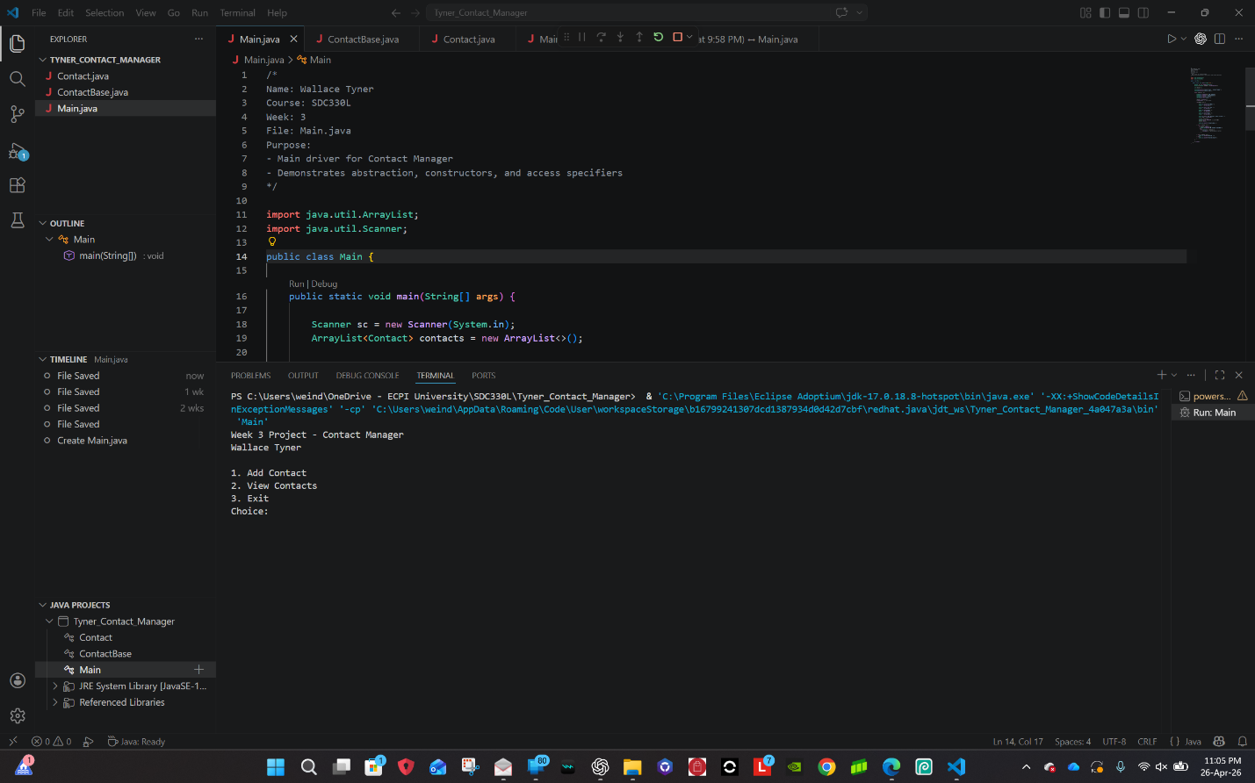
This screenshot shows the program starting and displaying the menu options for the user.

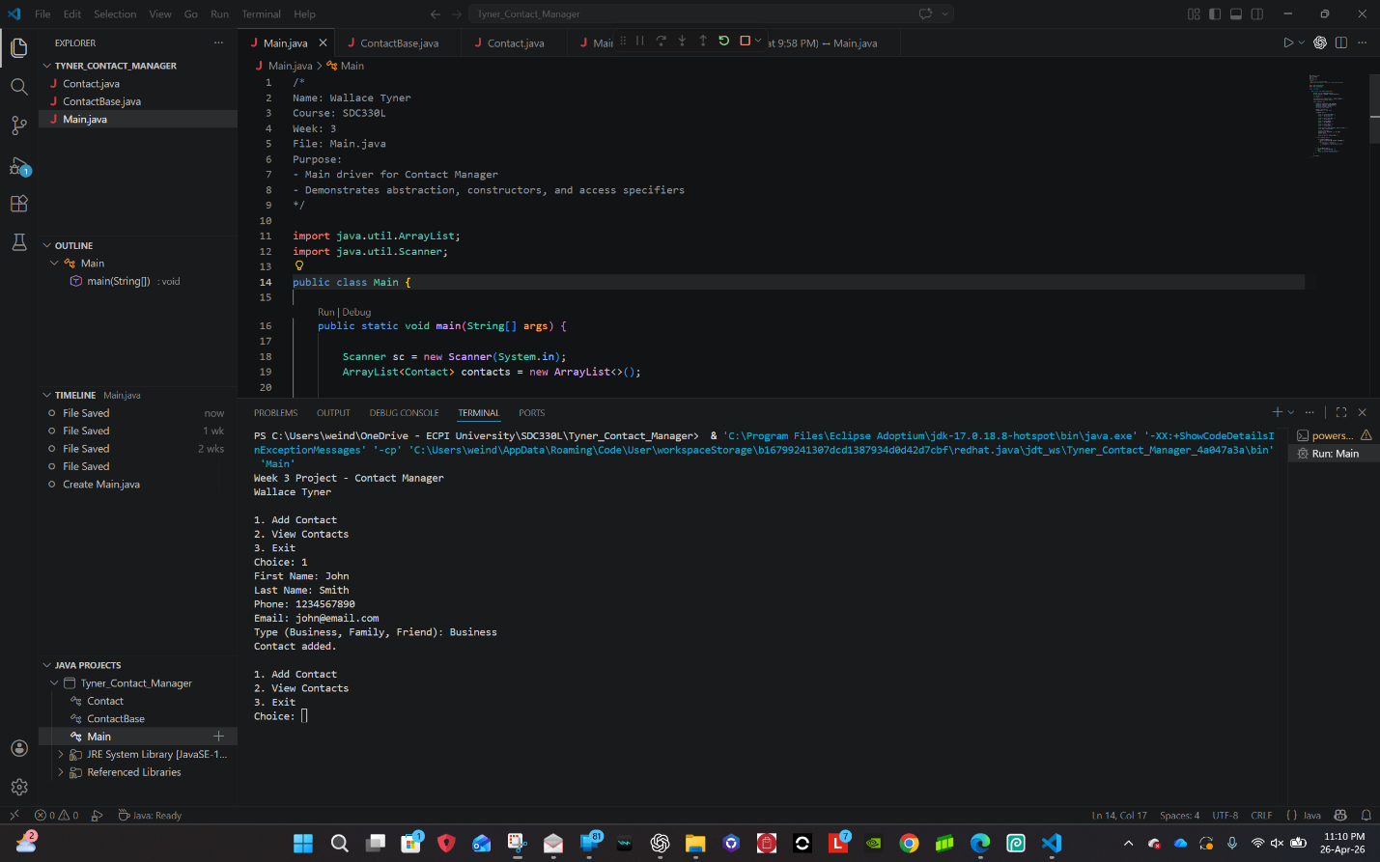
This screenshot shows adding a new contact using user input.

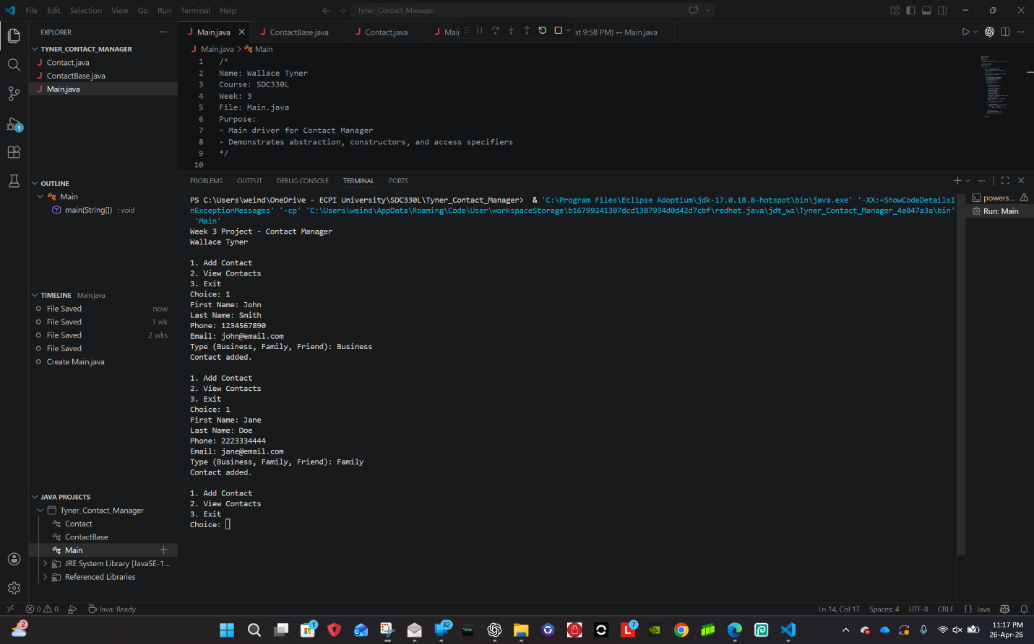
This screenshot shows the stored contacts being displayed, demonstrating abstraction and polymorphism.

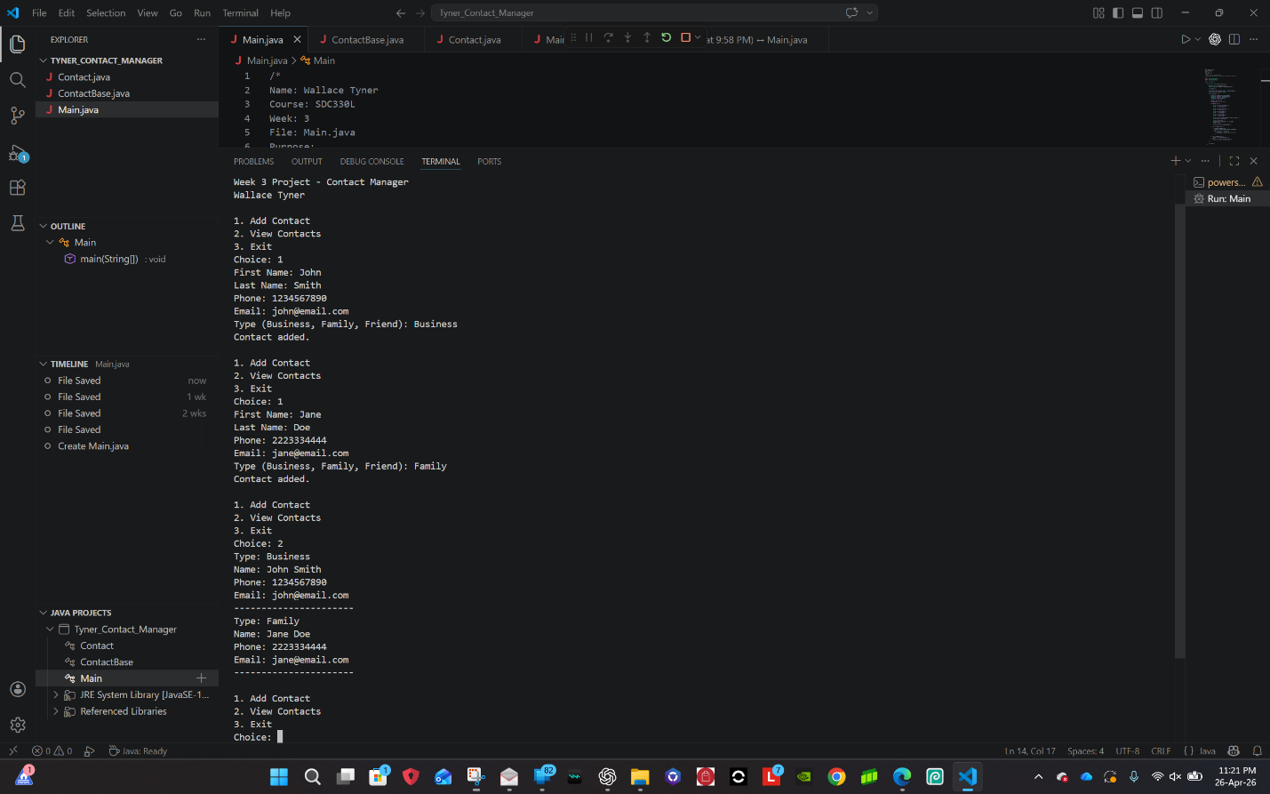
This screenshot shows the implementation of the abstract class, constructors, and access specifiers in the code.

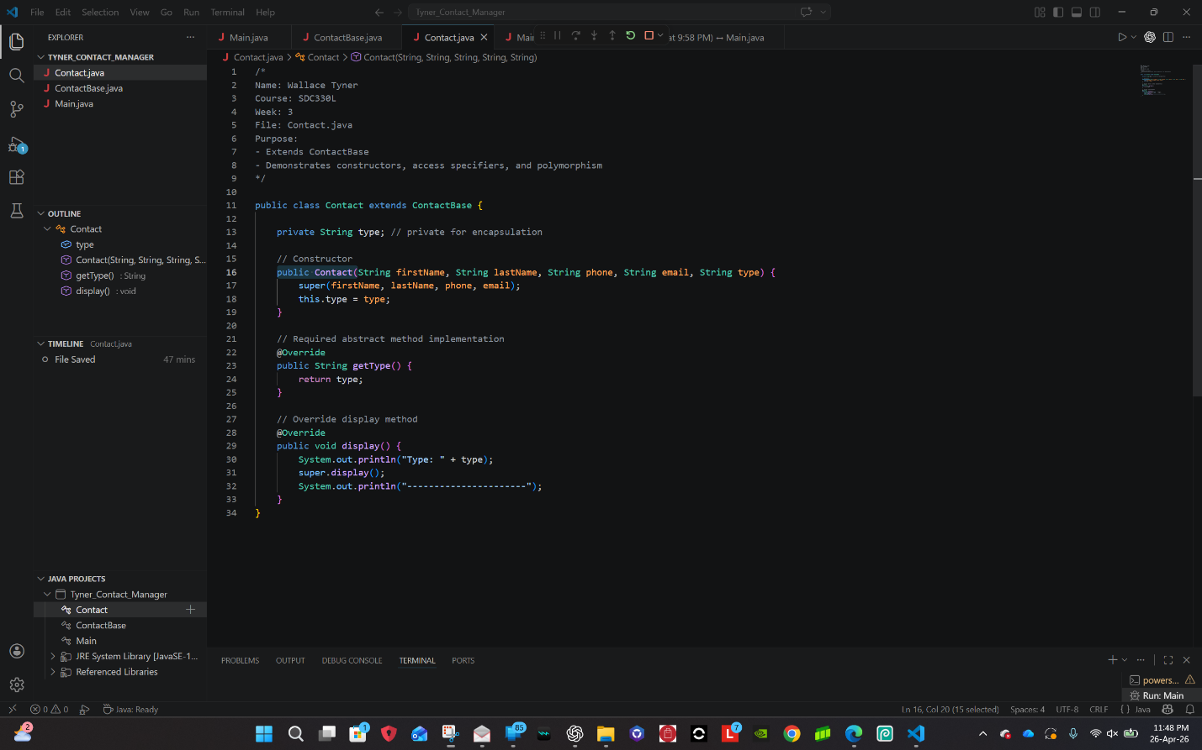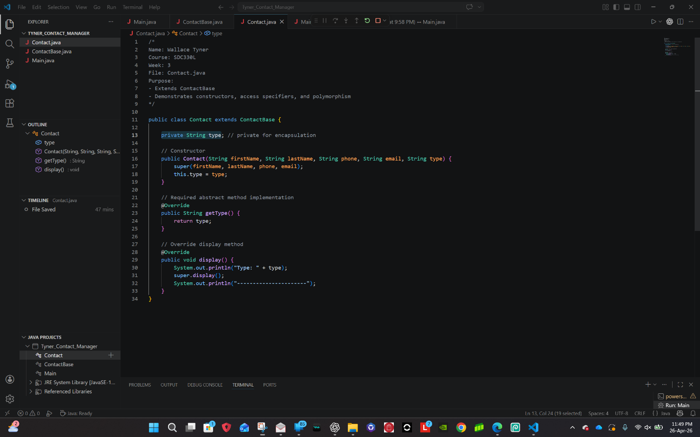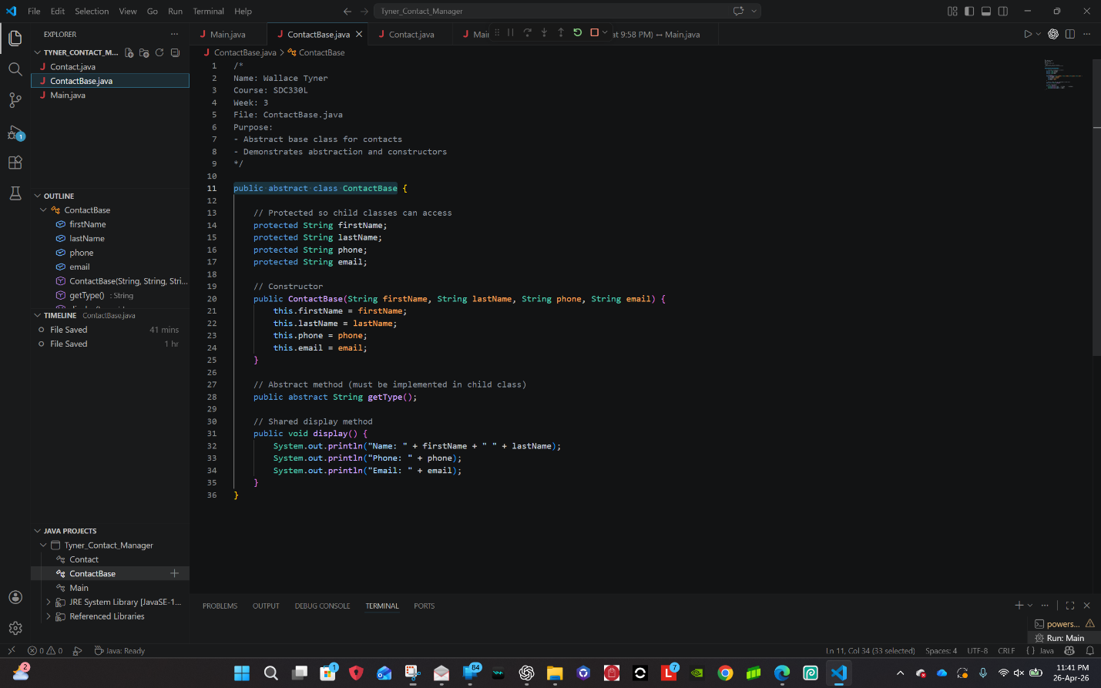

Github Repo Link:
https://github.com/waltyn4684/Tyner_Week1_Project/releases/tag/Phase-3

