

UNITED CHURCH PLATFORM
System Workflow Diagrams and Implementation Proposal

Prepared for | UCZ Trinity Congregation
Prepared by | BAU Solutions Limited
Document status | Proposal for review
Date | 25 August 2026

A secure, modular administration platform for financial stewardship, organisational management, assets, communications, reporting and governance.

1. Executive summary
This proposal defines the operating model, principal workflows and delivery approach for the United Church Platform (UCP). The platform consolidates requisitions, contributions, entity funds, users and permissions, assets and fleet, communications, reporting, licensing, audit, backup and restore into one governed system. Its design goal is not merely digitisation: it is traceable stewardship, controlled access, timely approvals and reliable institutional records.
The recommended approach is to adopt UCP as a modular platform with explicit process boundaries, configurable rules and reusable shared services. Each transaction should carry its own audit trail, attachments, signatures, notifications and proof document, while cross-cutting controls enforce licensing, permissions, data scope, logging and retention.
Outcome | How UCP delivers it
Accountability | Named initiators and approvers, signatures, timestamps and immutable audit history.
Financial control | Entity funds, reservations, approval thresholds, reconciled allocations and completed-cycle reporting.
Operational visibility | Dashboards, filtered registers, proof documents and organisation-wide reports.
Security | Role/process permissions, entity scope, account controls, licence enforcement and secure configuration.
Resilience | Structured logs, delivery histories, scheduled backup and controlled restore.

2. Proposal objectives
- Establish one authoritative platform for financial, organisational and asset administration.
- Apply least-privilege permissions and entity-level visibility consistently across screens, APIs and reports.
- Standardise approval workflows while retaining configurable thresholds, routing and communication channels.
- Provide complete evidence through signatures, attachments, audit history and printable proof documents.
- Prepare the solution for replication, scaling, modular product derivation and future integrations.

3. Scope of the proposed platform
Domain | Included capabilities
Identity & access | Email/membership-ID login, optional Active Directory, configurable password/session rules, user/role/process permissions.
Organisation | Groups, sections and committees; membership, status, funds, fund history and entity-scoped access.
Finance | Requisitions, contributions, approval chains, allocations, balances, attachments, signatures and proof documents.
Assets & fleet | Asset register, up to six images, checkout requests, entity requests, payments, drivers, returns, inventory and reports.
Communications | Email, SMS and WhatsApp configuration, templating, approval links, delivery logs, failure reasons and retry.
Reports | A4 preview, portrait/landscape, filters, PDF, Excel, CSV and print; financial, summary, organisational and asset reporting.
Administration | System configuration, licensing, logs, backup/restore, categories, SMTP, communication settings and drivers.

4. Governance and access model
Authorisation must be enforced twice: process permission determines what a user may do; data scope determines which records the user may see. Hiding a navigation item is usability—not security—so every protected API must repeat the same checks.
Role group | Baseline access
SuperAdmin | Full platform, configuration, roles, licence administration, backup/restore and all data.
Admin | Administrative operations, dashboards and reports; no initiation/editing of requisitions or contributions.
Church leadership | ChurchAuth, Secretary, Treasurer, Accountant and Minister view all non-draft items and perform assigned approval duties.
Entity representatives | See assigned entities; initiate permitted processes; requisitions visible according to initiator/entity and workflow rules.
Senior representatives | Same-entity requisition approvals according to the configured two-approval requirement.
Auditor | Read-only evidence, audit and report access; cannot initiate asset checkouts.
General users | See assigned organisation details and their own relevant asset interactions; request permitted asset checkouts.

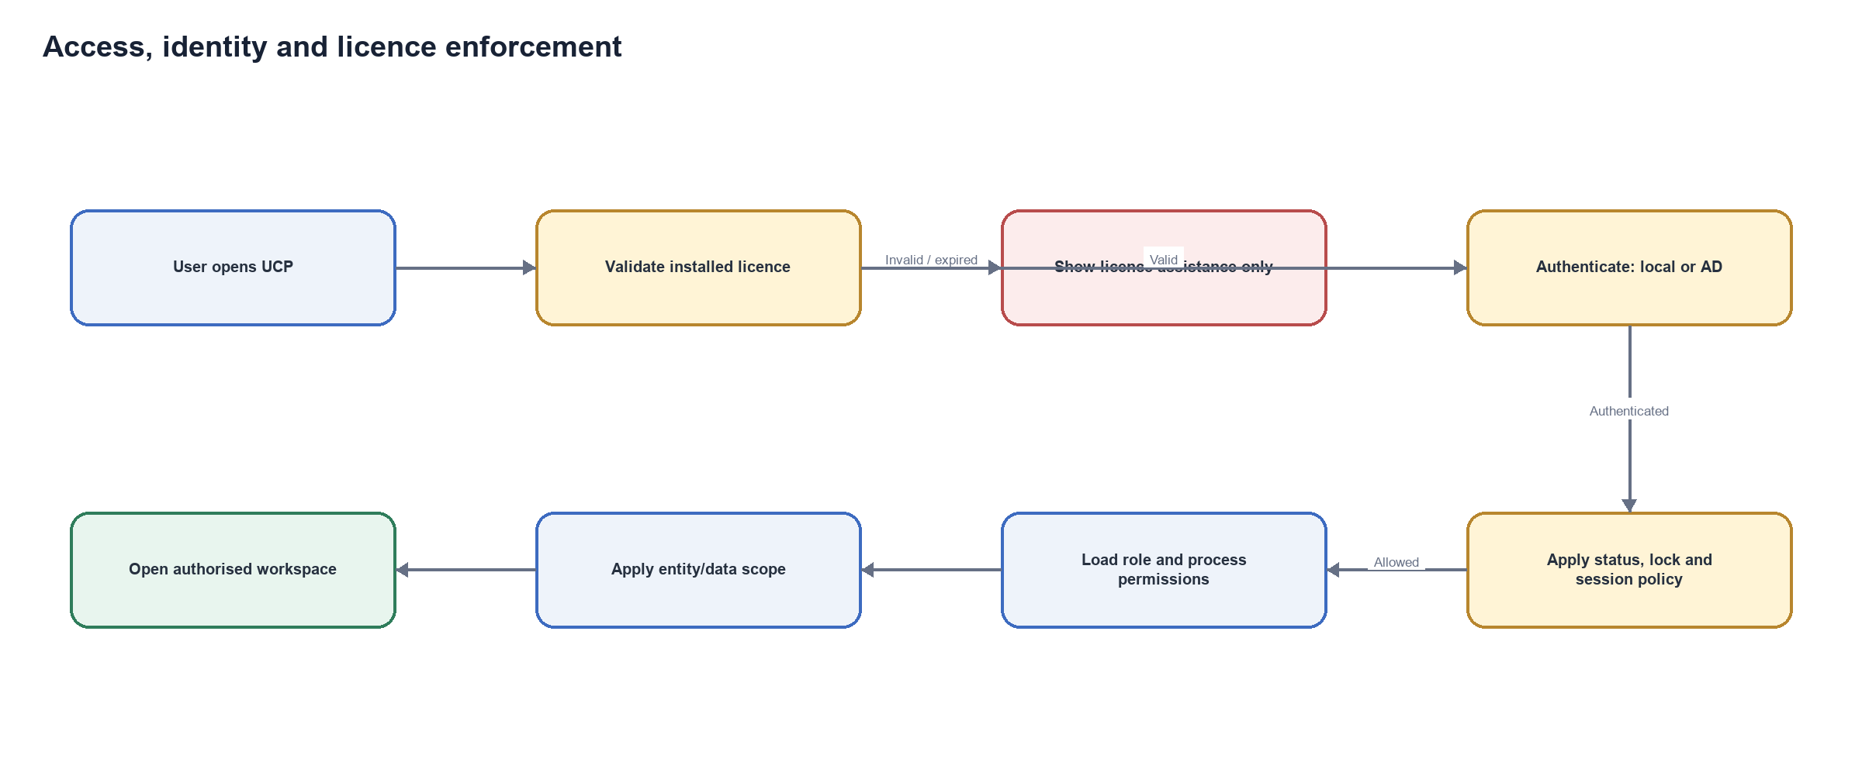
Figure 1. Access, authentication, licence and authorisation workflow.

5. Core business workflows

5.1 Requisitions
A requisition begins as an editable draft. Submission validates the requesting entity, allocations, signature and available balance. Pending requisitions reserve available funds without changing the posted/current balance. Approval requires two representatives associated with the same entity, with at least the required SeniorRep participation; church-level approval then includes Treasurer, Accountant and ChurchAuth/Secretary. A Minister approval is added above the configurable threshold.
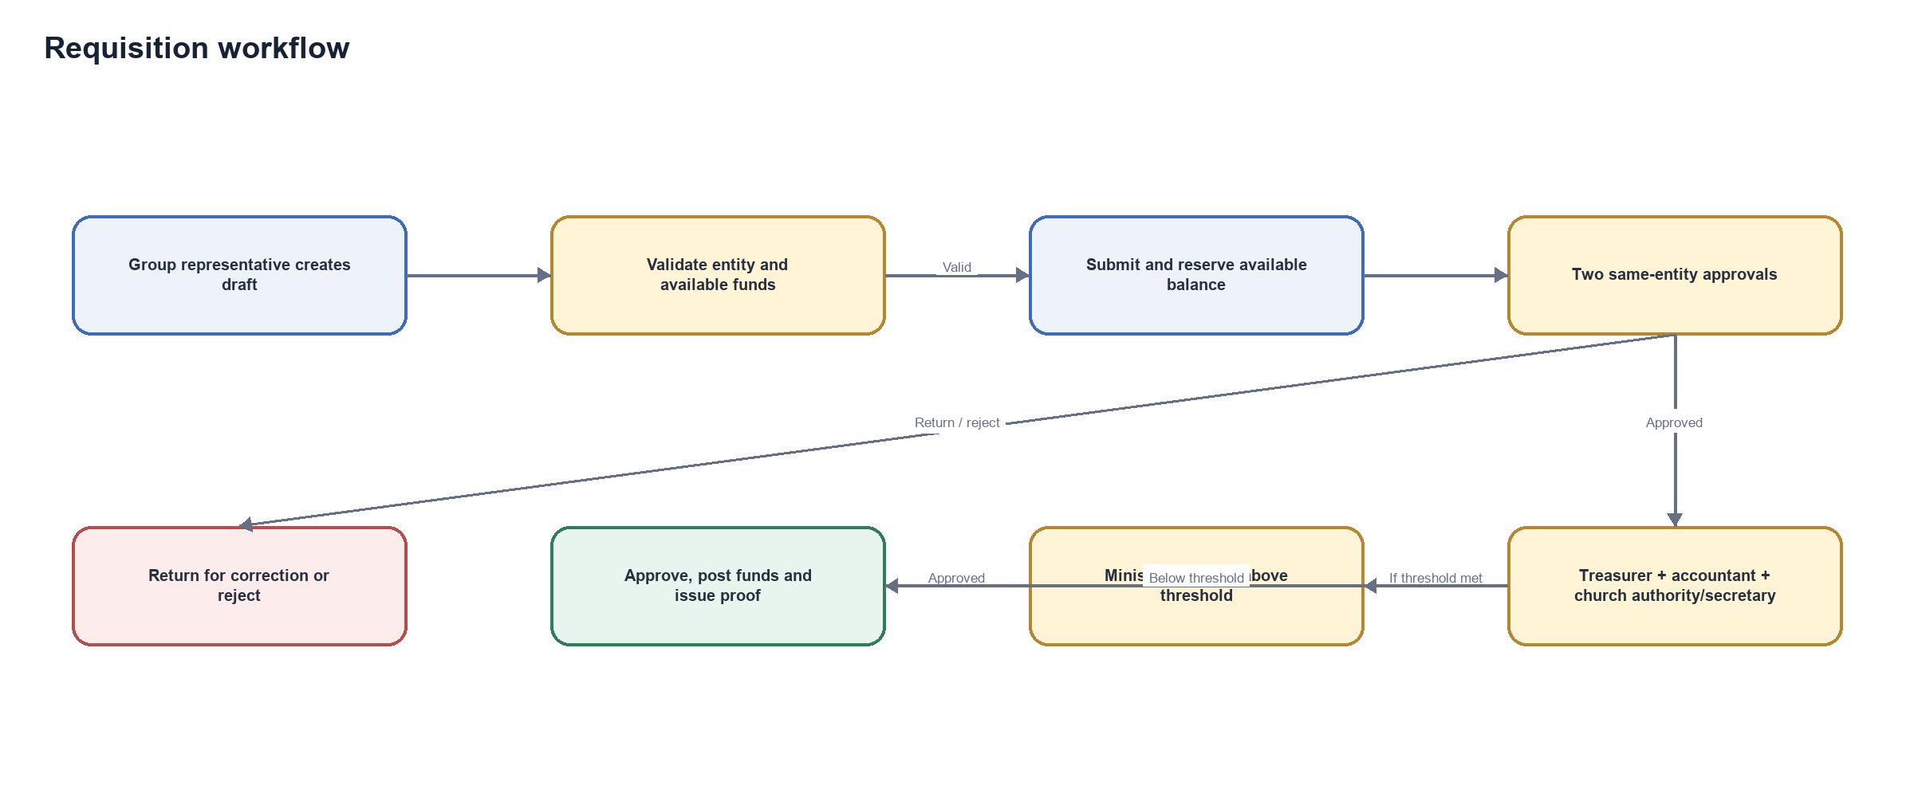
Figure 2. Requisition initiation, reservation and approval workflow.

5.2 Contributions
Contribution amounts and allocations must balance using decimal-safe validation. On submission, approval-required notifications are routed to the Accountant and Treasurer; the creator is excluded unless explicitly configured for another notification type. Review may confirm, reject or return the item for correction. Confirmation updates funds and produces auditable proof.
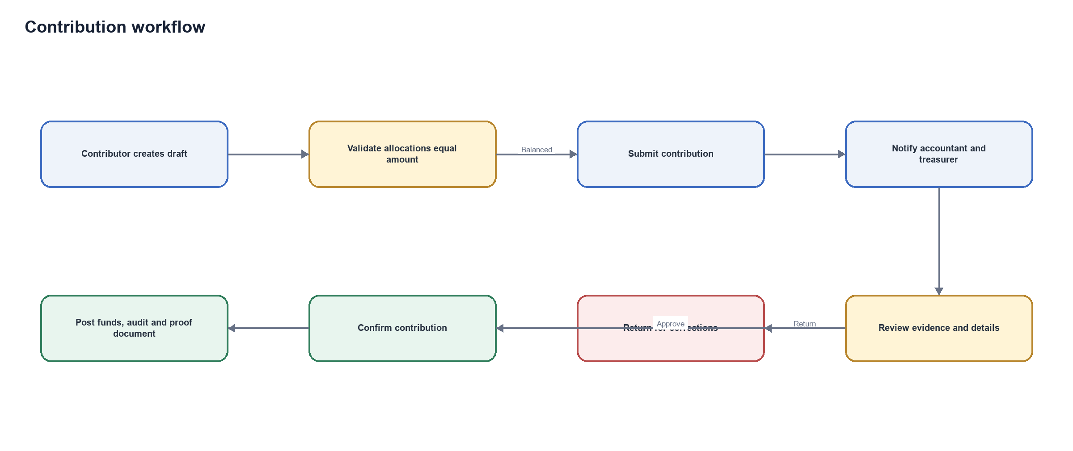
Figure 3. Contribution validation, review and confirmation workflow.

5.3 Assets and fleet
Assets are registered and edited only by authorised roles. Users can browse applicable inventory and request checkout for themselves or, where they represent it, an entity. Requests capture quantity, expected duration, payment requirements/proof, attachments and—in vehicle cases—a maintained driver. Approval, checkout, return and inspection update inventory and preserve request-level evidence.
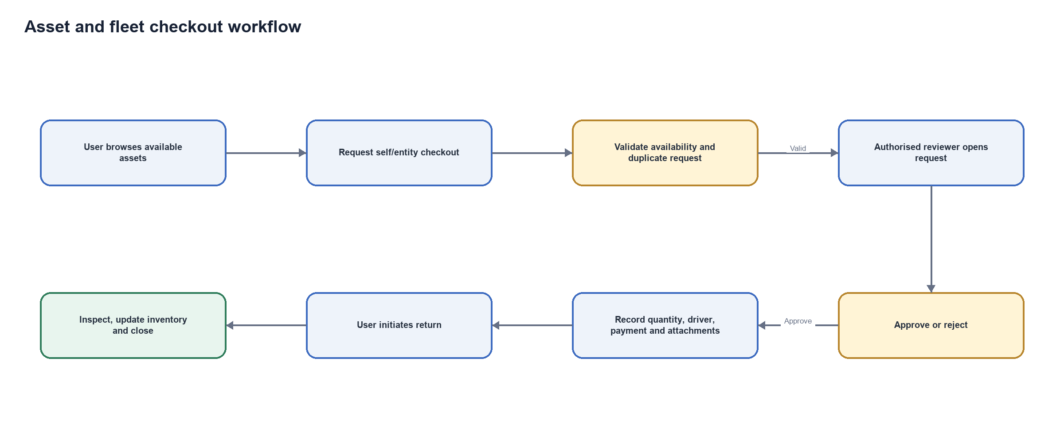
Figure 4. Asset and fleet request, checkout and return workflow.

6. Communication and action workflow
Business events should enqueue communications rather than block transaction submission while an SMTP or messaging provider times out. Each channel records recipient, subject/type, payload reference, status, attempts, timestamps and a concise but useful failure reason. Secure approval links open a mobile-friendly action page; links must be time-bound, identity-aware and subject to the same approval rules as the full portal.
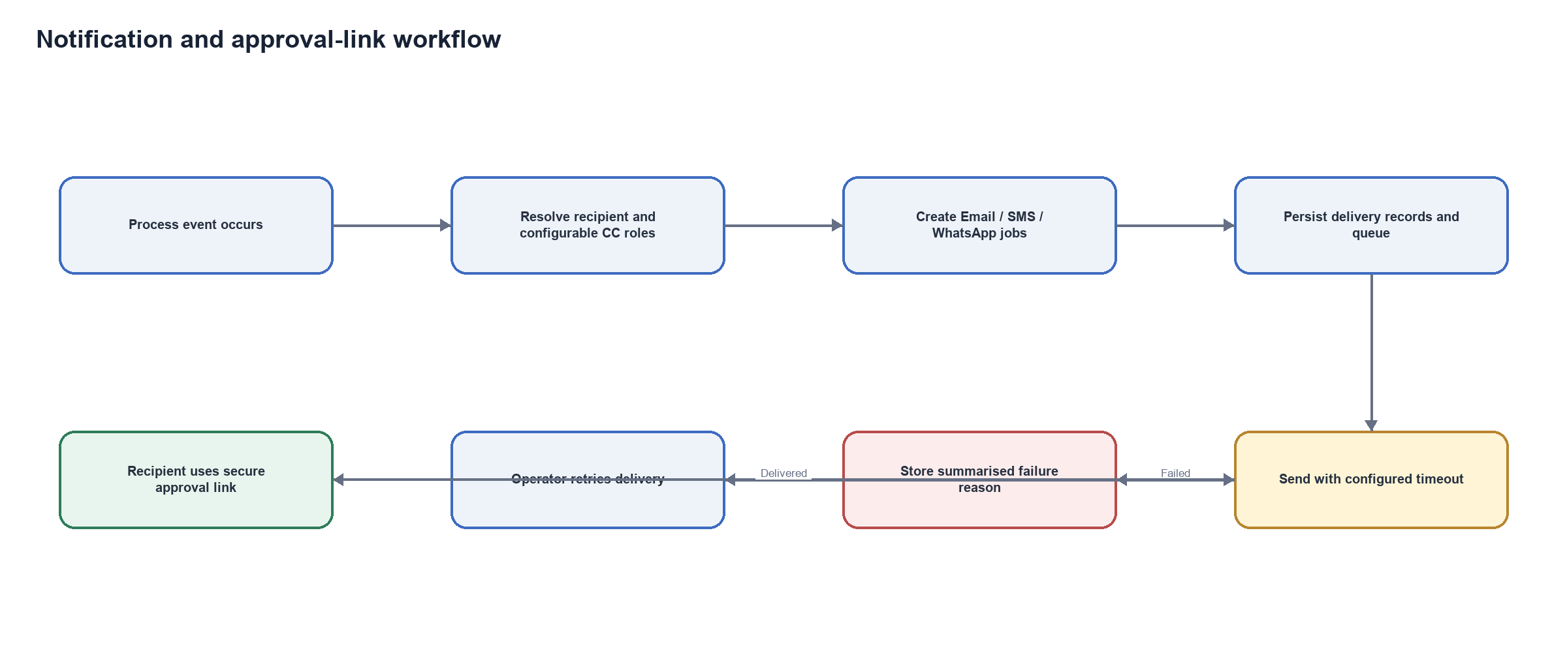
Figure 5. Multi-channel notification, delivery history and retry workflow.

7. Reporting and records
All printable artefacts should use one report viewer and one export pipeline. The screen preview is not the print source; PDF and print must be generated from a controlled A4 document layout with defined header, footer, logo sizing, page breaks, dates and numeric formatting. Financial reports include only approved/completed full-cycle records. Entity and description aggregation must be distinct and deterministic.
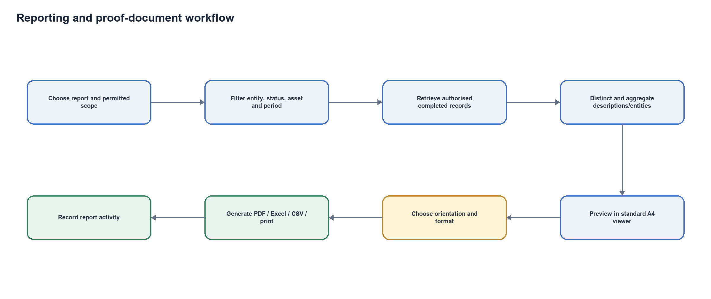
Figure 6. Filtered report preview and export workflow.
Report family | Purpose
Comprehensive financial | Completed requisitions, contributions and applicable paid asset transactions by entity and period.
Financial summary | Weekly, monthly, quarterly or yearly aggregation; identical descriptions are summed once.
Module registers | Detailed requisition, contribution and operational asset registers with status/entity filters.
Organisation assets | Organisation-wide asset activity, filterable by asset, user, entity and period.
Proof documents | Record-level A4 evidence with signatures, attachments reference and mini audit trail.

8. Audit, logging and continuity
Every material create, update, workflow action, status transition, delivery attempt and administrative action should produce a process audit entry and a central log entry. User-facing messages should be captured where useful, but sensitive values, credentials, tokens, private licence keys and raw personal evidence must be excluded or redacted. Database backup must support schedules, retention, verification and a guarded restore procedure.
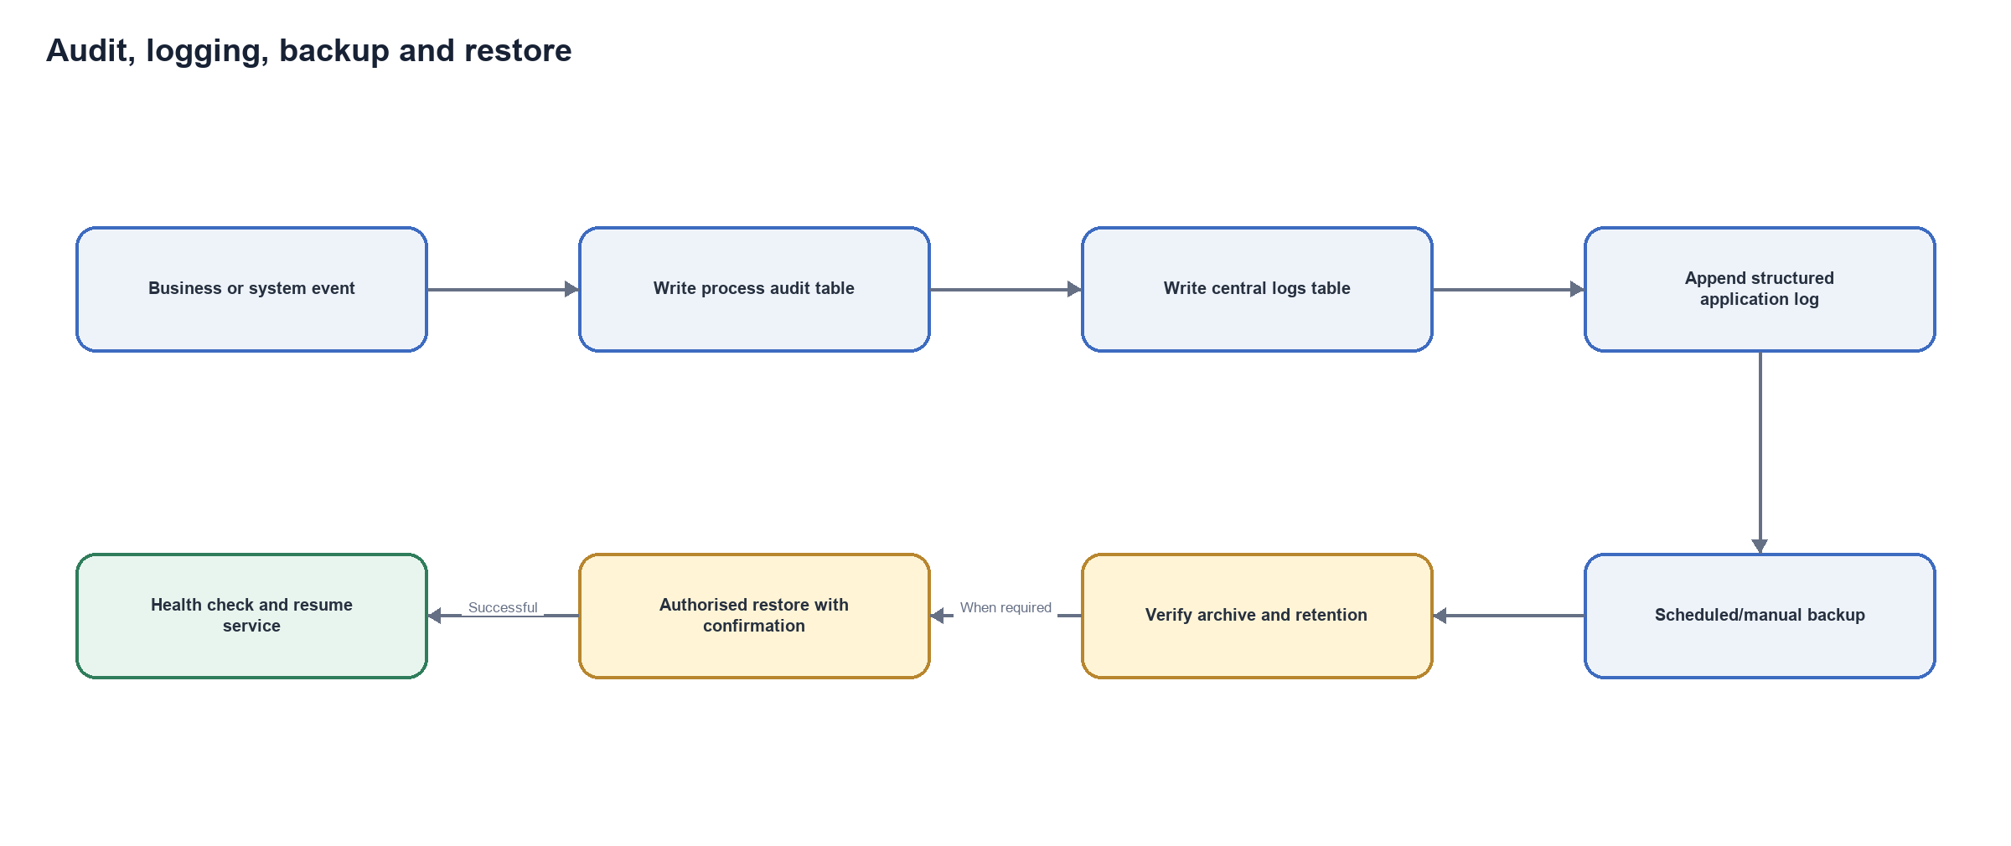
Figure 7. Audit, central logging, backup and controlled restore workflow.

9. Proposed solution architecture
Layer | Responsibility
Angular web client | Responsive portal, mobile action views, report viewer, overlays and accessible workflow screens.
.NET API | Authentication, policy enforcement, workflow orchestration, validation, notifications and exports.
PostgreSQL | Transactional data, audit tables, delivery histories, configuration, licence records and backup source.
Background processing | Queued email/SMS/WhatsApp delivery, scheduled backup and retry handling.
File storage | Controlled attachments, asset images, proofs and application logs with retention rules.
External services | SMTP, Twilio/other messaging providers, optional Active Directory and licence issuer trust chain.

Scalability recommendation: keep API instances stateless, move scheduled and delivery work to a single coordinated worker or distributed queue, use shared durable file/object storage, externalise secrets, add health checks, use a reverse proxy/load balancer and introduce PostgreSQL replication only after backup/restore tests and connection-pool monitoring are established.

10. Delivery approach
Phase | Indicative focus | Exit condition
1. Discover & baseline | Confirm process owners, rules, roles, data quality and infrastructure. | Signed workflow and acceptance baseline.
2. Stabilise controls | Permissions, entity scope, licence enforcement, logs, configuration and migrations. | Security and migration tests pass.
3. Complete workflows | Requisition, contribution, assets, approvals, returns, attachments and communications. | End-to-end scenarios pass by role.
4. Reporting & continuity | Viewer/exports, proof documents, backup/restore and audit evidence. | Report reconciliation and restore drill pass.
5. UAT & rollout | Training, data verification, UAT, defect closure and production cutover. | Business sign-off and support handover.
6. Optimise | Performance, queueing, observability, replication readiness and reusable module extraction. | Operational KPIs and roadmap agreed.

11. Acceptance criteria
- Users see only authorised navigation, actions and records; direct API access is equally protected.
- Draft, pending, returned, approved, rejected and completed transitions follow the approved workflow and balance rules.
- Every material action identifies who, when and what changed.
- Approval links work on mobile and cannot bypass signature, role, entity or threshold controls.
- PDF/print output is stable A4, centred and consistent with preview; Excel/CSV totals reconcile.
- Communication failures do not delay transaction submission and can be retried from delivery history.
- An expired/invalid licence blocks protected application access while preserving a safe assistance route.
- Backup completes on schedule and a documented restore drill succeeds in a non-production environment.

12. Key risks and mitigations
Risk | Mitigation
Complex role combinations | Maintain a permission catalogue, role templates and automated policy tests.
Historical data inconsistency | Use idempotent migrations, reconciliation reports and pre/post migration counts.
Slow external email/SMS providers | Queue delivery, configure timeouts and expose retry with failure diagnostics.
Balance discrepancies | Use database transactions, decimal precision, reservation rules and reconciliation tests.
Attachment growth | Apply size/type limits, malware controls, retention and scalable storage.
Key/licence compromise | Keep private issuer keys outside UCP; pin trusted public keys and use controlled rotation.
Operational restore failure | Encrypt backups, verify them, retain multiple generations and conduct restore drills.

13. Commercial and operational assumptions
Commercial pricing, hosting costs, messaging consumption, support service levels and final delivery dates are to be agreed after discovery. The indicative delivery sequence is not a fixed quotation. The proposal assumes access to process owners, a representative test database, SMTP/messaging provider accounts, deployment infrastructure and timely UAT decisions.

14. Recommended next steps
- Approve this document as the working process baseline.
- Nominate business owners for finance, administration, assets, reporting and infrastructure.
- Conduct a role/permission and entity-scope workshop.
- Agree UAT scenarios, reconciliation totals and production cutover criteria.
- Produce the priced statement of work and implementation schedule.

Appendix A. Workflow catalogue
ID | Workflow | Primary owner | Evidence produced
WF-01 | Access and licence enforcement | System administration | Login/session logs, licence status
WF-02 | Requisition lifecycle | Finance and entity representatives | Audit, signatures, attachments, proof
WF-03 | Contribution lifecycle | Finance | Audit, allocation history, proof
WF-04 | Asset checkout and return | Assets/fleet administration | Request ID, payment proof, checkout/return audit
WF-05 | Notifications and approval links | System administration | Delivery histories and attempts
WF-06 | Reporting and exports | Process owners/auditor | Generated report audit
WF-07 | Backup and restore | System administration | Backup register and restore log

