HexCalculator( a hexadecimal floating point calculator)
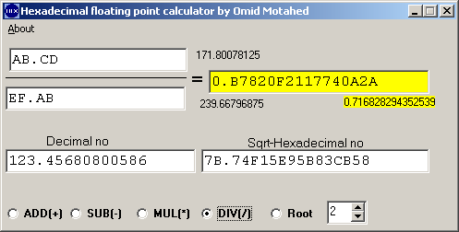
This hexadecimal calculator is actually a floating point hexadecimal calculator . The Windows calculator has integer hexadecimal number processing capability also, but it can not do floating point hexadecimal calculations and conversion . Calculator divided into 3 sections. The top section for doing arithmetic operations +, - ,*, / . The middle part is for converting floating point numbers between decimal and hexadecimal . The bottom section for selection which arithmetic operations should be performed in the top 2 edit boxes. Notice this calculator does not have button . As you type the numbers conversion is done.

For basic hexadecimal and decimal conversion all you need to do is to type in the corresponding edit box. As you type the floating point number is converted into the opposite base and displayed immediately.

This calculator also cal calculate the nth root also. To do that you must type the desired hexadecimal number in the middle right exit box. The desired root of the number can be controlled by the spin edit box next to it. As you type your number you will see immediately the result in the yellow edit box and its decimal value in the left edit box.. For maximum precision Delphi extended data type is used in all the calculation. In this calculator all the input numbers area treated as positive value numbers.

As you see in the above picture
decimal number 123.45680800586 in hexadecimal format is 7B.74F15E95B83CB58 . The base conversion is a simple division process. Notice the hexadecimal floating number can be converted to binary
111 1011.0111 0100 1111 ( 8=1000, A=1010, B=1011, C=1100, D=1101, E=1110, F=1111 )
For base 10 we use powers of 10 like 10¹, 10², 10³, 10⁴, 10⁵ … and floating point 10⁻¹, 10⁻², 10⁻³, 10⁻⁴, 10⁻⁵ … but
For hexadecimal numbers(base 16) 16¹, 16², 16³, 16⁴, 16⁵ floating point hexadecimal numbers 16⁻¹, 16⁻², 16⁻³, 16⁻⁴, 16⁻⁵ .
Notice also although integer decimal number 9999 in base 16 is written 270F but decimal number 0.9999 is written as 0.FFF972474538EF35 in hexadecimal format. 9999=270F but 0.9999=0.FFF972474538EF35

Anagram program has 2 tabs. In the first tab as you type the letters in the edit box the anagrams of the world will populate the editor. Like in the bellow picture you see all the words that can be made with the letters of
T H U R S D A Y . Words can be sorted reverse by last letter also.
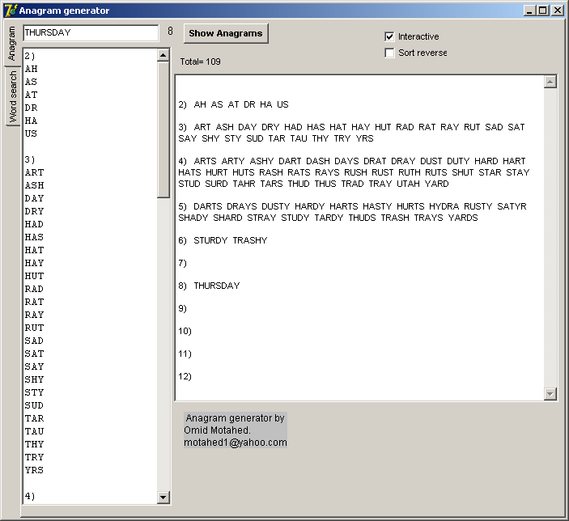
In the 2nd tab for word search from the 58000 built-in vocabulary list. You can specify wild cards. For example you see all the 12 words that end in GEMENT
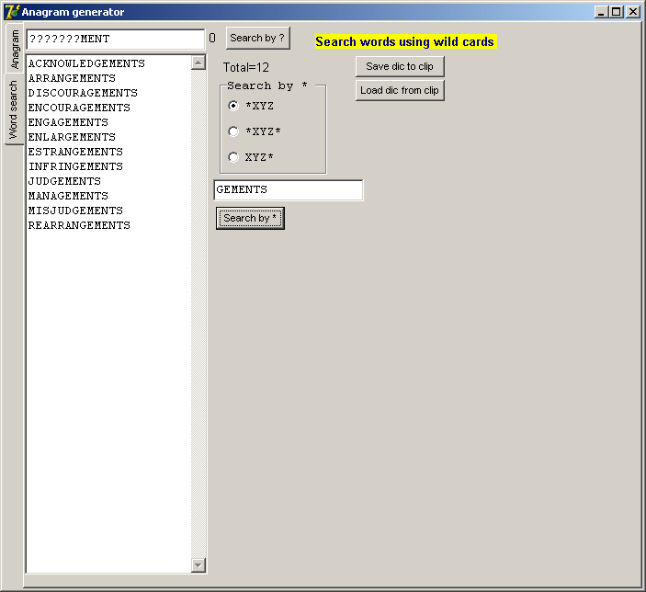

Now you see all the 6 words the begin with GEM
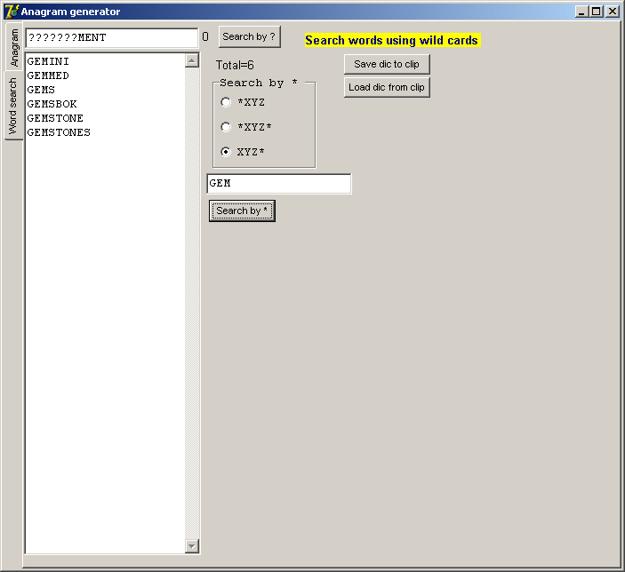
Accesstables program can be used to read and write MS Access(MDB) and export Access files into MS Excel files. It allows SQL statement to be executed, it also allows creation/edit of new tables in the Access database file. MS Access does not have to be installed.
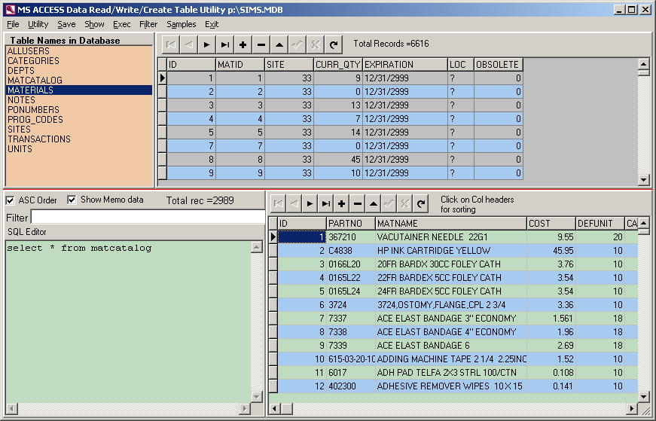

Program Fifteen is a very easy and challenging video game. It uses Delphi Tstringgrid for displaying and shifting of numbers. More detailed info about this game http://en.wikipedia.org/wiki/15_puzzle .
This is 8x8 grid with setup dialog box. You don’t need to use mouse also. Just use arrow keys and press enter
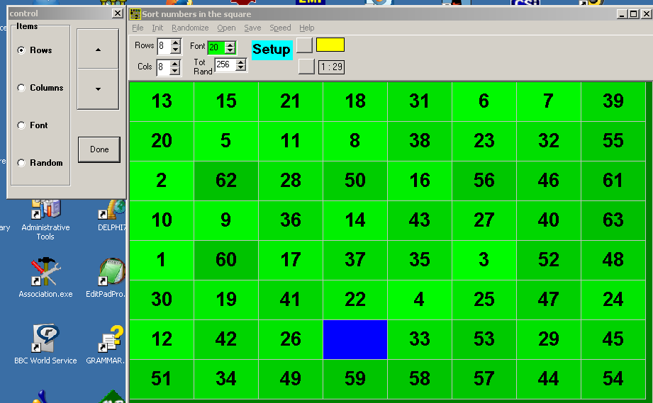
Program DelphiSyntax will highlight the Delphi reserved words in a text file. The file must be pasted into the editor first and then from File--> Highlight Syntax . The resulting file can be saved as an RTF file. If you want to document your PAS program this utility very useful for you.
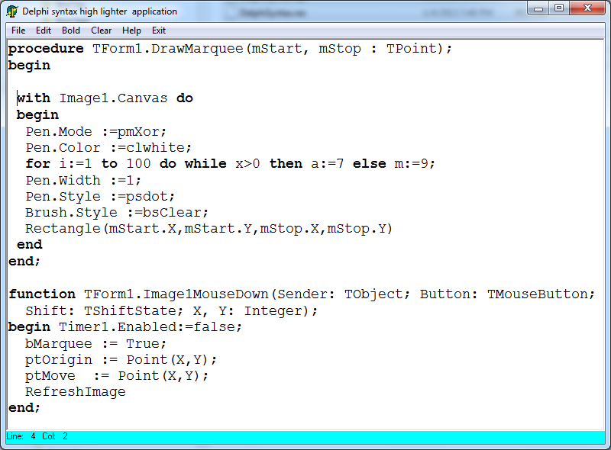
…………………………………………………………………………………………………………
Program Grid2EMF simply demonstrates how to export a Delphi TstringGrid into an EMF vectored file. EMF files are very powerful vector graphics files. Unlike bitmap files they can be scaled without any loss of detail. The export is copied into clipboard and later in the WORD you can paste it anywhere. See bellow table for 2 examples.
It is best not to use this EXE directly, instead copy this
procedure StringGrid2EMF(grid : Tstringgrid; Horlines,Verlines : boolean; filename : string); into your code
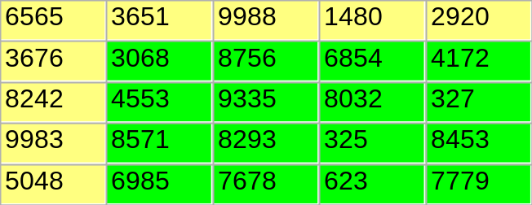 | 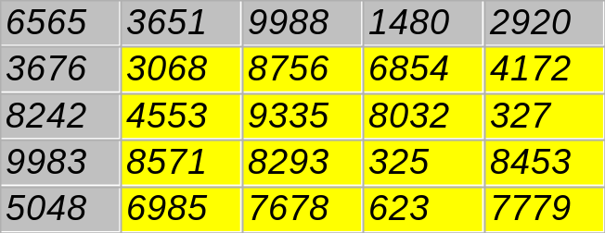

Program StretchPic . We all take it for granted how an image can be stretched to any rectangular shaped size. This project shows how this is done by the simple method of pixel duplication. The method of pixel duplication and reduction is used for zooming and shrinking. In this method no new pixel value is added, however in case of shrinking only some pixels are copied. The resize is done in the procedure Tfrm1.ResizeImage(Sender: TObject);
……………………………………………………………………………………………………………..
Program RichSpell is an interactive spelling check TXT/RTF editor as you type the words. If word is not in dictionary its color will be turned to red. This program is identical to the Richedit demo that come with Delphi. All I did I added spelling check functionality to that demo program. The VSS Activex spelling check component not used so editor can be run even on the computers where Delphi is not installed.
…………………………………………………………………………….

Program Thumbnails simply combines several other pictures in one JPG image file. You are presented with a stringgrid. You click on any cell and in open dialog you select the picture that you want for the particular cell. The picture does not have to be the same size as the cell. You can rearrange the cell to any size the picture will be stretched properly. This tiled image file can be saved . In the bellow table below you see 2 examples.
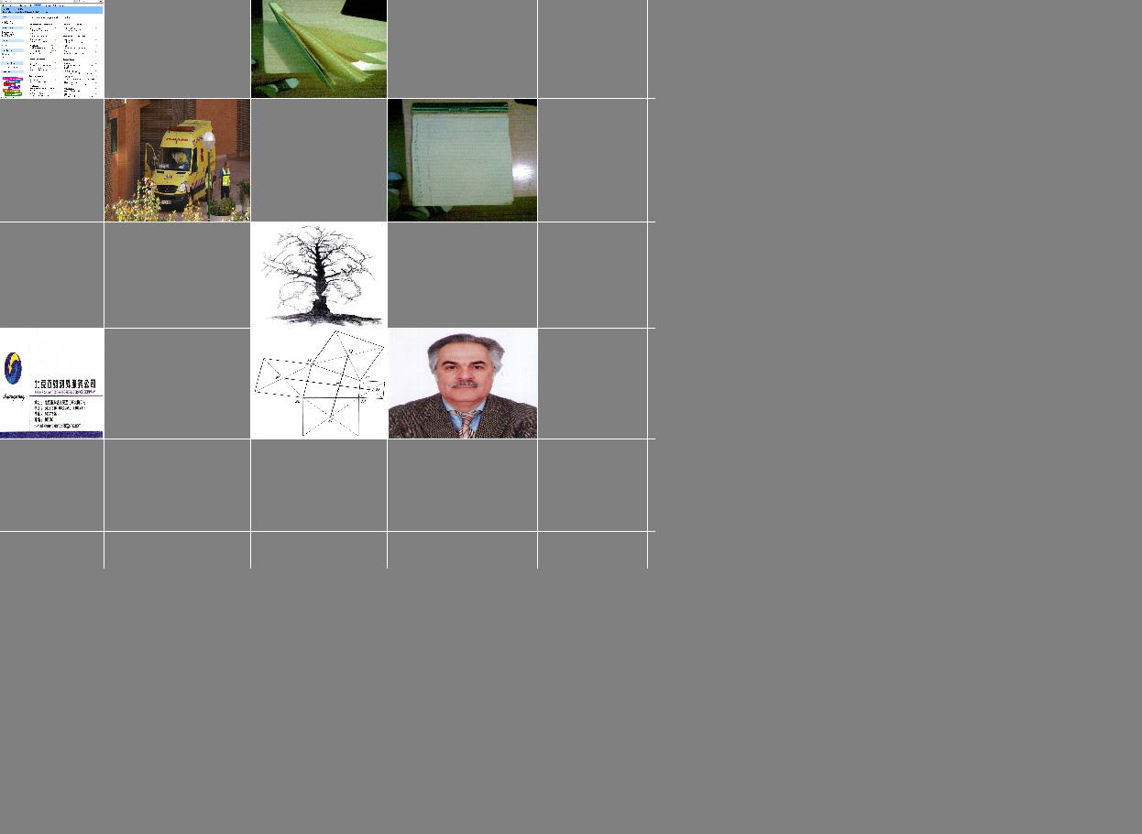 | 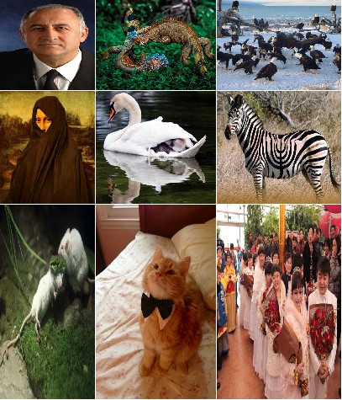
…………………………………………………………………………………………………………
Program Pictureoverlay will allow you to overlay as many smaller images on the main image. In addition you can control transparency and the rotation of the overlay image. With this program you can easily create interesting ghost images. Something no other painting artist can do it on their canvas. In bellow table you see 2 such ghosted images. For maximum flexibility the image can also be pasted to clipboard. The left image bellow is stretched which makes Mona Lisa(funny) look quadrilateral..
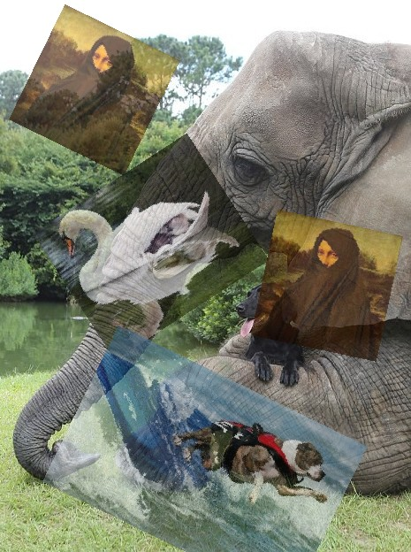 | 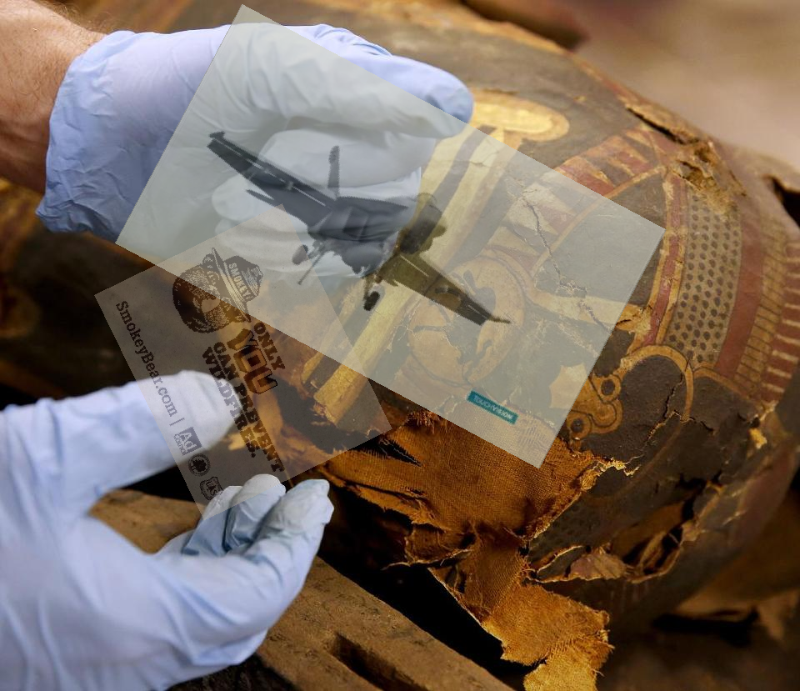
………………………………………………………………………………………………………
Program Morphing allows 1 image to be morphed into another image of the same size. The resulting file is an GIF animated file. You can specify the number of transition images(frames) and delay time of each GIF file frame. The morphing is not perfect. RxLib component library is required for this program. See morphingdemo1.gif and morphingdemo2.gif . Here you see a 5 frame morph.
 |  |  |  | 
……………………………………………………………………………………………………….
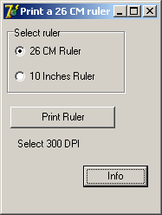
Program Printruler . An accurate 30 cm ruler is printed on your printer. Later on you have to manually cut it with a scissor and you can now have a cheap and flexible ruler anywhere you want. You need make sure and manually set the printing density to 300 DPI for correct printing. Other DPI will be implemented soon !
………………………………………………………………………………………………………..
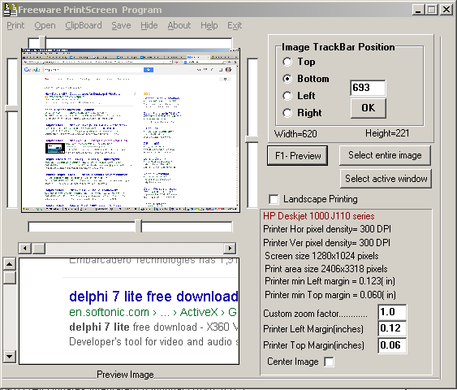

Program Printscreen will capture the screenshot of the PC display. You can later save the desired cropped area. Program can optionally register itself to run automatically when windows starts. With program you can open any BMP and JPG file and crop the desired portion of it.
…………………………………………………………………………………………
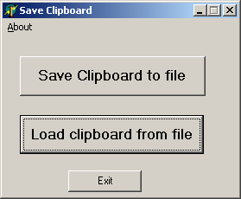
Program SaveClipboard will save the exact content of the windows clipboard as a binary file. Later this file can be read and pasted back into clipboard again. I wrote it mainly because of mathcad 6 and 7 problems . The worksheets of NEW mathcad files under Windows 7 can not be saved although existing files can be read and saved. With this program the content of mathcad worksheet is copied to clipboard first by the user. The user invokes SaveClipboard and saves the contents of Clipboard to disk. Next time that this file is needed you must use SaveClipboard again but this time you load the Clipboard from file. Now in mathcad you simply do a paste. Notice in this method the file is not saved the same format as mathcad mcd files and contents and format different.
................................................................................................................

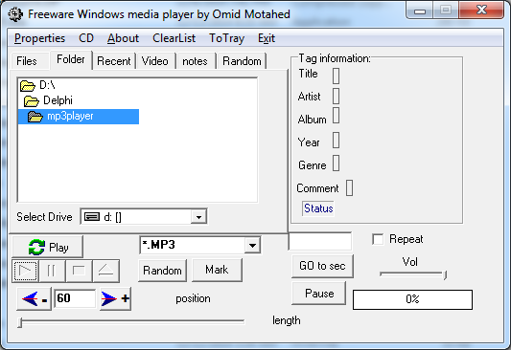

This mp3player is essentially the same as the one that is posted in http://delphi.about.com/od/multimedia/l/aa112800a.htm . I just added some bells and whistles to it. It can fast forward and reverse by seconds. Mark the desired location and jump to arbitrary location. Repeat a favorite song. Play random files so make it more like a radio station but no commercials . As songs are played the list of recent played files saved in text file. The program uses the Tmediaplayer component. Starting in Windows 98 now was possible to play MP3 files in addition to WAV files. But this component has a lot of limitations and lacks update that it deserves.

If you have any question or suggestions about any of the programs please feel free to contact me at motahed1@yahoo.com .

All the source codes can be compiled and run with Delphi 7. Delphi 7 is now free and available for legitimate download. You can see a video about it https://www.youtube.com/watch?v=xDoKyrkYOwI . There are many available download sources for it. Just Google Delphi 7 Lite and you see many download options.

Enjoy these programs

Regards
omid motahed
39.9139° N, 116.3917° E

