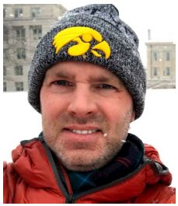

I am a student at the University of Iowa majoring in Geographic Information Science and minoring in Korean. I spent the past 24 years on active duty in the US Air Force.