1. Tendance au niveau des rendements de mais par provinces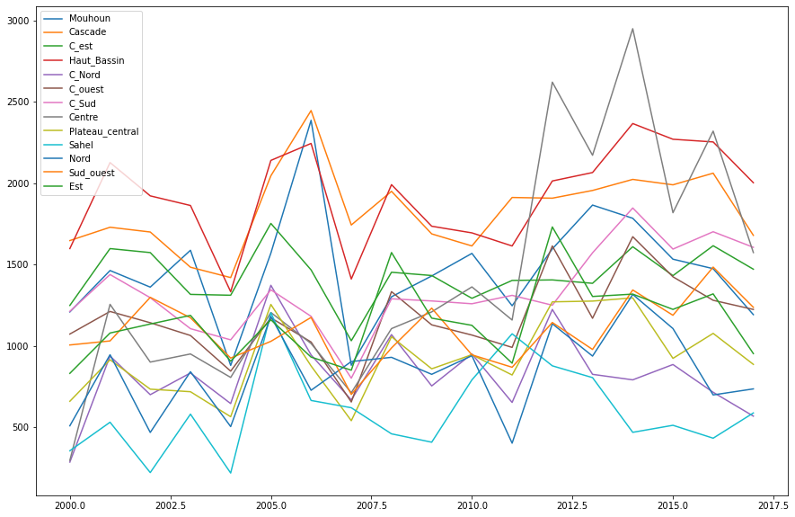
2. Correlation between dependent variables and crop yields

|  |  |  |
| --- | --- | --- |
|  | mil | mais |
| year | -0.0057704 | 0.16900459 |
| Tmin_ERA5 | -0.271013 | -0.515785 |
| ERA5_Pressure | 0.29282554 | 0.57985604 |
| ERA5_wins | -0.2307706 | -0.41307 |
| ARC2_year | 0.27752526 | 0.51956222 |
| Best_Temp_Max | -0.3128633 | -0.5326551 |
| Best_Temp | -0.2847737 | -0.4810347 |
| Tamsat_Prec | 0.2767934 | 0.55549829 |
| chirps_Prec | 0.31299869 | 0.58864239 |
| CDD | -0.039683 | -0.1412817 |
| CWD | 0.18322743 | 0.18066346 |
| PRCPTOT | 0.2931689 | 0.52374018 |
| R10mm | 0.26573121 | 0.48772966 |
| R1mm | 0.31627444 | 0.46490944 |
| R20mm | 0.2003021 | 0.4015268 |
| R5mm | 0.32675233 | 0.46667885 |
| R95pTOT | 0.09515807 | 0.20731599 |
| R99pTOT | 0.01728832 | 0.08629858 |
| RX1day | 0.1764552 | 0.38217602 |
| RX5day | 0.13189459 | 0.28208025 |
| SDII | 0.17757181 | 0.36984404 |
| TNn | -0.2659154 | -0.4435826 |
| TXn | -0.2344346 | -0.4154505 |
| TNx | -0.2984509 | -0.4757133 |
| TXx | -0.2358045 | -0.5054416 |
| Nino | 0.12020857 | 0.13244071 |
| sahel_rainfal | -0.0654072 | 0.12181655 |
| qbo | -0.0099835 | -0.0731261 |
| NDVI | -0.0164825 | 0.00424543 |
| ERA5_soil_moisture | 0.2722655 | 0.5339215 |
| AMM | 0.07675406 | -0.0103429 |
| AMO | 0.04447465 | 0.06112053 |
| AO | -0.0421952 | -0.0350802 |
| EA | -0.1306035 | -0.1549064 |
| NAO | -0.0349309 | -0.1247866 |
| NTA | 0.06946814 | 0.05190049 |
| PDO | 0.07775638 | 0.08519667 |
| gmsst | -0.0493293 | 0.10962692 |
| tna | 0.06646523 | 0.03059776 |
| tsa | -0.1482525 | 0.01521362 |
| mil | 1 | 0.51163794 |
| mais | 0.51163794 | 1 |

Tab1: Correlation between corn and millet yields and the predictor variables

1. Trend between climate variables and corn yield

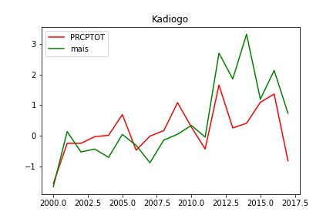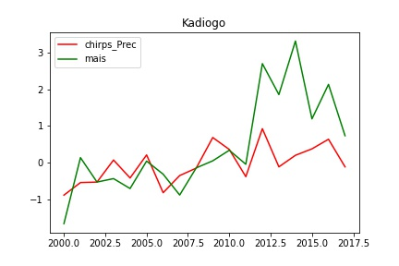

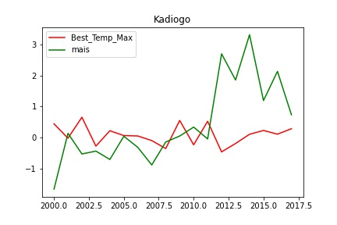 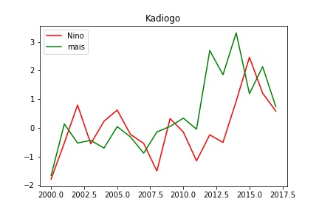

1. Variables importances for corn prediction with the Frorest rendom

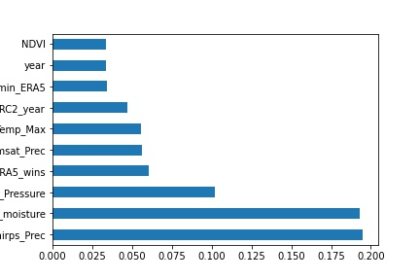 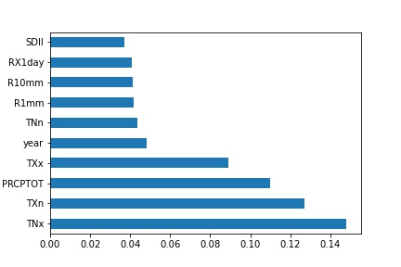

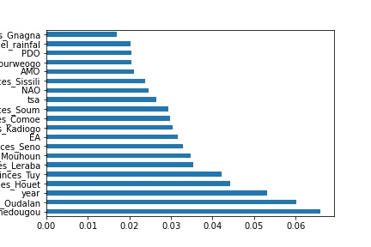

1. Variables importances for corn prediction with the Frorest rendom

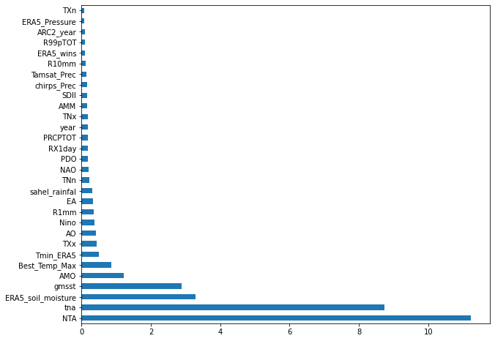

1. Prédictions des rendements de culture du maïs par provinces

